Chairs’ & Center Directors’ Meeting Minutes

Date: | January 22, 2007 (12:00 to 2:00 pm)
Location: | EBU II – Room 215
Attendees: | Abbaschian, Reza  Boretz, Mitch  Chute, Richard  Deshusses, Marc  Haddon, Robert  Hartney, Pat  Lake, Roger  Matsumoto, Mark  Norbeck, Joe  Payne, Tom  Ravishankar, Chinya  Schultz, Jerry
Absent: | Barth, Matt  Bhanu, Bir  DiGregorio, Joe

The agenda for the meeting is shown in Appendix 1.

1. Welcome – Request for Agenda Items from the Floor – Reza
Two agenda items were added: Development Priorities Input and Increase in Grad Student Fees.
Reza encouraged all faculty to respond to the NRC surveys. Faculty who respond by 2/15/07 will be eligible to rate graduate programs at other universities. Also, a high number of responses will help BCoE’s reputation.
Reza announced that Alex Balandin will be the Program Director of BCoE’s new Materials Science and Engineering (MSE) program. Alex will be contacting each department separately about the MSE program. It was noted that each department will need to provide the list of required and technical elective courses for its MSE specialization and will need to vote on these study plans. Also, it was noted that MSE will appear on MSE student degrees. The academic advisors for the MSE program are expected to be the department representatives on the MSE Committee. Department Chairs will need to determine if they will provide course relief for these advisors.

2. Minutes Approval - Pat
Minutes of the revised draft 1/12/07 Chairs/Directors Meeting were unanimously approved. These minutes will be posted on BCoE’s Intranet site.

3. Departments/Centers/Associate Deans/Assistant Deans and Development Updates
EE reported that the Statistics Department has provided an alternative to EE’s proposed new (applications specific) Statistics course. The Statistics Department will offer the course but will not keep ABET data. EE will inform Statistics that collecting ABET information is a required component of the course, no matter which department offers it.
Bioengineering is teaching several new courses this term. The Bourns B156/160 Lab renovation project is expected to be completed in March 2007. Prof. Anvari’s equipment has arrived but several benches in his new lab need to be removed before this equipment can be installed. Bioengineering’s Masters and PhD programs have been approved and are listed (even though the formal approval letter hasn’t been received). Bioengineering has about 25 graduate student applications so far for next year. They are inviting 8 faculty candidates to campus.
CEE is working on their ABET responses. They have a large number of grad student applications this year. Marc mentioned that CEE has an on-going Friday seminar series.
Joe Norbeck is on 5 search committees, including ones for the Blakely Center and BCoE’s CE-CERT Director position. The CE-CERT Search Committee will be requesting letters for 2 candidates. Joe expects about 270 attendees for a 1/25/07 Blakely conference at the Mission Inn entitled “Revitalizing the Suburbs.” Edward Blakely will give the welcome and introduction presentation at this conference. The $700K PACES grant was recently signed. The Guthrie Undergraduate Seminar is scheduled for 1/27/07.
Tom announced that one of Frank Vahid’s students received a top award. CSE has hired a new MSO, Cheryl Gerry from CEE, and expects to make an offer for its #2 Programmer/Analyst soon. CSE has received about 450 faculty applications so far. Tom noted that the overall quality of these applicants is excellent.
Mark noted that ME is having some problems with its undergrad labs, mostly due to the large number of students. ME will be bringing 2 faculty candidates to campus plus some biomechanical candidates.

4. Graduate Education - Mark
Mark met with the departmental Grad Advisors last week. Graduate student applications are up 40% from last year. Some departments are ready to make offers to potential grad students. In response to questions, Mark commented that financial offers should quote the current UCR fees and that any increase in fees will probably be covered by campus. Also, as a way to minimize the effects of processing delays of offers, departments can send email notifications to potential grad students indicating that the department has recommended acceptance of the student and include estimates of financial support.

5. Faculty Recruitment Update – Mark
Mark reported that BCoE has received about 1,200 faculty applications so far this year which is about 200 less than last year. However, Mark expects us to surpass last year’s total in 4-6 weeks. Reza reminded participants to use the candidate evaluation forms. According to UCR’s Affirmative Action Office, these forms do not have to be kept by departments. Robert mentioned that CNSE has a couple of good interdisciplinary faculty candidates. CNSE will hire a candidate from IBM as a Visiting Assistant Researcher or Postdoc.

6. Undergraduate Education - Ravi
Ravi noted that undergraduate application information will be released by UCR before 2/1/07. This year’s on-campus event for Chancellors and Regents Scholars has been scheduled on 2/24/07 which is the same date as UCR’s Alumni Homecoming event. It is hoped that these events will be synergistic. Ravi needs faculty (and student) volunteers for these events. Also, he needs faculty volunteers to call Chancellors and Regents Scholars to encourage them to attend UCR. Last year, only 29 out of 400 Chancellor Scholars enrolled at UCR. It was recommended that the dollar figures for the Chancellors and Regents Scholarships be provided to faculty making these calls. Ravi will be making a strong recruitment effort at RCC this year and will be utilizing a new brochure. Lastly, Ravi asked for nominations from departments for editors for UCR’s new Undergraduate Journal. He would like 2-3 students from BCoE to be editors of this Journal.

7. Visit to Western Digital - Richard
Richard commented that invitations to the Alumni Homecoming will be going out later this week or next week. Western Digital has invited BCoE faculty to meet with several of their engineers on either 2/12 or 2/19. Since 2/19 is a holiday (Presidents’ Day) it was recommended that this date might be preferable because the visit will take most of the day. Departments should contact Joe D. with their preference.

8. Tech Horizons/Sendai Tech Conference - Richard
There will be an event at UCR on March 22nd commemorating the 50th Anniversary of the establishment of Riverside/Sendai Sister City affiliation. This event will include a tour of CE-CERT. There will be two main sessions at the event: Environmental Technology and Technology and Trade between California and Japan. Also, Richard asked Chairs to decide on (faculty and industry partner) presenters for the May Tech Horizons Conference as soon as possible so that programs can be finalized and invitations mailed.

9. Other Topics
Richard requested input for BCoE’s list of Development (i.e., fund-raising) Priorities. BCoE’s priorities will be sent to UCR Development in mid-February.
UCR with meet with Riverside City and County representatives in February to discuss incubator space in the Research Park.
It was recommended that UCR establish a group to organize and run (small and large) conferences at UCR. The existence of such a group would encourage the scheduling of more of these events at UCR.

APPENDIX 1

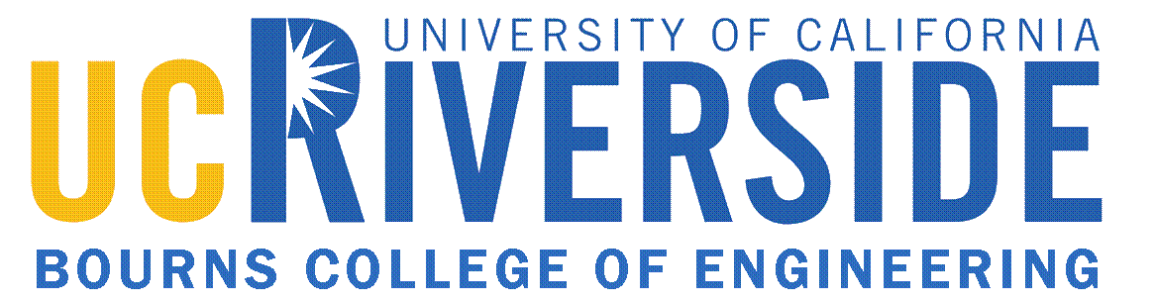
Chairs’ & Center Directors’ Meeting

January 22, 2007

Agenda
Engineering Building Unit II – Room 215

1. Welcome - Request for Agenda Items from the Floor Reza

2. Approval of Minutes from January 12, 2007 Meeting Pat

- Departments/Centers/Associate Deans/Assistant
Deans and Development Updates

4. Graduate Education Mark

5. Faculty Recruitment Update Mark

6. Undergraduate Education Ravi

7. Visit to Western Digital Richard
2/12 or 2/19 (holiday)

8. Tech Horizons/Sendai Tech Conference Richard
9. Other Topics

Next Scheduled Meeting is Monday, February 5, 2007
Please note: Meetings will be held in EBU II – Room 215

