University of California Riverside

Bourns College of Engineering

Computer Engineering

July 1, 2012

Submitted to the

Engineering Accreditation Commission
Accreditation Board for Engineering and Technology, Inc.
111 Market Place, Suite 1050
Baltimore, Maryland 21202-401
Please ignore minor typos, punctuation etc.
A week before the final draft is due, I will have a proofreader check the entire document. eamonn keogh
Table of Contents
BACKGROUND INFORMATION 5
CRITERION 1. STUDENTS 10
CRITERION 2. PROGRAM EDUCATIONAL OBJECTIVES 20
CRITERION 3. STUDENT OUTCOMES 31
CRITERION 4. CONTINUOUS IMPROVEMENT 33
CRITERION 5. CURRICULUM 48
A. Program Curriculum 48
B. Course Syllabi 48
CRITERION 6. FACULTY 50
Table 6-1. Faculty Qualifications 58
Name of Program 58
Table 6-2. Faculty Workload Summary 59
CRITERION 7. FACILITIES 60
CRITERION 8. INSTITUTIONAL SUPPORT 67
B. Program Budget and Financial Support 67
C. Staffing 67
E. Support of Faculty Professional Development 67
PROGRAM CRITERIA 68
Appendix A – Course Syllabi 69
Appendix B – Faculty Vitae 70
Appendix C – Equipment 71
Appendix D – Institutional Summary 72
1. The Institution 72
Table D-1. Program Enrollment and Degree Data 75
Signature Attesting to Compliance 77

ABET
Self-Study Report

for the

Computer Engineering
at

University of California Riverside
Riverside

July 1, 2012

CONFIDENTIAL

The information supplied in this Self-Study Report is for the confidential use of ABET and its authorized agents, and will not be disclosed without authorization of the institution concerned, except for summary data not identifiable to a specific institution.

BACKGROUND INFORMATION

- Contact Information

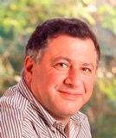 | Walid Najjar  Director, Computer Engineering Program  Department of Computer Science and Engineering  Winston Chung Hall, Room 351  University of California Riverside  Riverside, CA 92521  Email: najjar@cs.ucr.edu  Phone +1 951 827 4406 Fax +1 951 827 4643  Office Room 421

- Program History
We begin with a brief timeline of significant events in the computer engineering history, show in Table 1. (this section is WIP, Tom Payne is helping eamonn with it)
Table 1: A Brief Timeline of Significant Events in the Programs History
1972: CS track added to BS in math.  1972: BS and MS in Applied Science approved, both with CS tracks.  1976: Applied Science shut down and BS in CS established within Math Dept.  1977: First graduates from BS in CS.  1982: MS in CS started in Math Dept.  1984: First graduates from MS in CS.  1984: Math Dept changes name to Department of Mathematics and Computer Science.  1988: CoE proposal approved. Glenn Everett appointed as Acting Dean  1989: First BS students admitted to CoE.  1990: Math and CS become separate departments within CNAS  1990: Larry Larmore becomes chair of new CS Department  1990: College of Engineering and hires Susan Hackwood as founding dean.  1991: CS moves from Sproul Hall to University Office Building.  1992: CS joins CoE as its first “department” --- others are still “programs.”  1992: Teodor Przymusinski becomes chair  1994: PhD in CS approved.  1994: Tom Payne becomes CS chair  1995: CoE becomes BCoE, Bourns Hall opens, CS moves in along with rest of BCoE. | 1995: Susan Hackwood resigns deanship and Lee Rudi (retired UCSD dean of engineering) becomes interim dean  1997: Satish Tripathi becomes BCoE dean.  1998: First CS PhD (Torsten Berger) graduated.  1998: Dept of Computer Science renamed Department of Computer Science and Engineering.  1999: Mart Molle becomes CS chair.  2001: BS in Computer Engineering established (jointly administered by CS and EE  2001: CS&E moves to Surge Building.  2002: Tom Payne begins second term as chair.  2003: Mark Matsumoto becomes Acting Dean of Engineering.  2005: Reza Abbaschian becomes dean of BCoE  2005: CS&E and EE move to Engineering II.  2007: BS in Computer Science and BS in Computer Engineering both receive ABET accreditation.  20xx: BS/MS in CS approved.  2007: Laxmi Bhuyan becomes chair of CS&E.  2010: Computer Engineering becomes an official interdisciplinary program with its own committee-in-charge.  2012: MS in Computer Engineering approved.  2012: BS/MS in Computer Engineering approved.
In the UC system there is a distinction between a major and a program. An interdepartmental major is run by two or more departments. The Faculty members of all participating Departments must approve all curriculum changes, admission policies etc. The Chairs of the participating Departments must agree on an undergraduate advisor. A Program, on the other hand, has its own set of participating Faculty members drawn from two or more Departments. It is administered by a Program Director and an Associate Director, both appointed by the Dean from the participating Faculty members. Curricular decisions are taken by the participating Faculty members.
In 2011 we have started the process of organizing Computer Engineering (CEN) as a program within the UCR Bourns College of Engineering. The participating Faculty consists of:
- Laxmi N. Bhuyan, Professor, Computer Science and Engineering
- Philip Brisk, Assistant Professor, Computer Science and Engineering
- Rajiv Gupta, Professor, Computer Science and Engineering
- Roger K. Lake, Professor, Electrical Engineering
- Walid Najjar, Professor, Computer Science and Engineering, Director CEN
- Sheldon Tan, Associate Professor, Electrical Engineering, Associate Director CEN
- Frank Vahid, Professor, Computer Science and Engineering
- Albert Wang, Professor, Electrical Engineering
- Qi Zhu, Assistant Professor, Electrical Engineering
Since then the CEN Faculty has been working with the CSE and EE Departments to update the CEN curriculum. We have proposed a new MS degree in CEN and will be proposing this year a 5-year BS/MS degree in CEN.
Table 2 shows the CE enrollment and number of degrees awarded since the1999/2000 academic year.
Table 2: Computer Engineering Enrollment and Degrees
 | New Students |  | Total Enrollment |  |  | Degrees Granted
 | Freshmen | Transfer |  |  | Total |  |  | Total
1999-00 | 8 |  |  |  | 11 |  |  | 2
2000-01 | 77 | 6 |  |  | 118 |  |  | 3
2001-02 | 80 | 3 |  |  | 183 |  |  | 5
2002-03 | 74 | 4 |  |  | 226 |  |  | 10
2003-04 | 55 | 1 |  |  | 226 |  |  | 20
2004-05 | 72 | 1 |  |  | 207 |  |  | 29
2005-06 | 56 | 2 |  |  | 164 |  |  | 14
2006-07 | 83 | 3 |  |  | 202 |  |  | 21
2007-08 | 57 | 3 |  |  | 175 |  |  | 28
2008-09 | 102 | 3 |  |  | 195 |  |  | 14
2009-10 | 77 |  |  |  | 210 |  |  | 54
2010-11 | 106 | 4 |  |  | 234 |  |  | 16
2011-12 | 72 | 7 |  |  | 234

- Options
The program has no options, tracks or concentrations at this time.

- Organizational Structure
Table 3 shows the administrative structure of the Computer Engineering program
Table 3: The Organizational Structure of CE
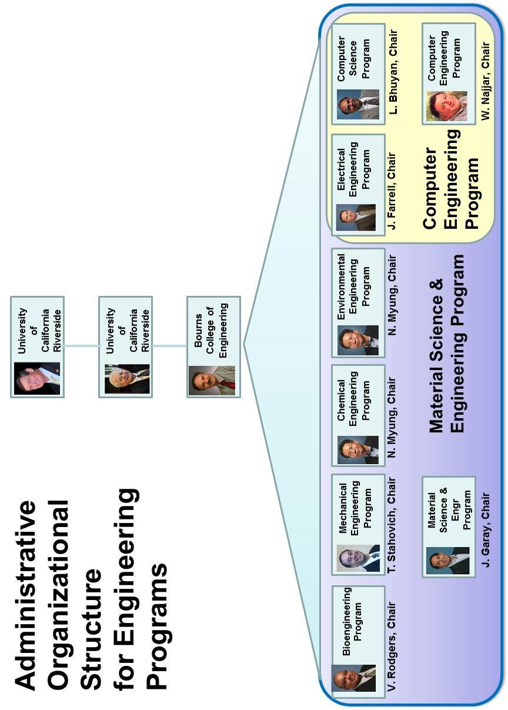

- Program Delivery Modes
All courses for the bachelor’s degree are delivered in campus classrooms and laboratories on weekdays and weeknights. The curriculum includes no cooperative education, distance education, or web-based instruction.
- Program Locations
All courses are delivered on the campus of the University of California, Riverside.
- Deficiencies, Weaknesses or Concerns from Previous Evaluation(s) and the Actions Taken to Address Them
This is addressed in great detail in a 109-page document produced by Eamonn Keogh, Reza Abbaschian, Thomas Payne, and Mitch Boretz. This document was sent to ABET on June 20th 2008. For brevity and to avoid redundancy, this document is attached as an appendix to this report. It is called “CE-response-062008.pdf”.
Below we briefly review the two issues, and how we resolved them, however we emphasize that the detailed and carefully documented response is in “CE-response-062008.pdf”.
We had both a Criteria 2 and 3 Weaknesses:
Weaknesses 1: Criterion 2. Program Educational Objectives.
Criterion 2 states, “... program educational objectives are broad statements that describe the career and professional accomplishments that the program is preparing graduates to achieve.” The program’s objectives are not broad statements that describe the accomplishments of computer engineering graduates and their achievements; instead they describe skills more appropriately articulated in program outcomes. In addition, it is not clear that these objectives were reached based on the needs of program constituents (students, faculty, employers, advisory boards, and the community at large). Since these objectives were not defined based on the needs of program constituents, it is not clear how the results are used to improve program outcomes and for graduates to attain the objectives.

Weaknesses 2: Criterion 3. Program Outcomes and Assessment
Criterion 3 states, “There must be processes to produce these outcomes and an assessment process, with documented results, that demonstrates that these program outcomes are being measured and indicates the degree to which the outcomes are achieved. There must be evidence that the results of this assessment process are applied to the further development of the program.” Course objectives are defined for each course but they are not clearly related to program outcomes that are referred to as departmental outcomes. It is stated in the report that the college will administer a new assessment tool in the fall of 2006 but the process used presently in measurement of program out comes is not documented. Achievement of program outcomes is demonstrated using course objectives and grades in homework assignments and exams. Sufficient evidence was not provided to demonstrate students attain the outcomes articulated by the computer engineering program.
We note that the department fully acknowledged both weaknesses, and worked tirelessly to address them.
We addressed Weakness 1 by the following:
In late October 2007, the two faculty members most responsible for ABET, Dr. Eamonn Keogh and Dr. Tom Payne, had a series of meetings with the interested parties, including the CE Assessment and Accreditation committee, the EE Assessment and Accreditation committee (Dr. Amit K. Roy-Chowdhury and Dr Roger Lake), the CE Undergrad education committee and the Chair of CS&E, Dr. Laxmi Bhuyan.
On November 6th 2007, Dr. Eamonn Keogh and Dr. Tom Payne wrote new PEOs. They based them very closely on the EE PEO. The Electrical Engineering Department was consulted and asked for feedback at this stage.
On November 8th 2007, Dr. Eamonn Keogh presented the new PEOs to the CSE Board of Advisors, from 1:00pm to 1:30pm. Each member got a take home copy, and was invited to discuss the PEOs both at the meeting, and offline by email at a later date.
On November 14th 2007, Dr. Eamonn Keogh presented the new PEOs with notes from the Board of Advisors to the entire CS&E faculty, 40 minutes were spent discussing the PEOs
and they were adopted by a majority vote.
Dr. Eamonn Keogh solicited feedback and approval for our new PEOs from employers of our CE students. This process was conducted by phone, email and in four cases, by an onsite visit by a delegation from our department. We also solicited comment and approval for our new PEOs from our students.
In summary, we created new PEO after soliciting input and approval from all our constituents, our Board of Advisors, employers of our students, faculty, and the students themselves. Furthermore, we have carefully documented this process at every step. This detailed documentation can be found in “CE-response-062008.pdf”.
We addressed Weakness 2 by the following:
To remedy the Criterion-3 weakness, UCR’s Computer Engineering program (CE) adopted the outcomes-assessment process of UCR’s Electrical Engineering program (EE). This was done for the following reasons:
1. CE is jointly administered by the Department of Electrical Engineering and by the Department of Computer Science and Engineering (CS&E).
2. The engineering portion of CE’s curriculum is composed of EE courses, taught by the Electrical Engineering Department, and CS courses, taught by CS&E.1
3. The CE and EE programs have the same outcomes, namely ABET’s A-K outcomes.
4. Following EE’s due-process response, EAC’s Final Statement of 2007 judged EE’s outcomes-assessment process to fulfill ABET’s Criterion-3 requirements, and indeed extensively complemented them.
The complication of joint administration by two departments is handled as follows. Both departments follow the same (EE’s) outcomes-assessment process with analysis and evaluation being performed by their respective Assessment Committees. Recommendations go to their respective faculties. Changes to courses are handle within the corresponding department following standard interdepartmental consultation. Changes to the curriculum must be approved by both departments. In principle, a change could be approved by one department and denied by the other. That has never happened, and it will be up to the dean to modify the organizational structure if and when such a problem arises.
The detailed documentation for all the above can be found in “CE-response-062008.pdf”.

- Joint Accreditation
This program is seeking EAC accreditation only.

GENERAL CRITERIA

CRITERION 1. STUDENTS

- Student Admissions
The admissions processes for all our programs conform to the UCR Academic Senate’s interpretation of the admission policies of the University of California, which, in turn, interpret the mandates of the California Master Plan for Higher Education.
In broad terms, the Master Plan constrains the University of California to admitting only students ranking in the top 12.5% of the High School graduates in the State. Students in lower tiers are eligible for admission to Campuses of the California State University system, or to Community Colleges in the State. Placement in the top 12.5% of the graduating class is determined by the UC Eligibility Index, which is computed centrally by the UC Office of the President, based on criteria defined by the UC System-Wide Academic Senate.
Figure 1 summarizes the admissions process to our college. Prospective students submit their applications to the Office of Admissions for the University of California, which serves all ten campuses of the University. Applicants may apply to multiple campuses, and to multiple programs at these campuses. They may also designate primary and alternate majors. The UC Office of Admissions determines whether each applicant meets the UC Eligibility criteria (which specify GPA and coursework requirements) and forwards each eligible application to the campuses to which admission is being sought. Ineligible applicants are rejected.
Within UCR, processing of these forwarded applications begins through the Campus Office of Admissions, in accordance with guidelines defined by the Undergraduate Admissions Committee (UAC) of the UCR Academic Senate. An Enrollment Management Council (EMC) also exists at the Campus level to make decisions annually on the enrollment targets at the Campus and College levels. These decisions are informed by the strategic planning processes at the Campus and College levels.
UCR follows a multi-tier admissions process, which operates as follows. At the first tier, an Academic Index Score (AIS) is computed for each applicant, based primarily on academic parameters such as the GPA, the SAT score, and the number of completed Advanced Placement or IB courses. College-specific upper and lower AIS thresholds are determined in accordance with the planned enrollment targets. All applicants to a College whose AIS scores exceed the upper threshold are automatically admitted to their program of interest. All applicants with AIS scores below the lower threshold for each college are removed from that college’s pool. The remaining applicants are forwarded to the respective colleges for further processing.
Once these forwarded applications arrive at BCoE, a, BCoE-specific Index Score (BIS) is computed for each applicant. This BIS score is a function of the applicant’s grades in Mathematics and Science, as well as the Math part of the SAT Reasoning Test (the SAT Advanced test is not required by UC). The applicants to each program are ranked by BIS score, and applicants are admitted starting at the top of the list for each program until the program’s enrollment target is met. Applicants may be placed on a wait list, to be admitted if the yield rate from the admitted pool is insufficient to satisfy program targets.
Figure 1: The CE Admissions Process

- Evaluating Student Performance
Student performance monitoring is primarily the role of the Office of Student Affairs, under the supervision of the Associate Dean. Each program also has a faculty member designated as the Program Faculty Adviser, who serves as the primary departmental contact for program-specific policy decisions. College-level policy is under the purview of the Associate Dean. The staff of Office of Student Affairs (OSA) supports the undergraduate programs.
Each student is assigned to a staff adviser in the OSA, and encouraged to meet with this adviser whenever the need arises, but at least once quarterly. In addition, attendance at a mandatory Annual Major Advising session is required of all undergraduates in the college. The Annual Major Advising session is conducted jointly by the OSA staff and the Program’s Faculty Adviser, and provides information on a variety of topics to students, including program requirements as well as academic success strategies and professional development opportunities.
Figure 2 depicts the process for monitoring student progress. Students are required to maintain a GPA of 2.0 each quarter, as well as cumulatively. Students are reminded of these requirements regularly, first during the registration process in their first quarter as freshmen, and again each year during Annual Major Advising. Grades are posted by instructors each quarter to the central SIS database, which tracks student performance, and provides degree audits to check for completion of degree requirements. At the end of each quarter, staff advisers in the OSA review the academic records of BCoE students and identify all whose term and cumulative GPAs are below 2.0.
A failure to meet these GPA requirements results in a student being placed on probation. The student is notified of this probationary status, and advised that a failure to obtain at least a 2.0 GPA the following term will result in dismissal. A registration hold is now placed on the student’s record, to be released only upon the completion of Academic Success Workshops and other advising and mentoring activities through the OSA. A student who receives a dismissal notice may appeal the dismissal to the Associate Dean, who may grant or reject the appeal based on extenuating circumstances.
The primary source of information regarding student performance is the campus-wide Student Information System (SIS) that records all student registrations and grades, and which is maintained by the Computing and Communications organization. All staff and faculty advisers have access to this system, either directly, or through the Student Advising System (SAS) front-end that provides access to student transcripts and degree audits. This system is used regularly by the staff of the OSA to monitor student progress.
Students who are about to graduate are required to complete a graduation application. At this point, the student’s academic adviser in OSA performs a detailed manual check to ensure that all degree requirements have been met. If the requirements have been met, the Office of the Registrar is notified of degree completion, so that the degree may be awarded.

B.1 Enforcing Prerequisites
All students are given a term-by-term course plan that ensures timely graduation as long as courses are completed in a timely manner. This course plan incorporates prerequisites, so that students who follow the course plan automatically satisfy prerequisites.

Whether or not students follow this course plan, prerequisites are enforced by the registration system. Students register for courses through the GROWL system that interfaces with SIS, and is able to enforce prerequisites. A student prevented from taking a course due to lack of prerequisites can petition the course instructor, who has the authority to grant the student a prerequisite waiver. The student is not permitted to take the course without such a waiver.

Figure 2: Academic Advising and Performance Monitoring

- Transfer Students and Transfer Courses
Transfer students apply using the same application portal that freshmen use. This portal is maintained by the System-Wide Office of Admissions, located in Oakland, CA. This office collects applications and forwards them to the UCR Office of Admissions.
In accordance with the California Master Plan for Higher Education, the University of California maintains extensive articulation agreements with Community Colleges in the State. Course articulations are reviewed and approved by the cognizant departments, and are tracked and maintained by the Campus Articulation Officer. All system-wide articulation agreements are available at the website www.assist.org, which is open access. The transfer route appears to be gaining popularity, especially given recent increases in tuition. When a transfer applicant (typically, from out of state) presents a transcript containing courses that have not already been articulated, the staff of the BCoE OSA collect the relevant course syllabi and work with the cognizant departments at UCR to determine articulations.
All BCoE programs have published detailed requirements for transfer admission. Admission to our programs requires a minimum GPA of 2.8, and the completion of coursework specific to the major being applied to. Incoming transfer students may transfer up to 105 quarter units (70 semester units) towards their degrees from the University. To ease the burden of consulting www.assist.org for each major an applicant may be interested in, we have prepared brochures showing transfer requirements for each of our majors. We make these brochures available both in hardcopy, as well as on the Web. Some examples appear at www.engr.ucr.edu/undergrads/transferring/SpecialAgreements.html.
If the transfer applicant for a major meets all the requirements specified by that major, the UCR Office Of Admissions admits that applicant. Applicants who satisfy most transfer requirements are forwarded to the College for additional review. The OSA staff reviews these applications, and in consultation with the departments and the Associate Dean, grants exceptions as warranted. Conditional admission is also sometimes granted, subject to the completion of some requirements that may not have been met at the time of application.
(Eamonn needs to add transfer requirements for CE/CS)

- Advising and Career Guidance
The mechanisms by which students receive academic advice have already been outlined in Section B: Evaluating Student Performance. Here, we will describe the mechanisms for providing Career and Professional guidance.
Professional guidance and mentoring is provided by staff (particularly, the Director of Student Professional Development), the faculty, and the Career Center. The overall College philosophy that guides all interactions with students is to ensure that they are both academically and professionally prepared to become leaders in their chosen fields. This goal is especially challenging to meet in engineering colleges.
As is typical for undergraduate programs in engineering, our students spend the first two years of their undergraduate work completing prerequisite coursework in mathematics, the sciences, and the humanities and social sciences. Unfortunately, instructors in these areas are unfamiliar with any of the engineering disciplines, and unable to motivate or mentor our students in their early years here. Consequently, our students fail to develop a clear sense of academic direction or a sense of professional pride, having no role models or mentors, either at home or on campus. Another consequence of this lack of engagement in the early years with BCoE is that it is harder for students to build effective working relationships with their peers, so they can begin to see them as technically strong, and as effective partners.
We are addressing these issues in several ways. The first of these is a series of 1-unit classes intended to promote engagement with BCoE in the early years and to help the student’s professional development in later years. This series of classes are numbered ENGR 1 (freshmen), ENGR 2 (sophomores), ENGR 101 (juniors), and ENGR 102 (seniors). These courses are intended to provide our students with involvement in Professional Development activities. Activities to be performed are program-specific, and will include projects, industry overviews and interactions, involvement with professional societies and clubs, team building, career guidance, and coverage of ethics and lifelong-learning issues. The specific list of topics in these courses includes the following:
- Participate in peer-group building activity.
- Understand Engineering as a creative process for solving real-world problems.
- Understand current and future trends in the student’s major discipline.
- Understand some analysis tools, and their use in design and practice.
- Understand the stages of development of an Engineer as a Professional
- Participate in individual and group projects.
- Participate in Professional Clubs.
- Participate in the Career Path Milestones program.
- Understand the role and importance of Ethics in the Engineering profession.
- Understand the importance of engaging in life-long learning.
- Participate in Industry visits.
These topics are presented in workshops and discussion-style activities. A suite of activities supported by the college under the Professional Development Milestones program complement the program-specific content in these courses. Examples of such activities are academically-oriented workshops on time management and study-skills, as well as professionally-oriented activities such as mock interviews, resume writing, as well as research and industrial internships. Figure 3 summarizes these milestones.

Figure 3: Professional Development Milestones Program
A total of 18 Student Professional Organizations exist in BCoE, and are supported financially by the College. These organizations are student-led, and are very active. Just over 800 students are active members of these organizations (roughly 40% of the students in College).

- BCOE SLC (Student Leadership Council)
- ACM (Association of Computing Machinery)
- AIChE (American Institute of Chemical Engineers)
- ASME (American Society of Mechanical Engineers)
- ASQ (American Society of Quality)
- BMES (Biomedical Engineering Society)
- EWB (Engineers Without Border)
- IEEE (Institute of Electrical and Electronics Engineers)
- IEEE EDS (Electron Devices Society)
- ION (Institute of Navigation)
- MRS (Material Research Society)
- NSBE (National Society of Black Engineers)
- OSA (Optical Society of America)
- SACNAS (Society for Advancement of Chicanos and Native Americans in Science)
- SHPE (Society of Hispanic Professional Engineers)
- SAE (Society of Automotive Engineers)
- SWE (Society of Women Engineers)
- TBP (Tau Beta Pi) – Honors Society
These organizations, under the mentorship of the Director of Student Professional Development, participate in a broad range of activities during the year. A summary appears below.

BCOE Professional Development Milestones Program 2,102 participants total
Date | Event | Students | Date | Event | Students
10/5/2010 | Technical Job Search Workshop | 27 | 1/19/2011 | Preparing for Engr. Technical Career Fair/Fashion Show | 72
10/11/2010 | Making Professional Connection with Western Digital | 21 | 1/20/2011 | Careers in Video Game & Animation Design | 30
10/11/2010 | Careers in Pharmaceutical Industry | 36 | 1/26/2011 | Google Info Night with Alumni | 155
10/12/2010 | Beginning Resume Writing | 15 | 1/26/2011 | Information Session with CIA | 43
10/14/2010 | Advanced Resume Writing | 17 | 1/26/2011 | Information Session with National Oil well Varco | 44
10/18/2010 | Google Careers Info Session & Resume Workshop | 146 | 1/27/2011 | Women in STEM Careers | 37
10/19/2010 | EPA Careers Info Session & Interview Workshop | 65 | 2/9/2011 | engineering, Science, & Metrology in Defense Industries | 54
10/19/2010 | Northrop Grumman Tech Talk | 45 | 2/15/2011 | From Internship to Career Alumni Panel | 32
10/19/2010 | CIA Information Session | 56 | 2/23/2011 | Making Professional Connections | 40
11/3/2010 | Advanced Resume Workshop with Western Digital | 24 | 3/1/2011 | Interview Skills Featuring Western Digital | 35
11/8/2010 | Careers in Sustainability | 26 | 3/2/2011 | NAVY Day at Bourns College of Engineering | 160
11/8/2010 | INROAD Mixer | 58 | 4/6/2011 | Engineering Careers in Pharmaceutical & Medicine Manufacturing | 120
11/15/2010 | Internships, What, Why & How | 40 | 4/12/2011 | Interview Skills, featuring: The Aerospace Corporation | 41
11/16/2010 | Phoenix Motorcars on Electronic Vehicles Industry | 66 | 4/12/2011 | Resumania, Featuring: Northrop Grumman | 35
11/18/2010 | Careers in Water Resources and Quality | 62 | 4/14/2011 | Coffee Chat: featuring: consolidated electrical distributors | 30
12/1/2010 | Engineering Presentation Skills | 28 | 4/20/2011 | Student Intern Panel | 28
1/1/2011 | Resume Writing with Skanska Constructions | 35 | 4/21/2011 | A Day in the Life of the EPA – What we do | 48
1/10/2011 | Careers in Aviation featuring Marine Corps | 32 | 4/21/2011 | Work Green, Earn Green: Careers that save the planet | 23
1/12/2011 | UG Research Internships with NSF | 70 | 4/25/2011 | Internship: What, Why, & How? | 23
1/12/2011 | FE/EIT Exam Preparation Workshop with California Water Board | 52 | 5/5/2011 | Interview Skills, Featuring INROADS | 37
1/18/2011 | Interview Skills Workshop with Abbott Vascular | 64 | 5/5/2011 | Advanced Resume Writing, Featuring: Sherwin Williams | 30

In addition, the College has a very active Undergraduate Research program. Faculty are very active participants in undergraduate research. Last year, 60 of the 83 faculty in BCoE were research mentors for undergraduates. Over 250 undergraduates worked with faculty on research projects. This research has resulted in a significant number of publications and research presentations. For example, in the 2010 Southern California Conference on Undergraduate Research, 18 of the 24 research presentations from UCR were by BCoE students. For the second year in a row, BCoE students made more presentations at SCCUR than students from any other engineering college in Southern California.
A summary of the range of Professional Development, Mentoring, and Success program in BCoE appears in Figure 4.
Figure 4: Professional Development, Placement, and Success Programs

- Work in Lieu of Courses
Credit is awarded for selected International Baccalaureate Advanced Placement courses taken in High School, in accordance with the charts on pages 28—31 in the General Catalog for the University of California, Riverside.
Internships and independent study courses may not be used to satisfy College subject requirements, as per the following College regulation:
- ENR3.2.8. Internships and independent study courses may not be used to satisfy College subject requirements. (En 25 May 95) (Renumbered & Am 25 May 00)
Credit by Examination is awarded subject to the following College Regulations:
- ENR2.5.1. A student who wishes to have the privilege of examination for degree credit must be in residence and not on academic probation.
- ENR2.5.2. Arrangements for examination for degree credit must be made in advance with the student's Faculty adviser. The approval of the Faculty adviser, the Dean of the college, and that of the instructor who is appointed to give the examination, are necessary before the examination can be given.
- ENR2.5.3. The results of all examinations for degree credit are entered on the student's record in the same manner as for regular courses of instruction.
- Graduation Requirements
Summarize the graduation requirements for the program and the process for ensuring and documenting that each graduate completes all graduation requirements for the program. State the name of the degree awarded (Master of Science in Safety Sciences, Bachelor of Technology, Bachelor of Science in Computer Science, Bachelor of Science in Electrical Engineering, etc.)
(eamonn will do)

- Transcripts of Recent Graduates
The program will provide transcripts from some of the most recent graduates to the visiting team along with any needed explanation of how the transcripts are to be interpreted. These transcripts will be requested separately by the team chair. State how the program and any program options are designated on the transcript. (See 2011-2012 APPM, Section II.G.4.a.)

CRITERION 2. PROGRAM EDUCATIONAL OBJECTIVES

- Mission Statement
The University of California, Riverside serves the needs and enhances the quality of life of the diverse people of California, the nation and the world through knowledge – its communication, discovery, translation, application, and preservation. The undergraduate, graduate and professional degree programs; research programs; and outreach activities develop leaders who inspire, create, and enrich California’s economic, social, cultural, and environmental future.
With its roots as a Citrus Experiment Station, UC Riverside is guided by its land grant tradition of giving back by addressing some of the most vexing problems facing society. Whether it is assuring a safe, nutritious, and affordable food supply; stimulating the human mind and soul through the humanities and arts; or finding solutions to the profound challenges in education, engineering, business, healthcare, and the environment, UC Riverside is living the promise.
The mission of the Bourns College of Engineering is to:
- Produce engineers with the educational foundation and adaptive skills to serve rapidly evolving technology industries;
- Conduct nationally recognized engineering research focused on providing a technical edge for the United States;
- Contribute to knowledge of both fundamental and applied areas of engineering;
- Provide diverse curricula that will instill in our students the imagination, talents, creativity, and skills necessary for the varied and rapidly changing requirements of modern life;
- Enable our graduates to serve in a wide variety of other fields that require leadership, teamwork, decision-making and problem-solving abilities; and
- Be a catalyst for industrial growth in Inland Southern California.
The vision of the Bourns College of Engineering is to become a nationally recognized leader in engineering research and education.
- Program Educational Objectives
Before listing our program educational objectives, we will take a moment to state the vision and mission of the College of Engineering, and vision and mission of the Computer Engineering program, since both of these informed the creation of our PEOs.
The vision of the College of Engineering is to become a nationally recognized leader in engineering research and education.
Its mission is to:
- Produce engineers with the educational foundation and the adaptive skills to serve rapidly evolving technology industries.
- Conduct nationally recognized engineering research focused at providing a technical edge for the U.S.
- Contribute to knowledge in both fundamental and applied areas of engineering.
- Provide diverse curricula that will instill our students with the imagination, talents, creativity and skills necessary for the varied and rapidly changing requirements of modern life and to enable them to serve in a wide variety of other fields that requires leadership, teamwork, decision making, and problem solving abilities.
- Be a catalyst for industrial growth in the Inland Empire.

The vision of the Computer Engineering program at UC Riverside is to provide students with the knowledge and skills needed to:
- Pursue the two primary alternatives after graduation, which are to obtain employment in industry or pursue graduate studies.
- Succeed in a career involving a lifelong learning process.
- The curriculum is also designed to provide the breadth and the intellectual discipline required to enter professional careers in fields outside engineering such as business and law.
This vision of the Computer Engineering program lead us to define the following Program Educational Objectives (PEOs):
Graduates of UCR’s BS degree program in Computer Science/Computer Engineering will meet high professional, ethical, and societal goals as demonstrated by:
success in post-graduation studies as evidenced by:
- satisfaction with the decision to further their education
- advanced degrees earned
- professional visibility (e.g., publications, presentations, patents, inventions, awards)
- professional responsibilities (e.g. professional mentoring, professional society membership and offices, reviewing and editorial work for professional journals)

success in a chosen profession or vocation as evidenced by:
- career satisfaction
- promotions/raises (e.g. Management leadership positions or distinguished technical positions)
- professional visibility (e.g., publications, presentations, patents, inventions, awards)
- professional responsibilities (e.g. professional registration, professional mentoring, professional society membership and offices)
- entrepreneurial activities
- consulting activities

contributions to society as evidenced by:
- Leadership roles
- Public service
- Mentoring / outreach activities
- Volunteer service

These PEOs are a change from the last ABET accreditation, and were changed in response to feedback from ABET after the 2006 site visit. Before adoption of these PEOs, a draft was circulated to all constituents, who were invited to give feedback. They were presented for review to the Board of Advisors Meeting at for the Computer Science & Engineering Department at UC Riverside on November 8th, 2007, and formally adopted by a unanimous vote at a faculty meeting on November 14th, 2007.
The above mission, vision and program educational objectives are published in the college catalog and are available online at the following URL:
http://cen.ucr.edu/education/objectives/
Both the Computer Science and Engineering Department and the Electrical Engineering Department, which jointly offer the Computer Engineering degree, consult regularly with their constituencies (see Section D. Program Constituencies), particularly their advisory boards, to review their Program Educational Objectives and update them as appropriate. Computer Science most recently updated its own objectives in 2005, and Electrical Engineering in 2006.
Naturally, the University and College of Engineering missions are much broader and more general than the Computer Engineering PEOs. However, we note that all are directed toward preparing our students to make an impact in their professional careers and all share the vision of developing leaders in industry, government, academia and society. Moreover, the PEOs articulate elements of the Computer Engineering curriculum that will enable our graduates to apply their knowledge, to communicate effectively, and to exercise creativity through problem-solving and to prepare our graduates for a variety of careers in industry, academia.
- Consistency of the Program Educational Objectives with the Mission of the Institution
Table 4 below illustrates the correspondence of the institutional objectives to the computer engineering program objectives. This mapping is shown to the entire faculty at least once a year (most recently on March 5th 2012) who are invited to open discussion and offer revisions.
Table 4: Program Educational Objectives and the Mission of the Institution
UCR CE Mission  UCR CE PEOs  (abridged) | ..educational foundation and the adaptive skills to serve rapidly evolving technology industries. | ..nationally recognized engineering research ... | Contribute knowledge fundamental and applied areas of engineering. | instill .. skills ..to enable .. a wide variety of other fields that requires leadership, teamwork, decision making, and problem solving abilities. | Be a catalyst for industrial growth in the Inland Empire.
success in post-graduation studies
success in a chosen profession or vocation |  |  |  |  | *
contributions to society
* We note that an unusually large fraction of our students are from the Inland Empire, and choose to stay in the area after graduation. For example ESRI in Redlands (the largest GIS company in the world) has hired dozens of our students, ISCA Tech in Riverside (chemical and biological sensors) has hired four of our graduates etc.
Our program objectives are designed to produce graduates who will be well educated in the fundamental concepts of computer engineering and mathematical principle. Moreover, they will have an appreciation of the need for, and the skills to be able to continue professional development throughout their life. Due to an progressively more globalized economy interdisciplinary teaming and communication skills are becoming increasingly important, and as such we prepare graduates to function responsibly in such diverse environments.
- Program Constituencies
The constituencies of the Computer Engineering program are the students, faculty, employers, alumni, our Advisory Boards, and the community at large. The faculty has primary responsibility for educating the students and to effect the program’s educational objectives. The current students in the program and Computer Engineering alumni are essential constituencies. The Computer Engineering degree program is supported by two departments: Computer Science and Engineering and Electrical Engineering. Both departments have Advisory Boards, which are listed in Table 5 and Table 6 respectively. Given that a large fraction of the Advisory Board members are associated with industry, the Advisory Board servers as an important bridge to our graduates’ employer constituency.
Table 5: Electrical Engineering Department Board of Advisors
Name | Affiliation
Mr. Anil Agarwal | Skyworks Solutions, Incorporated
Mr. Stephen Badgett | Riverside Public Utilities
Mr. Howie Chu | Zyxel Communications, Incorporated
Ms. Jean M. Easum | Naval Surface Warfare Center
Dr. Hossny El-Sherief | Northrop Grumman Corporation
Mr. Tom Kaboly | Broadcom Corporation
Mr. Kumaran Krishasamy | Broadcom Corporation
Dr. Bin Lu | Seagate Technology
Dr. William H. Luebke | NAVSEA Warfare Center Corona Division
Dr. Meya Meyyapan | NASA Ames
Dr. Sani Nassif | IBM Austin Research Lab
Mr. J.R. Richardson | Raytheon, Highway Transportation Systems
Dr. Patrick M. Sain | Raytheon Electronics Systems
Dr. Joel Schulman | The Aerospace Corporation
Dr. Allyson Yarbrough | The Aerospace Corporation
Mr. Ron Young | GM ATV
Professor Paul Yu | University of California, San Diego
Dr. Bin Zhao | Fairchild Semiconductor, Incorporated

Table 6: Computer Science Department Board of Advisors
Name | Affiliation
Dr. Amit Agrawal | Auryn, Inc
Mr. Flavio Bonomi | Cisco Systems
Dr. Michael Campbell (Chair) | The Aerospace Corporation
Mr. Son K. Dao | HRL Laboratories, LLC
Mr. Don Dye | Acorn Technology Corporation
Petros Efstathopoulos | Symantec Corporation
Mr. Vikram Gupta | Qualcomm Inc.
Dr. John Harrell | The Aerospace Corp.
Mr. Arman Hovakemian | Naval Surface Warfare Center
Mr. Erik Hoel | Environmental Systems Research Institute
Mr. Yu-Chin Hsu | Novas Software, Inc.
Mr. Mark Jeffrey | CTO Serial Entrepreneur/ Mahalo.com
Dr. Ram Keralapura | Office of CTO, Narus Inc.
Mr. Ravi Kumar | Yahoo! Research
Mr. Joachim Kunkel | Synopsys, Inc.
Dr. Bill Luebke | Naval Surface Warfare Center
Dr. James R. McGraw | Lawrence Livermore National Lab
Dr. Scott Morehouse | Environmental Systems Research Institute
Dr. Ravi Iyer, | Intel Corporation
Mr. Sibabrata Ray | Google Inc.
Dr. Prabhakar Raghavan | Yahoo! Labs
Mr. Doug Rosen | Microsoft
Mr. Anthony Sarris | Unisys Corporation
Ms. Pat Thaler | Agilent Technologies, Inc.
Mr. Geoffrey O. Thompson | Nortel Networks, Inc.
Mr. Kees Vissers | Xilinx Research, Inc.

The Computer Engineering Program is particularly sensitive to the needs of employers of our students. These employers are a diverse group, including (considering only students that graduated in 2012) defense contractors such as Raytheon Space and Airborne Systems, Rockwell Collins Inc and Boeing, communication/information heavyweights such as Ebay, Hewlett Packard, Microsoft, Google, Verizon Wireless, Environmental Systems Research Institute and SBC Communications, financial services companies including Farmers Insurance Group, and Ameriquest Mortgage Company, and numerous start-ups such as Fetch Technologies, LunarPages (Add2Net, Inc) and ACMS inc.
Table 7 illustrates how our program educational objectives meet the needs of our constituents. This mapping is shown to the entire faculty at least once a year (most recently on March 5th 2012) who are invited to open discussion and offer revisions.

Table 7: How Program Educational Objectives meet the needs of our Constituents
Constituents  PEOs (abridged) | Students | Faculty | Employers | Alumni | Advisory Boards | Community at large
success in post-graduation studies | students clearly benefit, financially and otherwise from going on to higher education | faculty care deeply about the reputation of UCR, and our students are our most important ambassadors to other universities | many employers need employees with advance degrees and significant networking skills | alumni benefit from a halo effect when our current students, become fellow alums and are successful in post-graduation studies and/or a chosen profession or vocation , and make significant contributions to society | note that our Advisory Boards have high overall with Alumni and Employers.  They have offered their valuable time and expertise for free, and naturally wish to see the maximum benefit extracted from it.  Our students success in post-graduation studies and/or a chosen profession or vocation , and their contributions to society, are the metrics they have suggested as a measure of the success of their input | students with post graduate degrees earn significantly more, boosting tax revenues for the community
success in a chosen profession or vocation | students clearly benefit from high career satisfaction and obtaining promotions/raises | faculty care deeply about the reputation of UCR, and our students are our most important ambassadors to industry | employers and our students mutually benefit when students have satisfying careers and are promoted/ recognized |  |  | entrepreneurial activities in a community increase the tax base
contributions to society | students benefit from even the possibility of public/volunteer service | faculty care deeply about the reputation of UCR, and our students are our most important ambassadors to society at large | employers benefit from the halo effect when they have employees that are engaged in public/volunteer service |  |  | the community clearly benefits from citizens anxious to engage in public/volunteer service

- Process for Revision of the Program Educational Objectives
The Computer Engineering degree is the product of a sequence of core and advanced courses offered by the Computer Science and Engineering Department and the Electrical Engineering Department. Each department controls the process of establishing course objectives for its respective courses in the Computer Engineering curriculum, and the departments collaborate on establishing the PEOs for the entire program.
Table 8 outlines the general process by which we use data to improve our program. Note that this process itself is examined once a year for meta-improvements, and it is this meta-process that is the Process for Revision of the Program Educational Objectives. The process can be seen as an “inner loop”, which is conducted once a quarter, and an “outer loop”, which is conducted once a year.
Table 8: The Program Iterative Improvement Process. Note that one item that is considered once a year in this process is the Program Educational Objectives (top left)

The Inner Loop: Individual Course and Course Sequence Level
The inner loop is discussed in exhaustive detail in Section 4.B, so we avoid a detailed discussion here. Suffice to say that each quarter, for each course offering, a great deal of empirical information regarding the coverage and performance on program educational objectives are gathered, analyzed and discussed at faculty meetings.
The Outer Loop: Curriculum and Program Level
At the end of each year, the following data is collected:
- Senior Exit Surveys. The survey allows the graduating seniors to rate how well the program met the objectives and outcomes. The senior Exit Surveys are distributed to the faculty and analyzed. The Undergraduate Committee then drafts an action plan for improvement.
- Board of Advisors surveys. Each year, the departments organize meetings with industry advisory boards. The Undergraduate and ABET Committees are tasked with collecting and analyzing the BOA feedback on the courses content, program objectives, etc.
- Quantitative assessment of the EE 175 and CS 179 Senior Design projects.
- Alumni Surveys. These surveys are collected from the set of alumni and analyzed with the goal to determine the importance and relevance of the program objectives and outcomes, as well as their achievement.
The assessment process itself has been continually revised and improved since 2003 to incorporate more quantitative assessment elements. For example, the student Exit Surveys were originally administered in the last session of the senior design course (CS 179 or EE 175), but we realized that this allowed students to graduate without filling out a survey. We now administer it through the Office of Student Academic Affairs. Students must complete the exit survey whey they file their applications for graduation. Graduation applications are not accepted without the survey. This assures 100% participation in the survey.
The instructor for each undergraduate course is required to keep a course file, documenting important information such as syllabus, course matrix (i.e. course objectives vs. outcomes), testing/measurement information, course assessments, report, and recommendations for future improvements. While the instructor is responsible for this, in practice the TAs actually do most of the paperwork. They are trained for this task in the first two weeks of CS 302, Apprentice Teaching. The loop is “closed” each time a new instructor teaches the course by a mechanism we call instructor “sign-on,” a procedure whereby each new instructor reads and signs off on the recommendations made by the previous instructor (which could be the same person) for the improvements in the course curriculum.
The information in the course files is integrated and analyzed by the CE ABET committee at the end of each academic year. Additional data obtained from the industry Board of Advisors (BOA), students, and alumni, is analyzed. Based on this analysis and in consultation with the Undergraduate Instructional Committee, recommendations may be made to the faculty for changes and/or improvements in the PEO, outcomes, or any aspect of the program. If the faculty approves, the improvement actions are then propagated forward to make the recommended changes in the EE program.
Changes Made to PEOs since Last ABET Accreditation
The last time the PEOs were changed was in 2007, below we describe this change in detail:
After the 2006/07 ABET evaluation, we received feedback that the evaluators found some shortcomings with our PEOs (we will not repeat them here, as this is extensively documented elsewhere, we will just document the process for revision of PEOs).
In late October 2007, the two faculty members from the ABET Committee, Dr. Eamonn Keogh and Dr. Tom Payne, had a series of meetings with the interested parties, including the CS ABET committee, the EE ABET committee (at the time, Dr. Amit K. Roy-Chowdhury and Dr Roger Lake), the CE Undergrad education committee, the Chair of CE/CE, Dr. Laxmi Bhuyan, some of the most frequent employers of our students (ISCA Tech in Riverside, ESRI in Redlands), and (by phone) some of our BOA, including Dr. Mark Campbell of The Aerospace Crop.
On November the 3rd to 6th 2007, Dr. Eamonn Keogh and Dr. Tom Payne wrote new PEOs. They based them very closely on the EE PEOS. The Electrical Engineering department was consulted and asked for feedback at this stage.
On November 8th 2007, Dr. Eamonn Keogh presented the new PEOs to the Board of Advisors, from 1:00pm to 1:30pm. Each member received a take home copy, and was invited to discuss the PEOs both at the meeting, and offline by email at a later date. Dr. Keogh also discussed ABET more generally, and with Dr. Neal Young they discussed the undergraduate program in general. Almost all the faculty were in attendance. Ms. Andrea Gonzales took minutes. Table 9 shows supporting documentation for this, the original documents are available on request.
Table 9: left) The Agenda for the BOA Meeting held on 11/8/07. center) and right) the attendance Roster at the BOA Meeting held on 11/8/07
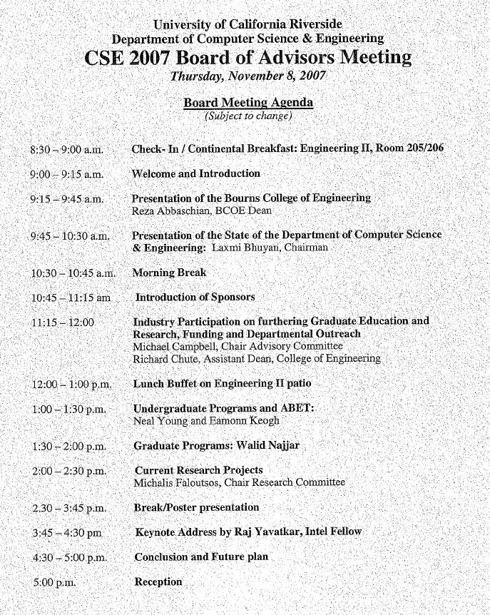 | 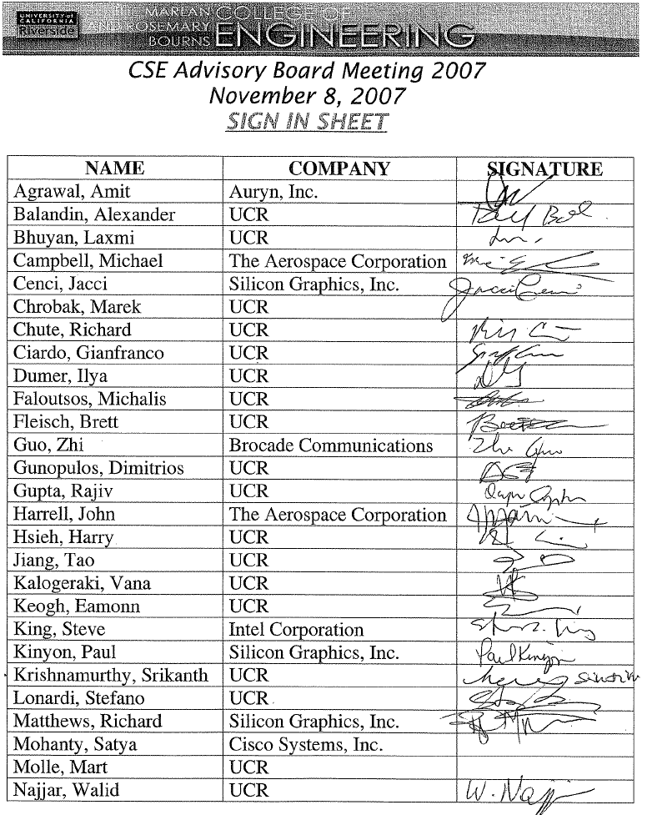 | 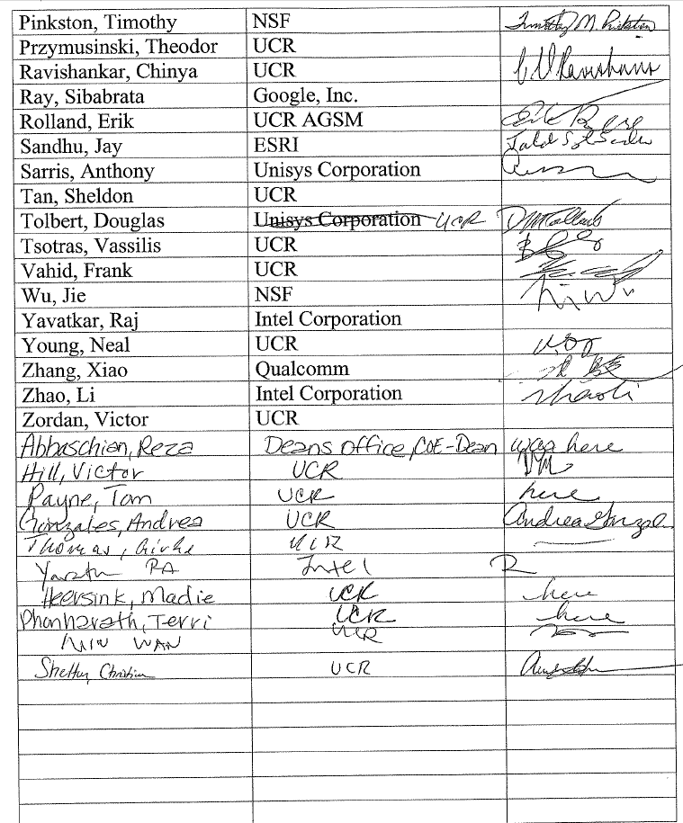
The ABET committee then solicited feedback and approval for our new PEOs from employers of our CE students. This process was conducted by phone, email and when possible, by an onsite visit by a delegation from our department. Table 10 documents this process with one company that has hired four Computer Engineering students, similar documentation for other companies is available on request.
Table 10: A Letter from an Employer of Several Computer Engineering Students, Discussing the PEO Feedback Solicitation
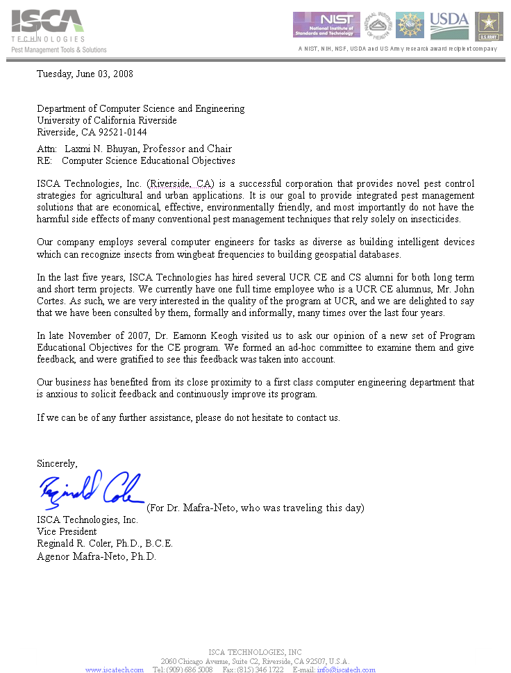
We also solicited comment and approval for our new PEOs from our students, this is documented elsewhere in this report, and omitted here for brevity.
On November 14th 2007, Dr. Keogh presented the new PEOs with notes from the Board of Advisors to the entire faculty, 40 minutes were spent discussing the PEOs and they were adopted by a majority vote. The minutes of this meeting are detailed in Table 11.
Table 11: Computer Science and Engineering Faculty Meeting Minutes from Nov 14, 2007
Faculty Meeting Minutes from November 14, 2007

The meeting commenced at 12:00 p. m. by Chair Laxmi Bhuyan. The following faculty were present: Laxmi Bhuyan, Rajiv Gupta, Tao Jiang, Mart Molle, Walid Najjar, Chinya Ravishankar, Vassilis Tsotras, Michalis Faloutsos, Eamonn Keogh, Srikanth Krishnamurthy, Stefano Lonardi, Thomas Payne, Neal Young, Harry Hsieh, and Christian Shelton.

(A) Announcements were made by Laxmi regarding:
(1) The faculty meeting will be held every two weeks from 12-1 p. m.
(2) No corrections were suggested for the October 24th meeting minutes.
(3) Intel will be sending from $10,000-$20,000 to support the distinguished lecture series and their logo will appear on the series posters.
(4) Mike Carrey has been recommended by Reza for an Eminent Scholar position at UCR- Discussion took place as to where he is interested in applying for a position and what we can do to make an attractive offer to him. Mike will be back to Riverside December 7th for a visit.
(B) Eamonn presented the proposed ABET program educational objectives and their need to be measurable and explicit. Discussion ensued as to whether or not they should be published in the general catalogue. A vote was taken and the faculty voted for the Program Educational Objectives as presented.
(C) Debate was held about the Advisory Board and what their role is in relation to the Department; their interest is in graduate and undergraduate programs. Laxmi suggested that perhaps there should not be an Advisory Board meeting every year. He stated that he had presented the agenda to faculty for feedback and received none. Perhaps the agenda should be different next year and change it to an Industry Day. Or perhaps have a separate Industry Day and keep the Board of Advisors for ABET purposes. It was suggested that if the department held an industry day there could be more research and poster presentations which would feature graduate student research. The population of the board of advisors was discussed and that most were high level managers. It was suggested that perhaps it would be better to target industry affiliates who are mid level managers and would be the managers of the people who would actually hire our students. The department could form a committee to update the list (which hasn’t been reviewed and updated since 2001) by deleting old inactive names and inviting new people. Due to time constraints it was suggested that this discussion be continued at another meeting.
(D) Christian Shelton’s merit was discussed and ballots were distributed for voting.
(E) Vassilis said it would be good to have 4:00 p. m. meetings on Fridays for students to meet with the faculty.
The meeting was adjourned at 1:40 p.m.
In summary, we created new PEO’s after soliciting input and approval from all our constituents, our Board of Advisors, employers of our students, faculty, and the students themselves. Furthermore we have carefully documented this process at every step.
Summary for this Section
As illustrated in Table 8, we have a detailed and rigorous process for review????of the Program Educational Objectives. This process takes place once a year, and input is obtained from all constituents. At least two hours a year (at the faculty retreat in September) are reserved for the entire faculty to discuss the PEOs face-to-face.

CRITERION 3. STUDENT OUTCOMES

- Student Outcomes
The faculty decided to adopt the ABET a-k as our student outcomes in 2005. We revisit this issue at least once a year at the faculty retreat (Mid-September), however thus far we have found no reason to change or augment the outcomes.
(a) an ability to apply knowledge of mathematics, science, and engineering
(b) an ability to design and conduct experiments, as well as to analyze and interpret data
(c) an ability to design a system, component, or process to meet desired needs within realistic constraints such as economic, environmental, social, political, ethical, health and safety, manufacturability, and sustainability
(d) an ability to function on multidisciplinary teams
(e) an ability to identify, formulate, and solve engineering problems
(f) an understanding of professional and ethical responsibility
(g) an ability to communicate effectively
(h) the broad education necessary to understand the impact of engineering solutions in a global, economic, environmental, and societal context
(i) a recognition of the need for, and an ability to engage in life-long learning
(j) a knowledge of contemporary issues
(k) an ability to use the techniques, skills, and modern engineering tools necessary for engineering practice.
- Relationship of Student Outcomes to Program Educational Objectives
Table 12 shows the relationship of student outcomes to Program Educational Objectives. This mapping was created after the revision in late October 2007 by the ABET Committee, and shown to the full faculty for comments and discussion on November 14th 2007.
Table 12: The Relationship of Student Outcomes to Program Educational Objectives
PEOs  (abridged)  Student  Outcomes | Success in post-graduation studies as evidenced by: | Success in a chosen profession or vocation as evidenced by: | Contributions to society as evidenced by:
(a) an ability to apply knowledge of mathematics, science, and engineering | advanced degrees earned | career satisfaction/ promotions & raises
(b) an ability to design and conduct experiments, as well as to analyze and interpret data |  | career satisfaction/ promotions & raises
(c) an ability to design a system, component, or process to meet desired needs within realistic constraints such as economic, environmental, social, political, ethical, health and safety, manufacturability, and sustainability |  | career satisfaction/ promotions & raises | public service
(d) an ability to function on multidisciplinary teams | professional responsibilities | entrepreneurial activities | leadership roles
(e) an ability to identify, formulate, and solve engineering problems |  | entrepreneurial activities /  consulting activities
(f) an understanding of professional and ethical responsibility |  |  | volunteer service/ mentoring / outreach activities/ public service
(g) an ability to communicate effectively | professional visibility | promotions & raises / professional visibility / consulting activities | mentoring / outreach activities
(h) the broad education necessary to understand the impact of engineering solutions in a global, economic, environmental, and societal context | professional responsibilities
(i) a recognition of the need for, and an ability to engage in life-long learning | satisfaction with the decision to further their education/ professional visibility | professional visibility
(j) a knowledge of contemporary issues |  | entrepreneurial activities /  consulting activities
(k) an ability to use the techniques, skills, and modern engineering tools necessary for engineering practice. | professional visibility | entrepreneurial activities /  consulting activities

CRITERION 4. CONTINUOUS IMPROVEMENT
We begin with a visual overview of the process which we use to assess and evaluate the extent to which the program educational objectives and student outcomes are being attained, and make improvements. While both processes are holistic, the “inner loop” focuses on the student outcomes and the “outer loop” focuses on the program educational objectives.
Table 13: The Continuous Improvement Process. Note that this table is similar to Table 8, however there we consider the process for revision of for Program Outcomes, here we are considering how we assess and evaluate the extent to which the program educational objectives and student outcomes are being attained.

The Inner Loop: Individual Course and Course Sequence Level
At the end of each quarter, the following data are collected:
- Grades in homework assignments, lab reports, short tests and examinations. Review of the student performance (grade received) for feedback on whether the course/program objectives are met. All the material in archived in a standardized format (see “the ABET Binder” in Section 4.B below), to simplify inspection (by ABET auditors) and analyses (by faculty).
- Student Evaluation of Teaching. Evaluations administered near the end of each quarter allow students to provide the instructor with anonymous feedback on the effectiveness of the course. The questions in the evaluation forms include questions relevant to the stated program objectives like “Have you learned something you consider valuable?”
- End-of-course student assessments/surveys. Course surveys are distributed at the end of each course. The course survey is based on the course objectives, and learning outcomes 1-11 from the course objective matrix. Students are asked how well the course learning objectives, and outcomes were achieved.
The Outer Loop: Curriculum and Program Level
At the end of each year, the following data is collected:
- Senior Exit Surveys. The survey allows the graduating seniors to rate how well the program met the course objectives and outcomes. The senior Exit Surveys are distributed to the faculty and analyzed. The Undergraduate Committee then drafts an action plan for improvement.
- Board of Advisors surveys. Each year, the departments organize meetings with industry advisory boards. The Undergraduate and ABET Committees are tasked with collecting and analyzing the BOA feedback on the courses content, program objectives, etc.
- Quantitative assessment of the EE 175 and CS 179 Senior Design projects.
- Alumni Surveys. These surveys are collected from the set of alumni and analyzed with the goal to determine the importance and relevance of the program objectives and outcomes, as well as their achievement.
Having seen an overview of the entire process, in the next two sections we will consider the PEOs (outer loop) and course objectives (inner loop) in great detail.

- Program Educational Objectives
It is recommended that this section include (a table may be used to present this information):
1. A listing and description of the assessment processes used to gather the data upon which the evaluation of each the program educational objective is based. Examples of data collection processes may include, but are not limited to, employer surveys, graduate surveys, focus groups, industrial advisory committee meetings, or other processes that are relevant and appropriate to the program.
2. The frequency with which these assessment processes are carried out
3. The expected level of attainment for each of the program educational objectives
4. Summaries of the results of the evaluation processes and an analysis illustrating the extent to which each of the program educational objectives is being attained
5. How the results are documented and maintained
(eamonn is working on these, he has about 8 pages of stuff so far, but this section need the most work)
- Student Outcomes
We consider the student outcomes at multiple levels of granularity and at multiple time scales. The core tool we use to do this called the Student Outcomes Binder. However over the years it became known colloquially as the ABET Binder, and to avoid confusion we will simply use this shorter term below.
The ABET Binder is a physical and logical record of each course offering. The binders for a given quarter are color coded for ease of reference. For example Fall 2011 Binders are yellow etc. They are kept in a secure room, and they are available for inspection by ABET accreditors during sites visits (or at any other time).
The binders are created by the TAs for the offering, under the supervision of the course instructor. The TAs are trained to create the binders in the first two weeks of CS 302 (Apprentice Teaching), which is taught by the ABET coordinator. All TAs must enroll in CS 302 for every quarter in which they TA. In the rare cases in which there is no TA for an offering, the course instructor creates the binder. This situation almost never happens. They only way it can happen is if a class has such a low enrollment that it would normally be canceled, but the Chair decides to offer the class anyway, as a service to the students the need that particular class.
At the end of each quarter, the TAs for each offering must present their binder to the ABET coordinator and have it inspected and “signed off” on. They cannot get credit for CS 302 unless the binder is complete. Thus over the last four years we have had 100% compliance, and the ABET binders form a detailed and carefully annotated archive which we use to assess student outcomes (details below).
The ABET binder contains:
- Course Information: This includes the full course syllabus, name of the professor and teaching assistants.
- Handouts: A copy of every item physically handed from the professor to the students, including notes, hard copies of slides, copies of newspaper articles etc. In some cases these may be non-paper items, such as a “fifteen puzzle” used for CS170 Introduction to Artificial Intelligence. For non-physical “objects” such as a suggested URL, the binder either includes the full text/screen dump of the contents of the URL, or in the case of a large resource, just the link and a description of the content.
- Exams: A copy of the final exam used in the class, annotated and cross-referenced by its relevance to the student’s outcomes (this is described in great detail below). For some offerings, the midterm(s) are also annotated and recorded in this fashion. The binder also includes a spreadsheet containing the student’s performance on the exam at a question by question level. It is this information that allows us to do a fine-grained assessment of student outcomes. Note that this paper copy is just for backup, the detailed analysis of this data is done electronically.
- Quizzes: A copy of every quiz given (if any), together with one annotated example of “A”, “B” and “C” quality work handed in by (randomly chosen) students. For quizzes that have a binary score, an annotated example of “Credit” and “No-Credit” are kept. Since in most cases the students quizzes are returned to them as a study aid, the binder contains a photocopy.
- Project: A copy of every project assigned (if any), together with one annotated example of “A”, “B” and “C” quality work handed in by (randomly chosen) students. If the project involved so much coding that a print-out is not feasible, a CD-Rom or USB stick is included.
- Homework: A copy of every homework assigned (if any), together with one annotated example of “A”, “B” and “C” quality work handed in by (randomly chosen) students.
- Labs: A copy of every lab assigned (if any), together with one annotated example of “A”, “B” and “C” quality work handed in by (randomly chosen) students.
- Special notes: This section is optional, but can be used to make note of any unusual occurrences during the quarter. For example “Midterm was canceled due to flooding, grade weight on final was increased to 30%”, or “Dr. Smith had medical problems in week 6 and, Dr. Keogh finished teaching the class” etc.
The ABET binders form a tangible, permanent and easy to understand record of every course offering. Faculty members teaching a class for the first time are encouraged to view the relevant binders from previous offerings. When discussing possible changes to a course at a faculty meeting, the relevant binders are brought to the faculty meetings for reference.
4.B.1 Quantitative Analysis of Student Outcomes
Our department’s continuous improvement process attempts to optimize two goals. The first, performance on the course objectives, which specify the concepts that a specific course strives to teach its students. For example, the introductory CS10 course has “Use variable to store computer program data” as one of its course objectives. The second goal is to optimize the PEOs. The PEO specify concepts that a student should attain at the time of graduation. The relationships between the course objectives and the Program Educational Objectives are critical in our assessment process, and have been the subject of a significant discussion and adjustment over the years. Although the department largely converged on these mappings by 2005/06, we occasionally revisit the mappings during course revisions and as part of the process for revision of the program educational objectives (c.f. Section 2.E)
While all these course objectives, with their mapping to our PEOS, are detailed in Appendix A, below we show a random representative example for concreteness. Table 14 shows the mapping of course objectives to PEOs for CS 153: Design of Operating Systems.
Table 14: Course Objectives with Mapping to Student Outcomes for CS 153
Objective Outcome Matrix
Objective Addresses Outcome: 1-slightly 2-moderately 3-substantially
Outcome Related Learning Objectives | A | B | C | D | E | F | G | H | I | J | K
Study basic principles underlying the design of operating systems with a focus on principles and mechanisms used throughout the design | 1 | 0 | 1 | 0 | 1 | 0 | 0 | 0 | 0 | 0 | 3
An understanding of CPU scheduling storage management: memory management virtual memory and file systems | 1 | 0 | 0 | 0 | 0 | 0 | 0 | 0 | 0 | 0 | 3
Study of concurrency control and synchronization classical algorithms for synchronization and concurrency management | 1 | 0 | 1 | 0 | 0 | 0 | 0 | 0 | 0 | 0 | 3
Study Deadlocks Devices device management and I/O systems | 1 | 0 | 0 | 0 | 0 | 0 | 0 | 0 | 0 | 0 | 3
Study dynamic binding | 0 | 0 | 0 | 0 | 0 | 0 | 0 | 0 | 0 | 0 | 3
An understanding of protection access control and security | 1 | 0 | 0 | 0 | 0 | 1 | 0 | 1 | 0 | 0 | 3
Improve skills in concurrent programming and introduce kernel programming | 3 | 2 | 0 | 0 | 0 | 0 | 0 | 0 | 0 | 0 | 3
The last major revision of these mapping happened in 2006/07, using the following process. For each course, a committee was formed consisting of everyone that had ever taught the course, everyone that might teach it in the future (i.e., new hires in that area) and any interested party. The committee drafted the mapping, after viewing the previous syllabi, teaching materials, and examples of graded instruments (exams/quizzes/homeworks/projects). The draft mappings were presented and discussed at several faculty meetings in the fall of 2005 and voted on by the full faculty.
Below we provide a detailed work explanation of how we analyze the student’s achievements on the final (and sometimes, midterm) for both coverage and performance on course objectives.
- Coverage measures the extent to which we are teaching and testing the course objectives.
- Performance measures the student’s knowledge of the course objectives.
Note that our decision to measure these metrics on only the final (and sometimes, midterm) exam was a conscious choice made at the faculty retreat in fall 2007. The final and midterm exams are always conducted in a controlled environment under the professor’s direct supervision, with 100% attendance, and thus avoid the difficulty of confounding factors such as absent students (quizzes), or students cheating (homeworks) etc.
In the below, term course objective has been shortened to objective, and the term program educational outcome has been shortened to outcome. Table 15 shows a running example we will us to explain our process. The student outcomes are shown as A, B, & C in the table.
Table 15: A worked example of how we determine coverage and performance on course objectives and PEOs
Exam Scores | Q1 | Q2
John Doe | 1 | 1
Jane Smith | 0 | 1
Normalized Question Performance | 0.5 | 1
Question-To-Objective | Q1 | Q2 |  | Objective Performance | Objective Coverage
Objective 1 | 3 | 3 |  | 0.75 | 1
Objective 2 | 0 | 3 |  | 1 | 0.5
Objective-To-Outcome | A | B | C
Objective 1 | 3 | 3 | 3
Objective 2 | 0 | 0 | 0
Outcome Performance | 0.75 | 0.75 | 0.75
Outcome Coverage | 0.5 | 0.5 | 0.5

The numbers in white cells are entered by faculty for each course offering; whereas all the numbers in gray cells are calculated (by automatic scripts) as part of our evaluation process, two week after finals week.
The performance data here is being calculated from two students’ scores on a single, two-question exam, as seen in the “Exam Scores” table. In our running example, John Doe answered two questions perfectly (1 out of 1 on both questions), whereas Jane Smith got zero credit on the first question, but aced the section question.
The “Question-To-Objective” table gives a weight to each objective-question pair, which states how related the question subject is to the objective. These weights are determined and recorded by the course instructor, as he/she writes the exam.
The “Objective-To-Outcome” table gives a weight (i.e. mapping) to each objective–outcome pair. Recall (as discussed above) these weights are relatively static, and have been essentially unchanged for 5 years. This is important, since it allows us (with appropriate statistical caution) to compare offerings of the same course offered in different quarters, and to plot and consider trends.
We wish to calculate how well a course covers its own objectives as well as the PEOs. We also calculate how well students of the course perform with respect to each objective/outcome. The steps to produce the derived data are as follows.
- Normalized Question Performance: Each question’s score is normalized by dividing it by the maximum possible number of points for that question. Then the average score across students is found for each exam question. In the example above, in the “Exam Scores” table, the max question point value possible is 1.

- Objective Performance: The relevance of each exam question to each class objective is given as input, as seen in the “Question-To-Objective”. To determine the performance of an objective we first multiply the Normalized Question Performance of a question by the objective-to-question weight for that objective, for each exam question. We then divide the sum of the sum of the objective-to-question weights for that objective. Table 16 shows an example of how this formula is used for the running example. Note that the performance for objective 2 is perfect since question 1, which had imperfect performance, is not relevant to objective 2 and thus not used in its calculation. Thus, if the faculty reviewed this data they would be happy to discover perfect performance on Objective 1, but would worry about the relatively poor performance on Objective 2.

Table 16: The Calculation of the Objective Performance
Exam Scores | Q1 | Q2
Normalized Question Performance | 0.5 | 1
Question-To-Objective | Q1 | Q2 |  | Objective Performance
Objective 1 | 3 | 3 |  | [(0.5*3) + (1*3)] / (3+3) = 0.75
Objective 2 | 0 | 3 |  | [(1*3) + (1*3)] / (0+3) = 1

- Objective Coverage: Knowing the performance on the course objectives is of little use without an understanding of the coverage. If nothing else, with very low coverage, the performance results are likely to be unreliable. To determine the coverage of an objective we first sum the question-to-objective weights for that objective. We then divide by the maximum possible coverage value, which is the number of questions multiplied by the max possible weight, which in this example is 3. Table 17 shows the relevant calculations for our running example.

Table 17: The Calculation of the Objective Coverage
Question-To-Objective | Q1 | Q2 |  | Objective Coverage
Objective 1 | 3 | 3 |  | (3+3) / (2*3) = 1
Objective 2 | 0 | 3 |  | (0+3) / (2*3) = 0.5

- Outcome Performance: To determine the performance of an outcome, we first multiple each objective’s performance value by its objective-to-outcome weight for that outcome, and sum over all objectives. We then divide by the maxium possible achievable value, which is just the sum of all of the objective-to-outcome weights for that outcome. Table 18 shows an example of this calculation. Note that since only objective 1 relates to each outcome (A, B, C), the outcome performance draws only upon objective 1’s performance, and thus are all the same.
Table 18: The Calculation of the Outcome Performance
Question-To-Objective | Objective Performance
Objective 1 | 0.75
Objective 2 | 1

Objective-To-Outcome | A | B | C
Objective 1 | 3 | 3 | 3
Objective 2 | 0 | 0 | 0
Outcome Performance | [(0.75*3) + (1*0)] / (3+0) = 0.75 | 0.75 | 0.75

- Objective Coverage: To determine the coverage of an outcome, we first multiple each objective’s coverage value by its objective-to-outcome weight for that outcome, and sum over all objectives. We then divide by the maximum possible coverage value, which is the number of objectives multiplied by the max possible weight, which in this example is 3. In Table 19 each outcome is fully covered by objective 1, which is in turn fully covered on each question. However since each outcome is missing coverage by objective 2, their final coverage is only 0.5.
Table 19: The Calculation of the Objective Coverage
Question-To-Objective | Objective Coverage
Objective 1 | 1
Objective 2 | 0.5

Objective-To-Outcome | A | B | C
Objective 1 | 3 | 3 | 3
Objective 2 | 0 | 0 | 0
Outcome Coverage | [(1*3) + (0.5*0)] / (3*2) = 0.5 | 0.5 | 0.5

- Multiple Exams: Our method can also handle the case of multiple exams. The summation of values is taken over all exams and then metrics are computed, rather than metrics being computed per exam and then averaged by number of exams. Below you can see a simple example with one student, one question, and two exams. The “Exam ‘x’ Objective Performance” tables show the performance metric for each exam individually. The “False Objective 1 Performance” table shows the result if the per-exam values are simply averaged. The problem with this is that the relative weight of the question-to-objective is lost between the same objective across exams. The “Actual Objective 1 Performance” shows the correct way to calculate across exams, where the summations are carried out across exams, and the objective-to-question weighting is preserved.

Table 20: Combining Results of Two Exams
Exam 1 | Q1
John Doe | 0
 |  |  | Exam 1 Objective Performance
Objective 1 | 1 |  | (0*1) / 1 = 0 |  | ABET Course Metric
 |  |  |  |  | False Objective 1 Performance
 |  |  |  |  | (0 + 1) / 2 = 0 .5
Exam 2 | Q1
John Doe | 1 |  |  |  | Actual Objective 1 Performance
 |  |  | Exam 2 Objective Performance |  | (0*1 + 1*3) / (1+3) = 0 .75
Objective 1 | 3 |  | (1*3) / 3 = 1

- Zero Coverage Case: Using the objective/outcome performance calculation given before would give you a value of 0 performance in the coverage was also 0. The problem is that in this case, because the objective did not relate to any questions, we do not have any information as to how the students would perform on that objective. We handle this as a special case, as indicated by the -1 performance value for objective 1 seen below. When summing the product of each objective performance / objective-to-outcome pair to find outcome performance, we ignore any objectives which have -1 performance. The outcome’s performance, just like objective performance, is given a -1 if that outcome’s coverage is 0.
Table 21: How the Pathological Zero Coverage Case is Handled
Question-To-Objective | Q1 | Q2 |  | Objective Performance | Objective Coverage
Objective 1 | 3 | 3 |  | xxx | 1
Objective 2 | 0 | 3 |  | -1 | 0
Objective-To-Outcome | A | B | D
Objective 1 | 3 | 0 | 0
Objective 2 | 3 | 0 | 3
Outcome Performance | xxx | -1 | -1
Outcome Coverage | 0.5 | 0 | 0

This section has been very long and technical. However the reader is now in a position to appreciate the following section, where we show how we use these formulas to produce intuitive visual summaries of student outcomes at multiple granularities, in order to support and direct our efforts in continuous improvement.

4.B.1.a Course Reports
Using the analytical algorithms discussed in the previous section, for every quarter, for all course offerings, we produce a visual report summarizing the coverage and performance on the course outcomes, together with the coverage and performance on the PEOs. Table 22 shows a randomly chosen example.
Table 22: A Sample Course Report, from the spring 2010 offering of CS141: Intermediate Data Structures and Algorithms
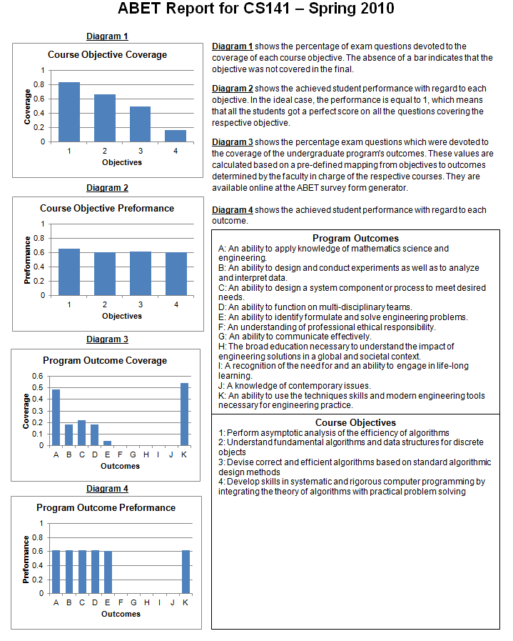
This report is produced within a week of the final grades being submitted, and is then sent to the course instructor, who compares it with the reports from previous offerings. The course instructor is encouraged to annotate the report. For example, a recent report was annotated: “The earlier introduction to the Relational Model does seem to have had the desired effect, however, the student’s performance on query evaluation and the internals of query optimization seems to have stalled... ”. The annotated reports are archived with the ABET binders (C.F Section 4.B), and are discussed at faculty meetings, and at the annual faculty retreat.
More critically, an instructor teaching an offering of a course is required to view the course report for at least the most recent offering (all reports are available if desired) and to contact the previous instructor (if a different person) to be briefed on the course. It is this step that is codified in Step 1 of Table 13, Data Collection for Course Assessment.
4.B.1.a Course Difference Reports
The course reports shown in the previous section allow the instructor an intuitive review of the coverage and performance on course objectives. Suppose an instructor spots an area of concern, perhaps the course is not covering an objective adequately (alternatively, an objective is being taught, but not adequately tested), or an objective is being covered, but the students are testing poorly on it. As shown in the “inner loop” of Table 13, the instructor in consultation with his/her colleagues that have experience/interest in teaching the class, and the undergraduate instruction committee, will attempt to find a remedy for the next course offering. How can we tell if that remedy is successful? For this purpose we generate a special course difference report, which use the formula introduced in Section 4.B.1 to produce a side-by-side comparison of two offerings. Table 23 shows an example of such a report, contrasting the Winter/Spring 2010 offerings of CS010: Introduction to Computer Science.
Table 23: A Sample Course Difference Report, Contrasting the Winter 2010/Spring offerings of CS010: Introduction to Computer Science
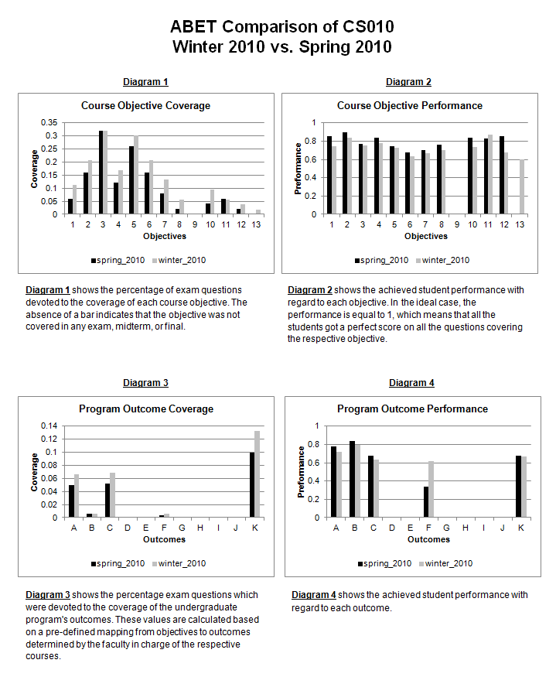
(ek will finish, waiting on input from faculty )

- Continuous Improvement
Without claiming to be exhaustive, below we list some representative examples of how the results of evaluation processes for the program educational objectives and the student outcomes and other available information have been used as input in the continuous improvement of the program.
Note that many of these changes are rather small; we feel that we had converged on an excellent program by 2006. Nevertheless the faculty is encouraged to, and rewarded for, fine-tuning any aspect of the curriculum.
Improvements to AI offerings based on discussions with constituents (Outer Loop, Table 13)
In 2011/2012, we significantly restructured our artificial intelligence offerings. Our inspiration to do so came from a variety of sources. The most significant of which were meetings between the two faculty most responsible for AI (Dr. Shelton and Dr. Keogh) meeting with the Board of Advisors, and Dr. Keogh’s meeting with several student employers, including Microsoft, ESRI and ISCA technologies (each of these companies have hired at least four of our students in the last five years). Moreover, Dr. Shelton spoke at length with instructors at other UC campuses about their experiences with undergraduate AI courses. Finally, Dr. Keogh interviewed several alumni who had taken CS 170: Intro to AI with him, and had gone on to work in a position that might reasonably use these skills (including Shruti Kasetty, Microsoft, Isaac Espinoz, PricewaterhouseCoopers etc).
Our findings from these constituents included:
- Need: We needed to offer an information retrieval course, as a very significant fraction of our students end up working in a related field (text retrieval at Microsoft Bing, Spatiotemporal information retrieval at ESRI, multimedia retrieval at ISCA technologies etc.) Action: We designed a new course (cf. Section 6.E), CS 172: Introduction to Information Retrieval. Moreover, when making hiring decisions in the 2010/11 cycle, the need for an instructor for this course was weighted. While (at least) Dr. Shelton, Dr. Keogh and Dr. Tsotras can teach this class, it was felt it would be good to have a specialist help develop the curriculum, and teach the first offering. In fact, we did hire Dr. Hristidis, an information retrieval specialist, and he did lead the charge in developing the curriculum, and he is teaching the first offering in spring 2012.
- Need: Our BOA questioned the need for us to have CS 171: Introduction to Expert Systems on the books, as this is now seen as a dated and unused technology, and many of its applications have been subsumed into other areas (Bayesian Networks etc). As it happens, that course had not been offered in over a decade. Action: In winter 2010, a committee of AI professors met to discuss this, and they proposed to the faculty that this course be removed from the curriculum. This was unanimously approved by the faculty.
- Need: Our BOA and (some of) our employers suggested that our AI class focus less on “classic AI” (search, logic, constraint satisfaction etc), and more on modern statistical/probabilistic learning techniques, as these are more pragmatic skills for companies such as Facebook, Microsoft etc. However, the faculty felt that the “classic AI” material was important to keep because it offered an opportunity for projects were students could both gain experience in significant in coding, and formally prove certain properties of their programs (completeness, optimality etc). Action: We restructured the course offerings. Beginning in 2012/2013, CS 170 will be a “classic AI” course on search, logic, constraint satisfaction, and the like. CS 171 will be a “machine learning / data mining” course that will consider statistical/probabilistic learning techniques. We feel these changes update the curriculum to a more modern standard and allow better coverage of the relevant topics. As we roll out the first offerings of these courses in 2012/2013 a committee consisting of Dr. Shelton, Dr. Keogh, Dr. Hristidis, and Dr. Tsotras will carefully evaluate the effects of these changes, both by using the classic measure of our course reports, and by more explicit surveying of the students that take the classes.
Improvements to CS180 based on viewing course reports (Inner Loop, Table 13)
In winter 2010 Dr. Neamtiu taught CS 180: Introduction to Software Engineering. The course report for the offering is shown in Table 24.
Table 24: The Course Report for CS180-Winter 2010
Notes: This is necessarily a low-resolution view of the course report. The original high resolution version, together with all the original raw data is available for inspection.  This report only reflects the course final, which was not cumulative. The midterm does reflect coverage on course objective 3. Nevertheless, based on a review of this report with the undergrad committee Dr. Neamtiu has decided that future offerings will have a cumulative exam, in order to allow a more meaningful comparison between different offerings of the class. | 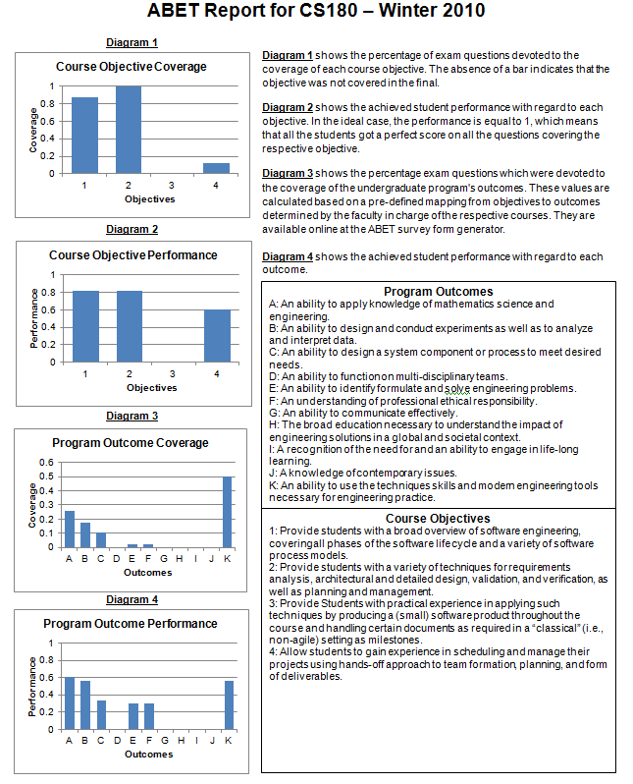
Dr. Neamtiu noted several things from the report which prompted him to make changes.
- Need: First, he noted that we were poorly assessing how well the students understand the ethics of software engineering and the societal implications of software errors. Moreover, from what little assessment we were doing it the students performance was lacking. Action: Dr. Neamtiu added contents to the lecture material to illustrate the consequence of software-induced disasters: the explosion of the Ariane 5 rocket, the 2003 Northeastern Blackout, the Marc Climate Orbiter explosion, avionics software. Also he added the following essay-like question on the final exam: “In engineering disciplines such as civil engineering, a product (e.g., bridge) failure might lead to the product designers and makers being prosecuted. However, in software engineering, product designers and makers are not only not held responsible, but the product itself usually comes with no warranty whatsoever, even though, as illustrated in class, software failures puts lives and livelihoods at risk. Why do you think software engineering is held to a lower responsibility standard than other engineering disciplines?”.
- Need: As per Course Objective #3, practical experience in building a small software product and handling documents in a milestone-setting is deemed important. Moreover, at the department’s Board of Advisors meeting in March 2010, leaders from industry, e.g., Yahoo! Research have noted that one of the best improvements we can make to our students’ preparation was to turn them into software engineers, rather than programmers. Briefly, the difference between the two categories is that programming essentially an individual activity, whereas software engineering involved multi-person construction of multi-version software. Action: In CS 180, for the project part of the course, Dr. Neamtiu has moved to an approach that emphasized flexibility in team formation and implementation strategy, while adhering to strict documentation and schedule guidelines; this approach has the role of exposing students to realistic software development practices, as well as issues and solution that appear in the development of large project in a multi-person team (this also addresses Course Objective #4). Moreover, projects change each quarter and topics are highly relevant to what students will work on after graduation. For example, recent team projects included implementing “lite” versions of LinkedIn, Facebook, YouTube, Twitter. Other projects involved developing Android and iPhone applications for augmented reality and time management. Finally, students have to construct their project in a succession of two milestones, to simulate the incremental delivery approach standard in real-world development. Projects are graded on requirement completion as well as documentation and a project demo presentation. The approach has already started to bear fruit. Apart from observing numerical improvement on course reports, Dr. Neamtiu has personally followed up by contacting both alumni, finding that they indicate they have being able to find jobs and internships based on the large, team-oriented, highly-relevant-to-employers project in the class, and with student employers, who report increase satisfaction with our students performance.

Improvements to CS111 based on viewing course reports (Inner Loop, Table 13)
Dr. Chrobak frequently teaches CS111: Discrete Structures. A sample report for a recent offering of this course is shown in Table 25.
Table 25: The Course Report for CS180-Winter 2010
Notes: This is necessarily a low-resolution view of the course report. The original high resolution version, together with all the original raw data is available for inspection. | 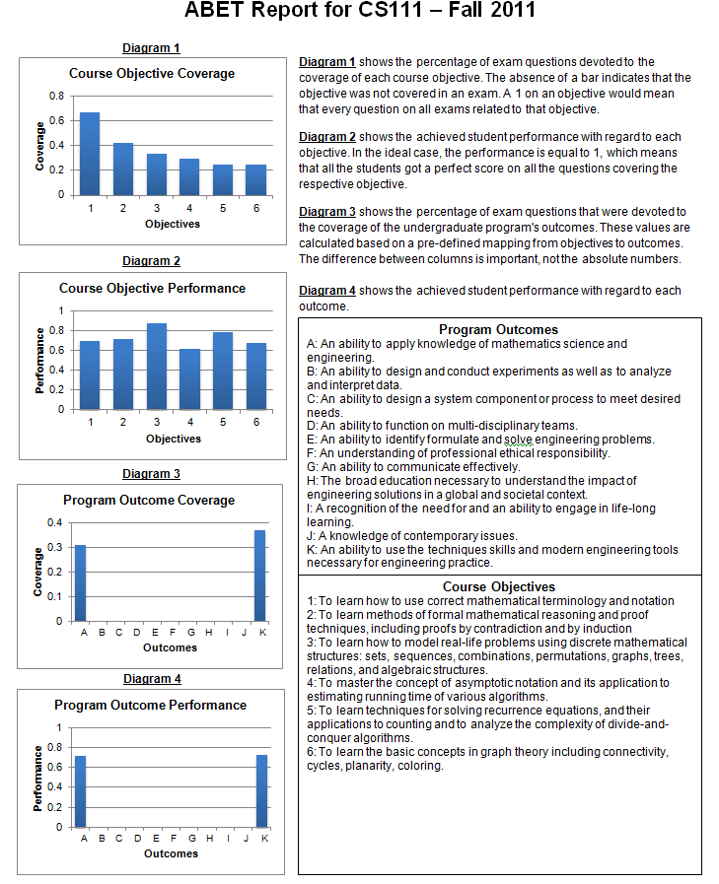
Dr. Chrobak noted several things from the course reports which prompted him to make changes to the course.
- Need: Dr. Chrobak noticed that students were scoring relatively poorly on outcome 1, his annotation of course reports included text such as “I noticed that many students, even those with solid understanding of the material, had difficulty presenting their solutions in a clear and rigorous fashion.”. Action: After discussion with the other faculty that teach this course, and with the undergraduate education committee, Dr. Chrobak took action to address this problem: “To address this, I introduced several changes to the way CS111 is taught. I provide students with strict guidelines for preparing homework assignments. At the beginning of the course students are required to read several articles on writing mathematical text. In lecture, I put more emphasis on rigorous formulations and reasoning. For example, when presenting Kuratowski's theorem “A graph is planar if and only if it does not contain a subgraph that is a sub-division of K5 or K3,3”, I would discuss common mistakes, like replacing “if and only if” by “if” or by “only if” weakens the statement, or why writing “does not contain K5 or K3,3” (that is, omitting the sub-division part) makes the statement incorrect. Questions to formally state definitions or theorems are now included on tests.” The results in the most recent offering of the course, are shown in Table 25, and they strongly suggest that this process is helpful, the outcome 1 scores have risen to be on par with other outcomes.
- Need: Dr. Chrobak made changes the syllabus for CS111 to address students' difficulties with the material (after consulting the entire faculty, at a faculty meeting in winter 2010). In earlier offerings of CS111, we covered generating functions. That topic caused significant difficulties for the students, partly because it requires solid background in calculus. Dr. Chrobak consulted with our BOA and several employers who note that generating functions are of limited educational value to students that major in computer science or computer engineering. Action: In more recent offerings of CS111 we now instead cover counting integer partitions, a topic that is mathematically equally sophisticated, but does not requiring background outside of discrete mathematics, and is more relevant to mathematical problems students are likely to encounter in their future study.
Improvements to curriculum based on alumni surveys (Outer Loop, Table 13)
Dr. Zordan was, until 2010, the only faculty in computer graphics, and as such anxious to improve the graphics part of our curriculum. He combed over the 2009 alumni survey, visited employers of our students with an interest in graphics (Dreamworks, Sony, THQ, and Electronic Arts.) and did personal one-on-one phone follow up interviews with students. Based on these efforts, he noted:
- Need: Students interested in video games and graphics as freshmen had no way to pursue their interest until their junior to senior year because there was a long list of requirements before they could take CS130 Intro to graphics. Many students seemed discouraged and unsure of their choice to invest several years in a discipline they saw as only peripheral related to their interests. Action: Dr. Zordan lead the charge in modifying the curriculum to add CS66 Introduction to Three-Dimensional Digital Modeling and CS67 Three-Dimensional Digital Modeling and Animation, as courses with no prerequisites that teach both about the topic and software as well as programming via a games industry scripting language. These courses are in their first complete run this academic year (11-12) so there are no hard measurements, but we will track to see if these students appear to yield higher retention rates over the average. We anticipate this as a result of their satisfaction and engagement in taking such courses earlier in their undergraduate experience. Anecdotal evidence shows that students appear more confident and satisfied after taking CS66. Their confidence is both in their choice of studies (computer science as a discipline that leads to pursuits in computer game development) as well as their sense of proficiency and experience in their field of choice (as programmers and masters of a suite of software that is used ubiquitously in the game industry).

(Frank Vahid has a full page, philip brisk has a page, eamonn will fold in first week of april)
(eamonn will add more case studies)
Summary for this Section:
Our department has a culture of data-driven continuous improvement of undergraduate education. Faculty are rewarded for their efforts in improving the curriculum, and in general teaching excellence by having this aspect of their work be a significant factor in promotion and tenure decisions.

- Additional Information
Copies of any of the assessment instruments or materials referenced in 4.A, 4.B, or 4.C must be available for review at the time of the visit. Other information such as minutes from meetings where the assessment results were evaluated and where recommendations for action were made could also be included. ( Eamonn will do, this in 90% done)

OAR Table
Observation | Action | Results
Actions based on assessment data—including reassessment
Actions based on other data, including confirmed anecdotal data

Summary SO Table
 | S- 08-09 |  |  |  |  |  | S 10--11 | F 11-12 | W-11-12
A | 0.62 | 0.61 | 0.65 | 0.66 | 0.63 | 0.68 | 0.70 | 0.70 | 0.69
B | etc
C
D
E
F
G
H
I
J
k

CRITERION 5. CURRICULUM

Program Curriculum

Complete Table 5-1 that describes the plan of study for students in this program including information on course offerings in the required curriculum in the form of a recommended schedule by year and term along with maximum section enrollments for all courses in the program over the two years immediately preceding the visit. If there is more than one curricular path, Table 5-1 should be provided for each path. State whether you are on quarters or semesters and complete a separate table for each option in the program. (ravi/rod will do)

Describe how the curriculum aligns with the program educational objectives. ( Eamonn will do)

Describe how the curriculum and its associated prerequisite structure support the attainment of the student outcomes. ( Eamonn will do)
- Attach a flowchart or worksheet that illustrates the prerequisite structure of the program’s required courses. ( Eamonn will do)
- Describe how your program meets the requirements in terms of hours and depth of study for each subject area (Math & Basic Sciences, Engineering Topics, and General Education) specifically addressed by either the general criteria or the program criteria. ( Eamonn will do)

Describe the major design experience that prepares students for engineering practice. Describe how this experience is based upon the knowledge and skills acquired in earlier coursework and incorporates appropriate engineering standards and multiple design constraints. ( Eamonn will do)

If your program allows cooperative education to satisfy curricular requirements specifically addressed by either the general or program criteria, describe the academic component of this experience and how it is evaluated by the faculty. ( Mitch has done this)
- Describe the materials (course syllabi, textbooks, sample student work, etc.), that will be available for review during the visit to demonstrate achievement related to this criterion. (See the 2011-2012 APPM Section II.G.6.b.(2) regarding display materials.) ( Eamonn will do)

Course Syllabi
In Appendix A, include a syllabus for each course used to satisfy the mathematics, science, and discipline-specific requirements required by Criterion 5 or any applicable program criteria. ( Eamonn will do, this is 90% done)
Table 5-1 Curriculum (done, just needs some editing)
Program Name

Course  (Department, Number, Title)  List all courses in the program by term starting with first term of first year and ending with the last term of the final year. |  |  | Indicate Whether Course is Required, Elective or a Selected Elective by an R, an E or an SE.¹ |  | Subject Area (Credit Hours) |  |  |  |  |  | Last Two Terms the Course was Offered:  Year and,  Semester, or  Quarter | Maximum Section Enrollment  for the Last Two Terms the Course was Offered²
 |  |  |  |  | Math & Basic Sciences |  | Engineering Topics  Check if Contains Significant Design (√) |  | General Education | Other
Add rows as needed to show all courses in the curriculum.
TOTALS-ABET BASIC-LEVEL REQUIREMENTS
OVERALL TOTAL CREDIT HOURS FOR COMPLETION OF THE PROGRAM |  | <192??????suppose 180
PERCENT OF TOTAL |  |  |  | e.g. 47/180
Total must satisfy either credit hours or percentage | Minimum Semester Credit Hours
Total must satisfy either credit hours or percentage | Minimum Percentage |  |  | 25% |  | 37.5 %

- Required courses are required of all students in the program, elective courses (often referred to as open or free electives) are optional for students, and selected elective courses are those for which students must take one or more courses from a specified group.
- For courses that include multiple elements (lecture, laboratory, recitation, etc.), indicate the maximum enrollment in each element. For selected elective courses, indicate the maximum enrollment for each option.

Instructional materials and student work verifying compliance with ABET criteria for the categories indicated above will be required during the campus visit.

CRITERION 6. FACULTY

- Faculty Qualifications
The Computer Engineering program possesses a wealth of talent, experience, and education in its faculty. The faculty has a wide diversity of emphasis areas within the electrical and computer engineering fields. This allows us to cover all major areas in our curriculum with ease. In fact, for every course offering in CE, there are at least four faculty that can teach it.
The Computer Engineering program is jointly administered by CS and EE:
- The Department of Computer Science currently has five lecturers and 22 tenure-track faculty that include three ACM Fellows, four IEEE Fellows, five AAAS Fellows, one NSF Presidential Young Investigator, one AFOSR Young Investigator, and seven NSF CAREER award holders.
- The Department of Electrical Engineering has 22 faculty members: 7 IEEE Fellows, 6 AAAS Fellows, 4 NSF Career Awardees, 3 ARO/ONR Young Investigator Awardees, 2 SPIE Fellows, 1 OSA and 1 APS Fellow.

6.A.1 An Overview of the Personnel Changes made since the last ABET Visit
Since the last ABET visit we lost :
- Dimitrios Gunopulos: Databases.
- Vana Kalogeraki: Operating Systems/ Distributed Systems.
- Brett Fleisch: Computer and Network Systems.
- Teodor Przymusinski: Artificial Intelligence.
Dr. Gunopulos and Dr. Kalogeraki (a married couple) left in 2010 to return to Greece to start a family. Dr. Fleisch left in 2011 to pursue an opportunity in Thailand. Dr Przymusinski retired in 2010. While he remains an emeritus professor, he is not active and does not retain an office at UCR.
We also had :
- Thomas Payne: Programming Languages.
retire and become an emeritus professor in 2010. However, Dr. Payne retains an office and remain very active, teaching one class per quarter, attending all faculty meetings and doing other department service. His retirement is just a bookkeeping device based on UC retirement rules.
Since the last ABET cycle we hired:
- Iulian Neamtiu: Software Engineering.
- Philip Brisk: Embedded Systems/Computer Architecture.
- Vagelis Hristidis: Databases/Information Retrieval
- Harsha Madhyastha: Networking.
- Tamar Shinar: Scientific Computing/Computer Graphics.
Below we briefly discuss why these faculty were hired, and the contributions to our strengths in undergrad teaching. Their significant contributions to undergraduate research are discussed elsewhere in this document.
Dr. Iulian Neamtiu was hired in 2008 to strengthen the existing Software Engineering group. Dr. Neamtiu has adjusted the lecture material for CS 180 to increase the use of formal methods in software construction. The use of formal methods in software specification and software validation leads to a better understanding of software requirements and software behavior, and prepares students to write higher quality software, i.e., more usable and less prone to errors. Moreover, the emphasis on rigor and formality gives students an opportunity to use their training and knowledge in mathematics and logic towards solid software construction methods. For the project part of the course, Dr. Neamtiu has chosen an approach that emphasizes flexibility in team formation and implementation strategy, while adhering to strict documentation and schedule guidelines; this approach has the role of exposing students to realistic software development practices, as well as issues and solution that appear in the development of large project in a multi-person team. Projects change each quarter and topics are highly relevant to what students will work on after graduation. For example, recent team projects included implementing “lite" versions of LinkedIn, Facebook, YouTube, Twitter, Blockbuster online store, Netflix, IMDB. Other projects involved developing Android and iPhone applications for augmented reality, time management, and restaurant reservations. The approach has already started to bear fruit, with outgoing students indicating being able to find jobs and internships based on the large, team-oriented, highly-relevant project topics in CS 180.
Dr. Philip Brisk was hired in 2009 to strengthen the existing embedded systems, architecture, and CAD group. Dr. Brisk's primary undergraduate teaching responsibility has been CS.120B; he has integrated learning materials developed by his colleague, Dr. Vahid, into the course. Through NSF funding Dr. Vahid and Dr. Tony Givargis (UC Irvine) developed an electronic textbook on undergraduate embedded systems which focuses on the usage of state machines as design patterns for microcontroller programming; the textbook also introduces fundamental concepts such as fixed-point arithmetic (in software), real-time systems, concurrent state machines, digital signal processing, and control theory. Dr. Vahid and Dr. Givargis also developed a software learning suite comprise of the Riverside-Irvine Builder of State Machines (RIBS) and the Riverside-Irvine Microcontroller Simulator (RIMS), which are used extensively in CS.120B. Although the development of these learning materials pre-dates Dr. Brisk's appointment at UCR, he has promoted their use and adoption in CS.120B. Students use RIBS and RIMS for homework assignment, and to help assist them in the laboratory sections where they program state machine applications using AVR microcontrollers.
Dr. Brisk also teaches the CS 179J senior design project course on computer architecture and embedded systems. Dr. Brisk has introduced several new project options into CS 179J, Dr. Brisk introduced smart phone application development for the Android platform as a new project option, which was received quite favorably by the students. Dr. Brisk has also developed projects around his research on programmable microfluidics, which expose undergraduates to an exciting and emerging interdisciplinary technology. Finally, Dr. Brisk has introduced video processing projects as options for CS 179J, which include the use of webcams and Microsoft Kinect 3D cameras. Dr. Brisk obtained an equipment donation from Intel for use in present and future CS 179J offerings. The equipment includes 10 Intel Atom processor development boards, and one Intel Atom E600 "Stellarton" development, which includes an lntel Atom processor and Altera Arria FPGA integrated into the same package. Dr. Brisk has used this equipment in video processing projects in the Winter 2012 offering of CS 179J, and they will be made available for future offerings of CS 179J as well.
Dr. Vagelis Hristidis was hired in 2011 partly to replace the loss of Dr. Gunopulos, but also to give us more of a presence in information retrieval. Since coming to UCR Dr. Hristidis created new course CS 172, “Introduction to Information Retrieval,” which is offered for the first time in Spring 2012. This course teaches to the students the cutting edge technologies employed in Web search engines and other domain-specific search systems. In addition to examinations, this course involves group projects, where students study and develop various aspects of Information Retrieval. Further, Dr. Christidis has experience in teaching Database Systems and Data Structures courses. He has also been involved in undergraduate research activities funded by the NSF, as supplements to his research grants. In the past, he has mentored about 10 undergraduate students through this program.
Dr. Harsha Madhyastha was hired in 2010 to augment our existing strength in networking and to add a more systems-building approach to research and teaching at UCR. Dr. Madhyastha has significantly revised the material for CS 153 to make the material more up-to-date. The class now covers all issues underlying operating systems, with a discussion on how various operating systems components (such as scheduling and virtual memory management) are implemented in modern operating systems such as Windows, Linux, and Mac OS. Dr. Madhyastha has also ensured now that the students in CS 153 get their "hands dirty" implementing the basics of operating systems, rather than simply learning the theory underlying them in class. For this, the class now includes projects based on the popular Nachos framework, which is also used in undergraduate operating systems classes at UC Berkeley and UC San Diego. Moreover, these projects are done in teams and requires students to build on top of a basic Nachos code base. This gives the students experience with working in groups and with adding to legacy code, issues that they will have to deal with when they graduate and take up positions in the industry. Since the Nachos framework requires students to write code in Java, an added benefit of the revised CS 153 is that UCR CSE students gain expertise in a new programming language.
Dr. Tamar Shinar was hired in 2010 because we only had one professor (Dr Zordan) who could teach our very popular classes in computer graphics, and in order to strengthen the department's presence in computer graphics and scientific computing. She has given informational lectures about her research in the undergraduate Computer Science seminar, advised undergrads with an interest in pursuing a career in graphics, and will be teaching undergraduate level computer graphics this academic year.
Finally, at the time of writing this document we have permission to hire two new faculty. We have completed our interview cycle and we have offers out. We are seeking candidates in Operating/Distributed Systems, Cyber-security and Cyber-physical systems.

- Faculty Workload
Complete Table 6-2, Faculty Workload Summary, and describe this information in terms of workload expectations or requirements. (eamonn/dennis)

- Faculty Size
Discuss the adequacy of the size of the faculty and describe the extent and quality of faculty involvement in interactions with students, student advising and counseling, university service activities, professional development, and interactions with industrial and professional practitioners including employers of students. ( Eamonn will do)

As noted above the Computer Engineering program is jointly administered by CS and EE. The Department of Computer Science currently has five lecturers and 22 tenure-track also has 22 faculty members.

Blah balh blah. For example in ENGR 101 the instructors bring in industrial and professional practitioners to both given formal talks, and participate in informal question and answer sessions. In the most recent offering, guest speakers included, Dr. Casey Czechowski (Teradata), Diego Villasenor (Microsoft), Dr. Lisa McIlwain and Dr. Sivaram Gopalakrishnan (Synopsys), Jose Medina (Dreamworks) and Marc Soriano (RCC Norco and Art Institute Santa Monica)

6.C.1 An Overview of our Efforts and Achievements in Undergraduate Research
The department has a long tradition of encouraging undergraduate research. For example, research efforts with undergraduates are highlighted in the department’s cover letter for promotion and tenure. In every case the faculty members labs are large enough to allow undergrads desk space next to graduate students and post-doc, and most of our faculty take advantage of this.
Some Representative Examples how our Faculty Engages Undergraduate Research:
In his three years at UC Riverside, Dr. Iulian Neamtiu has established a strong track record of supervising and publishing with undergraduate students. He has supervised one undergraduate student (Michael Lambert) under a Title V/STEM project (undergraduate research for Hispanic and low-income students). He has supervised another undergraduate student, Garrett Wong, for more than one year (2010--2011). Garrett is now an MS student at UC Irvine. In Summer 2011 he has supervised two undergraduate students (one female, Nada Hashem), and one Hispanic (Lorenzo Gomez) on research projects. Nada Hashem is currently applying to MS programs in bioinformatics. Lorenzo Gomez will pursue a PhD in Computer Science; he has been offered admission into the PhD programs at USC, UCI and UCLA.
Dr. Philip Brisk is a strong advocate of undergraduate research at UCR. He presently supervises approximately 10 undergraduate student researchers, the most advanced of which (approximately 5) are funded part-time through his NSF grant. The majority of these undergraduate student researchers are working on topics relating to programmable microfluidics, and one is using the Stellarton development board to accelerate image processing algorithms using the FPGA. Several of these students have co-authored papers submitted for publication to top-tier conferences in embedded systems, and several other papers co-authored by undergraduates are in preparation at the time of writing.
Dr. Eamonn Keogh demonstrates the decade-long culture of the CS department in encouraging and valuing undergraduate research. In his first year with the department he wrote two papers with an undergrad, Miss Shruti Kasetty. One of those papers, now has 539 citations (Google Scholar) and is widely regarded as a classic work in time series data mining. Dr Keogh has also published at least one top-tier paper with the following UCR undergrads Shashwati Kasetty, Scott Sirowy, Sam Meshkin, Jin Shieh and Isaac Espinoza. Dr Keogh is currently supervising two undergraduate students, Vinci Sevilla and Dante Jamal O'Hara who are both working on an insect classification project funded by the Bill and Melinda Gates foundation and a gift from IBM. With Dr. Keogh’s help and advice, both students are using this research experience as the cornerstone of their applications to graduate schools, and to apply for funding to cover their last year as undergrads. For example, Vinci has just applied for a UCR Chancellor's Research Fellowship, and Dante has won a HSI (Hispanic Serving Institution) Undergraduate Research Award based on the insect classification device he built in Keoghs Lab. Dr. Keogh has won more than $17,000 of grants just for undergrad research.
Dr. Christian Shelton has mentored four undergraduate students in his lab over the past five years. One is a current UCR undergraduate who has applied to PhD programs. The other three graduated in 2010. Two are current PhD students (at UCSD and UCI) in computer science, one just finished his MS degree (from UCSD). They are authors on two papers from Dr. Shelton's group, including a collaboration after leaving UCR. Dr. Shelton makes a point to include all undergraduates in group research meetings, to give them equal space in his research lab, and to encourage them to fully participate in the research activities so that they can better understand the research process and whether graduate work is of interest to them. He meets with undergraduate students in his group weekly (just as with graduate students) to discuss progress and possible solutions.
Dr. Vagelis Hristidis has worked with several undergraduate students on research projects in the last five years. These students were mostly supported by NSF Research Experiences for Undergraduates supplements. Dr. Hristidis has rigorously followed the process of regular research meetings, where students are exposed to the research process, as well as concrete research/implementation assignments. He has worked with students Alejandro Hernandez and Dionny Santiago, currently working for Ultimate Software in Miami, Michael Tracey, currently at Lockheed Martin, Salma Rodriguez, currently a senior student, and others.
Drs. Marek Chrobak and Neal Young have been working with undergraduate students on two research projects related to the design of algorithms and data structures. One project was focused on algorithms for drawing diagrams. Of the three students involved in this project, two (M. Yang and M. Ngan), are now in graduate programs, one at UCR and one at USC. The other research projects involved four students: S.Denny, F.Thomas, J.Fang and C.Manghane, who are working on designing efficient algorithms for computing dominators in graphs, a problem that has a variety applications ranging from compiler design to the design of multi-plot games. S.Denny has graduated last year and entered our graduate program, while the other three students continue working on this project. All of these students were supported by an REU grant from NSF. One of the students (M. Ngan) is female and one (C. Manghane) is African-American.
Dr. Walid Najjar has always been a very strong advocate of extensive faculty support for undergraduate research, having been himself the beneficiary of such efforts. Over the past four years Dr. Najjar has supervised the research experience of six undergraduate students. All of these are either already enrolled in a graduate program in CSE or have applied to one. These include Adrian Park (co-author on two research papers), Robert Halstead (co-author on two research papers), Joseph Tarango, Xi Luo, Scott Denny and Skyler Windh.
Dr. Stefano Lonardi has advised several undergraduate students either in a quarter of “directed studies” and/or by involving them directly the research of his lab. He has advised eight undergraduate students since 2002. At least four of these students were admitted to graduate school. The last undergraduate student under his supervision, Matt Alpert, worked in his lab for the last two years. Dr. Lonardi was able to obtain NSF REU for him twice during the summer. His contribution to Lonardi’s project on the genome sequencing of barley have been very significant. He is a co-author of a manuscript currently submitted a high impact factor journal and as a result of his work, Matt was awarded the 2011 CEPCEB Undergraduate Research Award, which is a campus-wide recognition at UC Riverside.
Prof. Frank Vahid actively seeks undergraduate researchers to work in his embedded systems research lab, to give them experiences that may improve their chances of completing their degree, to better understand and master their course material, and to encourage top students to consider graduate study. Prof. Vahid has consistently employed between 3-6 undergraduates at any given time during the past 15 years. Prof. Vahid presently employs six undergraduate students, with the two seniors planning on graduate studies with Vahid at UCR next year. Last year's two seniors went on to graduate studies in top research groups at UCLA and at EPFL (Switzerland). Eight of his past undergrad researchers obtained PhDs with Vahid, five of those became professors (two female), three of those thus far have received NSF CAREER awards, and one other recently won the prestigious international Terman award for young professors. Of the 20 or so undergraduates employed by Vahid in the past 10 years (about half of them female), nearly all have gone on to graduate studies, with most of those indicating they'd originally had no intention of considering grad school, and with the other students obtaining excellent jobs in part due to their unique lab experiences. In the past 10 years, Prof. Vahid has obtained more than 5 grants specifically to support undergrad research, totally $150,000.
Dr. Gianfranco Ciardo has worked with several undergraduate students at UCR in the past years. Jevons Chen and Miguel Rodriguez spent the 200 Summer quarter in an internship in Dr. Ciardo's lab, working in conjunction with graduate students on implementation of a software verification tool. Diego Villasenor was affiliated for two years with Dr. Ciardo's lab, supported by a UC LEADS fellowship; he implemented a run-time dynamic visualization tool in java to display large decision diagrams as they are being built. He is now a PhD student at UCLA. Currently, Dr. Ciardo is supervising Mantej Singh Rajpal on a research, and eventually implementation, project aimed at storing very large sets of arbitrary (but finite) length strings, and efficiently manipulate them symbolically (instead of one-by-one).
Dr. Victor Zordan has a continuing history of working with undergraduates in his research lab. He averages projects with 2-3 undergraduates per year and many of these have gone on to graduate school. One example is David Brown who has seen good success thus far. As an undergraduate David began volunteering in Dr. Zordan's lab and published a paper as a co-author in top conference in 2010. He also was admitted into our first cohort for the 5-year BS/MS program. Beyond being a top student academically, he has recently submitted a strong submission to Siggraph and has been admitted to several good schools to pursue his Ph.D. He plans to attend University of British Columbia in the fall. A second example, Raul Arista, (an ME undergraduate) has been working with Dr. Zordan for the past year, he will also be a co-author on a solid submission (in preparation) and is likely to attend graduate school. Other students (CS/CE) have worked with Dr. Zordan and most choose to attend graduate school after the experience.
- Professional Development
Faculty members have significant resources from initial complements, “various donors” funds, and contract and grant awards to travel to meetings and conferences in their disciplinary areas or in engineering education. Many of the faculty aggressively seek, and have been successful in obtained REU supplements to NSF awards. Additional funds are available from the College, the campus, and the Faculty Senate. One concrete example include yearly Academic Senate Award, which faculty may applied for to allow funding for conference travel, undergrad research etc. These awards range in value, but are typically $1,500. While these awards are not guaranteed, the acceptance rate is over 80%. These resources are more than sufficient to assure that professors are able to maintain currency in their fields.
Faculty are eligible for sabbaticals. Regular sabbatical leave provides salary at varying percentages of regular salary, depending on the amount of accrued sabbatical leave credit and the option elected by the eligible appointee. However, as a concrete example, a faculty member that has worked 18 quarters is entitled to two quarters sabbatical at full salary. An individual on such regular sabbatical leave is excused from all regular duties to enable full-time effort to research and/or study. The Leaves of Absence/Sabbatical Leave policies are detailed in document APM-740, which publicly available at this URL:
www.ucop.edu/acadpersonnel/apm/apm-740.pdf
They faculty frequently attend and present at conferences and workshops worldwide.
To address faculty’s currency in pedagogy, the UCR Office of Instructional Development has established a Scholarship of Teaching lecture series for faculty and instructor to enhance the quality of teaching throughout the campus. Presentations highlight:
- The effective use of current and emerging instructional methodologies and technologies.
- Strategies for the introduction of active learning, peer to peer learning, and collaborative approaches in teaching.
- Pedagogical approaches to enhance student engagement and optimize student learning outcomes.
- Effective approaches to teaching and learning in and outside of the classroom.
- The engagement of teaching community in the collaborative, scholarly examination of their practice as teachers.
- The development of assessment tools to measure student learning outcomes.
- The development of a campus culture of evidence regarding our academic programs.
Some lectures are presented by faculty or administrators from UCR, and some by outside presenters. Many deal with new teaching resources and technologies available for use at UCR. For a complete list of all topics presented in the 2010-2011 academic year, please see:
http://instruction.ucr.edu/scholarship_teaching.html

- Authority and Responsibility of Faculty
Describe the role played by the faculty with respect to their guidance of the program, and in the development and implementation of the processes for the evaluation, assessment, and continuing improvement of the program, including its program educational objectives and student outcomes. Describe the roles of others on campus, e.g., dean or provost, with respect to these areas. ( Eamonn will do, the below needs fixing)

Note: Below we describe the role played by the faculty in course revision. The role they play in the development and implementation of the processes for the evaluation, assessment, and continuing improvement of the program, including its program educational objectives and student outcomes is subsumed by the Section X.
Course creation, modification and evaluation are entirely the responsibility of CE faculty. The Dean of the College (or anyone else) may make suggestions about curricular matters, but it is the faculty’s responsibility to take action.
Courses may be created or modified through an established process through the faculty governance system. Ultimately, the Committee on Courses (a campus wide-committee), has authority for final approval of all courses of the Riverside Division. This committee consists of a minimum of eight members, normally with at least one member representing each of the areas: humanities, social sciences, biological sciences, and physical sciences, and each of the colleges/schools. One member of the Committee on Courses is also a member of the Committee on Educational Policy. In the recent past, Dr. Zhengyuan Xu, Electrical Engineering and Dr. Neal E. Young, Computer Science & Engineering have been committee members, and in the next Academic year, Dr. Philip Brisk, Computer Science & Engineering will serve.
The procedure for course creation or modification is as follows:
- A department faculty member identifies a need for course creation or modification. If the faculty member is not familiar with the process, he/she will read the following documents, which are maintain at http://senate.ucr.edu/committee/?do=info&id=8 :
- Preparer's Course Request Checklist and Quick Tips
- Faculty Checklist
- General Rules and Policies Governing Courses of Instruction (Course Guidelines)
- Submission Deadlines for Course Proposals for 2012-13
These documents are very detailed and complete, and perhaps a little intimating to a first time proposer. However, Academic Senate support staff member, Ms. Marla Jo Booth is very responsive to requests for help.
- After discussion with other department faculty, a “Request to Approve a New Course or Revise a Course” form is completed.
- Department faculty members, at every rank, vote on the proposal. At this stage the ABET Binders (c.f. Section 4.B) are consulted.
- The request is sent to the Committee on Courses, which presents the request at a meeting of the Committee for a vote.
Responsibility for consistency and quality of courses resides within the department.

Table 6-1. Faculty Qualifications

Name of Program . ( Eamonn will do)
Faculty Name | Highest Degree Earned- Field and Year | Rank ¹ | Type of Academic Appointment²  T, TT, NTT | FT or PT³ | Years of Experience |  |  | Professional Registration/ Certification | Level of Activity⁴  H, M, or L
 |  |  |  |  | Govt./Ind. Practice | Teaching | This Institution | Professional Registration/ Certification | Professional Organizations | Professional Development | Consulting/summer work in industry
Instructions: Complete table for each member of the faculty in the program. Add additional rows or use additional sheets if necessary. Updated information is to be provided at the time of the visit.
1. Code: P = Professor ASC = Associate Professor AST = Assistant Professor I = Instructor A = Adjunct O = Other
2. Code: T = Tenured TT = Tenure Track NTT = Non Tenure Track
3. Code: FT = Full-time PT = Part-time Appointment at the institution.
4. The level of activity (high, medium or low) should reflect an average over the year prior to the visit plus the two previous years.

Table 6-2. Faculty Workload Summary
Name of Program . ( Eamonn will do with dennis)

Faculty Member (name) | PT or FT¹ | Classes Taught (Course No./Credit Hrs.)  Term and Year² | Program Activity Distribution³ |  |  | % of Time Devoted  to the Program⁵
Faculty Member (name) | PT or FT¹ | Classes Taught (Course No./Credit Hrs.)  Term and Year² | Teaching | Research or Scholarship | Other⁴ | % of Time Devoted  to the Program⁵

- FT = Full Time Faculty or PT = Part Time Faculty, at the institution
- For the academic year for which the self-study is being prepared.
- Program activity distribution should be in percent of effort in the program and should total 100%.
- Indicate sabbatical leave, etc., under "Other."
- Out of the total time employed at the institution.

CRITERION 7. FACILITIES
A. Offices, Classrooms and Laboratories ( maggie will do)
Summarize each of the program’s facilities in terms of their ability to support the attainment of the program educational objectives and student outcomes and to provide an atmosphere conducive to learning.
- Offices (such as administrative, faculty, clerical, and teaching assistants) and any associated equipment that is typically available there.
2. Classrooms and associated equipment that is typically available where the program courses are taught.

3. Laboratory facilities including those containing computers (describe available hardware and software) and the associated tools and equipment that support instruction. Include those facilities used by students in the program even if they are not dedicated to the program, and state the times they are available to students. Complete Appendix C containing a listing the major pieces of equipment used by the program in support of instruction.
B. Computing Resources
Information technology support, services and facilities are available from several sources for use by the programs of The Marlan and Rosemary Bourns College of Engineering and its students, faculty, and staff:
1. Campus-wide support, services, and facilities are provided by Computing and Communications (C&C) and managed by full-time professional staff.
2. The College, through its programs of Chemical/Environmental Engineering, Computer Science and Engineering, Electrical Engineering, and Mechanical Engineering, and its Research units also provide a variety of technical services and support.
Details of these support, services, and facilities are as follows:
C&C Overview
• Support Services
• Facilities and Infrastructure
• Other Services and Support
C&C (which includes the Instructional Technology Group, Computing Infrastructure and Security, the Computer Support Group, and Communications) is under the direction of the Associate Vice Chancellor and CIO who reports to the Provost. The Instructional Technology Group, Computer Support Group, and Communications sub-units have primary responsibility for providing network access and general computing services to the UC Riverside campus.
Support Services

• Instructional Technology Support
C&C’s Instructional Technology Group offers faculty and students technical and pedagogical support that is academic discipline specific. The Instructional Technology Group emphasize a “hands-on” approach to its services including Blackboard (learning management system) training and support and the management and support of campus site-licensed software.
• Classroom Technology Support
C&C provides classroom technology support, services, and infrastructure services (e.g. connection to the wireless network, projection systems, etc.). UCR’s best-of-breed technology-enabled classrooms include the following:
- The capability to present materials from a wide variety of sources, including (at a minimum) DVD, document camera, a personal computer, laptop computer, and Internet.
- Chalkboard or whiteboard that is available and viewable at the same time digital or analog presentations are underway.
- Combination of high-powered data projectors and/or lighting zone controls that allow students to take notes and view presentation material at the same time.
- “Self-service” design which allows instruction to occur without the aid of technical operators and without the delivery of equipment.
- Based on the academic discipline, sound systems and data projection resolution requirements may drive certain classroom minimum standards.
UCR has implemented “clicker” technology in all its classrooms. In actual use on this campus clicker technology has been shown to:
- Increase attendance (sometimes dramatically)
- Coax participation from normally non-participative students
- Create a more engaging lecture environment
Additionally, all UCR classrooms are equipped with podcasting capabilities. This can be in the form of audio podcasting or lecture capture as supported by Echo360 course capture technology. Students in these classrooms will have on-demand access to archived educational content as presented during lecture, including a video camera feed and classroom audio.
• General Technology Support
C&C provides UCR faculty and students with technology to assist them in their instructional and academic pursuits. Services like e-mail, iLearn (Blackboard Learning Management System) and the wireless network ensure that all of UCR faculty and students stay connected with their colleagues, peers and the rest of the world. The Computer Support Group provides desktop computing support for faculty and staff. Services include consulting on hardware, software and networking, plus assistance with acquiring, learning and using stand-alone or networked microcomputers (Windows, Macintosh, Linux, and UNIX platforms). Services offered include telephone support, on-site and carry-in services, on-line remote support, a knowledgebase and software downloads. C&C also implemented and spearhead the Microcomputer Support Specialist (MSS) program, which provides decentralized departmental support.
• Multimedia Development and Research Visualization Support
This group provides innovative and creative full service web and graphic design for the UCR campus and community. With fully integrated, back-end programming solutions tailored to each client's specific needs, the group supports university's efforts to secure extramural funds and the campus’ various outreach efforts.
Facilities and Infrastructure
• Computer Labs
Student Computing Services maintains four public computer labs featuring approximately 149 computers available for academic use by all UCR students, with open hours of approximately 160 hours per week. Faculty instructing a course may reserve the public computing facilities for instructional use or request to have software installed on the machines. Lab assistance and software checkout is available in the labs. C&C provides research software (SAS, SPSS, Mathematica) in most public computer labs.
• Classrooms and Learning Spaces
The Multimedia Technologies Group maintains all of UCR's general assignment classrooms that have been equipped with data/video projectors, document cameras, DVD players, PC computer on the network, computer interface for laptop users and network connections. Lecture halls are also equipped with wireless microphones and multiple (two to three) projection systems. Their commitment to instructional technology has led the design and implementation of “smarter” classrooms, such as the Flex Rooms and the Hyperstruction Studio. These rooms feature mobile furniture, whiteboards on every wall, and multiple projection systems.
All general assignment classrooms are equipped with a multimedia controller maintained by C&Cs Multimedia Technologies Group for operation the various presentation technologies and audio equipment. Internet connectivity is via a robust wired and wireless network. Each controller has a “Help” button for the instructor to alert technicians if there is a problem with the equipment.
A help desk is staffed full time, and at least one field technician is available on campus during instructional hours. Either the help desk (working remotely) or the field technician (in the classroom) can quickly resolve any problem that occurs. In a survey (most recently conducted in 2011), 90% of instructors responded that UCR’s available classroom technology either “Completely” or “Mostly” met their pedagogical needs.
• Research Technology
As part of UCR’s Cyberinfrastructure (CI) strategy, C&C supports three computational cluster support models. These include departmentally maintained clusters, dedicated clusters, and a shared collaborative cluster. Three programs are described as follows:
1. A centrally managed, standardized/dedicated cluster of processors, in which researchers pay an annual fee for essentially unlimited use.
2. A collaborative computational cluster, in which each PI can buy a certain amount of hardware, which Computing and Communications will manage. The PI has priority access to the equipment that he or she acquired, plus access to the entire cluster as available. UCR’s collaborative cluster provides a shared system as a computing resource for campus researchers with limited financial resources.
3. Departmentally maintained clusters, centrally managed. This type of cluster is meant for researchers who have computing needs that fall outside of the campus cluster standards. These systems are built to particular PI/lab/center specifications and managed by PI funded staff, but housed within C&C’s data center with C&C
C&C also provides other research technology support, ranging from network creation / configuration, colocation support, budget preparation / equipment configuration, and cloud services provisioning.
• Wired and Wireless Networks
UCR supports 1,200+ wireless access points that provide wireless connectivity to approximately 8,000 concurrent users daily. Additionally, the campus network backbone consists of 10 GB fiber-optic connections, with a minimum of 1 GB capacity to each building on campus. The campus has more than 500,000 feet of air blown fiber conduit, which enables the addition of fiber connectivity essentially “on demand”.
Other Services and Support
• Libraries
- The UCR Libraries have over 400 public computers among the four campus libraries with selected information resources and software to support and enhance student learning and the research and scholarship activities of the University. Specialized software has been installed on the Learning Commons Computers located in Rivera Library 1st Floor, Rivera Basement, Rivera 2nd Floor, Rivera 3rd Floor, and Science Library 1st Floor. 20 wireless laptops/netbooks are available in Rivera and Science Libraries to faculty, students and staff.
• CENIC Regional Higher Education Network
- C&C provides support and maintenance of off-campus network access via connections to the CENIC regional higher education network. All Bourns College of Engineering computing facilities and faculty have high-speed access to CENIC members (e.g. other UC campuses, private research universities in California, the California State University System, etc.) and to Internet2 via C&C support of the CENIC network.
C. Guidance ( eamonn will do)
Describe how students in the program are provided appropriate guidance regarding the use of the tools, equipment, computing resources, and laboratories.

D. Maintenance and Upgrading of Facilities ( pat will do)
Describe the policies and procedures for maintaining and upgrading the tools, equipment, computing resources, and laboratories used by students and faculty in the program.
E. Library Services

Library collections that support the Bourns College of Engineering are housed in the Orbach Science Library. The Orbach Science Library has a seating capacity of 1,500 including individual carrels, study tables and 25 group study rooms. The library makes available 79 computer workstations for students to use in their research and study, and another 32 computers to support information literacy instruction. The entire UCR library system provides both wired and wireless access to the internet for student laptop use, and laptops are available for check-out at the Circulation Desk.
Normal library hours during the regular school year are as follows:
Monday-Thursday 7:30am – 11pm
Friday 7:30am to 5:00pm
Saturday Noon to 5:00pm and Sunday 1:00pm to11:00pm.
The Orbach Science Library maintains a professional staff of eight librarians, all of whom provide reference and research assistance to engineering students, faculty, and staff. Of these librarians, one is assigned subject responsibility for engineering and is available to assist students, faculty and staff with in depth research questions. The Engineering Librarian and Subject Specialist also offers tutorials and classes on engineering information topics, and maintains Web pages and path-finders to assist engineering students, faculty, and staff in locating the information they need.
The UCR Libraries offers a full range of reference services, including walk-up, telephone, and 24/7 e-mail reference services (Ask A Librarian) through a UC-wide and national network as well as reference by appointment. The Orbach Science Library reference desk is staffed 52 hours per week during the academic year (9am-8pm. Monday-Thursday, 9am-5pm on Friday) and 40 hours per week during inter-session periods. In addition to these standard services, engineering students can receive additional reference help from other reference librarians who are assigned to the Science Information Services desk. The Engineering Librarian is available for extended consultation on Senior Design or other research projects.
Incoming freshman typically receive library orientation sessions in their introductory classes. They might also have additional information literacy instruction in classes that require independent research, such as senior design classes. One-on-one or group tutorials are available for any research topic that might be desired and helpful to engineering students.
Library Collections
- Books
Engineering books are acquired as part of the Orbach Science Library’s purchasing profile, ordered from catalogs or suggested by students, faculty, and staff. Within the past three years, the library has initiated the purchase of engineering e-books and currently supports and maintains a collection of thousands of electronic books in the discipline. The Libraries provides licensed access to all of the current Springer books online, many of the e-books from the CRC EngNetBase, the Knovel Collection, the Wiley Online collection and many more.
Recently, through a special competitive initiative, the UCR Libraries has brought to our campus, from its former Berkeley location, the extensive and world class Water Resources and Archives Collection (WRCA) containing many materials relevant to dam and bridge construction which is also available to engineering students and researchers from across UCR and the UC system.
- Journals
The Libraries currently subscribe to 121 engineering print journals, and Engineering students have access to a vast collection of online journals (94,770 unique titles). UCR maintains access, for example, to all of the journals and proceedings of IEEE, OSA, MRS, and ACM, as well as either proceedings or journals from many other societies. Faculty, staff, and students may suggest new books, journals or other media to be purchased by the library. Library users may request materials that are not available on campus through Interlibrary Loans, and the materials will be made available to them at no cost in a very reasonable amount of time.
- Research (Journal Article) Databases
UC Riverside engineering students have access to a number of journal databases to assist them in their research in engineering and in other areas of study. Through co-investments with the other eight UC campuses and the California Digital Library (CDL) Inspec, Compendex, and the Web of Science as well as SciFinder Scholar for chemistry and chemical engineering and Biosis or MEDLINE for biotechnological literature are all available to engineering faculty and students. UCR also licenses Water Resources Abstracts locally with the arrival on our campus in 2010 of the Water Resources Archives and Collections.

- LIBRARY COLLECTIONS
 | Books | Periodicals
Entire Institutional Library | 2,810,229: (PrintVols.) 404,191: (e-Books)  Total Vols.: 3,214,420 | 6,329 (Active Local Titles)
Engineering and Computer Science | 71,757 Print / 29305 online | 168 print / 3976 online

LIBRARY EXPENDITURES (See key below)
 | 2008-2009 | 2009-2010 | 2010-2011
Expenditures for Engineering (Total) | $75,749 | $75,107 | $45,975
Print Books | $13,264 | $11,824 | $9,629
Local Costs Only for Engineering Periodicals Subscriptions | $47,589 | $47,706 | $21,163
E-Book Packages (EngNetbase, O’Reilly) | $7,043 | $7,332 | $6,483
Research Databases | $15,185 | $14,741 | $15,957

- Overall Comments on Facilities ( eamonn will do)
Describe how the program ensures the facilities, tools, and equipment used in the program are safe for their intended purposes (See the 2012-2013 APPM Section II.G.6.b.(1)).

CRITERION 8. INSTITUTIONAL SUPPORT

- Leadership
Describe the leadership of the program and discuss its adequacy to ensure the quality and continuity of the program and how the leadership is involved in decisions that affect the program. ( Eamonn will do)

B. Program Budget and Financial Support . ( Pat will do)
- Describe the process used to establish the program’s budget and provide evidence of continuity of institutional support for the program. Include the sources of financial support including both permanent (recurring) and temporary (one-time) funds.
- Describe how teaching is supported by the institution in terms of graders, teaching assistants, teaching workshops, etc.
- To the extent not described above, describe how resources are provided to acquire, maintain and upgrade the infrastructures, facilities and equipment used in the program.
- Assess the adequacy of the resources described in this section with respect to the students in the program being able to attain the student outcomes.

C. Staffing ( Pat will do)
Describe the adequacy of the staff (administrative, instructional, and technical) and institutional services provided to the program. Discuss methods used to retain and train staff.

D. Faculty Hiring and Retention ( ronda will do)
- Describe the process for hiring of new faculty.
- Describe strategies used to retain current qualified faculty.

E. Support of Faculty Professional Development ( mark/ ronda will do)
Describe the adequacy of support for faculty professional development and how such activities such as sabbaticals, travel, workshops, seminars, etc., are planned and supported.

PROGRAM CRITERIA
Describe how the program satisfies any applicable program criteria. If already covered elsewhere in the self-study report, provide appropriate references. ( eamonn will do)

APPENDICES

Appendix A – Course Syllabi ( eamonn will do, they are 90% done at this point)

Please use the following format for the course syllabi (2 pages maximum in Times New Roman 12 point font)

- Course number and name

- Credits and contact hours

- Instructor’s or course coordinator’s name

- Text book, title, author, and year
- other supplemental materials

- Specific course information
- brief description of the content of the course (catalog description)
- prerequisites or co-requisites
- indicate whether a required, elective, or selected elective (as per Table 5-1) course in the program

- Specific goals for the course
- specific outcomes of instruction, ex. The student will be able to explain the significance of current research about a particular topic.
- explicitly indicate which of the student outcomes listed in Criterion 3 or any other outcomes are addressed by the course.

- Brief list of topics to be covered

Appendix B – Faculty Vitae (these are 100% done, they are not attached to save space)

Please use the following format for the faculty vitae (2 pages maximum in Times New Roman 12 point type)

- Name

- Education – degree, discipline, institution, year

- Academic experience – institution, rank, title (chair, coordinator, etc. if appropriate), when (ex. 1990-1995), full time or part time

- Non-academic experience – company or entity, title, brief description of position, when (ex. 1993-1999), full time or part time

- Certifications or professional registrations

- Current membership in professional organizations

- Honors and awards

- Service activities (within and outside of the institution)

- Briefly list the most important publications and presentations from the past five years – title, co-authors if any, where published and/or presented, date of publication or presentation

- Briefly list the most recent professional development activities

Appendix C – Equipment ( maggie will do)

Please list the major pieces of equipment used by the program in support of instruction.

Appendix D – Institutional Summary

Programs are requested to provide the following information.

The Institution

University of California, Riverside
(Legal name: The Regents of the University of California)
900 University Avenue
Riverside, CA 92521

Name and title of the chief executive officer of the institution.
Timothy P. White, Chancellor

- Name and title of the person submitting the self-study report.
Reza Abbaschian, Dean, Bourns College of Engineering

1.d The organizations by which the institution is now accredited and the dates of the initial and most recent accreditation evaluations.
The University of California, Riverside, is accredited by the Western Association of Schools and Colleges (WASC). UCR was most recently accredited on March 3, 2010. WASC reaccreditation occurs approximately every 10 years, and UCR’s next proposal for reaccreditation is due to be submitted to WASC in fall 2016.
Other accreditations at UCR include:
- Graduate School of Education, accredited by the California Commission on Teacher Credentialing. Reaccreditation is under way now; a report is due in fall 2012, and the next site visit is expected to be in 2014. Further, the GSOE School Psychology program is being reaccredited in 2012. A site visit was in March 2012, and a decision is due in August 2012.
- The Chemistry Department is reviewed by the American Chemical Society. The Chemistry department provides annual reports and 5-year reports on curriculum and student performance. The most recent 5-year report was in June 2010.
- The School of Business Administration (SoBA) will begin its AACSB Maintenance of Accreditation in 2012-13, with a site visit expected in January 2013.
- The UCR School of Medicine was denied initial accreditation by the Liaison Committee on Medical Education (LCME) in June 2011 because of budget uncertainties. The University expects to reapply this year with a new funding model that is less reliant on state funds.

- Type of Control
The University is a state-controlled institution of higher education and an accredited Hispanic Serving Institution (HSI).

- Educational Unit
Describe the educational unit in which the program is located including the administrative chain of responsibility from the individual responsible for the program to the chief executive officer of the institution. Include names and titles. An organization chart may be included.

- Academic Support Units
Table 26 lists the names and titles of the individuals responsible for each of the units that teach courses required by the program being evaluated.
Table 26: Academic Support Units
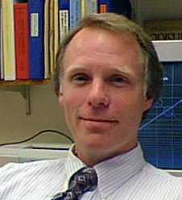 | Chemistry  eric.chronister@ucr.edu  951-827-3288 | Eric Chronister | Chair
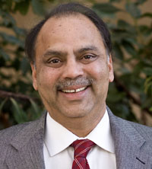 | Computer Science  bhuyan@cs.ucr.edu  951-827-2244 | Laxmi Bhuyan | Chair
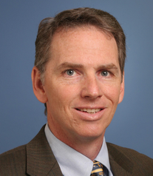 | Electrical Engineering  farrell@ee.ucr.edu  951-827-2159 | Jay Farrell | Chair
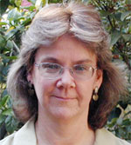 | English  deborah.willis@ucr.edu  951-827-1458 | Deborah Willis | Chair
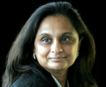 | Math  chari@math.ucr.edu  951-827 6463 | Vyjayanthi Chari | Chair
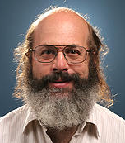 | Physics  jory.yarmoff@ucr.edu  951-827-5336 | Jory Yarmoff | Acting Chair
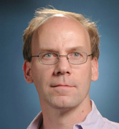 | Statistics  daniel.jeske@ucr.edu  951-827-3014 | Daniel Jeske | Chair

- Non-academic Support Units

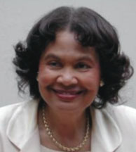 | UCR Libraries: Dr. Ruth Jackson, University Librarian  ruth.jackson@ucr.edu
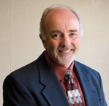 | Computing & Communications: Charles J. Rowley, Associate Vice Chancellor & Chief Information Officer  rowley@ucr.edu
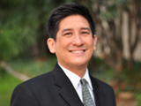 | Learning Center: Michael P. Wong, Director  michaelpaul.wong@ucr.edu
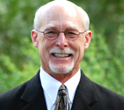 | Career Center: Randy Williams, Director  randy.williams@ucr.edu

- Credit Unit
It is assumed that one semester or quarter credit normally represents one class hour or three laboratory hours per week. One academic year normally represents at least 28 weeks of classes, exclusive of final examinations. If other standards are used for this program, the differences should be indicated.

- Tables
Complete the following tables for the program undergoing evaluation.

Table D-1. Program Enrollment and Degree Data

Name of the Program

 | Academic Year |  | Enrollment Year |  |  |  |  | Total  Undergrad | Total  Grad | Degrees Awarded
 |  |  | 1st | 2nd | 3rd | 4th | 5th | Total  Undergrad | Total  Grad | Associates | Bachelors | Masters | Doctorates
Current |  | FT
Year |  | PT
1 |  | FT
 |  | PT
2 |  | FT
 |  | PT
3 |  | FT
 |  | PT
4 |  | FT
 |  | PT

Give official fall term enrollment figures (head count) for the current and preceding four academic years and undergraduate and graduate degrees conferred during each of those years. The "current" year means the academic year preceding the fall visit.

FT--full time
PT--part time
Table D-2. Personnel ( Pat will do)

Name of the Program

Year¹: _________

 | HEAD COUNT |  | FTE²
 | FT | PT | FTE²
Administrative³
Faculty (tenure-track)
Other Faculty (excluding student Assistants)
Student Teaching Assistants
Student Research Assistants
Technicians/Specialists
Office/Clerical Employees
Others⁴

Report data for the program being evaluated.

- Data on this table should be for the fall term immediately preceding the visit. Updated tables for the fall term when the ABET team is visiting are to be prepared and presented to the team when they arrive.

² For student teaching assistants, 1 FTE equals 20 hours per week of work (or service). For undergraduate and graduate students, 1 FTE equals 15 semester credit-hours (or 24 quarter credit-hours) per term of institutional course work, meaning all courses — science, humanities and social sciences, etc. For faculty members, 1 FTE equals what your institution defines as a full-time load.

³ Persons holding joint administrative/faculty positions or other combined assignments should be allocated to each category according to the fraction of the appointment assigned to that category.

⁴ Specify any other category considered appropriate, or leave blank.

Signature Attesting to Compliance

By signing below, I attest to the following:

That _______________________ (Name of the program(s)) has conducted an honest assessment of compliance and has provided a complete and accurate disclosure of timely information regarding compliance with ABET’s Criteria for Accrediting Engineering Programs to include the General Criteria and any applicable Program Criteria, and the ABET Accreditation Policy and Procedure Manual.

________________________________
Dean’s Name (As indicated on the RFE)

________________________________ _______________________
Signature Date

The term “Inland Empire” is most commonly used in reference to the U.S. Census Bureau's federally defined Riverside-San Bernardino-Ontario metropolitan area, which covers more than 27,000 square miles (70,000 km²). Informally it includes Palm Springs and Palm Desert.
We note that the assessment and improvement processes are very similar for both the PEOs and for program learning outcomes, and these two processes run in parallel. This is a deliberate decision to simplify the process and ensure compliance from all parties. The assessment part of this process is described in more detail in Section 4.
This figure does not include the total amount ($2.4 million ) expended annually by the UCR Libraries as co-investments with other UC campuses and the California Digital Library (CDL) to support access to e-journals, e-books, and electronic databases. The value of the e-journals for supporting engineering alone is over a million dollars annually
This figure reflects a major journal cancellation which included duplicate and low use titles especially targeting print titles that duplicated e-journal titles. This was a UCR project in response to budget reductions
Cost for Compendex and Inspec databases. Other databases such as SciFinder, Water Resources Abstracts, Web of Science support multiple disciplines, in addition to Engineering.

