Table of Contents

BACKGROUND INFORMATION

A. Contact Information

B. Program History

C. Options

D. Organizational Structure

E. Program Delivery Modes

F. Program Locations

G. Deficiencies, Weaknesses or Concerns from Previous Evaluation(s) and the Actions Taken to Address Them

H. Joint Accreditation

CRITERION 1. STUDENTS

A. Student Admissions

B. Evaluating Student performance

B.1 Enforcing Prerequisites

C. Transfer Students and Transfer Courses

D. Advising and Career Guidance

E. Work in Lieu of Courses

F. Graduation Requirements

G. Transcripts of Recent Graduates

CRITERION 2. PROGRAM EDUCATIONAL OBJECTIVES

A. Mission Statement

B. Program Educational Objectives

C. Consistency of the Program Educational Objectives with the Mission of the Institution ................................................................

D. Program Constituencies

E. Process for Revision of the Program Educational Objectives

CRITERION 3. STUDENT OUTCOMES 25

A. Student Outcomes

B. Relationship of Student Outcomes to Program Educational Objectives

CRITERION 4. CONTINUOUS IMPROVEMENT

A. Program Educational Objectives

B. Student Outcomes

C. Continuous improvement

D. Additional Information

CRITERION 5. CURRICULUM

A. Program Curriculum

B. Course Syllabi

CRITERION 6. FACULTY

A. Faculty Qualifications

B. Faculty Workload

C. Faculty Size

D. Professional Development

E. Authority and Responsibility of Faculty

CRITERION 7. FACILITIES

A. Offices, Classrooms and Laboratories

B. Computing Resources

C. Guidance

D. Maintenance and Upgrading of Facilities

E. Library service

F. Overall Comments on Facilities

CRITERION 8. INSTITUTIONAL SUPPORT 62

A. Leadership

B. Program Budget and Financial Support

C. Staffing

D. Faculty Hiring and Retention

E. Support of Faculty Professional Development

PROGRAM CRITERIA

Appendix A – Course Syllabi

Appendix B – Faculty Vitae

Appendix C – Equipment

Appendix D – Institutional Summary

Signature Attesting to Compliance

**ABET**

**Self-Study Report**

**for the**

**Materials Science and Engineering Program**

**at**

**University of California, Riverside**

**July 1, 2012**

**CONFIDENTIAL**

The information supplied in this Self-Study Report is for the confidential use of ABET and its authorized agents, and will not be disclosed without authorization of the institution concerned, except for summary data not identifiable to a specific institution.

# BACKGROUND INFORMATION

1. **Contact Information**

The Chair of the Department of Materials Science and Engineering Program is Javier Garay. He will serve as the main point of contact for the visit. Alexander Balandin is also a member of the program ABET Accreditation and Assessment Committee. Contact information for these individuals is given below:

Javier E. Garay, Ph.D.

Associate Professor, Department of Mechanical Engineering

Chair, Materials Science and Engineering Program

University of California

Riverside, CA 92521

Tele: (951) 827 2449

e-mail: [jegaray@engr.ucr.edu](mailto:jegaray@engr.ucr.edu)

Alexander A. Balandin, Ph.D.

Professor , Department of Electrical Engineering

Founding Chair, Materials Science and Engineering Program

University of California, Riverside, CA 92521

Tele: (951) 827 2351

e-mail: [balandin@ee.ucr.edu](mailto:balandin@ee.ucr.edu)

1. **Program History**

**Summer 2005:** Professor Reza Abbaschian becomes Dean of Engineering at UCR.

**Spring 2006:** Dean Reza Abbaschian holds consultations with the BCOE department chairs and faculty active in materials research on prospects of creating MSE program at UCR.

**September 2006:** Dean Reza Abbaschian appoints Professor Alexander Balandin to chair the MSE Program Committee, and tasks him with creation of the undergraduate MSE program.

**September 2006:** MSE Program Committee is formed with representatives from each BCOE departments: Electrical Engineering, Mechanical Engineering, Chemical and Environmental Engineering, Computer Science and Engineering and Bioengineering. The committee’s charge is to prepare the proposal for the college-wide undergraduate MSE program.

**December 2006:** MSE Undergraduate Program proposal receives the letters of support and participation from each BCOE department. The proposal is submitted for approval to each of the departments, BCOE Executive committee, and for the BCOE faculty-at-large vote.

**January 2007:** Professor Alexander Balandin submits the MSE Undergraduate Proposal to the campus Committee on Educational Policy (CEP) for approval. The first MSE Faculty Search committee is formed to hire MSE Core Faculty members. The committee is chaired by Professor Alexander Balandin and includes representatives from each BCOE department. The committee considers and recommends faculty pre-selected by the participating departments.

**May 2007:** Dean Reza Abbaschian tasks MSE Founding Chair Professor Alexander Balandin to initiate work for creating the campus-wide MSE Graduate Research and Educational program.

**June 2007:** UCR Academic Senate meeting approves the MSE Undergraduate Program leading to B.S. degree in MSE. The program starts the student recruiting activities.

**July 2007:** The first MSE Core Faculty members join the program.

**July 2007:** Professor Balandin is formally appointed a Chair of the MSE Program and charged with running the undergraduate program and developing the MSE Graduate Program.

**September 2007:** Professor David Kisailus starts serving as the first MSE Undergraduate Advisor chairing the undergraduate committee, which consists of representatives of each department.

**September 2007:** Professor Javier Garay becomes the first MSE ABET coordinator. The MSE educational objectives are posted on the BCOE web-site.

**September 2007:** MSE Program welcomes its inaugural class of 20 undergraduate students.

**December 25, 2007:** The proposal of MSE Graduate Program is submitted for consideration to the BCOE faculty. The proposal is supported by 40 Founding Faculty Members and chairs of the participating departments, including all BCOE departments and two CNAS departments.

**January 17, 2008:** Dean Reza Abbaschian and MSE Chair Alexander Balandin submit proposal for the campus-wide MSE Graduate Program to Executive Vice Chancellor and Provost Ellen Wartella and pertinent CNAS and campus committees.

**July 2008:** The MSE Core Faculty members Assistant Professors Elaine Haberer (Electrical Engineering) and Masaru Rao (Mechanical Engineering) join the program. Professor Elaine Haberer becomes the first MSE colloquium series coordinator.

**April 22, 2009:** Professor Alexander Balandin submits a response to the CCGA committee with outside reviewers’ reports of the MSE graduate program proposal.

**August 24, 2009:** The University of California President Mark G. Yudof approves the campus-wide UCR Graduate Program leading to MS and PhD degrees in MSE.

**September 2009:** Professor Ludwig Bartels (Chemistry) and Professor Cengiz Ozkan (Mechanical Engineering) are appointed as the first MSE Graduate Advisors for Curriculum and Recruitment, correspondingly. Ms. Julia Nemeth is appointed as the first MSE Graduate Program Assistant.

**June 2010:** The first three students with BS degree in MSE are graduated. The students transferred from other colleges and/or majors.

**September 2010:** The first cohort of 10 PhD graduate students is welcomed by the MSE Program.

**September 2011**: MSE program has 25 graduate students (6 MS and 19 PhD). It graduated 3 MS students.

**November 2011:** The first US News and World Report ranking is submitted by MSE Program.

**January 2012**: Professor Balandin, Founding Chair of MSE steps down as a chair considering his mission accomplished and planning to focus on his family and research.

**January 2012:** Professor Javier Garay (Mechanical Engineering) becomes the Chair of MSE Program.

**February 2012:** Professor Javier Garay coordinates MSE lab organization in the new MSE building.

**February 2012:** Jennifer Morgan, MSE Graduate Program Assistant moves the MSE office to the new MSE Building.

|  |  |  |  |  |  |  |  |  |
| --- | --- | --- | --- | --- | --- | --- | --- | --- |
|  |  |  |  |  |  |  |  |  |
| **Material Science & Engineering Enrollment and Degrees** | | | | | |  |  |  |
|  | **New Students** | | **Total Enrollment** | | | **Degrees Granted** | | |
|  | **Freshmen** | **Transfer** | **UG** | **Grad** | **Total** | **UG** | **Grad** | **Total** |
| 2008-09 | 15 | 0 | 17 | 0 | 17 |  |  | 0 |
| 2009-10 | 14 | 1 | 31 | 0 | 31 | 1 |  | 1 |
| 2010-11 | 20 | 1 | 53 | 11 | 64 | 6 | 2 | 8 |
| 2011-12 | 4 | 2 | 39 | 23 | 62 |  |  |  |
|  |  |  |  |  |  |  |  |  |

This is the first time that the MS&E program is being evaluated for ABET accreditation. Table 1 summarizes the student enrollment and degrees granted to date.

1. **Options**

List and describe any options, tracks, concentrations, etc. included in the program.

There are currebnly no track options for the BS in MS&E.

1. **Organizational Structure**

Figure 3 presents a schematic of UCR/BCOE/ME organizational structure.

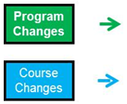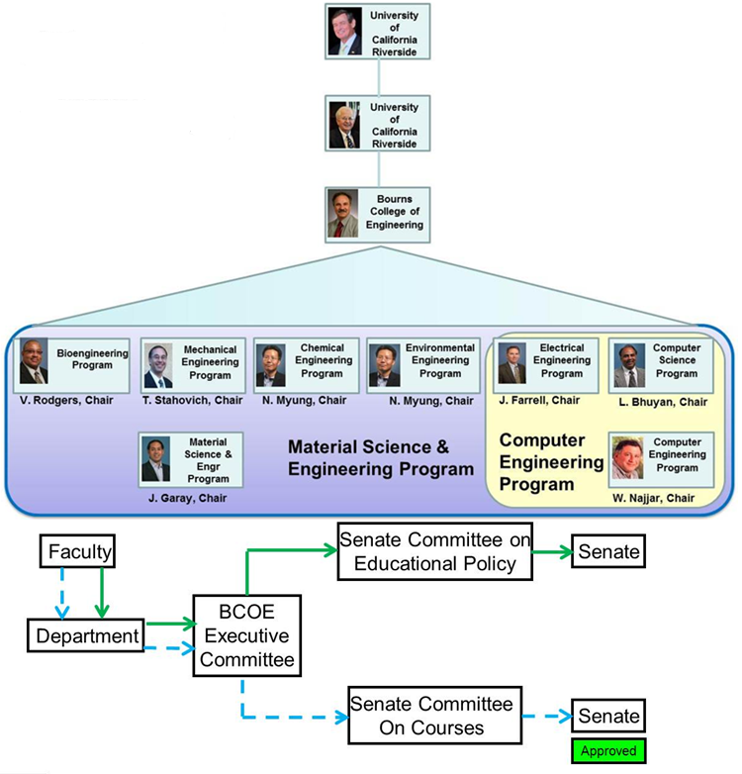

Figure 3. Organizational structure

1. **Program Delivery Modes**

All courses for the bachelor’s degree are delivered in campus classrooms and laboratories on weekdays and weeknights. The curriculum includes no cooperative education, distance education, or web-based instruction.

1. **Program Locations**

All courses are delivered on the campus of the University of California, Riverside.

1. **Deficiencies, Weaknesses or Concerns from Previous Evaluation(s) and the Actions Taken to Address Them**
2. **Joint Accreditation**

This program is seeking EAC accreditation only.

**GENERAL CRITERIA**

# CRITERION 1. STUDENTS

1. **Student Admissions**

The admissions processes for all our programs conform to the UCR Academic Senate’s interpretation of the admission policies of the University of California, which, in turn, interpret the mandates of the California Master Plan for Higher Education.

In broad terms, the Master Plan constrains the University of California to admitting only students ranking in the top 12.5% of the High School graduates in the State. Students in lower tiers are eligible for admission to Campuses of the California State University system, or to Community Colleges in the State. Placement in the top 12.5% of the graduating class is determined by the UC Eligibility Index, which is computed centrally by the UC Office of the President, based on criteria defined by the UC System-Wide Academic Senate.

Figure summarizes the admissions process to our college. Prospective students submit their applications to the Office of Admissions for the University of California, which serves all ten campuses of the University. Applicants may apply to multiple campuses, and to multiple programs at these campuses. They may also designate primary and alternate majors. The UC Office of Admissions determines whether each applicant meets the UC Eligibility criteria (which specify GPA and coursework requirements) and forwards each eligible application to the campuses to which admission is being sought. Ineligible applicants are rejected.

Within UCR, processing of these forwarded applications begins through the Campus Office of Admissions, in accordance with guidelines defined by the Undergraduate Admissions Committee (UAC) of the UCR Academic Senate. An Enrollment Management Council (EMC) also exists at the Campus level to make decisions annually on the enrollment targets at the Campus and College levels. These decisions are informed by the strategic planning processes at the Campus and College levels.

UCR follows a multi-tier admissions process, which operates as follows. At the first tier, an Academic Index Score (AIS) is computed for each applicant, based primarily on academic parameters such as the GPA, the SAT score, and the number of completed Advanced Placement or IB courses. College-specific upper and lower AIS thresholds are determined in accordance with the planned enrollment targets. All applicants to a College whose AIS scores exceed the upper threshold are automatically admitted to their program of interest. All applicants with AIS scores below the lower threshold for each college are removed from that college’s pool. The remaining applicants are forwarded to the respective colleges for further processing.

Once these forwarded applications arrive at BCoE, a, BCoE-specific Index Score (BIS) is computed for each applicant. This BIS score is a function of the applicant’s grades in Mathematics and Science, as well as the Math part of the SAT Reasoning Test (the SAT Advanced test is not required by UC). The applicants to each program are ranked by BIS score, and applicants are admitted starting at the top of the list for each program until the program’s enrollment target is met. Applicants may be placed on a wait list, to be admitted if the yield rate from the admitted pool is insufficient to satisfy program targets.

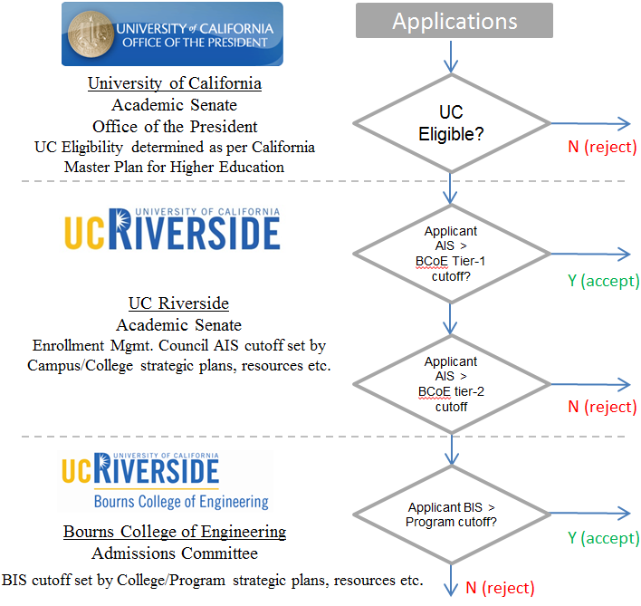

Figure 4: The Admissions Process

1. **Evaluating Student Performance**

Student performance monitoring is primarily the role of the Office of Student Affairs, under the supervision of the Associate Dean. Each program also has a faculty member designated as the Program Faculty Adviser, who serves as the primary departmental contact for program-specific policy decisions. College-level policy is under the purview of the Associate Dean. The staff of Office of Student Affairs (OSA) supports the undergraduate programs.

Each student is assigned to a staff adviser in the OSA, and encouraged to meet with this adviser whenever the need arises, but at least once quarterly. In addition, attendance at a mandatory Annual Major Advising session is required of all undergraduates in the college. The Annual Major Advising session is conducted jointly by the OSA staff and the Program’s Faculty Adviser, and provides information on a variety of topics to students, including program requirements as well as academic success strategies and professional development opportunities.

Figure depicts the process for monitoring student progress. Students are required to maintain a GPA of 2.0 each quarter, as well as cumulatively. Students are reminded of these requirements regularly, first during the registration process in their first quarter as freshmen, and again each year during Annual Major Advising. Grades are posted by instructors each quarter to the central SIS database, which tracks student performance, and provides degree audits to check for completion of degree requirements. At the end of each quarter, staff advisers in the OSA review the academic records of BCoE students and identify all whose term and cumulative GPAs are below 2.0.

A failure to meet these GPA requirements results in a student being placed on probation. The student is notified of this probationary status, and advised that a failure to obtain at least a 2.0 GPA the following term will result in dismissal. A registration hold is now placed on the student’s record, to be released only upon the completion of Academic Success Workshops and other advising and mentoring activities through the OSA. A student who receives a dismissal notice may appeal the dismissal to the Associate Dean, who may grant or reject the appeal based on extenuating circumstances.

The primary source of information regarding student performance is the campus-wide Student Information System (SIS) that records all student registrations and grades, and which is maintained by the Computing and Communications organization. All staff and faculty advisers have access to this system, either directly, or through the Student Advising System (SAS) front-end that provides access to student transcripts and degree audits. This system is used regularly by the staff of the OSA to monitor student progress.

Students who are about to graduate are required to complete a graduation application. At this point, the student’s academic adviser in OSA performs a detailed manual check to ensure that all degree requirements have been met. If the requirements have been met, the Office of the Registrar is notified of degree completion, so that the degree may be awarded.

# B.1 Enforcing Prerequisites

All students are given a term-by-term course plan that ensures timely graduation as long as courses are completed in a timely manner. This course plan incorporates prerequisites, so that students who follow the course plan automatically satisfy prerequisites.

Whether or not students follow this course plan, prerequisites are enforced by the registration system. Students register for courses through the GROWL system that interfaces with SIS, and is able to enforce prerequisites. A student prevented from taking a course due to lack of prerequisites can petition the undergraduate committee, who has the authority to grant the student a prerequisite waiver. The student is not permitted to take the course without such a waiver. Such waivers are generally approved for outstanding students, transfer students and in very special situations.

SIS

Course

Grades

GPA < 2?

Dismissal?

Appeal?

N

Granted By

Associate Dean?

Y

Registration Hold

+

Academic Success

Workshops

N

Every Quarter

Y

N

Graduation,

as per SIS?

Manual Degree

Check

Registration

Term-by-term

Course plan



Advising

By OSA

and Faculty

Y

Y

Y

N

**Dismissed**

**(explore**

**readmission)**

Prerequisites

Figure 5. Academic Advising and Performance Monitoring

1. **Transfer Students and Transfer Courses**

Transfer students apply using the same application portal that freshmen use. This portal is maintained by the System-Wide Office of Admissions, located in Oakland, CA. This office collects applications and forwards them to the UCR Office of Admissions.

In accordance with the California Master Plan for Higher Education, the University of California maintains extensive articulation agreements with Community Colleges in the State. Course articulations are reviewed and approved by the cognizant departments, and are tracked and maintained by the Campus Articulation Officer. All system-wide articulation agreements are available at the website <http://www.assist.org>, which is open access. The transfer route appears to be gaining popularity, especially given recent increases in tuition. When a transfer applicant (typically, from out of state) presents a transcript containing courses that have not already been articulated, the staff of the BCoE OSA collect the relevant course syllabi and work with the cognizant departments at UCR to determine articulations.

All BCoE programs have published detailed requirements for transfer admission. Admission to our programs requires a minimum GPA of 2.8, and the completion of coursework specific to the major being applied to. Incoming transfer students may transfer up to 105 quarter units (70 semester units) towards their degrees from the University. To ease the burden of consulting <http://www.assist.org> for each major an applicant may be interested in, we have prepared brochures showing transfer requirements for each of our majors. We make these brochures available both in hardcopy, as well as on the Web. Some examples appear at <http://www.engr.ucr.edu/undergrads/transferring/SpecialAgreements.html>.

If the transfer applicant for a major meets all the requirements specified by that major, the UCR Office Of Admissions admits that applicant. Applicants who satisfy most transfer requirements are forwarded to the College for additional review. The OSA staff reviews these applications, and in consultation with the departments and the Associate Dean, grants exceptions as warranted. Conditional admission is also sometimes granted, subject to the completion of some requirements that may not have been met at the time of application.

In addition to the college transfer requirements the Materials Science and Engineering Program requires the the following courses to be completed at the time of application: WE NEED TO FILL THIS IN

1. **Advising and Career Guidance**

The mechanisms by which students receive academic advice have already been outlined in **Section B: Evaluating Student Performance**. Here, we will describe the mechanisms for providing Career and Professional guidance.

Professional guidance and mentoring is provided by staff (particularly, the Director of Student Professional Development), the faculty, and the Career Center. The overall College philosophy that guides all interactions with students is to ensure that they are both academically and professionally prepared to become leaders in their chosen fields. This goal is especially challenging to meet in engineering colleges.

As is typical for undergraduate programs in engineering, our students spend the first two years of their undergraduate work completing prerequisite coursework in mathematics, the sciences, and the humanities and social sciences. Unfortunately, instructors in these areas are unfamiliar with any of the engineering disciplines, and unable to motivate or mentor our students in their early years here. Consequently, our students fail to develop a clear sense of academic direction or a sense of professional pride, having no role models or mentors, either at home or on campus. Another consequence of this lack of engagement in the early years with BCoE is that it is harder for students to build effective working relationships with their peers, so they can begin to see them as technically strong, and as effective partners.

We are addressing these issues in several ways. The first of these is a series of 1-unit classes intended to promote engagement with BCoE in the early years and to help the student’s professional development in later years. This series of classes are numbered ENGR 1 (freshmen), ENGR 2 (sophomores), ENGR 101 (juniors), and ENGR 102 (seniors). These courses are intended to provide our students with involvement in Professional Development activities. Activities to be performed are program-specific, and will include projects, industry overviews and interactions, involvement with professional societies and clubs, team building, career guidance, and coverage of ethics and lifelong-learning issues. The specific list of topics in these courses includes the following:

* Participate in peer-group building activity
* Understand Engineering as a creative process for solving real-world problems.
* Understand current and future trends in the student’s major discipline
* Understand some analysis tools, and their use in design and practice.
* Understand the stages of development of an Engineer as a Professional
* Participate in individual and group projects.
* Participate in Professional Clubs.
* Participate in the Career Path Milestones program.
* Understand the role and importance of Ethics in the Engineering profession.
* Understand the importance of engaging in life-long learning.
* Participate in Industry visits.

These topics are presented in workshops and discussion-style activities. A suite of activities supported by the college under the Professional Development Milestones program complement the program-specific content in these courses. Examples of such activities are academically-oriented workshops on time management and study-skills, as well as professionally-oriented activities such as mock interviews, resume writing, as well as research and industrial internships. **Figure**  summarizes these milestones.

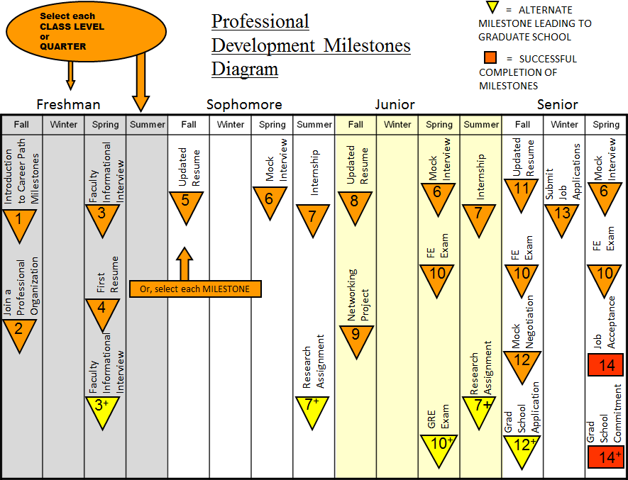

Figure 6. Professional Development Milestones Program

A total of 18 Student Professional Organizations exist in BCoE, and are supported financially by the College. These organizations are student-led, and are very active. Just over 800 students are active members of these organizations (roughly 40% of the students in College).

1. BCOE SLC (Student Leadership Council)
2. ACM (Association of Computing Machinery)
3. AIChE (American Institute of Chemical Engineers)
4. ASME (American Society of Mechanical Engineers)
5. ASQ (American Society of Quality)
6. BMES (Biomedical Engineering Society)
7. EWB (Engineers Without Border)
8. IEEE (Institute of Electrical and Electronics Engineers)
9. IEEE EDS (Electron Devices Society)
10. ION (Institute of Navigation)
11. MRS (Material Research Society)
12. NSBE (National Society of Black Engineers)
13. OSA (Optical Society of America)
14. SACNAS (Society for Advancement of Chicanos and Native Americans in Science)
15. SHPE (Society of Hispanic Professional Engineers)
16. SAE (Society of Automotive Engineers)
17. SWE (Society of Women Engineers)
18. TBP (Tau Beta Pi) – Honors Society

These organizations, under the mentorship of the Director of Student Professional Development, participate in a broad range of activities during the year. A summary appears below.

|  |  |  |  |  |  |
| --- | --- | --- | --- | --- | --- |
| **BCOE Professional Development Milestones Program 2,102 participants total** | | | | |  |
| **Date** | **Event** | **Students** | **Date** | **Event** | **Students** |
| 10/5/2010 | Technical Job Search Workshop | 27 | 1/19/2011 | Preparing for Engr. Technical Career Fair/Fashion Show | 72 |
| 10/11/2010 | Making Professional Connection with Western Digital | 21 | 1/20/2011 | Careers in Video Game & Animation Design | 30 |
| 10/11/2010 | Careers in Pharmaceutical Industry | 36 | 1/26/2011 | Google Info Night with Alumni | 155 |
| 10/12/2010 | Beginning Resume Writing | 15 | 1/26/2011 | Information Session with CIA | 43 |
| 10/14/2010 | Advanced Resume Writing | 17 | 1/26/2011 | Information Session with National Oil well Varco | 44 |
| 10/18/2010 | Google Careers Info Session & Resume Workshop | 146 | 1/27/2011 | Women in STEM Careers | 37 |
| 10/19/2010 | EPA Careers Info Session & Interview Workshop | 65 | 2/9/2011 | engineering, Science, & Metrology in Defense Industries | 54 |
| 10/19/2010 | Northrop Grumman Tech Talk | 45 | 2/15/2011 | From Internship to Career Alumni Panel | 32 |
| 10/19/2010 | CIA Information Session | 56 | 2/23/2011 | Making Professional Connections | 40 |
| 11/3/2010 | Advanced Resume Workshop with Western Digital | 24 | 3/1/2011 | Interview Skills Featuring Western Digital | 35 |
| 11/8/2010 | Careers in Sustainability | 26 | 3/2/2011 | NAVY Day at Bourns College of Engineering | 160 |
| 11/8/2010 | INROAD Mixer | 58 | 4/6/2011 | Engineering Careers in Pharmaceutical & Medicine Manufacturing | 120 |
| 11/15/2010 | Internships, What, Why & How | 40 | 4/12/2011 | Interview Skills, featuring: The Aerospace Corporation | 41 |
| 11/16/2010 | Phoenix Motorcars on Electronic Vehicles Industry | 66 | 4/12/2011 | Resumania, Featuring: Northrop Grumman | 35 |
| 11/18/2010 | Careers in Water Resources and Quality | 62 | 4/14/2011 | Coffee Chat: featuring: consolidated electrical distributors | 30 |
| 12/1/2010 | Engineering Presentation Skills | 28 | 4/20/2011 | Student Intern Panel | 28 |
| 1/1/2011 | Resume Writing with Skanska Constructions | 35 | 4/21/2011 | A Day in the Life of the EPA – What we do | 48 |
| 1/10/2011 | Careers in Aviation featuring Marine Corps | 32 | 4/21/2011 | Work Green, Earn Green: Careers that save the planet | 23 |
| 1/12/2011 | UG Research Internships with NSF | 70 | 4/25/2011 | Internship: What, Why, & How? | 23 |
| 1/12/2011 | FE/EIT Exam Preparation Workshop with California Water Board | 52 | 5/5/2011 | Interview Skills, Featuring INROADS | 37 |
| 1/18/2011 | Interview Skills Workshop with Abbott Vascular | 64 | 5/5/2011 | Advanced Resume Writing, Featuring: Sherwin Williams | 30 |

In addition, the College has a very active Undergraduate Research program. Faculty are very active participants in undergraduate research. Last year, 60 of the 83 faculty in BCoE were research mentors for undergraduates. Over 250 undergraduates worked with faculty on research projects. This research has resulted in a significant number of publications and research presentations. For example, in the 2010 Southern California Conference on Undergraduate Research, 18 of the 24 research presentations from UCR were by BCoE students. For the second year in a row, BCoE students made more presentations at SCCUR than students from any other engineering college in Southern California.

A summary of the range of Professional Development, Mentoring, and Success program in BCoE appears in **Figure** 7.

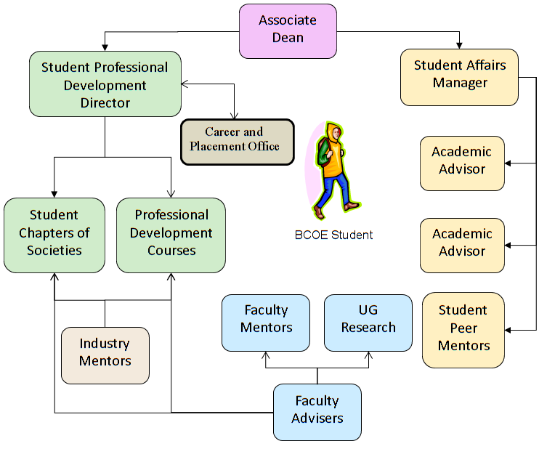

Figure 7. Professional Development, Placement, and Success Programs

1. **Work in Lieu of Courses**

Credit is awarded for selected International Baccalaureate Advanced Placement courses taken in High School, in accordance with the charts on pages 28—31 in the General Catalog for the University of California, Riverside.

Internships and independent study courses may not be used to satisfy College subject requirements, as per the following College regulation:

* **ENR3.2.8.** Internships and independent study courses may not be used to satisfy College subject requirements. (En 25 May 95) (Renumbered & Am 25 May 00)

Credit by Examination is awarded subject to the following College Regulations:

* **ENR2.5.1.** A student who wishes to have the privilege of examination for degree credit must be in residence and not on academic probation.
* **ENR2.5.2.** Arrangements for examination for degree credit must be made in advance with the student's Faculty adviser. The approval of the Faculty adviser, the Dean of the college, and that of the instructor who is appointed to give the examination, are necessary before the examination can be given.
  + **ENR2.5.3.** The results of all examinations for degree credit are entered on the student's record in the same manner as for regular courses of instruction.

1. **Graduation Requirements**

The Materials Science and Engineering major uses the following major requirements to satisfy the **college’s** Natural Sciences and Mathematics breadth requirement.

1. One course in the biological sciences

chosen from an approved list

2. CHEM 001A, CHEM 001LA

3. MATH 008B or MATH 009A

4. PHYS 040A, PHYS 040B

**MS&E Major Requirements**

1. Lower-division requirements (68 units)

a) CHEM 001A, CHEM 01LA, CHEM 001B,

CHEM 01LB, CHEM 001C, CHEM 01LC

b) CS 030

c) EE 001A (circuit anal), EE 01LA

e) MATH 009A, MATH 009B, MATH 009C,

MATH 010A, MATH 010B, MATH 046

d)ME 010 (statics)

f) MSE 001

g) PHYS 040A (newton’s laws), PHYS 040B (waves & osc, elasticity, fluids), PHYS 040C (E&M)

2. Upper-division requirements (53 units)

a) CHEM 112A (organic chem.)

b) CEE 135 (chemistry of materials)

c) CHE 100 (engineering thermodynamics)

d) EE 138 (magnetic materials)

e) ENGR 180W

f) ME 110 (mechanics of materials), ME 114 (intro to materials science & engr), ME 156 (mechanical behavior of materials)

g) MSE 160 (nanostructure characterization), MSE 161 (analytical materials characterization), MSE 175A,

MSE 175B (senior design sequence)

h) STAT 155

i) Technical Electives (20 units): chosen

from BIEN 140A/CEE 140A, BIEN 140B/

CEE 140B, CEE 147, EE 133, EE 136,

EE 137, EE 139, ME 113, ME 116,

ME 138, ME 153, ME 180

To provide depth in satisfying breadth in the humanities and social sciences, at least two of the courses must be upper division. And at least two courses, one of them upper division, must be from the same subject area. The list of approved courses is available in the Office of Student Academic Affairs.

1. **Transcripts of Recent Graduates**

The program will provide transcripts from some of the most recent graduates to the visiting team along with any needed explanation of how the transcripts are to be interpreted. These transcripts will be requested separately by the team chair. State how the program and any program options are designated on the transcript. (See 2011-2012 APPM, Section II.G.4.a.)

# CRITERION 2. PROGRAM EDUCATIONAL OBJECTIVES

1. **Mission Statement**

The University of California, Riverside serves the needs and enhances the quality of life of the diverse people of California, the nation and the world through knowledge – its communication, discovery, translation, application, and preservation. The undergraduate, graduate and professional degree programs; research programs; and outreach activities develop leaders who inspire, create, and enrich California’s economic, social, cultural, and environmental future.

With its roots as a Citrus Experiment Station, UC Riverside is guided by its land grant tradition of giving back by addressing some of the most vexing problems facing society. Whether it is assuring a safe, nutritious, and affordable food supply; stimulating the human mind and soul through the humanities and arts; or finding solutions to the profound challenges in education, engineering, business, healthcare, and the environment, UC Riverside is living the promise.

The mission of the Bourns College of Engineering is to:

* Produce engineers with the educational foundation and adaptive skills to serve rapidly evolving technology industries;
* Conduct nationally recognized engineering research focused on providing a technical edge for the United States;
* Contribute to knowledge of both fundamental and applied areas of engineering;
* Provide diverse curricula that will instill in our students the imagination, talents, creativity, and skills necessary for the varied and rapidly changing requirements of modern life;
* Enable our graduates to serve in a wide variety of other fields that require leadership, teamwork, decision-making and problem-solving abilities; and
* Be a catalyst for industrial growth in Inland Southern California.

The vision of the Bourns College of Engineering is to become a nationally recognized leader in engineering research and education.

In agreement with the College vision, the vision of the Department of Mechanical Engineering is to be nationally recognized as an innovator in both research and education in mechanical engineering. Its mission is to provide quality education, conduct strong research, foster close partnership with industry and government, and provide related service to the campus community and the community at large. The department mission is guided by a commitment to continuous improvement in the overall quality of teaching, research, and service, while adhering to the highest standard of ethics. This vision is used in formulating the Department educational objectives which are described next.

1. **Program Educational Objectives**

The Vision of the program is to be nationally recognized as an innovator in both research and education in materials science and engineering (MSE). The MSE program objectives are to produce mechanical engineers who:

1) Have the knowledge and skills to adapt to the dynamic engineering environment in industry.

2) Are able to pursue and succeed in graduate studies.

3) Exercise professional responsibilities and are sensitive to a broad range of societal concerns, such as ethical, environmental, economic, regulatory, and global issues.

4) Have an ability to work in multi-disciplinary teams.

5) Engage in a lifetime of learning.

These objectives are met through:

1) Strong training in the areas of mathematics, science, and the fundamentals of materials science and engineering that constitute the foundation of the discipline.

2) Extensive laboratory and hands-on experience to strengthen understanding of fundamental principles.

3) Exposure to contemporary computer/numerical methods.

4) Application of knowledge to design problems common to modern engineering practice.

5) Emphasis on both oral and written communication throughout the curriculum.

6) A well-rounded and balanced education achieved through required studies in selected areas of the Humanities and Social Sciences.

1. **Consistency of the Program Educational Objectives with the Mission of the Institution**

UCR’s mission statement is as follows: The University of California, Riverside, is a research university committed to the creation and transmission of knowledge at the highest level, and to the translation of that knowledge for the public good. Our comprehensive programs and services, excellent faculty and staff, and vibrant and attractive physical environment are designed to: provide a high quality learning environment for undergraduate and graduate students; advance human knowledge and accomplishment through research and scholarship; enhance the public good through community service and initiatives; seek preeminence among U.S. research universities, recognizing UCR’s quality in every area.

Superimposed over this mission are seven strategic goals articulated by Chancellor:

1. To enhance UCR’s reputational rankings: UCR will have the profile of an AAU member university.

2. To invest in areas of strength: UCR will be recognized for its distinction among all research universities in selected areas which exhibit quality and momentum.

3. To expand opportunities for learning and personal growth for all students, undergraduate and graduate: UCR will become a campus of “first choice” for applicants, and students will have a successful experience at UCR.

4. To reshape the curriculum: UCR will build on the diversity of its students and the distinction of its faculty, and connect the curriculum to the vision of UCR as an AAU institution.

5. To diversify our faculty, staff and graduate population: UCR will be a pre-eminent research university that has diversity as one of its measures of distinctiveness.

6. To build professional schools: UCR will offer expanded professional education in areas that respond to the needs of the state and region and that help to stimulate a knowledge-based economy.

7. To forge closer ties with the community: UCR will organize and coordinate with others to achieve common goals for prosperity and sustainability of the Inland Empire through technology transfer, attraction and retention of highly skilled jobs and industries, and responsiveness to regional issues

The vision of the Bourns College of Engineering is to become a nationally recognized leader in engineering research and education. The mission of the Bourns College of Engineering is to:

* Produce engineers with the educational foundation and adaptive skills to serve rapidly evolving technology industries;
* Conduct nationally recognized engineering research focused on providing a technical edge for the United States;
* Contribute to knowledge of both fundamental and applied areas of engineering;
* Provide diverse curricula that will instill in our students the imagination, talents, creativity, and skills necessary for the varied and rapidly changing requirements of modern life;
* Enable our graduates to serve in a wide variety of other fields that require leadership, teamwork, decision-making and problem-solving abilities; and
* Be a catalyst for industrial growth in Inland Southern California.

The components of the mission of the Bourns College of Engineering relevant to the undergraduate program in Materials Science and Engineering are:

* To produce engineers with the educational foundation and the adaptive skills to serve rapidly evolving technology industries.
* To provide diverse curricula that will instill our students with the imagination, talents, creativity and skills necessary for the varied and rapidly changing requirements of modern life and to enable them to serve in a wide variety of other fields that requires leadership, teamwork, decision making, and problem solving abilities.
* To be a catalyst for industrial growth in the Inland

The broad creation and transmission of knowledge in UCR’s mission is consistent with the College mission to provide our students with a diverse curriculum that will engender their creativity in a rapidly changing environment. The College mission is to produce engineers who can function in technology industries. This enables translation of their knowledge for the good of the public, consistent with the University mission and the Mechanical Engineering program educational objectives. The notion of engineers working successfully in interdisciplinary teams that require technical and non-technical expertise is emphasized in the college mission and program objectives. Specifically, an ability to write technical reports and to present technical material orally with suitable visual aids is emphasized in the program experience. The program aims to offer opportunities for undergraduate research experience as a means to motivate graduates to pursue advanced graduate degrees in mechanical engineering and other fields. Thus the program educational objectives are consistent with the mission of the Bourns College of Engineering and the University of California, Riverside.

1. **Program Constituencies**

The stakeholders of our program are mechanical engineering undergraduate and graduate students, program faculty and lecturers, program alumni, employers in industry, and representatives from graduate schools. The MS& E Program has a Board of Advisors (BOA), currently comprised of 2 members representing from Industry. The primary purpose of the BOA is to provide insight and counsel to the Chair and members of the faculty in defining the future direction of the department, its curriculum and degree programs (BS, MS, and PhD), and research directions. Typically, the Board convenes once each year for a day to discuss current issues. On occasion, the Chair may also call upon Board members for individual advice and input. Areas for which the Chair seeks such counsel include, but are not limited to the following.

• Industry trends and needs

• Industry collaboration opportunities

• Centers of excellence

• Program expansion

• Industry recruitment process, internship and employment opportunities for UCR-ME students

• Consultation as stakeholder in ABET accreditation process

Given the significant industrial experience of our BOA, it serves as a vital link to the employer constituency.

Mechanical Engineering Department Board of Advisors

|  |  |
| --- | --- |
| **Name** | **Affiliation** |
| Dr. Mike Clinch | Luxfer Inc |
| Dr. Joseph Wilde | Raytheon |

1. **Process for Revision of the Program Educational Objectives**

A summary of the procedures adopted to review and refine the program educational objectives and our assessment methodology is presented below:

* Program educational objectives are reviewed by the program faculty annually at a department planning retreat for faculty and lecturers (September of each year).
* An update of our assessment procedure and a review of our overall objectives are carried out as part of the agenda of Board of Advisors and stakeholders meetings
* Program educational objectives guide our assessment process review at faculty meetings (monthly during the 9 month academic year).

# CRITERION 3. STUDENT OUTCOMES

This section describes Student Outcomes and their relation to the Program Educational Objectives. Our process for evaluating outcomes as well as the process by which the assessment results are applied to further develop and improve the program is described in the next section – Continuous Improvement.

1. **Student Outcomes**

To prepare students to attain the Program Educational Objectives we adapted the ABET outcomes (a) through (k):

(a) an ability to apply knowledge of mathematics, science, and engineering

(b) an ability to design and conduct experiments, as well as to analyze and interpret data

(c) an ability to design a system, component, or process to meet desired needs within realistic constraints such as economic, environmental, social, political, ethical, health and safety, manufacturability, and sustainability

(d) an ability to function on multidisciplinary teams

(e) an ability to identify, formulate, and solve engineering problems

(f) an understanding of professional and ethical responsibility

(g) an ability to communicate effectively

(h) the broad education necessary to understand the impact of engineering solutions in a global, economic, environmental, and societal context

(i) a recognition of the need for, and an ability to engage in life-long learning

(j) a knowledge of contemporary issues

(k) an ability to use the techniques, skills, and modern engineering tools necessary for engineering practice.

These student outcomes are available on our website http://www.mse.ucr.edu/

1. **Relationship of Student Outcomes to Program Educational Objectives**

The current sets of objectives are the same as those used by the Mechanical Engineering Program at UCR. The ME program has current ABET accreditation and has numerous course overlap with MS&E.

The program outcomes are strongly related to program objectives. To qualitatively delineate the most significant specific impacts of outcomes to objectives we designed the “influence” matrix shown in Figure x24.

|  |  |  |  |  |  |
| --- | --- | --- | --- | --- | --- |
| Objectives / Outcomes | 1 | 2 | 3 | 4 | 5 |
| (a) |  |  |  |  |  |
| (b) |  |  |  |  |  |
| (c) |  |  |  |  |  |
| (d) |  |  |  |  |  |
| (e) |  |  |  |  |  |
| (f) |  |  |  |  |  |
| (g) |  |  |  |  |  |
| (h) |  |  |  |  |  |
| (i) |  |  |  |  |  |
| (j) |  |  |  |  |  |
| (k) |  |  |  |  |  |

Figure x24. The relevance of the (a) through (k) program outcomes, shown in the row headings, in achieving the 5 program objectives, which appear as column headings.

# CRITERION 4. CONTINUOUS IMPROVEMENT

This section of your self-study report should document your processes for regularly assessing and evaluating the extent to which the program educational objectives and student outcomes are being attained. This section should also document the extent to which the program educational objectives and student outcomes are being attained. It should also describe how the results of these processes are being utilized to effect continuous improvement of the program.

Assessment is defined as one or more processes that identify, collect, and prepare the data necessary for evaluation. Evaluation is defined as one or more processes for interpreting the data acquired though the assessment processes in order to determine how well the program educational objectives and student outcomes are being attained.

Although the program can report its processes as it chooses, the following is presented as a guide to help you organize your self-study report. It is also recommended that you report the information concerning your program educational objectives separately from the information concerning your student outcomes.

1. **Program Educational Objectives**

It is recommended that this section include (a table may be used to present this information):

1. A listing and description of the assessment processes used to gather the data upon which the evaluation of each the program educational objective is based. Examples of data collection processes may include, but are not limited to, employer surveys, graduate surveys, focus groups, industrial advisory committee meetings, or other processes that are relevant and appropriate to the program.
2. The frequency with which these assessment processes are carried out
3. The expected level of attainment for each of the program educational objectives
4. Summaries of the results of the evaluation processes and an analysis illustrating the extent to which each of the program educational objectives is being attained
5. How the results are documented and maintained

The Materials Science and Engineering program objectives are to graduate students who:

1. Have the knowledge and skills to adapt to the changing engineering environment in industry.
2. Are able to pursue and succeed in graduate studies
3. Have the educational breadth and the intellectual discipline required to enter professional careers outside engineering, such as business and law
4. Have an ability to work in multi-disciplinary teams.
5. Engage in a lifetime of learning.

The MS&E program uses alumni surveys, employer surveys, and feedback from our board of advisors to assesses the program objectives

1. **Student Outcomes**

It is recommended that this section include (a table may be used to present this information):

1. A listing and description of the assessment processes used to gather the data upon which the evaluation of each student outcome is based. Examples of data collection processes may include, but are not limited to, specific exam questions, student portfolios, internally developed assessment exams, senior project presentations, nationally-normed exams, oral exams, focus groups, industrial advisory committee meetings, or other processes that are relevant and appropriate to the program.

2. The frequency with which these assessment processes are carried out

3. The expected level of attainment for each of the student outcomes

1. Summaries of the results of the evaluation process and an analysis illustrating the extent to which each of the student outcomes is being attained
2. How the results are documented and maintained

To prepare students to attain the Program Educational Objectives we adapted the ABET outcomes (a) through (k):

(a) an ability to apply knowledge of mathematics, science, and engineering

(b) an ability to design and conduct experiments, as well as to analyze and interpret data

(c) an ability to design a system, component, or process to meet desired needs within realistic constraints such as economic, environmental, social, political, ethical, health and safety, manufacturability, and sustainability

(d) an ability to function on multidisciplinary teams

(e) an ability to identify, formulate, and solve engineering problems

(f) an understanding of professional and ethical responsibility

(g) an ability to communicate effectively

(h) the broad education necessary to understand the impact of engineering solutions in a global, economic, environmental, and societal context

(i) a recognition of the need for, and an ability to engage in life-long learning

(j) a knowledge of contemporary issues

(k) an ability to use the techniques, skills, and modern engineering tools necessary for engineering practice.

1. The instructor of each course establishes a set of course objectives for that course. These are linked to the student outcomes via a matrix. The instructor selects particular exercises throughout the course to measure student performance on each course objective. The matrix is then used to compute the performance on the student outcomes. The exercises used for assessment may include exam questions, quiz questions, homework questions, and class projects. The analysis of this data results in a quantitative measure of the efficiency with which the students achieve both the course objectives and the student outcomes.

At the end of each course, students are also asked to complete surveys in which they report their perceived level of accomplishment of the both the course objectives and the student outcomes.

2. Assessment is conducted continuously throughout each course.

3. The assessment results for each course offering are organized into an ABET course binder. These binders are stored in a designated ABET course binder storage area in the ME office suite.

1. **Continuous Improvement**

Describe how the results of evaluation processes for the program educational objectives and the student outcomes and any other available information have been used as input in the continuous improvement of the program. Indicate any significant future program improvement plans based upon recent evaluations. Provide a brief rationale for each of these planned changes.

At the end of each class, the instructor reviews the assessment results including (a) quantitative performance on the course objectives and (b) student outcomes and qualitative performance on these measured with student surveys. The instructor uses this data to recommend changes to improve the course. In making these recommendations, the instructor may also consider a variety of other qualitative data. This may include particular types of errors students made on homework and exam problems, feedback from students during office hours, and faculty course evaluations administered by campus. The recommendations are recorded on a form included in the ABET course binder.

When a course is taught the next time, the instructor reviews the course changes recommended by the previous instructor and identifies suitable improvements. The new instructor summarizes any changes on a new recommendation form. At the end of the course, the instructor adds to this form, recommendations for the next instructor, and the process repeats.

Figure x23 depicts the system used by the MS&E program to “foster the systematic improvement in the quality of engineering education that satisfies the needs of constituencies in a dynamic and competitive environment”. The yellow boxes refer to the processes used in the system, while the blue boxes refer to the “objects” that these processes operate on.

Course objectives are formulated to yield course outcomes, which in turn produce program outcomes. The program outcomes are designed to foster attainment of program objectives.

The outcomes are assessed to produce qualitative and quantitative measures of performance. These measures are then evaluated against metrics. We do not have established absolute metrics to evaluate assessment results. We have evaluated these results by quantifying year to year changes in measures of their relative importance in the curriculum and student performance in achieving them.

Evaluation of results from outcomes assessment leads to the modification of a variety of components of the educational process to improve the effectiveness of attaining program outcomes and objectives. The processes illustrated in Figure x23 are carried out by a stakeholder group consisting of faculty members, graduate and undergraduate students, alumni, , industry representatives.

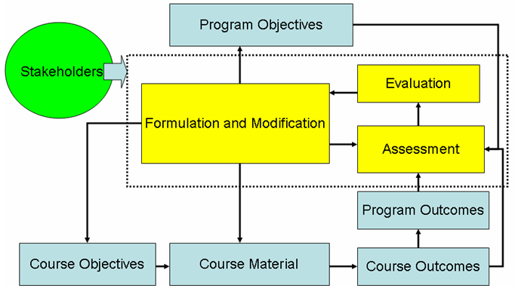

Figure x23. Mechanical Engineering Department’s system to make continuous improvements in the ME program to achieve objectives formulated by stakeholders.

Quarterly course assessment

Instructor training workshops – in planning

Laboratory manager addition in 2008 (in 2010 we lost machinist and now laboratory manager works 50% as a machinist 50% as laboratory manager)

Surveys

After each class on class objectives and program outcomes

Exit survey – before graduation, after senior design

Alumni surveys – months, years after graduation

Employer surveys

Specialized concept testing assignments at the beginning and end of course offering – “Concept Inventories” – to be implemented

Student projects: HPV, Baja car, SAE Formula

Machine shop class (for fee): welding

The Freshman Experience

* Designed to
  + Engage students early on
  + Provide foundation for success
  + Enable internships after freshman year
  + Freshman Mentoring
* Courses
  + Winter Quarter: ME 2 -Introduction to Mechanical Engineering
  + Spring Quarter: ME 9 - Computer Aided Design

Program outcomes are assessed through quantitative and qualitative techniques. The quantitative methods depend on student performance in courses while the qualitative techniques are based on surveys. We first describe the method based on student performance.

Every course in Mechanical Engineering lists a set of objectives that are designed to ensure that students completing the class will have the knowledge and skills to perform a specific set of tasks related to course content. These course objectives are linked to program outcomes using the objective-outcome matrix presented by Fiedler and Brent in “Designing and Teaching Courses to Satisfy the ABET Engineering Criteria (Journal of Engineering Education, January

2003).

Relationship of course to program outcomes: As an example, the contribution of ME 118 (formerly ENGR 118) to program outcomes (1) – (11) is summarized in the objective-outcome matrix , shown in Figure 25. The objectives are linked to program outcomes using a number on a scale of 1 to 3 to denote the strength of the relationships. Student performance in the course is evaluated through fulfillment of course objectives. This performance in achieving course objectives is translated into performance in achieving program outcomes using the mapping scheme of the objective-outcome matrix. The mechanics of the process are described next.

When examinations, homework or quizzes are set, the faculty member or the teaching assistant assigns a set of numbers to each one of the problems to link the relevance of the problem to each of the course objectives. This set of numbers is then scaled by the average of student scores for each problem to obtain measures of the degree of achieving course objectives. A manual (<http://www.engr.ucr.edu/abet2000/repository/ABET%20Users%20Manual-ME.doc)>describing the procedures used in obtaining these achievement scores is available to faculty members and teaching assistants. New teaching assistants are given an hour of instruction on these procedures before every quarter.

Figure 26 provides details on how student grades are translated into outcome weights and efficiencies. To explain the process, we have considered a course with 4 objectives and 5 outcomes. The course matrix is shown in the lower left corner of the figure. The table in the top left corner provides the weights assigned to each of the objectives in the assignments named in the rows. Each entry corresponds to the sum of the weights, ranging from 0 to 3, assigned to objectives for the problems in the assignment. For example, the entry 12 for HW 1 might correspond to 4 problems in which objective 1 was assigned a weight of 3. The same 4 problems could have the following distribution of weights for objective 2: 3, 2, 0. 0. The sum of these weights corresponds to the entry 5 for HW 1. The last column of the Table, titled ‘Weights,’ is the relative weights assigned by the instructor to the components of the course, named in the rows. For example, the Final Exam is assigned 0.5 or 50% of the total class grade, while the Mid-Term is assigned 20% of the final grade.

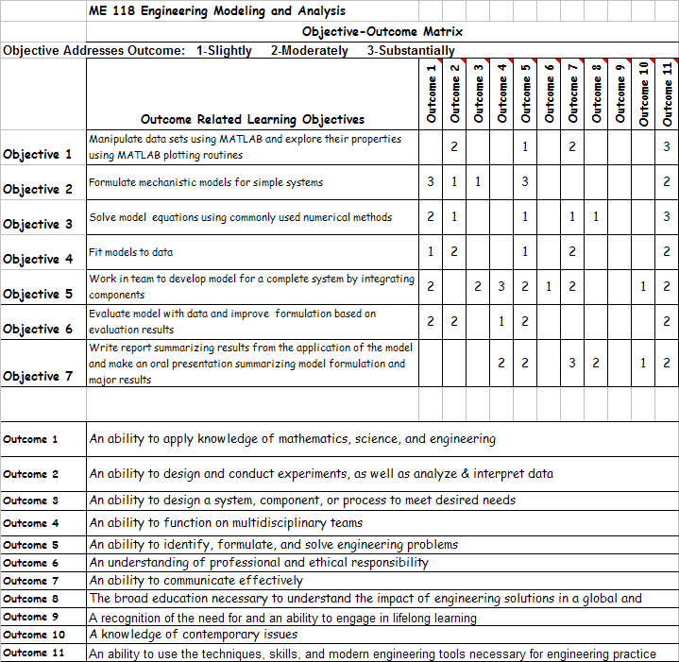

Figure 25. Example of the relationship between course objectives and program outcomes, in this case for ME 118, “Mechanical Engineering Modeling and Analysis.”

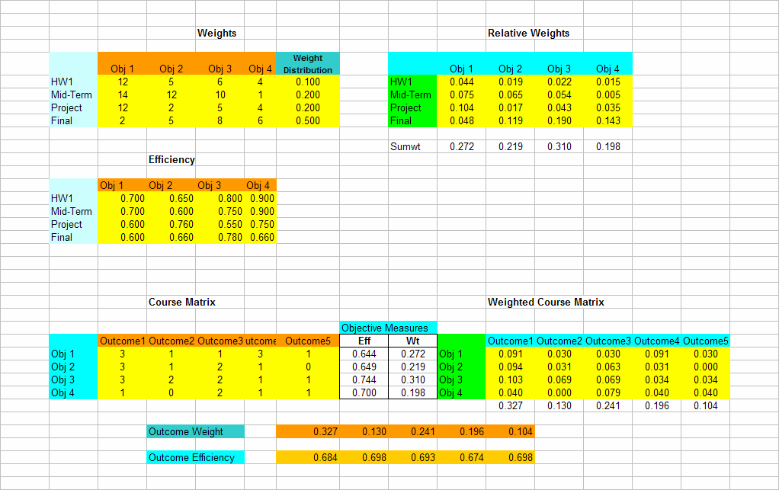

Figure 26. Process used to relate student grades to outcome weights and efficiencies.

The top right table, titled ‘Relative Weights,’ normalizes the entries in ‘Weights’ table as follows. Each entry in ‘Weights’ is divided by the sum of the entries in the row, and multiplied by the entry in the last column of the row to yield the corresponding entry in ‘Relative Weights’. Each entry in ‘Relative Weights’ can be interpreted as the contribution of a component of the course to each objective. For example, the mid-term contributes 7.5% to objective 1 and 6.5% to objective 2. The sum of all the entries in the table equals unity or 100%. The sum of the rows in a column, corresponding to an objective, represents the weight attributed by the course to the objective. In this example, objective 1 has a relative weight of 0.272, objective 2 has a relative weight of 0.219, objective 3 has a relative weight of 0.310, and objective 4 has a relative weight of 0.198. These relative weights sum to unity.

The ‘Efficiency’ table in the middle of the figure summarizes the performance of students in each of the components of the course. For example, in HW 1, each entry corresponds to the average of the student grades in problems related to each of the objectives. Assume that in the 4 problems that are assigned a weight of 3 for objective 1, the average student grades are 60%,

80%, 75%, and 65%. Then the weighted average grade in problems addressing objective 1 is (3×0.60+3×0.80+3×0.75+3×0.65)/12= 0.70. The entry of 0.66 for the ‘Final’ row suggests that in problems addressing objective 4, the average student grade is 66%.

The ‘Eff’ column between the bottom two tables corresponds to the scores obtained by students in the course content addressing each of the objectives. Each entry in the column is a weighted score obtained by performing a vector multiplication of each column in the ‘Relative Weights’

table with the corresponding column in the ‘Efficiency’ table, and then normalizing by the weight assigned to the objective. For example, the first entry is obtained as follows:

(0.7×0.044+ 0.7×0.075+0.6×0.104+0.6×0.048)/0.272=0.644.

The ‘Wt’ column reproduces the ‘Relwt’ numbers below the ‘Relative Weights’ table. So we now have the weights assigned to each of the course objectives and the performance (Efficiency) of students in course content addressing these objectives.

The two columns ‘Wt’ and ‘Eff’ are measures related to course objectives. These measures are now mapped to outcomes using the ‘Course Matrix’ discussed earlier. Before this mapping can be done, the matrix is normalized using the same steps as that used to construct the ‘Relative Weights’ matrix, shown in the top right of the figure. Each entry in the Course Matrix is divided by the sum of the entries in each row, and then multiplied by the ‘Wt’ entry in the row. Each entry in the ‘Weighted Course Matrix’ corresponds to the contribution of a particular objective to an outcome. For example, the contribution of objective 1 to outcome 1 is 0.091. The sum of all the entries is unity, and the sum of each column corresponding to an outcome corresponds to the weight assigned to the outcome by the course in setting homework, exams, and projects. Note that outcome weights are not pre-assigned, but are the result of the educational activities of the class.

The last step of the process is calculating the weighted efficiency in achieving the outcomes. Each Outcome Efficiency is obtained by vector multiplication of the column corresponding to the outcome in the ‘Relative Course Matrix’ by the ‘Eff’ vector and normalizing by the outcome weight.

The tables shown on the right side of Figure 26 are generated by TAs and faculty members through manual entry and Excel spreadsheets. The calculations that yield the objective and outcome weights and efficiencies are performed using a MATLAB code by a student assistant, who is responsible for organizing the course data. A graphical representation of the output from the code is presented in Figure 27.

The primary products of the procedure are 1) the relative weights assigned by course activities to program objectives and outcomes, and 2) measures of the degree of achievement of the objectives and outcomes. At the end of each course, students also fill out surveys that provide subjective assessments of achieving course objectives and outcomes. These surveys ask students to make comments on how course can be improved.

This procedure used to assess achievement of program outcomes ensures that faculty members and teaching assistants are constantly aware of program objectives and outcomes.

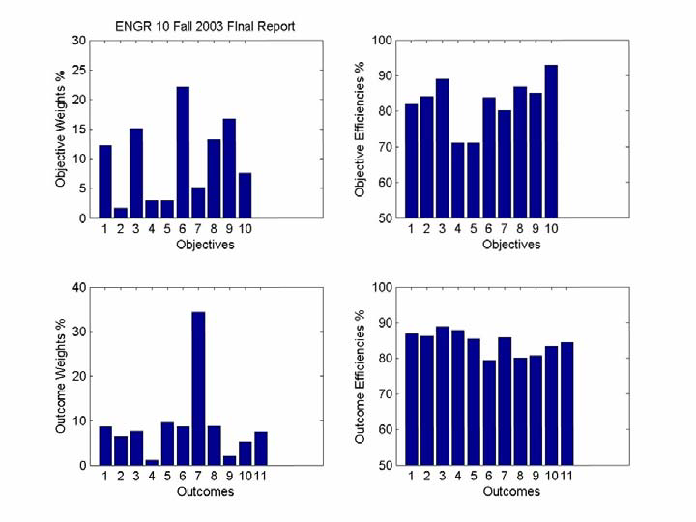

Figure 27. Example of assessment results for ME 10, Statics.

In summary, the assessment process results in:

1. Relative weights assigned to outcomes by each course in the ME program.

2. Grade based measures of degree of achievement of course objectives and outcomes.

3. Survey based measures of degree of achievement of course objectives and outcomes.

4. Comments from students on course deficiencies and possible improvements in course.

This information is used by faculty members to improve the course. Faculty members also rely on formal teaching evaluations conducted by the University.

To ensure that the information generated by the assessment procedures is used to modify courses to achieve program objectives and outcomes, faculty members are asked to make specific suggestions, which are included in the course file. The faculty member who teaches the course the next time is then asked to respond to these suggestions in writing, and relate improvements to these suggestions if possible.

Because every course results in relative weights and achievement scores for the same set of program outcomes, the course statistics can be combined to provide a composite picture of the entire program, which can be then related to the ME program objectives. Figure 28 shows the outcome weights resulting from educational activities in the courses taught during 2003-2004. There is a similar table for outcome efficiencies, which can be combined with the table of weights (Figure 28) to produce outcome weights and outcome efficiencies for the program as a whole.

course that emphasizes the application of science and mathematics to engineering problems. Other foundational courses, such as ME 115A, B and ME 116A, B, offered in the junior year also focus on applications of mathematics and basic science.

Outcome 2: An ability to design and conduct experiments, as well as analyze and interpret data

ME 118 (called ENGR 118 in 2003-2004) teaches methods to formulate empirical and

mechanistic models to explain data. This includes the application of statistics to the analysis of data. Students also become comfortable with using MATLAB, which is ideally suited for data analysis and interpretation. ME 170A provides the fundamentals of experimental techniques used in engineering. ME 170B requires students to design and conduct experiments to achieve stated goals. It also combines experiments drawn from both the thermal and the mechanical sciences to ensure that students appreciate the need to integrate their knowledge in solving engineering problems. It is offered in the senior year after the students have a thorough grounding in the topics required to design the experiments. Outcome 2 has a weight of about

7.7% in the overall ME program for 2003-04.

Outcome 3: An ability to design a system, component, or process to meet desired needs within realistic constraints such as economic, environmental, social, political, ethical, health and safety and health, manufacturability, and sustainability

This is a relatively important outcome which was assigned a weight of 8.3% in 2003-04 in the

ME program. Design is emphasized in most courses including those offered in the junior year. In these classes, students work in teams to design a system or component to meet specifications, write a report, and make an oral presentation. For example, in ME 118, students worked in groups of three to design the major features of a hybrid automobile to meet specified performance characteristics such as gas mileage and time to reach 60 mph. The capstone design courses, ME 175A, B, and C, and the laboratory courses ME 170A and ME 170B pay special attention to ethical, health and safety concerns in design. Courses such as ME 117 and ME 136 stress environmental concerns. ME 175 A, B, C also requires consideration of economics and manufacturability, and sustainability issues.

Outcome 4: An ability to function on multidisciplinary teams

Although design teams in classes consist almost exclusively of mechanical engineering students,

students are expected to work in areas that cross disciplines. For example, in ME 133, students in a team specialize in electronics to design an electro-mechanical system. Students in ME 170A work in teams to prepare technical memos and technical reports, while understanding the basics of data acquisition, using electronic equipment, and data analysis. The scope of the projects included in the capstone course, ME 175ABC, requires students to learn and apply knowledge outside traditional mechanical engineering. For example, students are currently designing a wastewater treatment system, which requires them to understand bacterial degradation of waste. The ME program has assigned a relative weight of 5.8% to this outcome.

Outcome 5: An ability to identify, formulate, and solve engineering problems

This important outcome, with a relative weight of close to 15.3%, is emphasized in the majority

of the courses in the ME curriculum.

Outcome 6: An understanding of professional and ethical responsibility

The introductory courses in mechanical engineering, such as ENGR 10 (replaced by ME 1A, 1B,

and 1C) deal with professional and ethical responsibility in all activities related to being a student as well as a practicing engineer. ME 175A, the first in the senior design course series, has several lectures devoted to ethics and professional responsibility. A discussion on ethics and responsibilities is covered in several classes, ex: in ME 115A. In 2003-2004, the ME curriculum dealt with this outcome in 2.6% of the course content.

Outcome 7: An ability to communicate effectively

Students are required to write design reports and make oral presentations in several courses. The

capstone design course, ME 175ABC, emphasizes this outcome. The relative weight assigned to this outcome was 7.3% in 2003-04.

Outcome 8: The broad education necessary to understand the impact of engineering solutions in a global, economic, environmental, and societal context

Lectures and discussions in ENGR 10 (now in ME 1A) and ME 175A deal explicitly with this

outcome. Several technical electives deal with this outcome. ME 136, an elective on the environmental impact of energy production, emphasizes the need to understand the impact of engineering on society. In ME 117, the societal and economic impact of prescribed burning as a tool to manage forest fuels is discussed. In ME138, students learn to identify cutting-edge research in the field of transport phenomena in living systems, and to present that orally. A general knowledge of the contemporary applications of optics and lasers is presented in ME 180. ME156 introduces students to fundamental concepts of macro- and nano-scale mechanical testing of a variety of engineering materials. The relative weight of this outcome in the curriculum was 5.5% in 2003-04.

Outcome 9: Recognition of the need for and an ability to engage in lifelong learning

Most courses assign problems and design projects that require research and understanding of

material not included in the syllabi. This is likely to promote the need to engage in lifelong learning. The relative weight of this outcome in the curriculum during 2003-04 was 5.3%.

Outcome 10: Knowledge of contemporary issues

Several courses assign problems and design projects that require students to be aware of

contemporary issues. For example, students in ME 136, were asked to write a short paper on global climate change. In ME 117, students are asked to write a position paper on a hydrogen based economy. In ME 118 (formerly ENGR 118), the design project involved hybrid automobiles, which have become popular with the rise in oil prices. In ME156, students learn about failure process in materials and its relevance to materials for integrated circuits and microelectro mechanical systems (MEMS). The relative weight of this outcome in the curriculum was 5.3%. Most senior design projects are sponsored by industry giving students an opportunity to be engaged in contemporary technological and other issues.

Outcome 11: Ability to use the techniques, skills, and modern engineering tools necessary for engineering practice

This important outcome, with a relative weight was 13.9% in 2003-2004, is emphasized in all

courses. Modern engineering requires an appreciation of modeling, software tools, and experimental techniques. Freshmen are introduced to CAD software (Solid Works) in ME 1B.

ME 1C provides skills in Excel and MATLAB. ME 9 introduces students to engineering design through Solid Works. ME 18 and ME 118 provides instruction on modeling using MATLAB. ME 170A and ME 170B provide thorough grounding in modern experimental techniques and experimental design, and enables student to master a state-of the art data acquisition software LABVIEW. The knowledge and skills acquired in these classes are integrated in the senior design project conducted in the ME 175 series.

Figure 29 shows the distribution of the weights assigned to the outcomes and the performance in achieving them as measured by student grades. The right panels of the figure show the changes in these two statistics between 2003-2004 and 2004-2005.

We see that the outcome weights for the overall ME program changed by less than 2% between

2004 and 2005. The performance, as measured by student grades, increased by an average of 4 points over this time period, which indicates that faculty members became more aware of the need to tailor problems to objectives. The next section discusses the evaluation of the assessment of outcomes, and the changes made in response.

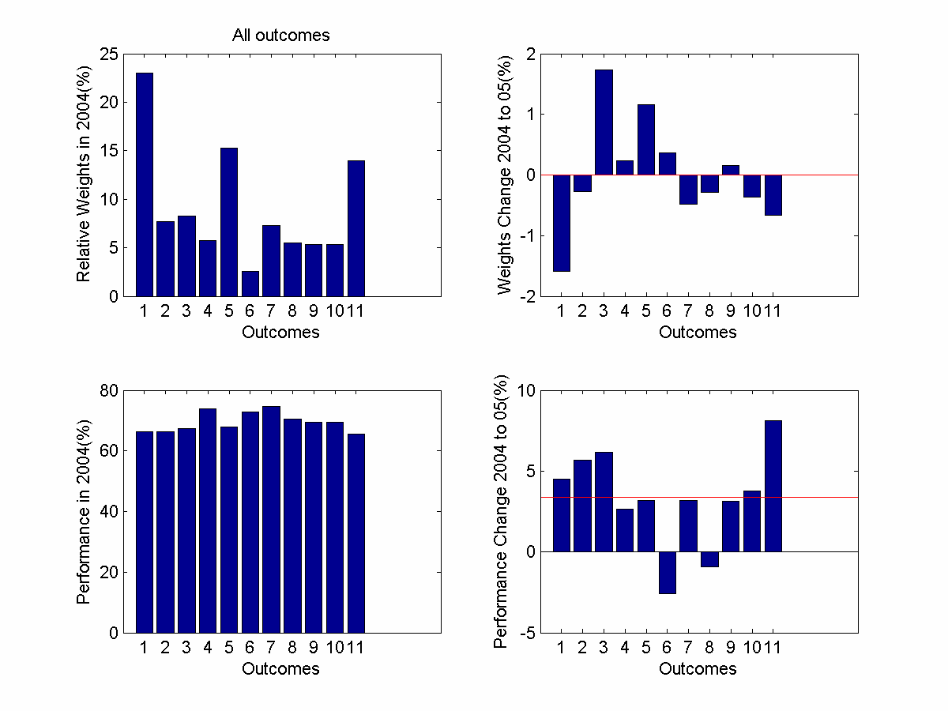

Figure 29. Left panels show distribution of outcome weights and performance in 2003-2004 as a function of outcomes shown on the x-axis Right panels show the changes that occurred in 2004-2005.

The changes in course statistics between 2003 and 2004 stratified according to the importance of outcomes in courses are illustrated in Figure 30. The bar heights in the left panels correspond to averages over the top 10 courses where the courses have been ranked by the weights they have assigned to the outcomes. For example, the relative weight of 40% for outcome 1 has been obtained by averaging over the 10 courses with the highest weights for outcome 1. These courses emphasize outcome 1 more than the others do. Note that in 2004-05, the weight of outcome 1, which focuses on the purely technical aspects of engineering, has been reduced. The weights attributed to the non-technical outcomes, 7, 8, and 9, have increased between 2004 and 2005. In general, the performance of all outcomes, except 8, increases between 2004 and 2005.

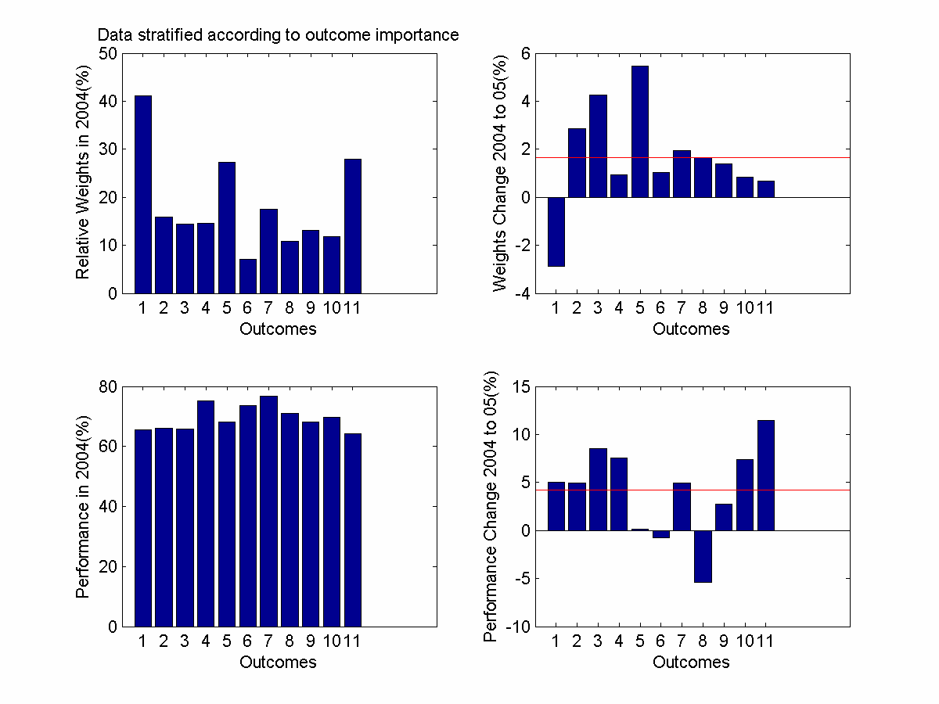

Figure 30. Distribution of weights and performance stratified according to the importance given to outcome. See text for explanation.

The evaluation of the senior exit surveys, discussed in Section B.2.6, indicated the need to improve the ME program in the following areas:

1. Ability to design and conduct experiments as well as to analyze and interpret data. Note that even in this area, the students rated UCR between 5.17 and 5.58 (in 2004) which

differ from the means of the comparison group by less than one half of the standard deviation of the population: There is no statistical difference between UCR scores and those of the comparison group.

2. Mathematical skills.

3. Ability to function in multidisciplinary groups.

4. Communication in written reports. Here the UCR scores are not statistically different from the comparison group.

Scores for outcomes 1 to 5 generally improved between 2004 and 2005. However, it is clear that the curriculum needs to give more attention to the non-technical aspects of the education as embodied in outcomes 6 to 10. In response, ME 175A has been revised to focus on ethics and professional responsibility.

B.3.5 Other Outcome Analysis Mechanisms

The College and the campus also perform assessments to evaluate student expectations and performance. At the campus level, the most significant assessment tool is the UC Undergraduate Experience Survey, or UCUES. This is a uniform questionnaire, which is administered at all UC campuses. Each campus also is able to add its own questions. The questionnaire is administered every two years, although there is some discussion of converting to an annual format. While UCUES does not enable us to compare our student responses directly with those of non-UC campuses, it does provide a basis for comparison with all of the other UCs with undergraduate programs (note that UC San Francisco has no undergraduate programs).

UCR also conducts an annual senior survey. This survey is not particularly valuable for assessing engineering outcomes because of its breadth.

The campus has developed a single relational database (200 fields) to answer queries on student performance and trends, with longitudinal information. There is tiered access to different levels of detail; this protects the privacy of the students for whom data are gathered. As the database is

populated with new information, it should be a valuable resource for providing information on the performance of engineering students in non-engineering courses and for evaluating their overall experiences.

The Bourns College of Engineering will begin to administer a new assessment tool in the fall of 2006. All incoming freshmen will receive a questionnaire designed to explore their expectations. In the fall, a second questionnaire will examine how well the actual experience matched the expectations.

1. **Additional Information**

Copies of any of the assessment instruments or materials referenced in 4.A, 4.B, or 4.C must be available for review at the time of the visit. Other information such as minutes from meetings where the assessment results were evaluated and where recommendations for action were made could also be included.

Exit surveys

**EBI alumni survey**

The college of engineering surveys the students immediately after graduation. After graduation or sometime during the senior year?). Below here are summarized the students answers that are relative to the educational outcomes for the MS&E Program. The scale 1-7 corresponds to 1 = ‘Not at all’ to 7 = “Extremely’.

NEED TO GET SURVEY RESULTS>

**Alumni surveys**

LORENZO WILL BW CONDUTING ALUMIN SURVEYS

.

# CRITERION 5. CURRICULUM

### Program Curriculum

#### Complete Table 5-1 that describes the plan of study for students in this program including information on course offerings in the required curriculum in the form of a recommended schedule by year and term along with maximum section enrollments for all courses in the program over the two years immediately preceding the visit. If there is more than one curricular path, Table 5-1 should be provided for each path. State whether you are on quarters or semesters and complete a separate table for each option in the program.

#### Describe how the curriculum aligns with the program educational objectives.

The Materials Science and Engineering Program Objectives presented earlier are broadly met through a curriculum that offers:

* A well-rounded and balanced education achieved through required studies in selected areas of the Humanities and Social Sciences.
* Strong training in the areas of mathematics, science, and the fundamentals of mechanical engineering that constitute the foundation of the discipline.
* Laboratory and hands-on experience to strengthen understanding of fundamental principles, with opportunities for team work, written, and oral communication.
* Extensive use of computer simulation and modeling in the solution of problems and in design.
* Application of knowledge to design problems common to modern mechanical engineering practice.
* Introduction of design for manufacturability, engineering economics, and engineering ethics into the curriculum to emphasize the relationship between design, fabrication, cost, and impact on society.
* Freedom for the student to mold his or her program of professional specialty studies by allowing each student to choose from a number of technical electives, including credit for independent research, and offering a selection of senior design capstone projects sponsored by faculty and industrial sponsors.

The relationship between each educational program objective and the curriculum is discussed in some detail below.

EDUCATIONAL OBJECTIVE RELATIONSHIPs NEED TO BE WORKED OUT

**Educational Objective 1:** To produce mechanical engineers who have the knowledge and skills to adapt to the changing engineering environment in industry

**Educational Objective 2:** To produce graduates who are able to pursue and succeed in graduate studies

The technical rigor required to pursue advanced graduate degrees in mechanical engineering and other allied fields is emphasized in our basic curriculum. Students are exposed to basic mathematical tools including applied linear algebra, solution of ordinary, and partial differential equations relevant to mechanical engineering science, thereby preparing them for advanced degrees in engineering and other technical disciplines. In addition, the curriculum allows students the explicit option to experience research under faculty supervision as a technical elective. Faculty are available to advise students about career options that include opportunities for advanced study through graduate education. Senior students with a GPA of 3.0 and above (this is the minimum required for admission to most U.S. graduate programs) are invited to an annual presentation by the Graduate Advisor to discuss graduate research opportunities.

**Educational Objective 3:** To produce graduates who have the educational breadth and the intellectual discipline required to enter professional careers outside engineering, such as business and law

Science and engineering courses discussed in the context of Educational Objective 1 provides students with disciplinary intellectual rigor required to succeed in industry or in their pursuit of advanced degrees. The ability to formulate problems, make and test assumptions, predict and solve problems enable students to branch out in to other professional areas such as business and law. In addition, the College has breadth requirements that include English composition, Humanities, Social Sciences, and Ethnicity. Thus the overall set of skills acquired, enable graduates to make contributions to society in a multitude of fields.

**Educational Objective 4:** To produce grauduates who have an ability to work in multi-disciplinary teams.

**Educational Objective 5:** To produce graduates who engage in a lifetime of learning

Most courses assign problems and design projects that require research and understanding of material not included in the syllabus. The program’s emphasis on design provides a natural avenue that promotes intellectual curiosity. All technical elective classes expose students to state of the knowledge in those areas highlighting open questions, unsolved problems, etc. This is likely to promote the need to engage in lifelong learning.

#### Describe how the curriculum and its associated prerequisite structure support the attainment of the student outcomes.

1. Attach a flowchart or worksheet that illustrates the prerequisite structure of the program’s required courses.

ADD TABLE WITH PRE-RECS (ASK RAVI)

1. Describe how your program meets the requirements in terms of hours and depth of study for each subject area (Math & Basic Sciences, Engineering Topics, and General Education) specifically addressed by either the general criteria or the program criteria.

#### Describe the major design experience that prepares students for engineering practice. Describe how this experience is based upon the knowledge and skills acquired in earlier coursework and incorporates appropriate engineering standards and multiple design constraints.

The program culminates in a major, high-quality capstone design experience, and these senior design projects address real world problems from industry and are excellent examples of teamwork. The scope of the projects included in the capstone course, ME 175ABC, requires students to learn and apply knowledge outside traditional mechanical engineering. For example, students are currently designing a XXXXXX

Capstone senior design classes require extensive faculty contact with groups of students through the course of the quarter. In addition, ME faculty devote substantial time to edit and grade technical reports for senior design and laboratory-intensive courses. Formal design presentations by student teams typically occur over a period of 8 to 10 hours, requiring extensive faculty participation and guidance. In the Department of Mechanical Engineering, graduate student research training and supervision is a teaching activity over and above the activities described above.

#### If your program allows cooperative education to satisfy curricular requirements specifically addressed by either the general or program criteria, describe the academic component of this experience and how it is evaluated by the faculty.

#### Not applicable.

1. Describe the materials (course syllabi, textbooks, sample student work, etc.), that will be available for review during the visit to demonstrate achievement related to this criterion. (See the 2011-2012 APPM Section II.G.6.b.(2) regarding display materials.)

The MS&E department will provide the following materials for review during the visit by the ABET Examiners:

1. Course files, which will include syllabi, textbook, lectures notes, homework assignments, mid-term and final examinations, and examples of student work in homework and examinations. Each file will also include a course matrix, and summary of student performance in achieving objectives and outcomes.

2. Files organized in terms of outcomes. These files will include course material relevant to each outcome, assessment of student performance and survey responses, and descriptions of modifications in courses to improve performance in achieving outcomes.

3. Minutes of meetings and discussions held by faculty and stakeholder groups to formulate course objectives and modify program in response to assessment process.

4. Survey forms used to measure attainment of course objectives and outcomes.

5. Alumni and employer survey questionnaires and results.

6. Laboratory manuals describing experimental procedures.

7. Health and safety manuals used in laboratories.

8. Equipment lists.

9. University evaluations of teaching by faculty members.

### Course Syllabi

In Appendix A, a syllabus for each course used to satisfy the mathematics, science, and discipline-specific requirements required by Criterion 5 or any applicable program criteria is included.

Table 5-1 Curriculum

Program Name

|  |  |  |  |  |  |  |  |  |  |  |  |  |
| --- | --- | --- | --- | --- | --- | --- | --- | --- | --- | --- | --- | --- |
| Course  (Department, Number, Title)  List all courses in the program by term starting with first term of first year and ending with the last term of the final year. | | | Indicate Whether Course is Required, Elective or a Selected Elective by an R, an E or an SE.1 | | *Subject Area (Credit Hours)* | | | | | | Last Two Terms the Course was Offered:  Year and,  Semester, or  Quarter | Maximum Section Enrollment  for the Last Two Terms the Course was Offered2 |
| Math & Basic Sciences | | Engineering Topics  Check if Contains Significant Design (√) | | General Education | Other |
|  | | |  | |  | |  | |  |  |  |  |
|  | | |  | |  | |  | |  |  |  |  |
|  | | |  | |  | |  | |  |  |  |  |
|  | | |  | |  | |  | |  |  |  |  |
| *Add rows as needed to show all courses in the curriculum.* | | | | | | | | | |  |  |  |
| TOTALS-ABET BASIC-LEVEL REQUIREMENTS | | | |  | |  | |  | |  |  |  |
| OVERALL TOTAL CREDIT HOURS FOR COMPLETION OF THE PROGRAM | |  | |  | |  | |  | |  |  |  |
| PERCENT OF TOTAL | | | |  | |  | |  | |  |  |  |
| Total must satisfy either credit hours or percentage | Minimum Semester Credit Hours | | | 32 Hours | | 48 Hours | |  | |  |  |  |
| Minimum Percentage | | | 25% | | 37.5 % | |  | |  |  |  |

1. **Required** courses are required of all students in the program, **elective** courses (often referred to as open or free electives) are optional for students, and **selected elective** courses are those for which students must take one or more courses from a specified group.
2. For courses that include multiple elements (lecture, laboratory, recitation, etc.), indicate the maximum enrollment in each element. For selected elective courses, indicate the maximum enrollment for each option.

Instructional materials and student work verifying compliance with ABET criteria for the categories indicated above will be required during the campus visit.

# CRITERION 6. FACULTY: MSE CORE Faculty

1. **Faculty Qualifications**

**The MSE**

**Program Committee**

Javier E. Garay, Chair, PhD., (Mechanical Engineering)

Alexander A. Balandin, Ph.D., (Electrical

Engineering)

Mart Molle, Ph.D. (Computer Science and

Engineering)

Nosang Myung, Ph.D. (Chemical and Environ -

mental Engineering)

Cengiz Ozkan, Ph.D. (Mechanical Engineering)

Valentine Vullev, Ph.D. (Bioengineering)

Faculty members have resources from initial complements, “various donors” funds, and contract and grant awards to travel to meetings and conferences in their disciplinary areas or in engineering education. Some additional funds are available from the College, the campus, and the Faculty Senate. These resources are sufficient to assure that professors are able to maintain currency in their fields.

1. **Faculty Workload**

Complete Table 6-2, Faculty Workload Summary, and describe this information in terms of workload expectations or requirements.

1. **Faculty Size**
2. **Professional Development** Describe the professional development activities that are available to faculty members.

sabbaticals, travel, workshops, seminars etc. ?

1. **Authority and Responsibility of Faculty**

Table 6-1. Faculty Qualifications

**NEED TO ADD NON ME ATBLE REFLECTING CORE FACULTY IN MSE**

Mechanical Engineering

|  |  |  |  |  |  |  |  |  |  |  |  |
| --- | --- | --- | --- | --- | --- | --- | --- | --- | --- | --- | --- |
| Faculty Name | Highest Degree Earned- Field and Year | Rank 1 | Type of Academic Appointment2  T, TT, NTT | FT or PT3 | Years of Experience | | | Professional Registration/ Certification | Level of Activity4  H, M, or L | | |
| Govt./Ind. Practice | Teaching | This Institution | Professional Organizations | Professional Development | Consulting/summer work in industry |
| Cengiz S. Ozkan | PhD, Materials Science and Engineering, 1997 | P | T | FT | 5 | 27 | 11 | None | H | H | L |
| Javier E. Garay | PhD. MSE (2004) | ASC | T | FT |  | 8 | 8 | None | L | L | L |
| Lorenzo Mangolini | Ph.D. Mechanical Engineering, 2007 | AST | TT | FT | 3 | 2 | 2 | None | L | M | L |
| Masaru P. Rao | PhD | AST | TT | FT | 1 | 5 | 3 | None | L | L | L |

Instructions: Complete table for each member of the faculty in the program. Add additional rows or use additional sheets if necessary. Updated information is to be provided at the time of the visit.

1. Code: P = Professor ASC = Associate Professor AST = Assistant Professor I = Instructor A = Adjunct O = Other

2. Code: T = Tenured TT = Tenure Track NTT = Non Tenure Track

3. Code: FT = Full-time PT = Part-time Appointment at the institution.

4. The level of activity (high, medium or low) should reflect an average over the year prior to the visit plus the two previous years.

Table 6-2. Faculty Workload Summary

Name of Program

|  |  |  |  |  |  |  |
| --- | --- | --- | --- | --- | --- | --- |
| Faculty Member (name) | PT or FT1 | Classes Taught (Course No./Credit Hrs.)  Term and Year2 | Program Activity Distribution3 | | | % of Time Devoted  to the Program5 |
| Teaching | Research or Scholarship | Other4 |
|  |  |  |  |  |  |  |
|  |  |  |  |  |  |  |
|  |  |  |  |  |  |  |
|  |  |  |  |  |  |  |
|  |  |  |  |  |  |  |
|  |  |  |  |  |  |  |
|  |  |  |  |  |  |  |
|  |  |  |  |  |  |  |
|  |  |  |  |  |  |  |
|  |  |  |  |  |  |  |
|  |  |  |  |  |  |  |

1. FT = Full Time Faculty or PT = Part Time Faculty, at the institution
2. For the academic year for which the self-study is being prepared.
3. Program activity distribution should be in percent of effort in the program and should total 100%.
4. Indicate sabbatical leave, etc., under "Other."
5. Out of the total time employed at the institution.

# CRITERION 7. FACILITIES

**A.** **Offices, Classrooms and Laboratories**

Summarize each of the program’s facilities in terms of their ability to support the attainment of the program educational objectives and student outcomes and to provide an atmosphere conducive to learning.

1. Offices **(**such asadministrative,faculty, clerical, and teaching assistants) and any associated equipment that is typically available there.

2. Classrooms and associated equipment that is typically available where the program courses are taught.

Instructional classrooms are provided by the University and the College of Engineering and centrally administered by the campus. Typically, a tentative list of course offerings is prepared in the spring quarter for the following academic year. This list is developed by the Chair of the department of Mechanical Engineering with input from Chairs of the departmental Undergraduate and Graduate Program Committees, and in coordination with program advisors in the College Student Affairs Office. Multiple-quarter offerings of key courses are decided upon at this stage, based on previous year’s demand and projections for the upcoming academic year. In addition, number of discussion section offerings for each course is determined. Most classrooms offered by the campus and the college are media-equipped, facilitating computer and Internet access for the classroom instructor.

1. Laboratory facilities including those containing computers (describe available hardware and software) and the associated tools and equipment that support instruction. Include those facilities used by students in the program even if they are not dedicated to the program, and state the times they are available to students. Complete Appendix C containing a listing the major pieces of equipment used by the program in support of instruction.

A 1733 sq ft laboratory (B213AA) used mostly for instruction associated with ME 170A. It houses 10 computing stations that include computers equipped with LABVIEW software for data acquisition and analysis, generators, DC power supplies, digital multimeters and oscilloscopes for signal generation, measurement, acquisition, analysis and display. The lab also houses the following additional equipment for performing basic instrumentation, data conversion, filtering, amplification and typical mechanical engineering measurements such as temperature, pressure, strain and vibration including strain gauges, strain gauge beams and holders, accelerometers, model 355 flow meter, gas regulator, high-pressure gas supplies, pressure gauges, thermocouples, thermistors, infrared thermometer, pressure transducers, water baths, blowers, air speed indicator, stirring hotplates, resistance decade box, Mettler Toledo AB104 analytical balance, Mettler Toledo AB104 topload balance, and 110V transformer, various resistors, capacitors and operational amplifiers.

In addition to equipment for data acquisition, B213AA houses a Mechatronics laboratory used mostly for instruction associated with technical elective ME133. The equipment includes:

1. GE-FANUC 23 point Programmable Logic Controllers (IC200UAL006 PLC), 10 each.

2. GE-FANUC Proficy Logic Developer software, 10 each.

3. PLC Nano/Micro/Programming Cable for interface between PLC and PC.

4. Many 18 DIP Microcontrollers (PIC16F84).

5. Micro Engineering Lab USB programmer with accessories (2 copies).

6. Micro Engineering Lab PIC Basic Pro compiler (2 copies).

7. Micro Engineering Lab integrated development environment (IDE) windows software.

8. Many electronics components (micro switches, 4 MHz microprocessor crystals, LED, Transistors, Power Transistors, Logic components (AND, OR, NAND, NOR), Motorola LS7084 chip for optical encoder interface, and operational amplifiers).

9. 10 each NI data acquisition board NI DAQ PCI-6221.

10. 10 each robotics experiments (each includes 5 arms, 2 DC motors, 2 optical encoders, and 2 power amplifier).

11. 10 each pneumatic experiments (each includes 1 linear potentiometer, 1 optical encoder, 1 pneumatic actuator, and power amplifier).

A 977 square foot laboratory (B164) used primarily for instruction associated with ME 170B. Major equipment includes:

1. 4 personal computers for data analysis.

2. A small wind tunnel.

3. Thermal radiation apparatus consisting of black aluminum plate with thermocouples, anodized steel and aluminum plates with thermocouples, polished steel and aluminum plates with thermocouples, freestanding thermocouple, Linear Laboratories C-1700

Radiometer, thermocouple temperature readout, Vernier calipers, power supply unit, anemometer, hand held thermometer.

4. Instron Universal testing machine supplied with computer, Vernier calipers, sample specimens of aluminum, plain carbon steel, stainless steel, and nylon.

5. Rope testing apparatus consisting of static rope, dynamic rope, support rope and pulley arrangements, weights for calibration, strain gage with computer, DBK-43 strain gage card, and ruler.

6. Accelerometer and accelerometer tilt table supplemented with power supply unit, cantilever beam with strain gages mounted, weights, spring, Vernier calipers, digital millimeter, meter stick, balance, stand, computer with DBK-12 multiplexer card and DBK-43 strain gage card, three-option expansion card cable, beaker, trough, and washers of 1¼’’, 2’’ and 2½’’ diameter.

7. Hot-ball anemometer consisting of brass and aluminum spheres with K-type thermocouples attached, chromel-alumel thermocouple, thermocouple card (DBK-19). Supplemental equipment includes alcohol-in-glass thermometer, stirrer, beakers, heater, blower, ring stand and clamp for suspending thermocouple, hand held anemometer, thermocouple extension wire, and digital voltmeter.

8. (8) 3-point and 4-point configuration attachments for bending testing, in-house built apparatus for undamped and damped vibration testing, an in-house built apparatus for dynamical tensile testing.

9. A photoelasticity system for characterizing stress concentrations in engineering structures via polarization modulation.

Available teaching equipment for ME 180 includes one set of photoelastic polariscope, one 2- mW He-Ne laser, 2 linear polarizers, 2 quarter wave plates, one integrating sphere, and 8 pairs of safety goggles. These are located in the Nano Mechanics and Materials Laboratory (see Section B.6.6).

A 1022 sq ft teaching lab (B162) shared with the department of Chemical and Environmental

Engineering department. Relevant equipment utilized for instruction in ME170B includes:

1. Armfield Multi-Pump test rig model C3-00 supplemented hook and point gauge, thermocouple, and stopwatch

2. Armfield fluid friction apparatus, model C6, supplemented with thermocouple, stopwatch, Vernier caliper, sudden contraction, sudden expansion, ball valve (fully open), globe valve (fully open), gate valve (fully open, ½ open), Venturimeter, 90 degree elbow, smooth pipe

17.5 mm diameter, and rough pipe 17.5 mm diameter.

Design Studio

In 2005, the program acquired a 2665 sq ft space (B265) for design studio. It provides space for assembly, preparation of posters, and discussions. In addition, the studio is used for instruction in ME 1A.

Research Laboratories

In addition to several computing laboratories supervised by faculty, the department has several major experimental research laboratories. These include:

(a) Laboratory of Transport Phenomena for Biomedical Applications

(b) Laboratory for Advanced Materials Processing and Synthesis

(c) Biomaterials and Nanotechnolgy Laboratory

(d) Laboratory for Environmental Flow Modeling (e) Smart Tools Laboratory

(f) Nano Mechanics and Materials Laboratory

Although these laboratories are used by faculty and graduate students for their research, program students have access to these laboratories for carrying out directed research and earning technical elective credit (ME190).

**B. Computing Resources**

Information technology support, services and facilities are available from several sources for use by the programs of The Marlan and Rosemary Bourns College of Engineering and its students, faculty, and staff:

1. Campus-wide support, services, and facilities are provided by Computing and Communications (C&C) and managed by full-time professional staff.
2. The College, through its programs of Chemical/Environmental Engineering, Computer Science and Engineering, Electrical Engineering, and Mechanical Engineering, and its Research units also provide a variety of technical services and support.

Details of these support, services, and facilities are as follows:

**C&C Overview**

* ***Support Services***
* ***Facilities and Infrastructure***
* ***Other Services and Support***

C&C (which includes the Instructional Technology Group, Computing Infrastructure and Security, the Computer Support Group, and Communications) is under the direction of the Associate Vice Chancellor and CIO who reports to the Provost. The Instructional Technology Group, Computer Support Group, and Communications sub-units have primary responsibility for providing network access and general computing services to the UC Riverside campus.

**Support Services**

* **Instructional Technology Support**

C&C’s Instructional Technology Group offers faculty and students technical and pedagogical support that is academic discipline specific. The Instructional Technology Group emphasize a "hands-on" approach to its services including Blackboard (learning management system) training and support and the management and support of campus site-licensed software.

* **Classroom Technology Support**

C&C provides classroom technology support, services, and infrastructure services (e.g. connection to the wireless network, projection systems, etc.). UCR’s best-of-breed technology-enabled classrooms include the following:

* The capability to present materials from a wide variety of sources, including (at a minimum) DVD, document camera, a personal computer, laptop computer, and Internet.
* Chalkboard or whiteboard that is available and viewable at the same time digital or analog presentations are underway.
* Combination of high-powered data projectors and/or lighting zone controls that allow students to take notes and view presentation material at the same time.
* “Self-service” design which allows instruction to occur without the aid of technical operators and without the delivery of equipment.
* Based on the academic discipline, sound systems and data projection resolution requirements may drive certain classroom minimum standards.

UCR has implemented “clicker” technology in all its classrooms. In actual use on this campus clicker technology has been shown to:

* Increase attendance (sometimes dramatically)
* Coax participation from normally non-participative students
* Create a more engaging lecture environment

Additionally, all UCR classrooms are equipped with podcasting capabilities. This can be in the form of audio podcasting or lecture capture as supported by Echo360 course capture technology. Students in these classrooms will have on-demand access to archived educational content as presented during lecture, including a video camera feed and classroom audio.

* **General Technology Support**

C&C provides UCR faculty and students with technology to assist them in their instructional and academic pursuits. Services like e-mail, iLearn (Blackboard Learning Management System) and the wireless network ensure that all of UCR faculty and students stay connected with their colleagues, peers and the rest of the world. The Computer Support Group provides desktop computing support for faculty and staff. Services include consulting on hardware, software and networking, plus assistance with acquiring, learning and using stand-alone or networked microcomputers (Windows, Macintosh, Linux, and UNIX platforms). Services offered include telephone support, on-site and carry-in services, on-line remote support, a knowledgebase and software downloads. C&C also implemented and spearhead the Microcomputer Support Specialist (MSS) program, which provides decentralized departmental support.

* **Multimedia Development and Research Visualization Support**

This group provides innovative and creative full service web and graphic design for the UCR campus and community. With fully integrated, back-end programming solutions tailored to each client's specific needs, the group supports university's efforts to secure extramural funds and the campus’ various outreach efforts.

**Facilities and Infrastructure**

* **Computer Labs**

Student Computing Services maintains four public computer labs featuring approximately 149 computers available for academic use by all UCR students, with open hours of approximately 160 hours per week. Faculty instructing a course may reserve the public computing facilities for instructional use or request to have software installed on the machines. Lab assistance and software checkout is available in the labs. C&C provides research software (SAS, SPSS, Mathematica) in most public computer labs.

* **Classrooms and Learning Spaces**

The Multimedia Technologies Group maintains all of UCR's general assignment classrooms that have been equipped with data/video projectors, document cameras, DVD players, PC computer on the network, computer interface for laptop users and network connections. Lecture halls are also equipped with wireless microphones and multiple (two to three) projection systems. Their commitment to instructional technology has led the design and implementation of "smarter" classrooms, such as the Flex Rooms and the Hyperstruction Studio. These rooms feature mobile furniture, whiteboards on every wall, and multiple projection systems.

All general assignment classrooms are equipped with a multimedia controller maintained by C&Cs Multimedia Technologies Group for operation the various presentation technologies and audio equipment. Internet connectivity is via a robust wired and wireless network. Each controller has a “Help” button for the instructor to alert technicians if there is a problem with the equipment.

A help desk is staffed full time, and at least one field technician is available on campus during instructional hours. Either the help desk (working remotely) or the field technician (in the classroom) can quickly resolve any problem that occurs. In a survey (most recently conducted in 2011), 90% of instructors responded that UCR’s available classroom technology either "Completely" or "Mostly" met their pedagogical needs.

* **Research Technology**

As part of UCR’s Cyberinfrastructure (CI) strategy, C&C supports three computational cluster support models. These include departmentally maintained clusters, dedicated clusters, and a shared collaborative cluster. Three programs are described as follows:

1. A centrally managed, standardized/dedicated cluster of processors, in which researchers pay an annual fee for essentially unlimited use.
2. A collaborative computational cluster, in which each PI can buy a certain amount of hardware, which Computing and Communications will manage. The PI has priority access to the equipment that he or she acquired, plus access to the entire cluster as available. UCR’s collaborative cluster provides a shared system as a computing resource for campus researchers with limited financial resources.
3. Departmentally maintained clusters, centrally managed. This type of cluster is meant for researchers who have computing needs that fall outside of the campus cluster standards. These systems are built to particular PI/lab/center specifications and managed by PI funded staff, but housed within C&C’s data center with C&C

C&C also provides other research technology support, ranging from network creation / configuration, colocation support, budget preparation / equipment configuration, and cloud services provisioning.

* **Wired and Wireless Networks**

UCR supports 1,200+ wireless access points that provide wireless connectivity to approximately 8,000 concurrent users daily. Additionally, the campus network backbone consists of 10 GB fiber-optic connections, with a minimum of 1 GB capacity to each building on campus. The campus has more than 500,000 feet of air blown fiber conduit, which enables the addition of fiber connectivity essentially “on demand”.

**Other Services and Support**

* **Libraries**
  + The UCR Libraries have over 400 public computers among the four campus libraries with selected information resources and software to support and enhance student learning and the research and scholarship activities of the University. Specialized software has been installed on the Learning Commons Computers located in Rivera Library 1st Floor, Rivera Basement, Rivera 2nd Floor, Rivera 3rd Floor, and Science Library 1st Floor. 20 wireless laptops/netbooks are available in Rivera and Science Libraries to faculty, students and staff.
* **CENIC Regional Higher Education Network**

C&C provides support and maintenance of off-campus network access via connections to the CENIC regional higher education network. All Bourns College of Engineering computing facilities and faculty have high-speed access to CENIC members (e.g. other UC campuses, private research universities in California, the California State University System, etc.) and to Internet2 via C&C support of the CENIC network.

Two computing laboratories are dedicated to program students. Room B207 located in Bourns Hall is a 1671 square feet facility that includes 40 networked computers and a networked printer. Room B238 is a 2038 sq ft facility that was acquired in 2006 to keep pace with growth in the program enrollment. It houses 30 additional computers and a networked printer. B238 is open

24/7 for all ME students. Courses that require computer use during class time are scheduled in B207. At all other times, the lab is open to all ME students. The computers run Windows and have most recent versions of MATLAB, SOLIDWORKS, MS-OFFICE, VISUAL STUDIOS, AUTOCAD and other various engineering applications. Each lab is also equipped with LANSCHOOL – a software program that enables monitoring of all computers with an ability to broadcast material from the instructor’s computer. This facilitates class room instruction and is conducive to effective learning of software tools.

**C. Guidance**

Describe how students in the program are provided appropriate guidance regarding the use of the tools, equipment, computing resources, and laboratories.

**D. Maintenance and Upgrading of Facilities**

Describe the policies and procedures for maintaining and upgrading the tools, equipment, computing resources, and laboratories used by students and faculty in the program.

Bourns Hall is approximately 21 years old and provides more than 100,000 square feet of office, classroom, and wet laboratory space for the Bourns College of Engineering. Engineering Building II is one year old and has 98,177 assignable square feet of office, classroom, and dry lab space.

The College recently opened the Materials Science Building. This building is designed at 76,940 square feet, including laboratory, office, and classroom space. Laboratory facilities will include a larger clean room nanofabrication facility than the one currently available in the B-wing of Bourns Hall.

Formal plans for Engineering III and Engineering IV are not yet in place.

The Bourns College of Engineering provides one-time equipment funds annually to upgrade and acquire equipment. In addition, the College provides facilities to house and operate the equipment. A brief recent history of funding is provided in the table below:

In 2007-2008 we conducted a major upgrades and repairs for our laboratory classes ME170 A and B and for the Senior Design ME 175 A, B and C.

In 2008-2009 we purchased 45 new computers for ME computer Lab B207 and updated instrumentation for 14 ME170A lab stations.

In 2009-2010 we updated undergraduate labs with the Refrigeration performance apparatus $20,000, Materials science experiments $21,000 and Solidworks license renewal $ 5,000.

In 2010-2011, the College provided $31,254 for the program. Out of this pool, $15,000 was used to purchase a CNC plasma cutter for senior design. This plasma cutter is located in the machine shop. This is an example of equipment that is used for both research and undergraduate student instruction. $3,000 was used for the assignment drop boxes to streamline the submission of projects and homeworks in our large classes. The remaining was used for the software licenses, in class demos, tablet PC and repair of existing laboratory setups.

For 2011-2012 we requested 80K

**E. Library Services**

Library collections that support the Bourns College of Engineering are housed in the Orbach Science Library. The Orbach Science Library has a seating capacity of 1,500 including individual carrels, study tables and **25** group study rooms. The library makes available 79 computer workstations for students to use in their research and study, and another 32 computers to support information literacy instruction. The entire UCR library system provides both wired and wireless access to the internet for student laptop use, and laptops are available for check-out at the Circulation Desk.

Normal library hours during the regular school year are as follows:

Monday-Thursday 7:30am – 11pm

Friday 7:30am to 5:00pm

Saturday Noon to 5:00pm and Sunday 1:00pm to11:00pm.

The Orbach Science Library maintains a professional staff of eight librarians, all of whom provide reference and research assistance to engineering students, faculty, and staff. Of these librarians, one is assigned subject responsibility for engineering and is available to assist students, faculty and staff with in depth research questions. The Engineering Librarian and Subject Specialist also offers tutorials and classes on engineering information topics, and maintains Web pages and path-finders to assist engineering students, faculty, and staff in locating the information they need.

The UCR Libraries offers a full range of reference services, including walk-up, telephone, and 24/7 e-mail reference services (Ask A Librarian) through a UC-wide and national network as well as reference by appointment. The Orbach Science Library reference desk is staffed 52 hours per week during the academic year (9am-8pm. Monday-Thursday, 9am-5pm on Friday) and 40 hours per week during inter-session periods. In addition to these standard services, engineering students can receive additional reference help from other reference librarians who are assigned to the Science Information Services desk. The Engineering Librarian is available for extended consultation on Senior Design or other research projects.

Incoming freshman typically receive library orientation sessions in their introductory classes. They might also have additional information literacy instruction in classes that require independent research, such as senior design classes. One-on-one or group tutorials are available for any research topic that might be desired and helpful to engineering students.

**Library Collections**

Books

Engineering books are acquired as part of the Orbach Science Library’s purchasing profile, ordered from catalogs or suggested by students, faculty, and staff. Within the past three years, the library has initiated the purchase of engineering e-books and currently supports and maintains a collection of thousands of electronic books in the discipline. The Libraries provides licensed access to all of the current Springer books online, many of the e-books from the CRC EngNetBase, the Knovel Collection, the Wiley Online collection and many more.

Recently, through a special competitive initiative, the UCR Libraries has brought to our campus, from its former Berkeley location, the extensive and world class Water Resources and Archives Collection (WRCA) containing many materials relevant to dam and bridge construction which is also available to engineering students and researchers from across UCR and the UC system.

Journals

The Libraries currently subscribe to 121 engineering print journals, and Engineering students have access to a vast collection of online journals (**94,770** unique titles). UCR maintains access, for example, to all of the journals and proceedings of IEEE, OSA, MRS, and ACM, as well as either proceedings or journals from many other societies. Faculty, staff, and students may suggest new books, journals or other media to be purchased by the library. Library users may request materials that are not available on campus through Interlibrary Loans, and the materials will be made available to them at no cost in a very reasonable amount of time.  
  
Research (Journal Article) Databases

UC Riverside engineering students have access to a number of journal databases to assist them in their research in engineering and in other areas of study. Through co-investments with the other eight UC campuses and the California Digital Library (CDL) Inspec, Compendex, and the Web of Science as well as SciFinder Scholar for chemistry and chemical engineering and Biosis or MEDLINE for biotechnological literature are all available to engineering faculty and students. UCR also licenses Water Resources Abstracts locally with the arrival on our campus in 2010 of the Water Resources Archives and Collections.

**LIBRARY COLLECTIONS**

|  |  |  |
| --- | --- | --- |
|  | Books | Periodicals |
| Entire Institutional Library | 2,810,229: (Print Vols.) 404,191: (e-Books)  Total Vols.: 3,214,420 | 6,329 (Active Local Titles) |
| Engineering and Computer Science | 71,757 Print / 29305 online | 168 print / 3976 online |

**LIBRARY EXPENDITURES (See Table Explanations below)**

|  |  |  |  |
| --- | --- | --- | --- |
|  | 2008-2009 | 2009-2010 | 2010-2011 |
| Expenditures for Engineering (Total) | $75,749 | $75,107 | $45,975 |
| Print Books | $13,264 | $11,824 | $9,629 |
| *Local Costs Only for Engineering Periodicals Subscriptions | $47,589 | $47,706 | **$21,163 |
| E-Book Packages (EngNetbase, O’Reilly) | $7,043 | $7,332 | $6,483 |
| ***Research Databases | $15,185 | $14,741 | $15,957 |

* This figure does not include the total amount ($2.4 million ) expended annually by the UCR Libraries as co-investments with other UC campuses and the California Digital Library (CDL) to support access to e-journals, e-books, and electronic databases. The value of the e-journals for

supporting engineering alone is over a million dollars annually.  
 ** This figure reflects a major journal cancellation which included duplicate and low use titles

especially targeting print titles that duplicated e-journal titles. This was a UCR project in

response to budget reductions.

*** Cost for Compendex and Inspec databases. Other databases such as SciFinder, Water

Resources Abstracts, Web of Science support multiple disciplines, in addition to Engineering.

1. **Overall Comments on Facilities**

Describe how the program ensures the facilities, tools, and equipment used in the program are safe for their intended purposes (See the 2012-2013 APPM Section II.G.6.b.(1)).

# CRITERION 8. INSTITUTIONAL SUPPORT

1. **Leadership**

Describe the leadership of the program and discuss its adequacy to ensure the quality and continuity of the program and how the leadership is involved in decisions that affect the program.

The program is supported by full time departmental staff, part-time student assistants, teaching assistants, readers, and graders as needed to support individual courses and program administration. The College provides Student Advisors who interact with program students, monitor academic progress, enable registration, and direct them to appropriate services on campus for tutoring, career counseling, etc. Tutoring service is provided at the Learning Center and in the student dormitories (free for students living on campus). The College has developed a Professional Milestones Program to enable each program student to prepare for internships, job interviews, and research opportunities. The College provides funds to support teaching assistants, graders, and readers, assigned based on course enrollment and need for laboratory supervision. Teaching Assistants conduct discussion sessions in which students are exposed to additional problems and concepts to reinforce material covered in lectures, and to enable students to complete course assignments. All instructors and teaching assistants maintain posted office hours for assisting students outside scheduled classes. The program has a designated Undergraduate Advisor (currently Dr. Princevac) to oversee curricular matters and to offer advice on curricular issues.

### B. Program Budget and Financial Support

1. Describe the process used to establish the program’s budget and provide evidence of continuity of institutional support for the program. Include the sources of financial support including both permanent (recurring) and temporary (one-time) funds.
2. Describe how teaching is supported by the institution in terms of graders, teaching assistants, teaching workshops, etc.
3. To the extent not described above, describe how resources are provided to acquire, maintain and upgrade the infrastructures, facilities and equipment used in the program.
4. Assess the adequacy of the resources described in this section with respect to the students in the program being able to attain the student outcomes.

The University of California, Riverside has a multi-step budget development process. The major steps in the annual process are:

February: Campus Budget Call Letter is distributed and meetings held with academic units to discuss faculty renewal models

March: Comprehensive Planning Documents are submitted to the

Executive Vice Chancellor

April: Individual unit hearings with senior UCR management

May: Input and feedback from Faculty Senate Committee on Planning and Budget to EVC

June: Final unit budgets announced

In response to the February Budget Call Letter, the Dean’s Office in the Bourns College of Engineering requests budget proposals from each academic department in the College. These proposals include undergraduate and graduate student projections, course load information, staffing requirements and needs for additional supply, travel and miscellaneous expenses. Any additional resources requested are presented in the context of departmental Five-Year Plans. In this way, departments demonstrate their progress in attaining Five-Year goals and request the resources required for the next year to maintain that progress. In most cases, departmental current year (Permanent) budgets are the starting points for the next fiscal year’s budgets. UC Permanent Budget resources do not have expiration dates and are used to fund long-term commitments from the University. In addition to Permanent funds, departments can request Temporary funds from the Dean’s Office either during the budget proposal cycle or during the fiscal year for exceptional (one-time) expenses. The Dean’s Office evaluates annual departmental funding requests and submits a combined budget proposal from the College in late March to the EVC’s Office. After the final College budget is announced in June, any additional resources approved are allocated to the departments beginning the start of the fiscal year, July 1st. Temporary funding requests approved during the fiscal year are allocated at the time of approval or are reimbursed to departments after expenses are incurred. Each department is responsible for monitoring its expenses and projected ending balances during the fiscal year.

### C. Staffing

Describe the adequacy of the staff (administrative, instructional, and technical) and institutional services provided to the program. Discuss methods used to retain and train staff.

**D. Faculty Hiring and Retention**

1. Describe the process for hiring of new faculty.
2. Describe strategies used to retain current qualified faculty.

### E. Support of Faculty Professional Development

Describe the adequacy of support for faculty professional development and how such activities such as sabbaticals, travel, workshops, seminars, etc., are planned and supported.

Faculty professional development funds are provided to assistant professors as part of their faculty start-up packages. The University has a normal sabbatical program to maintain faculty currency. In addition, the Academic Senate provides travel assistance grants, and the campus provides grants to support innovative teaching. Also, funds area available to all faculty from their faculty support accounts, which are funded by a number of activities including a (small) portion of indirect costs generated by grants and contracts.

# PROGRAM CRITERIA

Describe how the program satisfies any applicable program criteria. If already covered elsewhere in the self-study report, provide appropriate references.

The ABET program criteria for mechanical engineering is incorporated into the program outcomes via outcomes (a)-(k).

Program students are required to undertake courses in Chemistry, Physics, Mathematics, and Biology ensuring that graduates have knowledge of chemistry, biology, and calculus based physics including multivariate calculus and differential equations. Course objectives in basic mechanical engineering courses ME10, ME103, ME110, ME100A, ME113, ME116A, ME135 utilize multivariate calculus, differential equations, and linear algebra concepts from a mechanical engineering professional perspective. Program students also learn basic statistics, and the course objectives in ME18, ME118 ensures basic competence in linear algebra. The program curriculum is designed to ensure that graduates can work professionally in both thermal and mechanical systems. This is achieved via course objectives in ME100A, ME100B, ME115A, ME135, ME116A (thermal systems) and ME103, ME110, ME120, and ME130 (mechanical systems). Mechanical and thermal system concepts including an ability to design such systems is covered through program objective in a major laboratory course ME170B.

**APPENDICES**

# Appendix A – Course Syllabi

# Appendix B – Faculty Vitae

# Appendix C – Equipment

Please list the major pieces of equipment used by the program in support of instruction.

# Appendix D – Institutional Summary

### The Institution University of California, Riverside (Legal name: The Regents of the University of California) 900 University Avenue Riverside, CA 92521

#### Name and title of the chief executive officer of the institution

Timothy P. White, Chancellor

1. Name and title of the person submitting the self-study report.

Reza Abbaschian, Dean, Bourns College of Engineering

1. Name the organizations by which the institution is now accredited and the dates of the initial and most recent accreditation evaluations.

The University of California, Riverside, is accredited by the Western Association of Schools and Colleges (WASC). UCR was most recently accredited on March 3, 2010. WASC reaccreditation occurs approximately every 10 years, and UCR’s next proposal for reaccreditation is due to be submitted to WASC in fall 2016.

Other accreditations at UCR include:

Graduate School of Education, accredited by the California Commission on Teacher Credentialing. Reaccreditation is under way now; a report is due in fall 2012, and the next site visit is expected to be in 2014. Further, the GSOE School Psychology program is being reaccredited in 2012. A site visit was in March 2012, and a decision is due in August 2012.

The Chemistry Department is reviewed by the American Chemical Society. The Chemistry department provides annual reports and 5-year reports on curriculum and student performance. The most recent 5-year report was in June 2010.

The School of Business Administration (SoBA) will begin its AACSB Maintenance of Accreditation in 2012-13, with a site visit expected in January 2013.

The UCR School of Medicine was denied initial accreditation by the Liaison Committee on Medical Education (LCME) in June 2011 because of budget uncertainties. The University expects to reapply this year with a new funding model that is less reliant on state funds.

1. **Type of Control**

The University is a state-controlled institution of higher education and an accredited Hispanic Serving Institution (HSI).

1. **Educational Unit**

Describe the educational unit in which the program is located including the administrative chain of responsibility from the individual responsible for the program to the chief executive officer of the institution. Include names and titles. An organization chart may be included.

1. **Academic Support Units**

List the names and titles of the individuals responsible for each of the units that teach courses required by the program being evaluated, e.g., mathematics, physics, etc.

1. **Non-academic Support Units**

*UCR Libraries:* Dr. Ruth Jackson, University Librarian

*Computing & Communications:* Charles J. Rowley, Associate Vice Chancellor & Chief Information Officer, C&C Associate Vice Chancellor

*Learning Center:* Michael P. Wong, Director

*Career Center:* Randy Williams, Director

1. **Credit Unit**

It is assumed that one semester or quarter credit normally represents one class hour or three laboratory hours per week. One academic year normally represents at least 28 weeks of classes, exclusive of final examinations. If other standards are used for this program, the differences should be indicated.

1. **Tables**

Complete the following tables for the program undergoing evaluation.

Table D-1. Program Enrollment and Degree Data

Name of the Program

|  |  |  |  |  |  |  |  |  |  |  |  |  |  |
| --- | --- | --- | --- | --- | --- | --- | --- | --- | --- | --- | --- | --- | --- |
|  | Academic Year | | Enrollment Year | | | | | Total  Undergrad | Total  Grad | Degrees Awarded | | | |
|  | 1st | 2nd | 3rd | 4th | 5th | Associates | Bachelors | Masters | Doctorates |
| Current |  | FT |  |  |  |  |  |  |  |  |  |  |  |
| Year | PT |  |  |  |  |  |  |  |  |  |  |
| 1 |  | FT |  |  |  |  |  |  |  |  |  |  |  |
|  | PT |  |  |  |  |  |  |  |  |  |  |
| 2 |  | FT |  |  |  |  |  |  |  |  |  |  |  |
|  | PT |  |  |  |  |  |  |  |  |  |  |
| 3 |  | FT |  |  |  |  |  |  |  |  |  |  |  |
|  | PT |  |  |  |  |  |  |  |  |  |  |
| 4 |  | FT |  |  |  |  |  |  |  |  |  |  |  |
|  | PT |  |  |  |  |  |  |  |  |  |  |

Give official fall term enrollment figures (head count) for the current and preceding four academic years and undergraduate and graduate degrees conferred during each of those years. The "current" year means the academic year preceding the fall visit.

FT--full time

PT--part time

**Table D-2. Personnel**

Name of the Program

Year1: _________

|  |  |  |  |
| --- | --- | --- | --- |
|  | HEAD COUNT | | FTE2 |
| FT | PT |
| Administrative3 |  |  |  | |
| Faculty (tenure-track) |  |  |  | |
| Other Faculty (excluding student Assistants) |  |  |  | |
| Student Teaching Assistants |  |  |  | |
| Student Research Assistants |  |  |  | |
| Technicians/Specialists |  |  |  | |
| Office/Clerical Employees |  |  |  | |
| Others4 |  |  |  | |

Report data for the program being evaluated.

1. Data on this table should be for the fall term immediately preceding the visit. Updated tables for the fall term when the ABET team is visiting are to be prepared and presented to the team when they arrive.

2 For student teaching assistants, 1 FTE equals 20 hours per week of work (or service). For undergraduate and graduate students, 1 FTE equals 15 semester credit-hours (or 24 quarter credit-hours) per term of institutional course work, meaning all courses — science, humanities and social sciences, etc. For faculty members, 1 FTE equals what your institution defines as a full-time load.

3 Persons holding joint administrative/faculty positions or other combined assignments should be allocated to each category according to the fraction of the appointment assigned to that category.

4 Specify any other category considered appropriate, or leave blank.

# Signature Attesting to Compliance

By signing below, I attest to the following:

That _______________________ (*Name of the program(s)*) has conducted an honest assessment of compliance and has provided a complete and accurate disclosure of timely information regarding compliance with ABET’s *Criteria for Accrediting Engineering Programs* to include the General Criteria and any applicable Program Criteria, and the ABET *Accreditation Policy and Procedure Manual.*

**________________________________**

**Dean’s Name (As indicated on the RFE)**

**________________________________ _______________________**

**Signature Date**