The ME self-study was prepared as a series of individual Word files, chapter by chapter. This Word file pastes together all of those individual chapters. As a result, pagination might deviate from what you see in the PDF version, which was assembled from the individual files.

Table of Contents

BACKGROUND INFORMATION 1

1. CRITERION 1. STUDENTS 12

2. CRITERION 2. PROGRAM EDUCATIONAL OBJECTIVES 37

3. CRITERION 3. STUDENT OUTCOMES 42

4. CRITERION 4. CONTINUOUS IMPROVEMENT 45

5. CRITERION 5. CURRICULUM 89

6. CRITERION 6. FACULTY 109

7. CRITERION 7. FACILITIES 118

8. CRITERION 8. INSTITUTIONAL SUPPORT 130

9. PROGRAM CRITERIA 139

Appendix A – Course Syllabi 141

Appendix B – Faculty Vitae 238

Appendix C – Equipment 275

Appendix D – Institutional Summary 279

Appendix E – Senior Design Problem Example 286

Appendix F– Alumni Survey Questions 290

Appendix G– Employer Survey Questions 296

Appendix H– Senior Student Survey Questions 298

Appendix I– Course Assessment Form 310

Signature Attesting to Compliance 312

# BACKGROUND INFORMATION

1. **Contact Information**

The Chair of the Department of Mechanical Engineering and the Mechanical Engineering Program is Thomas Stahovich. He will serve as the main point of contact for the visit. Marko Princevac is the chair of the ABET Accreditation and Assessment Committee and will assist in the planning of the site visit. Contact information for these individuals is given below:

Thomas Stahovich, Ph.D.

Professor and Chair

Department of Mechanical Engineering

University of California, Riverside, CA 92521

Tel: (951) 827 7719

Fax: (951) 827 2899

e-mail: [stahov@engr.ucr.edu](mailto:stahov@engr.ucr.edu)

Marko Princevac, Ph.D.

Associate Professor and Chair of ABET Accreditation and Assessment Committee

Department of Mechanical Engineering

University of California, Riverside, CA 92521

Tel: (951) 827 2445

Fax: (951) 827 2899

e-mail: [marko@engr.ucr.edu](mailto:marko@engr.ucr.edu)

1. **Program History**

The mechanical engineering program admitted its first students in 1994, and hired its first permanent faculty members in 1997. The program was first accredited in 1997, and was then granted a six year accreditation in 2000. In 2006, at the last general review, the program was again granted a six year accreditation, this time under the new ABET 2000 criteria.

The faculty has grown from five in 1997 to 15 in 2012. During this period, two senior faculty members accepted positions as Deans of Colleges at other universities; two assistant professors were not granted tenure; one senior faculty passed away; and two midcareer faculty members moved to other institutions. There are currently six full professors, three associate professors, and six assistant professors in the faculty. Tenured faculty members are expected to teach four courses every year, with most teaching at least three undergraduate courses. The department also employs three part time lectures who are senior engineers employed by local industry. Untenured faculty members are relieved of one course each year to allow them to focus on building their research programs.

All members of the Mechanical Engineering faculty maintain vigorous research programs in their fields of expertise. These fields include energy processing, biotransport, nano and micro devices, human computer interaction, design engineering, multiphase flow and combustion, and air quality and fire engineering. One of the strengths of the undergraduate program is the opportunity provided to students to participate in these research activities. Students can earn up to 4 units of research credits towards their technical elective requirements.

The undergraduate enrollment has grown steadily since its inception in 1994 (See Figure 1) to become the largest program in the Bourns College of Engineering. To date, 459 students have graduated with BS degrees in mechanical engineering. Figure 2 lists the number of graduates each year since our first graduating class in 1995. Since AY 05-06, our graduation rate has been relatively stable, with an average of about 54 students graduating every year.

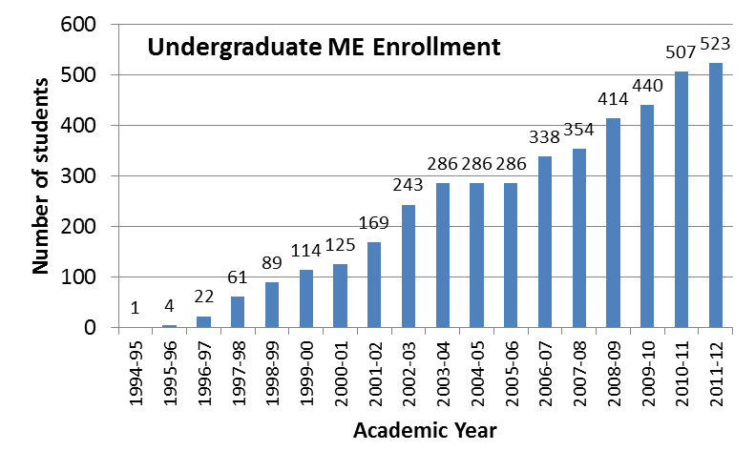

**Figure 1.** Undergraduate enrollment.

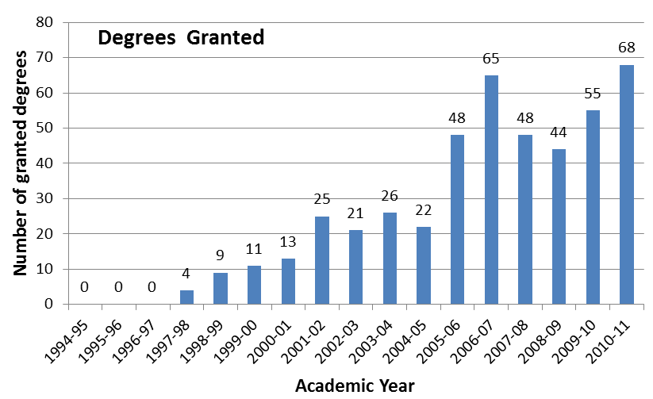

**Figure 2**. Degrees granted.

The mechanical engineering program has maintained its high quality and accreditation status since its inception in 1994 by continuous improvement of the curriculum in response to feedback from students and employers. The program has also been responsive to suggestions for improvement from our stakeholders and our Board of Advisors who meet with the faculty in bi-annual workshops. In addition to providing input into the curriculum, these advisory groups provide valuable advice on the formulation of program objectives.

Several important changes have been made to the curriculum since the last accreditation in 2006. Students can now pursue one of four focus areas: Mechanics and Materials, Energy and Environment, Design and Manufacturing, and General Mechanical Engineering. Students are required to take 16 units of technical electives from a list appropriate for each focus area.

In 2004, during the previous accreditation cycle, the Mechanical Engineering department introduced a series of introductory, freshman, courses, ME 1A, ME 1B, and ME 1C. These courses were designed to engage the students with the Mechanical Engineering faculty during all three quarters of the freshman year so that faculty could help students adjust to their new academic environment. These one-unit courses taught study skills, introduced students to the fundamentals of mechanical engineering, showed students how to use university resources effectively, and provided familiarity with computational software such as Excel and MATLAB required in later classes. Unfortunately, enrollment statistics suggested that the ME 1 series did not reduce the attrition rate of our students, which was one of our purposes for creating this course sequence. Also, the students were not pleased with the rigor and difficulty of these classes – the classes were perceived as too easy and did not prepare students adequately for subsequent Mechanical Engineering classes. For these reasons, we replaced the ME 1 series with the four-unit course “Introduction to Mechanical Engineering” (ME 2). The new course provides students with an introduction to many of the fundamental subjects that comprise the program including statics, fluid flow, heat transfer, and energy. In this way, the course provides a foundation for the study of these subjects in the remainder of the curriculum. The course also helps students to understand how the core subjects in the discipline relate to each other. This course has been well received by the students, although they consider it to be relatively difficult.

One of the objectives of the ME 1 A/B/C sequence was to provide an opportunity for freshman mechanical engineering students to connect with the mechanical engineering faculty. When we replaced this sequence with ME 2, we also moved ME 9 from the sophomore year to the freshman year. With the ME 1 sequence, students took a total of three units of mechanical engineering courses during the freshman year. They now take two four-unit courses. Our goal in increasing contact time in this way is to increase our retention rate.

The department has developed several courses to promote mechanical engineering among non-engineering students. These include ME 3, “How Stuff Works,” ME 4, “Energy and Environment,” and ME 5, “The Science of Myth Busting.” ME 3 and ME 4 have been enthusiastically received with enrollments exceeding 100 students per offering. ME 5 was recently approved for the course catalog and has not yet been offered.

1. **Options**

There are four focus areas in the program. To complete a focus area a student must complete four of the relevant technical elective courses (16 units) associated with that focus area. The list of focus areas and associated technical electives is given below:

1. Materials and Structures. The eligible technical elective courses in this focus area are:
   * Thermodynamics (ME 100B)
   * Heat Transfer (ME 116B)
   * Feedback Control (ME 121)
   * Vibrations (ME 122)
   * Finite Element Methods (ME 153)
   * Mechanical Behavior of Materials (ME 156)
   * Optics and Lasers in Engineering (ME 180)
   * Research for Undergraduates (ME 197)
2. Energy and Environment. The eligible technical elective courses in this focus area are:
   * Thermodynamics (ME 100B)
   * Heat Transfer (ME 116B)
   * Combustion & Energy Systems (ME 117)
   * Environmental Impacts of Energy Production & Conversion (ME 136)
   * Environmental Fluid Mechanics (ME 137)
   * Transport Phenomena in Living Systems (ME 138)
   * Research for Undergraduates (ME 197)
3. Design and Manufacturing. The eligible technical elective courses in this focus area are:
   * Feedback Control (ME 121)
   * Vibrations (ME 122)
   * Kinematic and Dynamic Analysis of Mechanisms (ME 130)
   * Design of Mechanisms (ME 131)
   * Introduction to Mechatronics (ME 133)
   * Ship Theory (ME 140)
   * Finite Element Methods (ME 153)
   * Mechanical Behavior of Materials (ME 156)
   * Sustainable Product Design (ME 176)
   * Optics and Lasers in Engineering (ME 180)
   * Research for Undergraduates (ME 197)
4. General Mechanical Engineering. For this focus area students can select any four technical electives.

The program originally received approval from the Academic Senate to implement these four focus areas on May 30, 2006[1] . However, at that time the first focus area was called “Mechanics of Materials and Structures.” On May 19, 2009[2], the program received approval from the Academic Senate to change the name of this focus area to “Materials and Structures” to better reflect the content of the focus area. More details of the technical electives and focus areas are provided under “Criterion 1.F. Students - Graduation Requirements.”

1. **Organizational Structure**

Figure 3 presents a schematic of the academic organizational structure for the programs in the Bourns College of Engineering (BCOE).

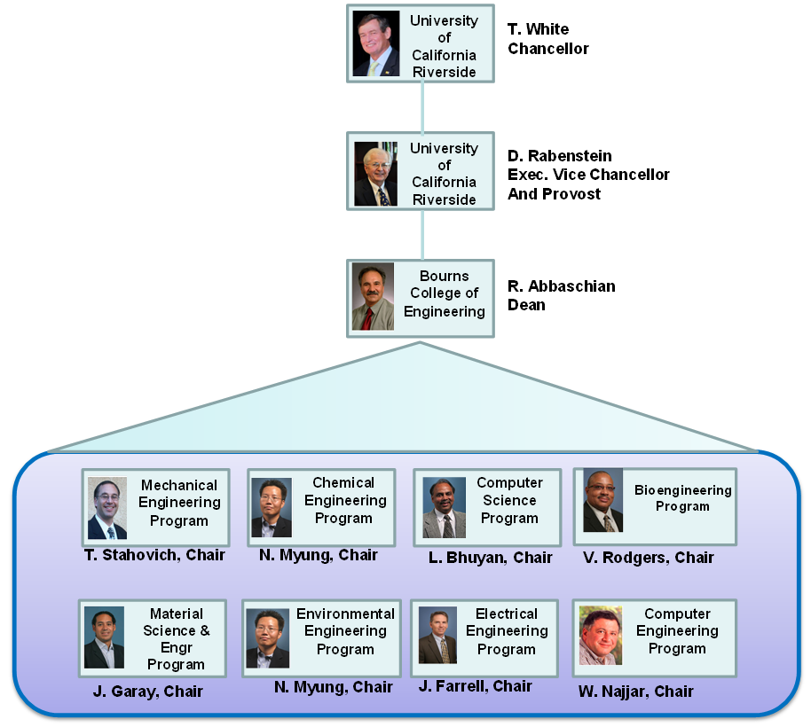

**Figure 3.** Organizational structure.

1. **Program Delivery Modes**

All courses for the bachelor’s degree are delivered in campus classrooms and laboratories on weekdays and weeknights. The curriculum includes no cooperative education, distance education, or web-based instruction.

1. **Program Locations**

All courses are delivered on the campus of the University of California, Riverside.

1. **Deficiencies, Weaknesses or Concerns from Previous Evaluation(s) and the Actions Taken to Address Them**

The Mechanical Engineering program was reviewed by ABET in 2006 and received a full 6-year accreditation. A summary of ABET Final Statement provided to the Mechanical Engineering Program following the Fall 2006 visit identified the following program strengths:

* The department has a number of bright, enthusiastic, and energetic young faculty members. There is currently a good balance of both experienced leadership and new energy in the program.
* The students are enthusiastic about the program and the faculty.

The Final Statement expressed two concerns:

Concern 1, pertaining to ABET Criterion 2. Program Educational Objectives:

*Criterion 2 states that program must have in place “… a process of ongoing evaluation of the extent to which the program educational objectives are attained, the result of which shall be used to develop and improve the program outcomes.” The Board of Advisors has evaluated achievement of the program educational objectives since 2001. Beginning in 2006, input from an important constituency, the alumni, has been gathered through the use of a survey instrument. The program is relatively new and has graduated 73 students prior to 2004. The response to the survey has been around 10 percent. A plan is in place to increase the survey response rate but until the plan is fully implemented and more time has passed, there is limited input from alumni to evaluate the achievement of program educational objectives. There is a process in place to use the results of the evaluation of the program educational objectives to improve the program outcomes. However, implementation of the process has been constrained by limited evaluation data and only limited improvement to the program outcomes has occurred. Also, Criterion 2 states, “… program educational objectives are broad statements that describe the career and professional accomplishments that the program is preparing graduates to achieve.” The program should consider rewording their program educational objectives to better describe accomplishments of their students three to five years after graduation.*

The following actions have been taken to address this concern:

1. In response to “…*there is limited input from alumni to evaluate the achievement of program educational objectives*…” we have implemented an annual online survey for alumni and employers of our graduates to collect more data with a higher response rate.
2. Concerning “… *The program should consider rewording educational objectives to better describe accomplishments of their students three to five years after graduation*..,” we responded promptly. After the 2006 ABET visit, we implemented modified Program Educational Objectives that we had been developed with our stakeholders in May 2006 (i.e., prior to that ABET visit). The new Program Educational Objectives appear in the university catalog and department website.

The old Program Educational Objectives that were in effect during the last ABET visit are:

* Provide students with the knowledge and skills required to enter and function in industry rapidly.
* Prepare students for graduate studies by providing opportunities for undergraduate research.
* Provide an educational experience with the breadth and the intellectual discipline required to enter professional careers outside engineering, such as business and law.
* Produce students with a strong sense of teamwork.
* Inculcate in students the intellectual curiosity required for a lifetime of learning.

The new Program Educational Objectives that we established in May 2006 and implemented after the last ABET visit are:

To produce mechanical engineers who:

* Have the knowledge and skills to adapt to the changing engineering environment in industry.
* Are able to pursue and succeed in graduate studies.
* Have the educational breadth and the intellectual discipline required to enter professional careers outside engineering, such as business and law.
* Have an ability to work in multi-disciplinary teams.
* Engage in a lifetime of learning.

During our most recent stakeholders meeting in May 2012, we again considered reformulating our Program Educational Objectives. Our stakeholders suggested that three to five years after graduation, our students should be able to:

* solve complex system level problems
* succeed in graduate studies
* pursue professional careers of their choice outside of mechanical engineering
* lead multidisciplinary teams

The stakeholders suggested that we should remove engagement in a lifetime of learning from the Program Educational Objectives as this is already a Student Outcome. It was agreed by the faculty and other stakeholders that further discussion and analysis was needed before changing the Program Educational Objectives. For example, achieving some of these objectives would require changes to the curriculum, especially the capstone senior design course. For these reasons, no changes have yet been made.

Concern 2, pertaining to ABET Criterion 3. Program Outcomes and Assessment:

*Criterion 3 states that the programs must demonstrate that program outcomes “… are being measured and indicates the degree to which the outcomes are achieved.” It further states that, “There must be evidence that the results of this assessment process are applied to the further development of the program.” The program has an assessment process in place that demonstrated the due diligence of the faculty in satisfying this criterion. Furthermore, the faculty has demonstrated their acceptance of the need to conduct outcomes assessment. However, the process in place for direct assessment of the program outcomes seems not to be capable of distinguishing the performance of one program outcome from another. The grade of each piece of student work is mapped to multiple course objectives, and each course objective is mapped to multiple program outcomes. Therefore, the result for a particular program outcome is essentially a weighted average of a weighted average of individual grades that each reflects multiple program outcomes. The effect is similar to use of course grades to assess program outcomes, a practice that is discouraged because of the lack of specificity that would result. The assessment process should be modified to establish a unique or nearly unique association between program outcomes and student work.*

In response to this concern we modified our approach to outcomes assessment in two important ways. First, a carefully selected subset of coursework is used for assessment. This coursework may or may not be included in the final course grade. Second, course objectives are more selectively mapped to Student Outcomes. Typically, each course objective is mapped to no more than three outcomes. Finally, in some courses, concept inventories are used for assessment. For example, in ME 10 Statics, the Force Concept Inventory and the Statics Concept Inventory (cihub.org) are used as pre- and posttests.

A summary of major curriculum changes driven by our assessment process is given below:

* ME 2 – Introduction to Mechanical Engineering: We carefully examined the strengths and weaknesses of the existing Mechanical Engineering freshman experience and determined that the ME 1 A/B/C sequence did not adequately prepare our students for the challenges of the subsequent courses. As a remedy, we developed a new four-unit course, ME 2, which provides a comprehensive overview of mechanical engineering. This course teaches engineering problem-solving skills without utilizing calculus, and is intended to provide a framework to help students connect concepts in subsequent courses. The Mechanical Engineering Board of Advisors (BOA) that includes the industry representative component of our stakeholders expressed their enthusiasm for this change at our Annual BOA Meeting held on April 24, 2009. This four-unit course was first taught in AY 2009-2010. ME1A/B/C is no longer required.
* ME 18 – Introduction to Engineering Computation: The course was changed from two units to three to absorb material from ME 1C (basic MATLAB programming), thus providing a more comprehensive introduction to engineering computation.
* ME 174 – Machine Design: ME 130 (Kinematics) was eliminated as a required course and replaced with ME 174. The latter covers strength-based design, an essential mechanical engineering topic that was absent from the curriculum. The inclusion of ME 174 in the required curriculum addressed deficiencies that were apparent in student performance in senior design, ME 175 B/C. ME 130 is now a technical elective.
* BIOL 003: This course was eliminated as a required course as it did not contribute material that is essential to the major. Now, only BIOL 005A and BIOL 005L which focus on cell and molecular biology are required.
* To help Mechanical Engineering freshmen stay connected with their major, the normal sequence of course offerings is: ME 2 in the winter quarter of the freshman year, followed by ME 9 (Engineering Graphics and Design) in the spring quarter.

Other changes were also implemented during this cycle. These changes include:

1. Introduction of Service Courses for non-engineering majors:

* ME 3 – How Stuff Works
* ME 4 – Energy and the Environment
* ME 5 – The Science of Mythbusting

1. We introduced a special mentoring program, called the Mechanical Engineering Highlander Club, for high-achieving students.
2. We made several major changes to improve individual courses are outlined in Table 1.

**Table 1.** Summary of major course changes.

|  |  |  |
| --- | --- | --- |
| **Course** | **Change** | **Justification** |
| ME 120 | New Course Objectives are:  Modeling linear systems (electrical, mechanical, and biological), Laplace transform method for solving differential equations, transfer functions and block diagrams, matrix representation of linear systems, similarity transformations and diagonalization, stability analysis for linear systems, linearization, controllability and observability, closed loop systems, and introduction to MATLAB linear systems toolbox. | The course previously focused on Laplace transforms (input/output methods) and applications exclusively in mechanical engineering. The course lacked an introduction to some of the fundamental concepts needed for more advanced feedback control and mechatronics courses such as stability analysis, the concepts of controllability and observability, linearization techniques, and feedback. The course was changed to include this material. Also, the course was modified to include more interdisciplinary examples, highlighting how linear systems theory can be applied to a broad spectrum of engineering and science problems. This will better prepare students to operate in multidisciplinary work environments. |
| ME 180 | New course description:  Focuses on principles of optics and lasers, wave equations, interferometry, diffraction, laser-material interactions. Applications in analytical characterization including confocal microscopy, Raman spectroscopy, mechanical deformation analysis, scanning probe microscopy, ultraviolet-visible spectrophotometry, photoluminescence, optical detectors, and lasers in materials processing. | The course was previously focused on traditional optics concepts. The course was changed to include an increased emphasis on modern techniques for analytical characterization. |

1. We made numerous minor changes to improve individual courses as outlined in Table 2.

**Table 2.** Summary of minor course changes.

|  |  |  |
| --- | --- | --- |
| **Course** | **Change** | **Justification** |
| ME 2 | Enrollment priority given to Mechanical Engineering majors. | ME 2 is mandatory for mechanical engineering freshmen who cannot enroll in most other ME courses without first completing this course. ME 2 is intended to prepare ME students for the rigors of subsequent ME courses. It is inappropriate for non-engineering majors who should instead take ME 3 or ME 4. |
| ME 3 | MATH 5 removed as prerequisite. | After careful examination of the course material, it was concluded that the material covered in MATH 5 is unnecessary for success in ME 3. |
| ME 9 | Add ME 2 as co-requisite. | ME 9 teaches engineering design and computer aided design (CAD). ME 2 provides students with knowledge of the engineering principles that are the foundation for the material in ME 9. |
| ME 10 | Enrollment priority given to Mechanical Engineering, Material Science and Engineering and Environmental Engineering majors. | ME 10 is offered in both the winter and spring quarters and is mandatory for ME, MSE and Env. Eng. majors. Taking the class in the winter quarter is crucial for these students to stay on track. Other engineering majors can take ME 10 in the spring without any negative downstream consequences. |
| ME 110 | CS 030 added as an equivalent of ME 18 prerequisite. | ME 110 is a mandatory course for the MSE program. MSE students are not required to take the prerequisite ME 18, which is an engineering computation course. However, MSE students are required to take CS 30, which provides adequate computing skills for students to complete ME 110. |
| ME 138 | Addition of prerequisite ME 113 or BIEN 105. | ME 138 is an advanced fluid mechanics course, thus knowledge of basic fluids mechanics is needed for success in this course. Both ME 113 and BIEN 105 provide the necessary knowledge. |
| ME 174 | Removal of ME 103 as a prerequisite and addition of ME 103 as a co-requisite. | Material from dynamics (ME 103) is required only in the last part of ME174. Students taking ME 103 concurrently with ME 174 will have the necessary knowledge of dynamics by the time that material is needed for ME 174. |
| ME 175A | ME170A removed as prerequisites for ME175A.  “Senior standing in the mechanical engineering major” added as a prerequisite. | The material covered in ME 170A is not needed for ME 175A. (It is needed for ME 175B. See next change.) Because ME 175A is part of the capstone design course, only seniors in mechanical engineering should be allowed to enroll. The inclusion of ME 170A as a prerequisite had the effect of limiting enrollment to seniors. This requirement is now explicit. |

|  |  |  |
| --- | --- | --- |
| ME 175B | ME 170B and ME 135 removed as prerequisites for ME 175B. ME 170A, ME 113, and ME 116A added as prerequisites. | After several offerings and careful examination of the course materials, it was concluded that the ME170A provides sufficient knowledge of experimental techniques and that ME 113 and ME116A provide sufficient knowledge of fluids and heat transfer. ME 170B and ME 135 provide more advanced knowledge of experimental techniques and fluids/heat transfer, but this advanced knowledge is not essential for ME 175B. |

1. We introduced ME 302, Apprentice Teaching, to train teaching assistants how to teach effectively and how to perform our ABET procedures. This course is mandatory for all teaching assistants.

More details about program changes are provided under “Criterion 4 – Continuous Improvement.”

1. **Joint Accreditation**

This program is seeking EAC accreditation only.

**GENERAL CRITERIA**

# CRITERION 1. STUDENTS

**1.A. Student Admissions**

The admissions processes for all engineering degree programs conform to the UCR Academic Senate’s interpretation of the admission policies of the University of California, which, in turn, interpret the mandates of the California Master Plan for Higher Education. In broad terms, the Master Plan constrains the University of California to admitting only students ranking in the top 12.5% of the high school graduates in the State. Students in lower tiers are eligible for admission to campuses of the California State University system, or to community colleges. Placement in the top 12.5% of the graduating class is determined by the UC Eligibility Index, which is computed centrally by the UC Office of the President, based on criteria defined by the UC System-Wide Academic Senate.

Figure 1.1 summarizes the freshman admissions process to the Bourns College of Engineering. Prospective students submit their applications to the Office of Admissions for the University of California, which serves all ten campuses. Applicants may apply to multiple campuses, and to multiple programs at these campuses. They may also designate primary and alternate majors. The UC Office of Admissions determines whether each applicant meets the UC Eligibility criteria (which specify GPA and coursework requirements) and forwards each eligible application to the campuses to which admission is being sought. Ineligible applicants are rejected. If a student is UC-eligible but is not selected for admission to the campus(es) that he or she applied to, admission to another UC campus is offered. It is notable that the Riverside campus switched from a referral campus to a selective campus within the past four years. That is, because of the increasing number and quality of students applying directly to UCR, we no longer offer admission to students who are UC-eligible but were declined by their first-choice campuses. Nevertheless, we remain the most diverse campus of the UC system (in terms of overall numbers; on a percentage basis, UC Merced has greater diversity because of its very small student population), with a substantial number of students who are the first in their families to attend college.

Within UCR, processing of the freshman applications begins through the Campus Office of Admissions, in accordance with guidelines defined by the Undergraduate Admissions Committee (UAC) of the UCR Academic Senate. An Enrollment Management Council (EMC) also exists at the campus level to make decisions annually on the enrollment targets at the campus and college levels. These decisions are informed by the strategic planning processes at the campus and college levels.

UCR follows a multi-tier admissions process. At the first tier, an Academic Index Score (AIS) is computed for each applicant, based primarily on academic parameters such as the grade-point average (GPA), the Scholastic Aptitude Test (SAT) score, and the number of completed Advanced Placement or International Baccalaureate courses. College-specific upper and lower AIS thresholds are determined in accordance with the planned enrollment targets. All applicants to a college whose AIS scores exceed the upper threshold are automatically admitted to their program of interest. All applicants with AIS scores below the lower threshold for each college are removed from that college’s pool. The remaining applicants are forwarded to the respective colleges for further processing.

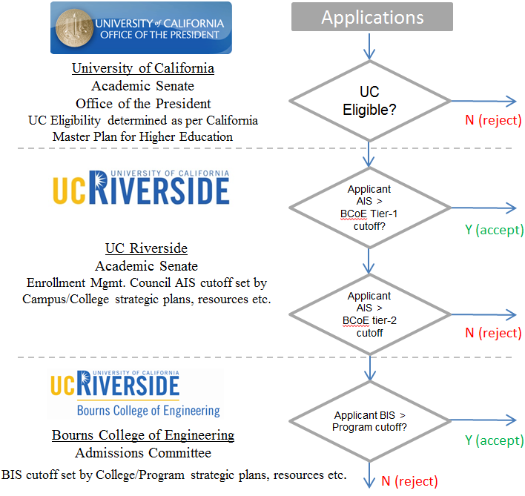

**Figure 1.1.** The admissions process begins with an application to the UC system, which is forwarded to the campus and then to the college for consideration.

Once these forwarded applications arrive at BCOE, a, BCOE-specific Index Score (BIS) is computed for each applicant. This BIS score is a function of the applicant’s grades in mathematics and science, as well as the math part of the SAT Reasoning Test (the SAT Advanced test is not required by UC). The applicants to each program are ranked by BIS score, and applicants are admitted starting at the top of the list for each program until the program’s enrollment target is met. Applicants may be placed on a wait list, to be admitted if the yield rate from the admitted pool is insufficient to satisfy program targets.

Subsection C addresses the transfer admission process.

**1.B. Evaluating Student Performance**

Student performance monitoring is primarily the role of the Office of Student Affairs, under the supervision of the Associate Dean for Undergraduate Affairs, Professor C.V. Ravishankar. Each program also has a faculty member designated as the Program Faculty Undergraduate Advisor, who serves as the primary departmental contact for program-specific policy decisions. College-level policy is under the purview of the Associate Dean. The staff of the Office of Student Academic Affairs (OSAA) supports the undergraduate programs.

Each student is assigned to a staff advisor in the OSAA, and encouraged to meet with this advisor whenever the need arises, but at least once per quarter. In addition, attendance at a mandatory Annual Major Advising session is required of all undergraduates in the college. The Annual Major Advising session is conducted jointly by the OSAA staff and the Program’s Faculty Undergraduate Advisor, and provides information on a variety of topics including program requirements, academic success strategies, and professional development opportunities.

Figure 1.2 depicts the process for monitoring student progress. Students are required to maintain a GPA of 2.0 each quarter, as well as cumulatively. Students are reminded of these requirements regularly, first during the registration process in their first quarter as freshmen, and again each year during Annual Major Advising. Grades are posted by instructors each quarter to the central Student Information System (SIS) database, which tracks student performance, and provides degree audits to check for completion of degree requirements. At the end of each quarter, staff advisors in the OSAA review the academic records of BCOE students and identify all whose term and cumulative GPAs are below 2.0.

A failure to meet these GPA requirements results in a student being placed on probation. The student is notified of this probationary status, and advised that a failure to obtain at least a 2.0 GPA the following term will result in dismissal. A registration hold is placed on the student’s record at that point, to be released only upon the completion of Academic Success Workshops and other advising and mentoring activities through the OSAA. A student who receives a dismissal notice may appeal the dismissal to the Associate Dean, who may grant or reject the appeal based on extenuating circumstances.

The primary source of information regarding student performance is the campus-wide Student Information System (SIS). SIS, which is maintained by the campus Computing and Communications office, records all student registrations and grades. All staff and faculty advisors have access to this system, either directly, or through the Student Advising System (SAS) front-end that provides access to student transcripts and degree audits. The staff of the OSAA uses this system regularly to monitor student progress.

# Students who are about to graduate are required to complete a graduation application. At this point, the student’s academic advisor in OSAA performs a detailed manual check to ensure that all degree requirements have been met. If the requirements have been met, the Office of the Registrar is notified of degree completion, so the degree may be awarded.

SIS

Course

Grades

GPA < 2?

Dismissal?

Appeal?

N

Granted By

Associate Dean?

Y

Registration Hold

+

Academic Success

Workshops

N

Every Quarter

Y

N

Graduation,

as per SIS?

Manual Degree

Check

Registration

Term-by-term

Course plan



Advising

By OSA

and Faculty

Y

Y

Y

N

**Dismissed**

**(explore**

**readmission)**

Prerequisites

**Figure 1.2.** Academic advising and performance monitoring.

# 1.B.1 Enforcing Prerequisites

All students are given a term-by-term course plan that ensures timely graduation as long as courses are completed in a timely manner. This course plan incorporates prerequisites, so that students who follow the course plan automatically satisfy prerequisites. Table 1.1 shows the basic course plan for the Mechanical Engineering program. More details on the curriculum, including technical electives and breadth courses are presented in Section 5 – Curriculum.

**Table 1.1**. The generic course plan for the Mechanical Engineering bachelor’s degree program.

|  |  |  |
| --- | --- | --- |
| **Fall Quarter** | **Winter Quarter** | **Spring Quarter** |
| **First year** | | |
| ENGL 001A  Beginning Composition | ENGL 001B  Intermediate Composition | ENGL 001C or Alternate  Applied Intermediate Composition |
| MATH 009A  First Year Calculus | MATH 009B  First Year Calculus | MATH 009C  First Year Calculus |
| Breadth __________  Humanities/Social Sciences | ME 002  Intro to Mechanical Engineering | ME 009  Engineering Graphics & Design |
|  | PHYS 040A  Physics (Mechanics) | PHYS 040B  Physics (Heat/Waves/Sound) |
| **Second year** | | |
| CHEM 001A & CHEM 01LA  General Chemistry & Lab | BIOL 005A & BIOL 05LA  Cell & Molecular Biology & Lab | EE 001A & EE 01LA  Engineering Circuit Analysis I & Lab |
| MATH 046  Differential Equations | CHEM 001B & CHEM 01LB  General Chemistry & Lab | MATH 010B  Multivariable Calculus |
| ME 018  Intro to Engineering Computations | MATH 010A  Multivariable Calculus | STAT 100A  Introduction to Statistics |
| PHYS 040C  Physics (Electricity/Magnetism) | ME 010  Statics | Breadth __________  Humanities/Social Sciences |
| **Third year** | | |
| ME 100A  Thermodynamics | ME 110  Mechanics of Materials | ME 116A  Heat Transfer |
| ME 103  Dynamics | ME 113  Fluid Mechanics | ME 170A  Experimental Techniques |
| ME 114  Intro to Materials Science & Engr. | ME 118  Mechanical Engr. Modeling & Analysis | ME 174  Machine Design |
| Breadth __________  Humanities/Social Sciences | ME 120  Linear Systems and Control |  |
| **Fourth Year** | | |
| ME 135  Transport Phenomena | ME 175B  Mechanical Engineering Design | ME 175C  Mechanical Engineering Design |
| ME 170B  Experimental Techniques | Technical Elective  _____________________ | Technical Elective  _____________________ |
| ME 175A  Professional Topics | Technical Elective  _____________________ | Technical Elective  _____________________ |
| Breadth __________  Humanities/Social Sciences | Breadth __________  Humanities/Social Sciences | Breadth __________  Humanities/Social Sciences |

Whether or not students follow this course plan, prerequisites are enforced by the registration system. Students register for courses through the GRades and Online Web Link (GROWL) system that interfaces with SIS, and is able to enforce prerequisites. GROWL is the secure student portal used to complete the majority of administrative transactions needed during a student’s academic career. This includes submission of a student’s Statement of Intent to Register, control of all privacy through FERPA based controls, access to their bill, submission of payment, term registration, review of administrative or advising holds, grades, transcript requests and review and acceptance of their financial aid to name a few. A student prevented from taking a course due to lack of prerequisites can petition the undergraduate committee, who has the authority to grant the student a prerequisite waiver. The student is not permitted to take the course without such a waiver. Such waivers are generally approved for outstanding students, transfer students, and very special situations. For example, an outstanding student (ID No. 860977737) was granted a waiver in winter 2012 to take Fluid Mechanics (ME 113) without completing the prerequisite statics course (ME 10). This student achieved an A+ in ME 113. Similarly, a transfer student (ID No. 860962853) was granted waivers for concurrent enrollment in ME 103 and ME 174, and concurrent enrollment in ME 18 and ME 100A. All waivers of prerequisites are documented by the OSAA who includes them with the student file.

**1.C. Transfer Students and Transfer Courses**

Transfer students apply using the same application portal that freshmen use. This portal is maintained by the System-Wide Office of Admissions, located in Oakland, CA. This office collects applications and forwards them to the UCR Office of Admissions.

In accordance with the California Master Plan for Higher Education, the University of California maintains extensive articulation agreements with community colleges in the state. Course articulations are reviewed and approved by the cognizant departments, and are tracked and maintained by the Campus Articulation Officer. All system-wide articulation agreements are available at the website <http://www.assist.org>, which has open access. The transfer route appears to be gaining popularity, especially given recent increases in tuition. When a transfer applicant (typically, from out of state) presents a transcript containing courses that have not already been articulated, the staff of the BCOE OSAA collect the relevant course syllabi and work with the cognizant departments at UCR to determine articulations.

All BCOE programs have published detailed requirements for transfer admission. Admission to our programs requires a minimum GPA of 2.8, and the completion of coursework specific to the major being applied to. Incoming transfer students may transfer up to 105 quarter units (70 semester units) towards their degrees from the University. To assist students who may be considering several alternative majors, we have prepared brochures showing transfer requirements for each of our majors. We make these brochures available both in hardcopy and on the Web. Some examples appear at: <http://www.engr.ucr.edu/undergrads/transferring/SpecialAgreements.html>.

If the transfer applicant for a major meets all the requirements specified by that major, the UCR Office of Admissions admits that applicant. Applicants who satisfy most, but not all, transfer requirements are forwarded to the College for additional review. The OSAA staff reviews these applications, and in consultation with the departments and the Associate Dean, grants exceptions as warranted. Conditional admission is also sometimes granted, subject to the completion of some requirements that may not have been met at the time of application.

In addition to the college transfer requirements the Mechanical Engineering requires the following courses to be completed at the time of application:

* one course in calculus based physics with lab (equivalent to UCR Physics-Mechanics PHYS 40A)
* two courses in general chemistry with labs (equivalents to UCR General Chemistry and Lab CHEM 1A/1LA, 1B/1LB)

Also, a minimum of three additional courses from this list must be completed:

* courses in calculus based physics with labs (equivalent to UCR Physics Heat/Wave/Sound PHYS 40B, and Physics Electricity/magnetism PHYS 40C)
* one course in introductory cellular and molecular biology with lab (equivalent to UCR Cell and Molecular Biology and Lab BIOL 5A/LA)
* one course in engineering circuit analysis with lab (equivalent to UCR Engineering Circuit Analysis and Lab EE 1A/LA)
* one course in introductory mechanical engineering-problem solving/computation (equivalent to UCR Introduction to Mechanical Engineering ME 2)
* one course in engineering graphics with computer applications (equivalents to UCR Engineering Graphics and Design ME 9)
* one course in statics (equivalent to UCR Statics ME 10)
* one course in introductory engineering computation (equivalent to UCR Introduction to Engineering Computations ME 18)

**1.D. Advising and Career Guidance**

The mechanisms by which students receive academic advice have already been outlined in Section B: Evaluating Student Performance. Here, we will describe the mechanisms for providing Career and Professional guidance.

Professional guidance and mentoring is provided by staff (particularly, the Director of Student Professional Development), the faculty, and the Career Center. The overall College philosophy that guides all interactions with students is to ensure that they are both academically and professionally prepared to become leaders in their chosen fields. This goal is especially challenging to meet in engineering colleges.

In many undergraduate engineering programs, students spend the first two years of their undergraduate work completing prerequisite coursework in mathematics, the sciences, and the humanities and social sciences. Unfortunately, instructors in these areas are not necessarily familiar with engineering, and thus may be unable to motivate or mentor engineering students. The lack of academic mentors would be a particularly difficult problem for our students, as many are the first generation of their families to attend college, and thus they also typically lack role models at home.

We have addressed this issue in several ways. First we conduct a freshmen welcome orientation and mandatory quarterly freshman advising sessions. These are presented by Mechanical Engineering program faculty, often by members of the undergraduate committee. Through these interactive sessions we present the highlights and challenges of the mechanical engineering profession and present techniques for success. We also encourage our students to pursue professional development activities such as involvement with professional societies and clubs. These same messages are reinforced in two required freshmen Mechanical Engineering courses: Introduction to Mechanical Engineering (ME 2) and Engineering Graphics and Design (ME 9). This mentoring and guidance is intended to help our students develop a clear sense of academic direction and professional pride. Additionally, these activities help our students to develop effective working relationships with their peers.

In May 2012, we began a new mentoring program for our high performing freshmen students to make sure that they remain adequately challenged throughout our program. The 40 best-performing students in the winter offering of ME 2, Introduction to Mechanical Engineering, were invited to participate in this program. These students were given an overview of the department’s graduate program and faculty research activities. The students were encouraged to contact faculty members and join their research groups. We believe this program will help us to retain our best students. Also, this program encourages these students to attend graduate school upon completion of their degree. We plan to survey students on benefits of the mentoring program.

A suite of activities supported by the college under the Professional Development Milestones program complement our program-specific guidance. Examples of such activities are academically-oriented workshops on time management and study-skills, as well as professionally-oriented activities such as mock interviews, resume writing, as well as research and industrial internships. Figure 1.3 summarizes these milestones.

A total of 18 Student Professional Organizations exist in BCOE, and are supported financially by the College. These organizations are student-led, and are very active. Just over 800 students are active members of these organizations (roughly 40% of the students in College).

1. BCOE SLC (Student Leadership Council)
2. ACM (Association of Computing Machinery)
3. AIChE (American Institute of Chemical Engineers)
4. ASME (American Society of Mechanical Engineers)
5. ASQ (American Society of Quality)
6. BMES (Biomedical Engineering Society)
7. EWB (Engineers Without Border)
8. IEEE (Institute of Electrical and Electronics Engineers)
9. IEEE EDS (Electron Devices Society)
10. ION (Institute of Navigation)
11. MRS (Material Research Society)
12. NSBE (National Society of Black Engineers)
13. OSA (Optical Society of America)
14. SACNAS (Society for Advancement of Chicanos and Native Americans in Science)
15. SHPE (Society of Hispanic Professional Engineers)
16. SAE (Society of Automotive Engineers)
17. SWE (Society of Women Engineers)
18. TBP (Tau Beta Pi) – Honors Society

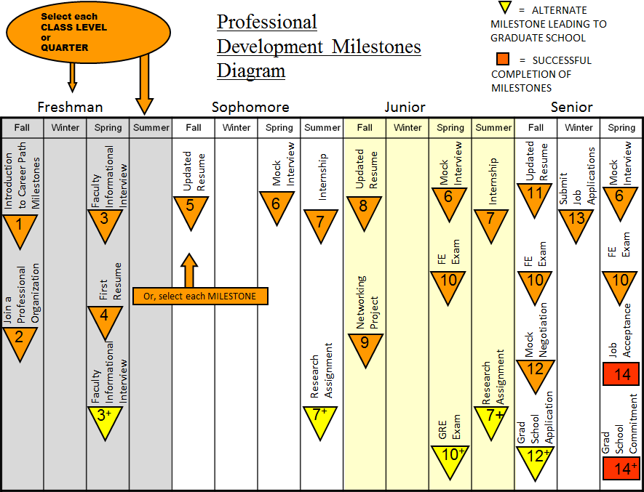

Figure 1.3. The Professional Development Milestones program guides students on key activities they should undertake during their undergraduate years to ensure that they are ready for professional careers or graduate school.

These organizations, under the mentorship of the Director of Student Professional Development, Mr. Jun Wang, participate in a broad range of activities during the year. A summary for the 2011-12 academic year appears in Table 1.2 below.

**Table 1.2.** A summary of the professional development activities from 2011-12. There have been a total of 5,774 participants in these activities as of 05/4/2012. (Note that some of these activities are scheduled in the future and thus have no attendance numbers reported.)

|  |  |  |  |  |  |
| --- | --- | --- | --- | --- | --- |
| **BCOE Professional Development Milestones Program** | | | | | |
| **Event** | **Date** | **Attendees** | **Event** | **Date** | **Attendees** |
| Student Leadership Workshop | 9/25/11 | 120 | Conversation Skills | 2/14/12 | 14 |
| Information Session: Peace Corps | 9/26/11 | 56 | Beginning Resume Writing | 2/15/12 | 28 |
| Information Session: HACU National Internship Program | 9/27/11 | 32 | Career Station | 2/15/12 | 13 |
| Information Session: U.S. Department of State | 9/27/11 | 45 | Visit to Circor | 2/15/12 | 10 |
| Information Session: U.S. Marine Corps | 9/28/11 | 27 | Agricultural Careers Dinner & Industry Professionals Networking Event | 2/15/12 | 85 |
| Beginning Resume Writing Workshop | 10/3/11 | 30 | Internships: What, Why & How? | 2/16/12 | 20 |
| Job Search 101 Workshop | 10/3/11 | 42 | GOVERNMENT AND NON-PROFIT JOB FAIR | 2/16/12 |  |
| Career Presentation by Synapse | 10/5/11 | 65 | SWE Resume Workshop | 2/21/12 | 45 |
| Internships: What, Why & How? | 10/6/11 | 37 | Career Station | 2/22/12 | 15 |
| Now Hiring Interns! | 10/11/11 | 40 | Presentation Skills | 2/22/12 | 32 |
| Beginning Resume Writing Workshop | 10/11/11 | 35 | Now Hiring Part-Time Jobs | 2/23/12 | 22 |
| Preparing for the Job Fair | 10/12/11 | 54 | Making Professional Connections | 2/23/12 | 26 |
| Interview Skills | 10/13/11 | 36 | Beginning Resume Writing | 2/27/12 | 20 |
| The New GRE: What does it mean for grad school applicants | 10/13/11 | 68 | Former Interns Tell All | 2/28/12 | 54 |
| Advanced Resume Writing, featuring Cal Steel Industries, Inc. | 10/13/11 | 70 | Interview Skills | 2/28/12 | 16 |
| Careers in BioTech | 10/14/11 | 98 | BCOE IMPACT Mentoring Meeting | 2/28/12 | 82 |
| Yikes! I'm Graduating! | 10/14/11 | 26 | Information Table: The Princeton Review | 2/29/12 | 19 |
| Resumania, Featuring Target | 10/17/11 | 30 | Career Station | 2/29/12 | 18 |
| Law School Forum | 10/17/11 | 35 | Advanced Resume Writing | 2/29/12 | 28 |
| Why Can't I Find a Job? | 10/17/11 | 42 | Are You Really Ready to Work? Workplace Etiquette | 3/1/12 | 46 |
| Google Day at BCOE | 10/17/11 | 135 | Careers with the Air Force | 3/1/12 | 24 |
| Resumania, Featuring Sherwin Williams | 10/18/11 | 25 | BCOE IMPACT Mentoring Meeting | 3/1/12 | 78 |
| Careers at EPA Info Session | 10/18/11 | 67 | ACM Guest Speaker from Western Digital | 3/5/12 | 56 |
| Career Expo | 10/19/11 |  | GRADUATE VIRTUAL FAIR | 3/7/12 |  |
| Visit at NAVSEA NSWC Corona | 10/20/11 | 25 | Making Professional Connections | 3/7/12 | 26 |
| Guest Speakers from NASA/Carnegie Mellon Silicon Valley | 10/20/11 | 59 | Yikes! I'm Graduating! | 3/7/12 | 24 |
| Part-Time Job Search/Beginning Resume Writing Workshop | 10/20/11 | 23 | Visit at JPL | 3/8/12 | 18 |
| Information Session: USMC Aviation | 10/20/11 | 25 | Part-Time Job Search/Beginning Resume Writing | 3/8/12 | 31 |
| Making Professional Connections, Featuring: Target | 10/24/11 | 28 | Interview Skills | 3/13/12 | 22 |
| LinkedIn 101: Networking Professionally Online | 10/26/11 | 30 | Why Can't I Find a Job? | 3/14/12 | 25 |
| Graduate & Professional School Information Day | 10/27/11 |  | Non-Academic Job Search (Grad Students Only) | 3/15/12 | 60 |
| Guest Speakers from Northrop Grumman Aerospace Systems | 10/27/11 | 78 | Information Table: Kaplan Test Prep | 4/4/12 | 21 |
| Interview Skills, Featuring: Aerotek | 10/31/11 | 35 | Information Session: Target Distribution | 4/5/12 | 32 |
| Law School Information Day | 11/1/11 |  | Yikes! I'm Graduating! | 4/9/12 | 17 |
| Advanced Resume Writing, featuring Kohl's | 11/2/11 | 21 | Part Time Job Search/Beginning Resume Writing Webinar | 4/9/12 | 20 |
| Interview Skills, Featuring: Best Buy | 11/7/11 | 27 | Prepare For Spring Job Fair and Dress for Success | 4/9/12 | 67 |
| Part-Time Job Search/Beginning Resume Writing Workshop | 11/7/11 | 32 | Careers in Public Service Webinar | 4/10/12 | 52 |
| Jump Start to Grad School, Featuring: Kaplan | 11/7/11 | 36 | Internships: What, Why & How Webinar | 4/10/12 | 21 |
| Careers in Internet Retail | 11/7/11 | 25 | Beginning Resume Writing | 4/10/12 | 19 |
| SWE Female Engineers Guest Speaker Panel | 11/7/11 | 67 | Career Station | 4/11/12 | 26 |
| ASQ Biomedical Industrial Panel | 11/7/11 | 75 | SPRING JOB FAIR: CAREER NIGHT | 4/11/12 |  |
| Information Table: Peace Corps | 11/8/11 | 29 | What Can You Do Besides Becoming a Doctor? | 4/12/12 | 30 |
| Engineer Your Future: Careers in Mechanical Eng (Northrop Grumman) | 11/8/11 | 56 | Choosing a Health Professions School | 4/12/12 | 32 |
| INROADS Meeting with BCOE students | 11/8/11 | 102 | Hands-On Healthcare: Volunteer Opportunities | 4/12/12 | 41 |
| Internships: What, Why & How? | 11/9/11 | 23 | HEALTH PROFESSIONS SCHOOL FAIR | 4/12/12 |  |
| Information Session: CIA | 11/9/11 | 46 | Advanced Resume Writing Webinar | 4/16/12 | 15 |
| Undergraduate Research Opportunities Workshop | 11/14/11 | 45 | Conversation Skills | 4/16/12 | 17 |
| Yikes! I'm Graduating! | 11/14/11 | 19 | Interview Skills | 4/17/12 | 13 |
| Now Hiring Interns! | 11/15/11 | 23 | Making Professional Connections | 4/17/12 | 20 |
| Information Session: 50th Anniversary of Peace Corp | 11/15/11 | 34 | Job Search Skills | 4/17/12 | 22 |
| Career Marathon (resume reviewing) | 11/16/11 | 60 | Information Table: Peace Corps | 4/18/12 | 23 |
| AICHE Presentation/Guest Speakers from Energy Industry | 11/18/11 | 76 | Information Table: Kaplan Test Prep | 4/18/12 | 14 |
| Visit at K&N Engineering | 11/19/11 | 25 | Career Station | 4/18/12 | 12 |
| INROADS Workshop & Interview with students | 12/10/11 | 32 | Careers at NAVY Info Session | 4/19/12 | 17 |
| Visit at Luxfer Cylinder Company | 12/14/11 | 15 | Entrepreneur Career Panel: Starting Your Own Business | 4/19/12 | 115 |
| Information Table: Graduate School Prep, featuring: Princeton Review | 1/4/12 | 36 | Work Green, Earn Green: Careers that Save the Planet | 4/20/12 | 46 |
| Internships: What, Why & How? | 1/17/12 | 27 | Information Session: City Year Los Angeles | 4/20/12 | 48 |
| Part-Time Job Search Webinar | 1/17/12 | 33 | LinkedIn: Network & Get Recruited, Featuring: Fresh & Easy | 4/23/12 | 68 |
| College to Careers: BCOE Alumni Panel | 1/17/12 | 65 | Now Hiring Part-Time Jobs | 4/24/12 | 40 |
| Career Station | 1/18/12 | 21 | Career Station | 4/25/12 | 25 |
| Beginning Resume Writing FYSS | 1/18/12 | 22 | Job Search (Grad Students Only) | 4/25/12 | 22 |
| Prepare For Engineering & Technical Career Fair | 1/19/12 | 97 | Now Hiring Interns | 4/25/12 | 24 |
| Interview Skills Workshop | 1/24/12 | 36 | Information Table: Across the Pond | 4/26/12 | 23 |
| Career Station | 1/24/12 | 12 | Visit at Chevron | 4/27/12 | 36 |
| LinkedIn: Your Professional Version of Facebook | 1/24/12 | 47 | Internships: What, Why & How | 4/30/12 | 20 |
| Now Hiring Interns: WINternships Edition | 1/24/12 | 25 | LinkedIn Webinar: Your Professional Version of Facebook | 4/30/12 | 14 |
| SHPE & NSBE Meeting with EPA | 1/24/12 | 66 | Interview Skills, Featuring: Consolidated Electrical Distributors | 5/1/12 | 42 |
| Information Table: The Princeton Review | 1/25/12 | 23 | Yikes! I'm Graduating! | 5/1/12 | 35 |
| ENGINEERING & TECHNICAL CAREER FAIR | 1/25/12 |  | Jump Start to Law School, Featuring: Kaplan | 5/1/12 | 22 |
| Career Station | 1/25/12 | 14 | Advanced Resume Writing, Feat: California Steel Industries | 5/2/12 | 29 |
| Why Can't I Find a Job? | 1/25/12 | 29 | Career Station | 5/2/12 | 15 |
| Advanced Resume Writing | 1/26/12 | 38 | Job Search Skills | 5/3/12 | 12 |
| Career Station | 1/26/12 | 24 | Interview Skills | 5/3/12 | 16 |
| How to Perfect Your 30-Second Elevator Speech | 1/26/12 | 50 | Resume & CV Writing (Grad Students Only) | 5/8/12 |  |
| Making Professional Connections | 1/27/12 | 31 | Career Station | 5/9/12 |  |
| Career Station | 2/1/12 | 12 | Beginning Resume Writing | 5/9/12 |  |
| Career Marathon (resume reviewing) | 2/1/12 | 36 | Interview Skills | 5/10/12 |  |
| ASQ Mock Interviews for Engineering Students | 2/2/12 | 87 | Job Search Skills Webinar | 5/10/12 |  |
| Trip to Life Technology | 2/3/12 | 34 | Yikes! I'm Graduating! | 5/14/12 |  |
| Yikes! I'm Graduating! | 2/7/12 | 21 | Career Marathon | 5/16/12 |  |
| Visit to Meggitt | 2/8/12 | 15 | Information Session: Peace Corps | 5/16/12 |  |
| Information Table: The Princeton Review | 2/8/12 | 20 | Former Interns Tell All | 5/16/12 |  |
| Career Station | 2/8/12 | 10 | Careers in Defense Industries | 5/16/12 |  |
| Undergraduate Research Opportunities Workshop | 2/9/12 | 42 | LAST CHANCE JOB FAIR | 5/17/12 |  |
| Non-Clinical Health Profession Panel | 2/9/12 | 48 | Seasonal Job Search/Beginning Resume Writing | 5/21/12 |  |
| Google Day at BCOE | 2/9/12 | 111 | Advanced Resume Writing | 5/22/12 |  |
| Jump Start to Medical School, Featuring: Kaplan | 2/9/12 | 21 | Conversation Skills | 5/22/12 |  |
| iStartStrong: Connection You to Satisfying Careers | 2/13/12 | 16 | Job Search Skills | 5/23/12 |  |
| AICHE Guest Speakers from Fluor Corp | 2/13/12 | 79 |  |  |  |

In addition, the College has a very active undergraduate research program with strong faculty engagement. Last year, 60 of the 83 faculty in BCOE were research mentors for undergraduates. Over 250 undergraduates worked with faculty on research projects. This research has resulted in a significant number of publications and research presentations. For example, in the 2010 Southern California Conference on Undergraduate Research, 18 of the 24 research presentations from UCR were by BCOE students. For the second year in a row, BCOE students made more presentations at SCCUR than students from any other engineering college in Southern California. According to a survey conducted in April 2012, over 100 Mechanical Engineering undergraduates were actively participating in research at the time of the survey.

A summary of the range of Professional Development, Mentoring, and Success programs in BCOE appears in Figure 1.4.

The Office of Student Academic Affairs (OSAA) implements and enforces academic policies developed by BCOE and its Departments and programs. The academic advisors at OSAA work closely with the program faculty. The mission of OSAA is to support engineering students in achieving their educational goals by providing guidance and services which enhance their academic development. OSAA strives to fulfill this mission by:

* Upholding academic policies of the university, BCOE and its departments.
* Assisting students in acclimating to and navigating the academic environment, policies and expectations.
* Working intentionally to build respect, trust and cooperation with students in support of their academic success.
* Considering individual student needs while encouraging student development.
* Encouraging academic planning, self-awareness, accountability and resourcefulness.
* Helping students respond proactively and productively to issues impacting academic success.
* Committing to excellence, the academic counseling profession and continued development.

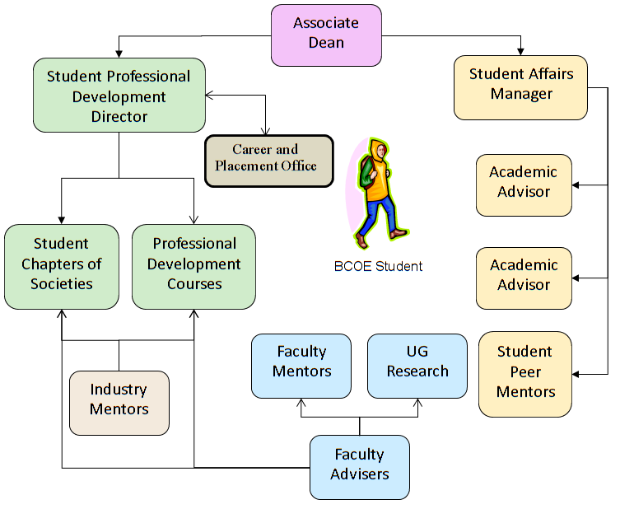

Figure 1.4. Professional development, placement, and success programs offered to BCOE undergraduate students.

Table 1.3 contains a list of the current OSAA staff, with brief biographical details. This dedicated staff has decades of combined experience. We are fortunate that there is an exceptionally low turnover rate for OSAA staff. As part of our annual surveys (more on surveys is given in Section 4 – Continuous Improvement) we survey student satisfaction with our advising by faculty and staff. The survey results from 2011 are shown in Figure 1.5. This figure compares survey results of Mechanical Engineering Students, BCOE students overall, “Select 6” students, “Carnegie Class” students, and students from all 65 universities surveyed by Engineering Benchmark Index. The “Select 6” universities, which are listed in Table 1.4, were selected by BCOE as universities that are comparable to our own. The “Carnegie Class” universities, which are listed in Table 1.5, are universities with high research activity. The complete list of 65 surveyed institutions is given in Table 1.6. Our students are generally satisfied with advising by faculty and non-faculty.

**Table 1.3.** Current staff of the Office of Student Academic Affairs.

|  |  |  |
| --- | --- | --- |
| Description: Rod Smith | Rod Smith | M.B.A., Business Administration, University of California Irvine, June 1994. 15 years in student affairs, 6 of those at BCOE. |
| Description: Tara Brown | Tara Brown | Master of Science in Counseling, College Counseling/Student Affairs. California State University, Northridge, May 2002, 9 years in student affairs, 5 of those at BCOE. |
| Description: Nikki Measor | Nikki Measor | M.S. in Higher Education and Student Affairs, Indiana University, Bloomington, May 2003. 9 years in student affairs, 2 of those at BCOE. |
| Description: Amber Scott | Amber Scott | M.S., Counseling & Guidance (Specialization in College Student Personnel), California Lutheran University, June 2007. 10 years in student affairs, 2.5 of those at BCOE. |
| Description: Terri Phonharath | Terri Phonharath | B.A., Political Science/Admin Studies, UCR, June 1998. 12 years in student affairs, 5 of those at BCOE. |
| Description: Sonia De La Torre-Iniguez | Sonia De La Torre-Iniguez | M.S., Educational Counseling and Guidance with Pupil Personnel Services Credential, CSU San Bernardino, June 2010. 9 years in student affairs, 8 of those at BCOE. |
| Description: Thomas McGraw | Thomas McGraw | M.S., Sport Management, California Baptist University, June 2006. 14 years in student affairs, 9 of those at BCOE. |
| Description: Jun Wang | Jun Wang | M.B.A., Business Administration, University of California Riverside, June 2007. 5 years in student professional development at BCOE |

**Table 1.4.** List of selected six universities used for comparison in Figure 1.5.

|  |  |
| --- | --- |
| University of California-San Diego | University of Virginia (2009) |
| University of Delaware | University of Wisconsin-Madison |
| University of Utah | Vanderbilt University |

**Table 1.5.** List of selected Carnegie Class universities used for comparison in Figure 1.5.

|  |  |
| --- | --- |
| Boston University | University of California-San Diego |
| Carnegie Mellon University | University of Connecticut |
| Columbia University | University of Delaware |
| Dartmouth College | University of Houston |
| Duke University (2009) | University of Illinois at Chicago (2009) |
| Louisiana State University | University of Kansas |
| Massachusetts Institute of Technology | University of Kentucky (2010) |
| Mississippi State University | University of Missouri-Columbia |
| Northwestern University | University of Notre Dame |
| Oregon State University | University of Rochester |
| Rice University (2009) | University of Southern California |
| Stony Brook University | University of Utah |
| The University of Texas at Austin | University of Virginia (2009) |
| University of Arkansas | University of Wisconsin-Madison |
| University of California-Riverside | Vanderbilt University |

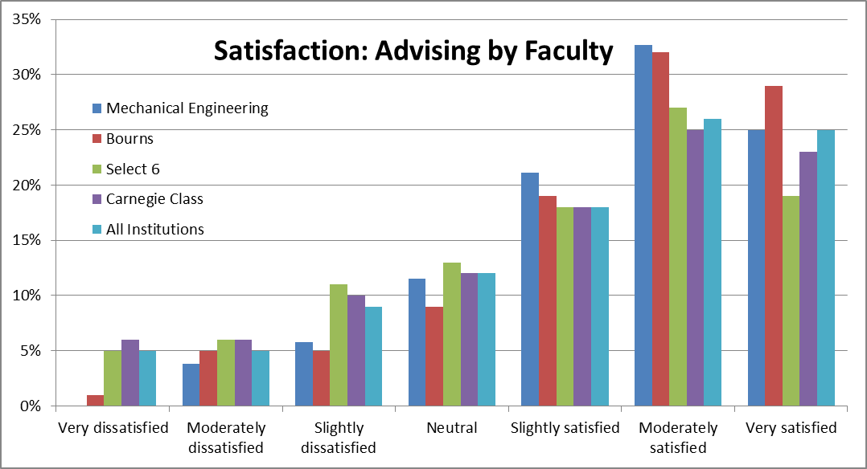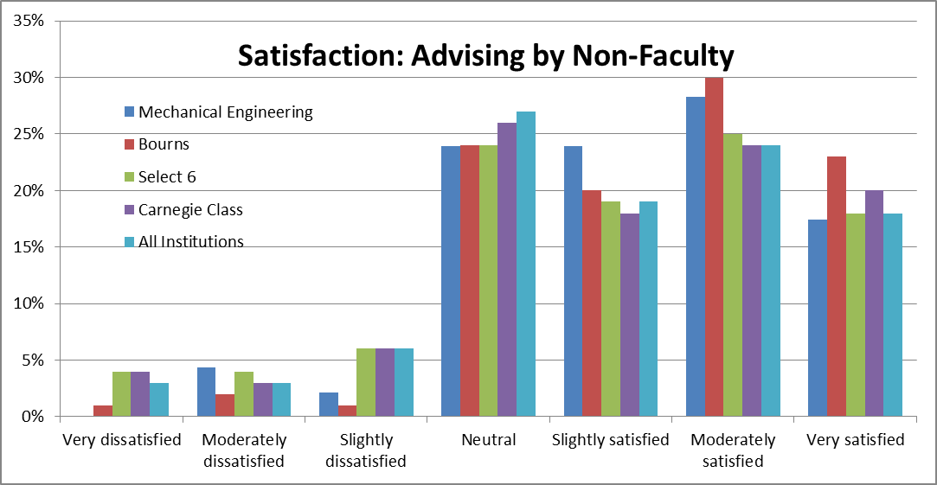

**Figure 1.5.** Student satisfaction with advising in Mechanical Engineering and BCOE from 2011 survey.

**Table 1.6.** List of all selected universities used for comparison in Figure 1.5.

|  |  |
| --- | --- |
| Auburn University | Stony Brook University |
| Boston University | Syracuse University |
| Bucknell University | Texas A & M University-Kingsville |
| California State University-Los Angeles | Texas Christian University |
| California State University-Northridge | The University of Alabama |
| California State University-Sacramento (2009) | The University of Rhode Island (2009) |
| Carnegie Mellon University | The University of Texas at Austin |
| Christian Brothers University | University of Arkansas |
| Columbia University | University of California-Riverside |
| Dartmouth College | University of California-San Diego |
| Duke University (2009) | University of Connecticut |
| Florida Atlantic University | University of Dayton |
| George Mason University | University of Delaware |
| Gonzaga University | University of Houston |
| Grove City College (2009) | University of Illinois at Chicago (2009) |
| Kettering University | University of Kansas |
| Lebanese American University | University of Kentucky (2010) |
| Louisiana State University | University of Missouri-Columbia |
| Marquette University | University of Notre Dame |
| Massachusetts Institute of Technology | University of Rochester |
| Michigan Technological University | University of San Diego (2009) |
| Mississippi State University | University of Southern California |
| National University (2010) | University of Tennessee at Chattanooga |
| Northeastern University | University of the Pacific |
| Northwestern University | University of Toledo |
| Old Dominion University | University of Utah |
| Oregon State University | University of Virginia (2009) |
| Penn State Erie, The Behrend College | University of Wisconsin-Madison |
| Prairie View A & M University | Vanderbilt University |
| Rice University (2009) | Virginia State University |
| Santa Clara University | Walla Walla University (2010) |
| Smith College | Worcester Polytechnic Institute |
| Stevens Institute of Technology |  |

Figure 1.6 presents the results of our most recent BCOE survey of student satisfaction with our academic advisors. About 25% of BCOE students responded. Overall, student satisfaction with advising is quite high. For all categories surveyed, most responses were “excellent – good”. Very few responses (well under 10%) were “fair – poor.” The "Support from Front Desk" category had the lowest score. This is not surprising as we do not currently have dedicated front-desk staff due to funding cuts. The college is currently considering remedies for this.

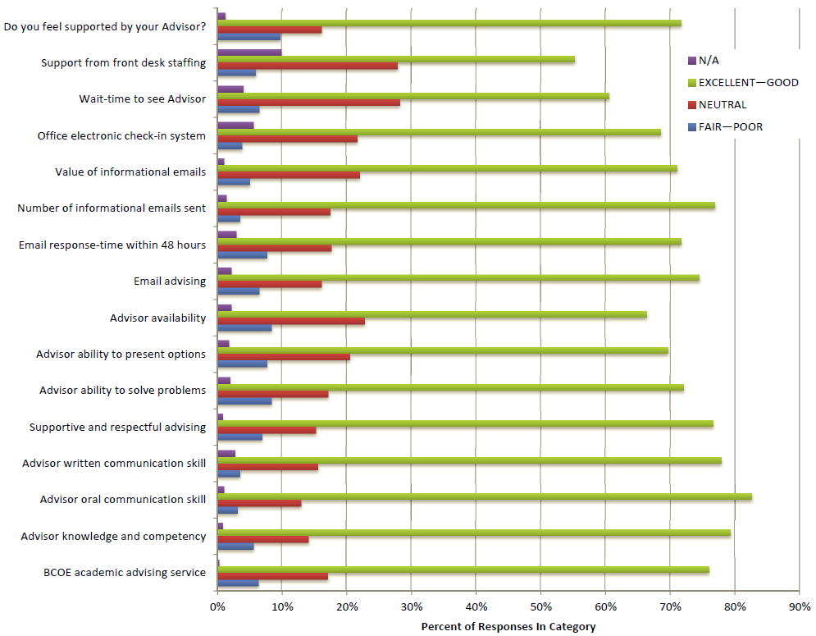

**Figure 1.6.** Student satisfaction with advising in Mechanical Engineering and BCOE from 2011 survey

**1.E. Work in Lieu of Courses**

Credit is awarded for selected International Baccalaureate Advanced Placement courses taken in high school, in accordance with the charts on pages 28-31 in the General Catalog for the University of California, Riverside.

Internships and independent study courses may not be used to satisfy College subject requirements, as per the following College regulation:

* **ENR3.2.8.** Internships and independent study courses may not be used to satisfy College subject requirements. (En 25 May 95) (Renumbered & Am 25 May 00)

Credit by Examination is awarded subject to the following College Regulations:

* **ENR2.5.1.** A student who wishes to have the privilege of examination for degree credit must be in residence and not on academic probation.
* **ENR2.5.2.** Arrangements for examination for degree credit must be made in advance with the student’s faculty advisor. The approval of the faculty advisor, the Dean of the college, and that of the instructor who is appointed to give the examination, is necessary before the examination can be given.
  + **ENR2.5.3.** The results of all examinations for degree credit are entered on the student’s record in the same manner as for regular courses of instruction.

**1.F. Graduation Requirements**

The course requirements for the Bachelor of Science in Mechanical Engineering are summarized in Table 1.7. The list of allowable technical electives and focus areas is given in Tables 1.8 and 1.9, respectively. More details of the graduation requirements are published in the 2011/12 General Catalog (<http://catalog.ucr.edu/>) on pages 73 – 76.

**Table 1.7.** Summary of required coursework for the Bachelor of Science in Mechanical Engineering (total 186 units)

|  |  |  |  |
| --- | --- | --- | --- |
|  | **Course Name** | **Number** | **Units** |
| **Lower Division (73 units)** | | | |
|  | First Year Calculus | MATH 009A | 4 |
| First Year Calculus | MATH 009B | 4 |
| First Year Calculus | MATH 009C | 4 |
| Differential Equations | MATH 046 | 4 |
| Multivariable Calculus | MATH 010A | 4 |
| Multivariable Calculus | MATH 010B | 4 |
| Cell and Molecular Biology and Lab | BIOL 5A & 5LA | 5 |
| Physics (Mechanics) | PHYS 040A | 5 |
| Physics (Heat/Waves/Sound) | PHYS 040B | 5 |
| Physics (Electricity/Magnetism) | PHYS 040C | 5 |
| General Chemistry & Lab. | CHEM 1A & 1LA | 5 |
| General Chemistry & Lab. | CHEM 1B & 1LB | 5 |
| Engineering Circuit Analysis I & Lab | EE 1A & 1LA | 4 |
| Intro to Mechanical Engineering | ME 2 | 4 |
| Engineering Graphics & Design | ME 9 | 4 |
| Statics | ME 10 | 4 |
| Intro to Engineering Computations | ME 18 | 3 |
| **Upper Division (77 units)** | | | |
|  | Introduction to Statistics | STAT 100A | 5 |
| Thermodynamics | ME 100A | 4 |
| Dynamics | ME 103 | 4 |
| Mechanics of Materials | ME 110 | 4 |
| Fluid Mechanics | ME 113 | 4 |
| Intro to Materials Science & Engineering | ME 114 | 4 |
| Heat Transfer | ME 116A | 4 |
| Mechanical Engr. Modeling & Analysis | ME 118 | 4 |
| Linear Systems and Control | ME 120 | 4 |
| Transport Phenomena | ME 135 | 4 |
| Experimental Techniques | ME 170A | 4 |
| Experimental Techniques | ME 170B | 4 |
| Machine Design | ME 174 | 4 |
| Professional Topics | ME 175A | 2 |
| Mechanical Engineering Design | ME 175B | 3 |
| Mechanical Engineering Design | ME 175C | 3 |
| Four technical electives must be selected from a focus area. The list of technical electives and focus areas is given in Tables 1.7 and 1.8, respectively. | | 16 |
| **Breadth Requirements (12 units of English + 24 breadth = 36 units)** | | | |
|  | **English Composition** | | |
| Beginning Composition | ENGL 001A | 4 |
| Intermediate Composition | ENGL 001B | 4 |
| Applied Intermediate Composition | ENGL 001C | 4 |
| **Humanities (three courses total, one from each of the following)** | To provide depth in satisfying breadth in the humanities and social sciences, at least two of the courses must be upper division. And at least two courses, one of them upper division, must be from the same subject area. The list of approved courses is available in the Office of Student Academic Affairs. |  |
| World History | 4 |
| Fine Arts, Literature, Philosophy or Religious Studies | 4 |
| Human Perspectives on Science, & Technology | 4 |
| Ethnicity, one course, may overlap a course in Humanities or Social Sciences |  |
| **Social Sciences (three courses total, be selected from the following)** |  |
| Economics or Political Science | 4 |
| Anthropology, Psychology or Sociology | 4 |
| General Social Science | 4 |
| **Total units: 73 + 77 + 36 = 186** | | | |

**Table 1.8.** List of available technical electives. All technical electives are 4 unit courses.

|  |  |
| --- | --- |
| **Technical Elective Course Name** | **Course Number** |
| Thermodynamics | ME 100B |
| Heat Transfer | ME 116B |
| Combustion & Energy Systems | ME 117 |
| Feedback Control | ME 121 |
| Vibrations | ME 122 |
| Kinematic and Dynamic Analysis of Mechanisms | ME 130 |
| Design of Mechanisms | ME 131 |
| Introduction to Mechatronics | ME 133 |
| Environmental Impacts of Energy Production & Conversion | ME 136 |
| Environmental Fluid Mechanics | ME 137 |
| Transport Phenomena in Living Systems | ME 138 |
| Ship Theory | ME 140 |
| Finite Element Methods | ME 153 |
| Mechanical Behavior of Materials | ME 156 |
| Sustainable Product Design | ME 176 |
| Optics and Lasers in Engineering | ME 180 |
| Research for Undergraduates* | ME 197* |

*To enroll in and earn Technical Elective credit for ME 197, students must complete a project abstract using a standard template. The abstract must be signed by the project faculty advisor and submitted to the Undergraduate Program Committee chair at least one week prior to the start of the quarter of enrollment. A final project report is required. For details, please see: <http://www.me.ucr.edu/undergrad/opportunities.html>

**Table 1.9.** Four focus areas and list of eligible technical electives

|  |  |
| --- | --- |
| **Focus Area** | **Eligible Technical Electives** |
| General Mechanical Engineering | Any four from the Table 1.8 |
| Energy and Environment | ME 100B, ME 116B, ME 117, ME 136, ME 137, ME 138, ME 197 |
| Design and Manufacturing | ME 121, ME 122, ME 130, ME 131, ME 133, ME 140, ME 153, ME 156, ME 176, ME 180, ME 197 |
| Materials and Structures | ME 100B, ME 116B, ME 121, ME 122, ME 153, ME 156, ME 180, ME 197 |

**1.G. Transcripts of Recent Graduates**

The program will provide transcripts from recent graduates to the visiting team along with an explanation of their interpretation. The program name and the focus area selected by the student are clearly stated in the transcript.

**1.H. Diversity in the Bourns College of Engineering**

**Figure 1.7.** Associate Dean C.V. Ravishankar, left, accepts the 2009 Claire Felbinger Award from ABET President-Elect David Holger.

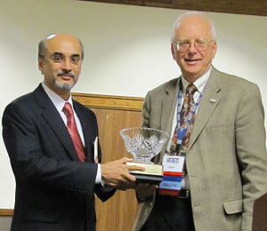

The Bourns College of Engineering is proud to be one of the most diverse engineering colleges in America. The number of domestic undergraduates from underrepresented backgrounds jumped 95.6% from the fall of 2006 to the fall of 2010 (the most recent academic year for which full data are available) (Table 1.10). In recognition of our efforts to recruit and retain students from diverse backgrounds to engineering, ABET awarded the Bourns College of Engineering the 2009 Claire Felbinger Award for Diversity (Figure 1.7). Our citation read: “In recognition of extraordinarily successful initiatives for recruiting undergraduate and graduate students from diverse and disadvantaged backgrounds, retaining them though the bachelor's degree, and advancing them to graduate studies and careers in engineering." Our faculty and staff truly appreciate this recognition of their efforts by ABET.

**Table 1.10.** The number of domestic undergraduates from underrepresented backgrounds in the Bourns College of Engineering has nearly doubled since 2006.

|  |  |  |  |  |  |
| --- | --- | --- | --- | --- | --- |
|  | Fall 2006 | Fall 2007 | Fall 2008 | Fall 2009 | Fall 2010 |
| Undergraduate: % domestic underrepresented | 27% | 29% | 31% | 31% | 33% |
| Undergraduate: # domestic underrepresented | 340 | 377 | 449 | 521 | 665 |
| Undergraduate: % domestic female | 12% | 12% | 15% | 17% | 17% |
| Undergraduate: # domestic female | 151 | 156 | 222 | 291 | 348 |
| Graduate: % domestic underrepresented | 16% | 21% | 18% | 16% | 17% |
| Graduate: # domestic underrepresented | 14 | 24 | 27 | 24 | 32 |

**1.I. Student Tracking Report**

Students in the Mechanical Engineering program are encouraged to meet frequently with their Academic Advisor to discuss their progress in the curriculum. During these appointments, Academic Advisors will:

• Review student academic performance in required coursework

• Review the suggested course plan

• Work with the student to create a personalized plan to complete the remaining degree requirements.

Any approved exceptions to degree requirements are recorded in a student’s electronic file.

In the past, students were required to participate in Annual Major Advising. During this annual spring event, the Faculty Advisor would review any changes to the curriculum and Academic Advisors would review any changes to academic policy. To better address the needs of students, we have replaced our Annual Major Advising program with our Academic Advising Milestones Program. The latter program identifies key benchmarks throughout a student’s educational career. Through group workshops and any necessary follow-up appointments, Academic Advisors facilitate students’ self-evaluation of progress in the curriculum and academic planning. Separate advising is provided to each class of students on an annual basis as follows:

* + Freshmen: At the end of the first year, students are required to assess their academic performance and create a plan to be successful in their second year.
  + Sophomores: During the second year, students are required to gauge their progress in the curriculum by evaluating their completion of key prerequisites in their major.
  + Juniors: During the third year, students are required to attend a group mentoring session conducted by the Faculty Advisor who reviews professionalism, co-curricular opportunities like undergraduate research, and preparation for technical electives.
  + Seniors: In a student’s fourth year, the Academic Advisor reviews a student for graduation to assure that all graduation conditions will be met on time.

To ensure that all students participate in this program, each year a hold is placed on their registration until they complete the program.

# CRITERION 2. PROGRAM EDUCATIONAL OBJECTIVES

**2.A. Mission Statement**

The University of California, Riverside serves the needs and enhances the quality of life of the diverse people of California, the nation and the world through knowledge – its communication, discovery, translation, application, and preservation. The undergraduate, graduate and professional degree programs; research programs; and outreach activities develop leaders who inspire, create, and enrich California’s economic, social, cultural, and environmental future.

With its roots as a Citrus Experiment Station, UC Riverside is guided by its land grant tradition of giving back by addressing some of the most vexing problems facing society. Whether it is assuring a safe, nutritious, and affordable food supply; stimulating the human mind and soul through the humanities and arts; or finding solutions to the profound challenges in education, engineering, business, healthcare, and the environment, UC Riverside is living the promise.

The mission of the Bourns College of Engineering is to:

* Produce engineers with the educational foundation and adaptive skills to serve rapidly evolving technology industries;
* Conduct nationally recognized engineering research focused on providing a technical edge for the United States;
* Contribute to knowledge of both fundamental and applied areas of engineering;
* Provide diverse curricula that will instill in our students the imagination, talents, creativity, and skills necessary for the varied and rapidly changing requirements of modern life;
* Enable our graduates to serve in a wide variety of other fields that require leadership, teamwork, decision-making and problem-solving abilities; and
* Be a catalyst for industrial growth in the Inland Empire region of Southern California (Riverside, San Bernardino, and Ontario metropolitan areas).

The vision of the Bourns College of Engineering is to become a nationally recognized leader in engineering research and education.

In agreement with the College vision, the vision of the Department of Mechanical Engineering is to be nationally recognized as an innovator in both research and education in mechanical engineering. Its mission is to provide quality education, conduct strong research, foster close partnership with industry and government, and provide related service to the campus community and the community at large. The department mission is guided by a commitment to continuous improvement in the overall quality of teaching, research, and service, while adhering to the highest standard of ethics. This mission is used in formulating the Program Educational Objectives which are described next.

**2.B. Program Educational Objectives**

The Mechanical Engineering Program Educational Objectives are to produce mechanical engineers who:

* Have the knowledge and skills to adapt to the changing engineering environment in industry.
* Are able to pursue and succeed in graduate studies.
* Have the educational breadth and the intellectual discipline required to enter professional careers outside engineering, such as business and law.
* Have an ability to work in multi-disciplinary teams.
* Engage in a lifetime of learning.

These Program Educational Objectives are published in the Mechanical Engineering section of the UCR General Catalog (<http://catalog.ucr.edu/UCR_Catalog_2011-12.pdf>, page 339) and on the Department web site (<http://cmsme.engr.ucr.edu/undergrad/>).

These objectives are met through:

* Strong training in the areas of mathematics, science, and the fundamentals of mechanical engineering that comprise the discipline.
* Laboratory and hands-on experience to strengthen the understanding of fundamental principles, with opportunities for teamwork and written and oral communication.
* Extensive use of computer simulation and modeling in the solution of problems and for design.
* Application of engineering principles to the solution of design problems typical of modern mechanical engineering practice.
* Coverage of design for manufacturability, engineering economics, and engineering ethics to emphasize the relationship between design, fabrication, cost, and impact on society.
* Flexibility in the curriculum enabling students to personalize their studies. Each student may chose a focus area and technical electives within that focus. Likewise, students may participate in independent research, and can select from a variety of senior design projects, typically sponsored by industry or government agencies.
* A well-rounded and balanced education with required studies in selected areas of the Humanities and Social Sciences.

We implemented these Program Educational Objectives after our 2006 accreditation. We had actually developed these Program Educational Objectives during a Board of Advisors (BOA) meeting held in May 2006, just prior to that accreditation, but did not implement them at that time. Based on suggestions received from ABET during our 2006 cycle, we implemented these Program Educational Objectives immediately after the completion of the 2006 accreditation process. During subsequent BOA meetings and annual departmental retreats, we continually reviewed these objectives but did not change them. During our most recent stakeholders meeting (May 2012), we again revisited our Program Educational Objectives. The discussion resulted in the following candidate objectives:

Mechanical Engineering graduates will be able to:

* solve complex system level problems
* succeed in graduate studies
* pursue professional careers of their choice outside of mechanical engineering
* lead multidisciplinary teams

The stakeholders recommended removing “engagement in lifetime of learning” as a Program Educational Objective because it is already a Student Outcome. The discussion at the meeting also considered needed adjustments to the curriculum and the capstone design experience if the new Program Educational Objectives are to be adopted. The stakeholders decided that further discussion of the proposed Program Educational Objectives is necessary. Thus, these new objectives have not yet been adopted.

**2.C. Consistency of the Program Educational Objectives with the Mission of the Institution**

Superimposed on the UCR mission are the strategic goals articulated by the Chancellor and elaborated in a strategic plan titled “The Path to Preeminence - A Living Document to Guide our Future”. This plan is available at: <http://strategicplan.ucr.edu/ucr2020.html>. The document outlines the following four strategic goals:

1. Academic Excellence – Developing a Preeminent Research University for the 21st Century
2. Access – Enhancing Opportunity for Graduate, Professional and Undergraduate Students
3. Diversity – Serving as a National Exemplar for Diversity, Inclusion and Community
4. Engagement – Shaping our World

The vision of the Bourns College of Engineering and its mission are directly related to the strategic goal of Academic Excellence and Engagement. The broad creation and transmission of knowledge in UCR’s mission is consistent with the College mission to provide our students with a diverse curriculum that will engender their creativity in a rapidly changing environment. The components of the mission of the Bourns College of Engineering relevant to the undergraduate program in Mechanical Engineering are:

- To produce engineers with the educational foundation and the adaptive skills to serve rapidly evolving technology industries.

- To provide diverse curricula that will instill our students with the imagination, talents, creativity and skills necessary for the varied and rapidly changing requirements of modern life and to enable them to serve in a wide variety of other fields that require leadership, teamwork, decision making, and problem solving abilities.

- To be a catalyst for industrial growth in the Inland Empire

The College mission is to produce engineers who can function in technology industries. This enables translation of their knowledge for the good of the public, consistent with the University mission and the Mechanical Engineering program educational objectives. The notion of engineers working successfully in interdisciplinary teams that require technical and non-technical expertise is emphasized in the college mission and Program Educational Objectives. Specifically, an ability to write technical reports and to present technical material orally with suitable visual aids is emphasized in the program experience. The program aims to offer opportunities for undergraduate research experience as a means to motivate graduates to pursue advanced graduate degrees in mechanical engineering and other fields.

Thus our Program Educational Objectives are consistent with the mission of the Bourns College of Engineering and the University of California, Riverside.

**2.D. Program Constituencies**

The stakeholders of our program are mechanical engineering undergraduate and graduate students, program faculty and lecturers, program alumni, employers in industry, and representatives from graduate schools. The Department of Mechanical Engineering has a Board of Advisors (BOA), currently comprised of 19 members representing a wide range of industries. The primary purpose of the BOA is to provide insight and counsel to the Chair and members of the faculty in defining the future direction of the department, its curriculum and degree programs (BS, MS, BS/MS and PhD), and research directions. Typically, the Board convenes once every two years for a day to discuss current issues. On occasion, the Chair may also call upon Board members for individual advice and input. Areas for which the Chair may seek counsel include, but are not limited to:

* + Industry trends and needs
  + Industry collaboration opportunities
  + Centers of excellence
  + Program expansion
  + Industry recruitment process, internship and employment opportunities for our students
  + Consultation as stakeholder in our ABET accreditation process

Given the significant industrial experience of our BOA, it serves as a vital link to the employer constituency. A list of the Mechanical Engineering Department’s Board of Advisors is given in Table 2.1. Our Program Educational Objectives are a direct result of the needs of our constituencies.

**Table 2.1.** Mechanical Engineering Department Board of Advisors/Stakeholders

|  |  |
| --- | --- |
| **Name** | **Affiliation** |
| Mr. Barry J. Nawa | Boeing |
| Mr. Thanh Nguyen | Bourns Inc. |
| Mr. Mark Hontz | Raytheon, Space & Airborne Systems |
| Dr. Wallace Brithinee | Brithinee Electric |
| Mr. Arman Hovakemia | Naval Surface Warfare Center |
| Mr. Ashish Gupta | Intel Corporation |
| Mr. LaRon Scott | Naval Surface Warfare Center |
| Mr. Feng Sun | LA Turbine |
| Dr. Khoo Ooi | Meggit Airdynamics |
| Mr. Craig Philips | Ironman |
| Mr. Rod Hoover | California Steel Industries Inc. |
| Mr. Steve Frietas | Control Components |
| Mr. Humberto (Bert) Acuna, Jr. | California Steel Industries |
| Professor Donald Dabdub | University of California Irvine |
| Professor Michael McCarthy | University of California Irvine |
| Professor Sutanu Sarkar | University of California San Diego |
| Professor Hidenori Murakami | University of California San Diego |
| Professor Manuel Gamero-Castano | University of California Irvine |
| Professor Jean-Pierre Delplanque | University of California Davis |

**2.E. Process for Revision of the Program Educational Objectives**

The procedures for reviewing and refining our Program Educational Objectives and assessment methodology are:

* Program Educational Objectives are reviewed by the program faculty annually at a department planning retreat for faculty and lecturers (typically in September each year).
* An update of our assessment procedure and a review of our overall objectives are carried out as part of the agenda of Board of Advisors and stakeholders meetings (on average once every two years)
* Program Educational Objectives guide our assessment process review at faculty meetings (monthly during the 9 month academic year).

# CRITERION 3. STUDENT OUTCOMES

This section describes Student Outcomes and their relation to the Program Educational Objectives. Our process for evaluating outcomes and our process for applying assessment results to further improve the program is described in the subsequent section – Continuous Improvement.

**3.A. Student Outcomes**

To prepare students to attain the Program Educational Objectives we adopted the ABET outcomes (a) through (k). At the time of graduation, graduates will possess:

(a) an ability to apply knowledge of mathematics, science, and engineering

(b) an ability to design and conduct experiments, as well as to analyze and interpret data

(c) an ability to design a system, component, or process to meet desired needs within realistic constraints such as economic, environmental, social, political, ethical, health and safety, manufacturability, and sustainability

(d) an ability to function on multidisciplinary teams

(e) an ability to identify, formulate, and solve engineering problems

(f) an understanding of professional and ethical responsibility

(g) an ability to communicate effectively

(h) the broad education necessary to understand the impact of engineering solutions in a global, economic, environmental, and societal context

(i) a recognition of the need for, and an ability to engage in life-long learning

(j) a knowledge of contemporary issues

(k) an ability to use the techniques, skills, and modern engineering tools necessary for engineering practice.

These student outcomes are available on our website <http://www.me.ucr.edu/undergrad/>

**3.B. Relationship of Student Outcomes to Program Educational Objectives**

Several discussions were conducted, both formally and informally, among members of the stakeholder group to establish consistency between our Program Educational Objectives and our Student Outcomes. The current set of Program Educational Objectives is the result of a meeting of the stakeholder group held in 2006. The group believed that the objectives should be relatively small in number, stated as simply as possible, not overlap with each other, and be consistent with the attainment of Program Educational Objectives. Also, these Program Educational Objectives reflect ABET’s recommendation that the program should consider rewording educational objectives to better describe accomplishments of their students three to five years after graduation. The current set of Program Educational Objectives is:

The Mechanical Engineering program objectives are to produce mechanical engineers who:

1. Have the knowledge and skills to adapt to the changing engineering environment in industry.
2. Are able to pursue and succeed in graduate studies.
3. Have the educational breadth and the intellectual discipline required to enter professional careers outside engineering, such as business and law.
4. Have an ability to work in multi-disciplinary teams.
5. Engage in a lifetime of learning.

The Program Educational Objectives are strongly related to the Student Outcomes. Figure 3.1 qualitatively depicts the most significant influences of the latter on the former.

|  |  |  |  |  |  |
| --- | --- | --- | --- | --- | --- |
| **Objectives/ Student Outcomes** | **1**- Adapt to changing industry | **2**- Pursue graduate studies | **3**- Pursue other professions | **4** - multi-disciplinary teams | **5** - lifetime of learning |
| (a) math, science, and engineering |  |  |  |  |  |
| (b) design and conduct experiments, analyze and interpret data |  |  |  |  |  |
| (c) design a system, component, or process |  |  |  |  |  |
| (d) function on multidisciplinary teams |  |  |  |  |  |
| (e) identify, formulate, and solve |  |  |  |  |  |
| (f) professional and ethical responsibility |  |  |  |  |  |
| (g) communicate effectively |  |  |  |  |  |
| (h) broad education |  |  |  |  |  |
| (i) life-long learning |  |  |  |  |  |
| (j) contemporary issues |  |  |  |  |  |
| (k) techniques, skills, and modern engineering tools |  |  |  |  |  |

**Figure 3.1.** Relationship between Student Outcomes (rows) and Program Educational Objectives. Red indicates a significant relationship.

The stakeholder group felt that translating these qualitative impacts presented in Figure 3.1 into numbers could be misleading. On the other hand, it was important to ensure that the Student Outcomes fostered the attainment of Program Educational Objectives by being related to as many objectives as possible; every Student Outcomes influences at least two of the Program Educational Objectives. Note that the “non-technical” Student Outcomes (h), (i), and (j) are closely tied to Program Educational Objectives 3, 4, 5. The “technical” Student Outcomes (a), (b), (c), (e), and (k) are designed to foster the attainment of Program Educational Objectives 1 and 2.

By way of an example, let us consider how Student Outcome (a), an ability to apply knowledge of mathematics, science, and engineering, speaks to four of the five Program Educational Objectives. As a review of the curriculum and course files will show, ME graduates are well-grounded in the mathematics, science, and engineering concepts that they will need to begin their careers or pursue higher studies. Because ME students learn in a highly interdisciplinary environment, and because science and engineering touches on so many fields, our students are exposed to examples of engineering challenges from many domains ranging from biomedical technology to energy and the environment. Because faculty members are encouraged to draw on examples from their own research in their teaching, undergraduates understand the pace of technological change and the many domains in which the concepts they are learning are applicable (Program Educational Objectives 1, 2, and 5). They also learn about typical constraints on engineering solutions, such as physical, economic, and sociopolitical constraints. This training speaks to Program Educational Objective 3.

# CRITERION 4. CONTINUOUS IMPROVEMENT

**4.A. Program Educational Objectives**

As stated before, the Mechanical Engineering Program Educational Objectives are to produce mechanical engineers who:

1. Have the knowledge and skills to adapt to the changing engineering environment in industry.
2. Are able to pursue and succeed in graduate studies
3. Have the educational breadth and the intellectual discipline required to enter professional careers outside engineering, such as business and law
4. Have an ability to work in multi-disciplinary teams.
5. Engage in a lifetime of learning.

The ME department uses alumni surveys, employer surveys, and feedback from our board of advisors to assesses the program objectives. For example, our alumni surveys include questions about our alumni’s pursuit of graduate studies.

Table 4.1 summarizes the processes and instruments that Mechanical Engineering program uses to evaluate its Program Educational Objectives. A discussion of the mechanisms follows the table.

**Table 4.1.** Mechanisms for evaluating attainment of the Mechanical Engineering Program Educational Objectives.

|  |  |
| --- | --- |
| **Mechanism** | **Frequency** |
| Alumni surveys (Appendix F) | Every year |
| Employer surveys (Appendix G) | Every year |
| Board of Advisors/Stakeholders meetings | Every 2 years |
| Informal feedback | Intermittent |

* Alumni surveys: The Bourns College of Engineering uses SurveyMonkey, a web-based surveying tool, to conduct surveys of alumni and employers. By conducting surveys annually, we are able to obtain multiple survey responses from each alumnus. The survey questions are given in Appendix F.
* Employer surveys: We use SurveyMonkey to ask employers about the qualities of our alumni. When we send a survey to our alumni, we ask them to forward a message to their supervisors with a link to the employer survey. Our experience, however, has been that the return rate for the employer survey is generally poor. We hypothesize that some of our alumni do not feel comfortable asking their supervisors to complete a survey, and that some employers do not respond because they are fearful of legal consequences. Our Board of Advisors confirmed the latter concern during a board of advisors meeting. The survey questions are given in Appendix G.
* Board of Advisors meetings: We strive to include on our board companies that hire our alumni so that they can provide feedback on our program from the perspective of an employer.
* Informal feedback: We obtain information from the UCR Career Center about placement of our alumni and their career progress. UCR’s Alumni Affairs office makes efforts to track our alumni. Further, alumni often come back to visit the department or otherwise contact faculty members for recommendations when they apply to graduate school or jobs (or are seeking graduate fellowships). While these informal contacts do give us a sense of how our students perform after graduation, this information does not come in a consistent enough format for a data-driven analysis of our Program Educational Objectives.

We expect that all of our graduates will attain all of our Program Educational Objectives. More specifically, we expect that all graduates will have the ability to succeed in industry, graduate studies, and professions outside of engineering. However, we expect that our students will typically pursue only one of these career paths during the first three to five years after graduation.

Figures 4.1 shows the achievement of Program Educational Objectives as assessed by alumni responding to our on-line survey. To better gauge the achievement of alumni 3 to 5 years after graduation, the survey data is sorted by graduation year: students who graduated by 2006 (29 respondents), students who graduated by 2007 (39 respondents), and students who graduated by 2008 (47 respondents). (See the bottom panel of Figure 4.3. for the distribution of respondents by graduation year.) Note that these categories overlap. For example, all of the students in the first group of alumni are also included in the second. Survey data from students who graduated after 2008 is not included because those students have not yet had three to five years after graduation to achieve the Program Educational Objectives (surveys are conducted in November each year, with the last survey in November 2011). In the figures, the horizontal axis lists the possible answers, which range from 1 to 5, with 5 indicating the highest level of achievement of the Program Educational Objective. The vertical axis provides the percent of respondents giving each of the possible responses. For example, 20% of students who graduated by 2006 provided a score of 5 for their achievement of objective 1, 30% provided a score of 4, 18% provided a score of 3, and 10% provided a score of 2. There are no statistically significant differences in the responses from the three alumni groups.

Figure 4.1 indicates that the ME program received high scores for the achievement of three of the five objectives. However, the alumni are less satisfied with their ability to succeed in graduate study and with their ability to pursue careers outside engineering. These are areas in which improvement is needed. We have already begun to remedy the first of these two issues. The new mentoring program we created for high-achieving freshmen (see Criterion 1, Section D) is designed to encourage these students to participate in undergraduate research and pursue graduate studies after completion of their undergraduate degrees. We also plan to augment our alumni surveys to determine how our alumni who enroll in graduate school feel prepared, and how many of them actually obtain graduate degrees.

Figure 4.2 shows our achievement of Program Educational Objectives as assessed by industry representatives responding to on-line surveys in November 2010 and 2011. These surveys are sent to all employers that hire our students. Surveys prior to 2010 had very few responses. We had extensive discussions during our Board of Advisors meetings about how to improve the response rate of employers. Our industry representatives indicated that there are numerous legal implications to providing feedback on employees. With this in mind, we redesigned our survey to state the questions more broadly and thus avoid legal concerns. This change in the survey design lead to a modest improvement in the response rate. A total of 20 companies responded in 2010 and 13 in 2011. Figure 4.2 shows the responses to two questions related to our Program Educational Objectives. The first question (left side of Figure 4.2) is: “We design our curriculum to enable our graduates to succeed in the following areas. Please provide feedback on how successful our program is in each of these areas.” The second question (the right side of Figure 4.2) is: “What importance do you place on each of the criteria we use?”

The industry representatives we surveyed appear to be pleased with the performance of our alumni. However, they do not place high importance on the ability to pursue and succeed in graduate studies. The most important Program Educational Objectives for industry are the ability to adapt to the changing environment in industry and the ability to work in multidisciplinary teams. We did not survey graduate schools that enroll our alumni as graduate students. We plan to do so in the future.

We also survey our seniors about their perceptions of their preparedness to achieve the Program Educational Objectives. Senior survey questions are given in Appendix H. We do not report this data here, because Program Educational Objectives are to be achieved three to five years after graduation, rather than immediately upon graduation.

Finally, we monitor the success of our alumni at entering the work force. Results from our most recent survey, which included 67 respondents from graduation years 1998 – 2011, are shown in Figure 4.3. The bottom panel of the figure shows the number of respondents from each graduating class. The top panel shows the time it takes our graduates to obtain their first job offer, while the middle panel shows their starting salary. More than 60% of the respondents obtained their first job offer within 6 months of graduation, while 25% took a year or longer to obtain employment. About 45% of respondents had a starting salary between $40,000 and $60,000, while 35% had a starting salary less than $40,000. It is possible that this employment data is negatively affected by current economic difficulties. Riverside has a higher unemployment rate than much of Southern California, hitting a peak of 15.3% in August 2010[3]. In the current job climate, it is possible that some of the respondents took part-time jobs. In future surveys, we will explicitly inquire about the level of employment.

Based on these surveys, we can conclude that our alumni are satisfied with the quality of the education they received in the Mechanical Engineering program at UCR. However, some of our graduates do have difficulty obtaining high-paying jobs soon after graduation.

**How did the UCR Mechanical Engineering program prepare you for each of the following?**

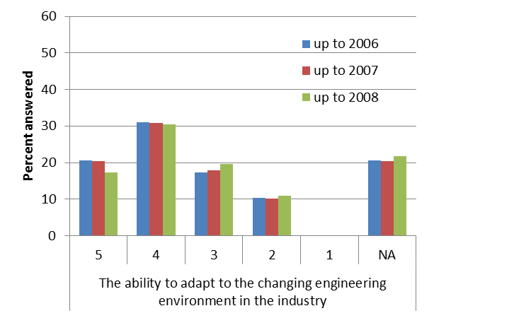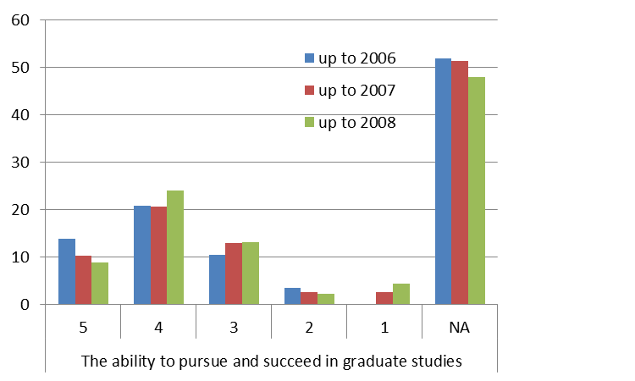

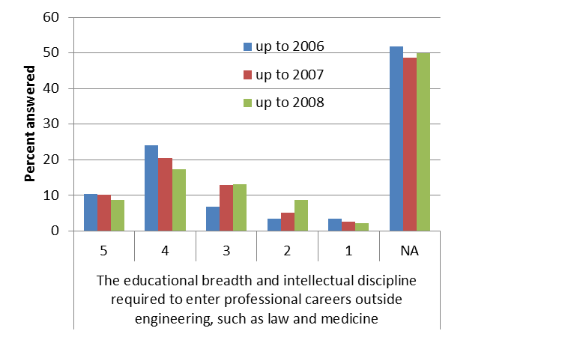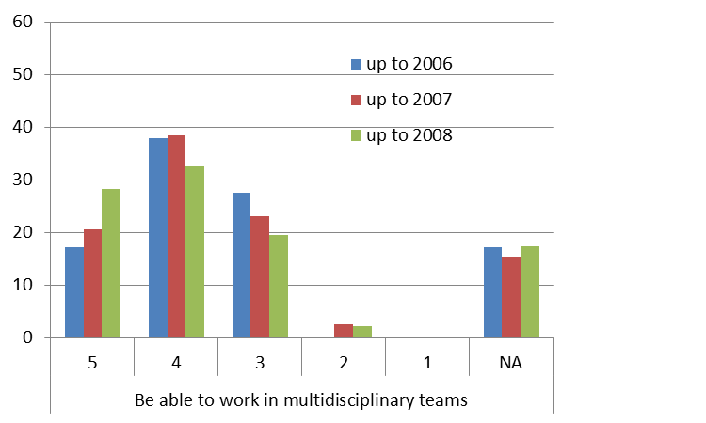

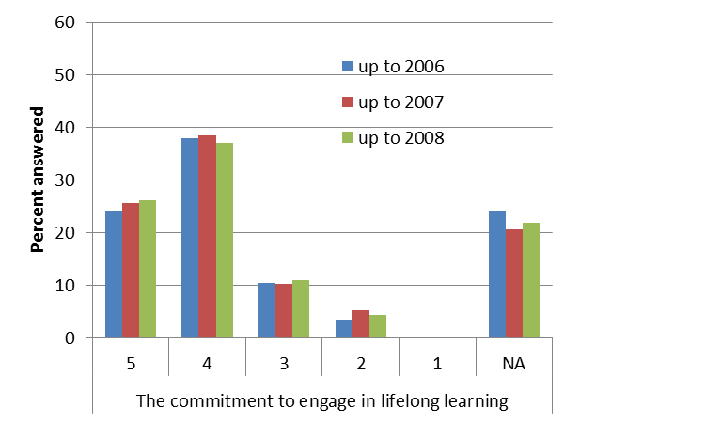

**Figure 4.1.** Alumni assessment of achievement of Program Educational Objectives. Data is presented for alumni who graduated by 2006 (“up to 2006”), by 2007 (“up to 2007”), and by 2008 (“up to 2008”). Note that these categories overlap. For example, all of the students in the first group are also in the second. The data represents students’ perceptions of their achievement of the Program Educational Objectives three to five years after graduation. The survey question is: “How did the UCR Mechanical Engineering program prepare you for each of the following?”

**How successful is our program in each of these areas?**

**What importance do you place on each of the criteria we use?**

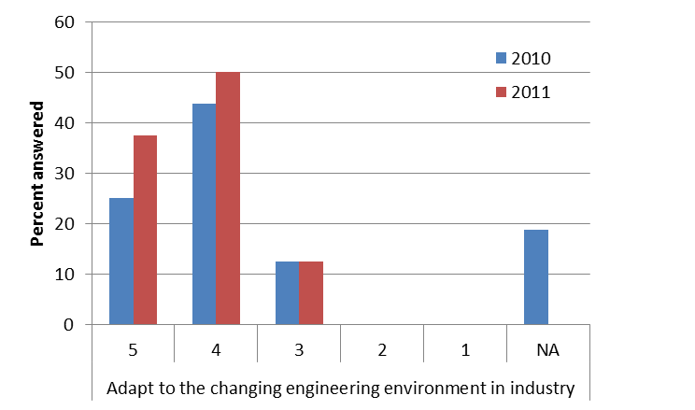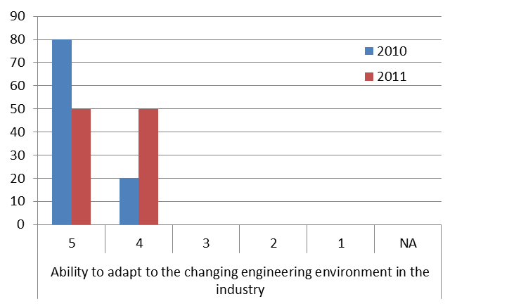

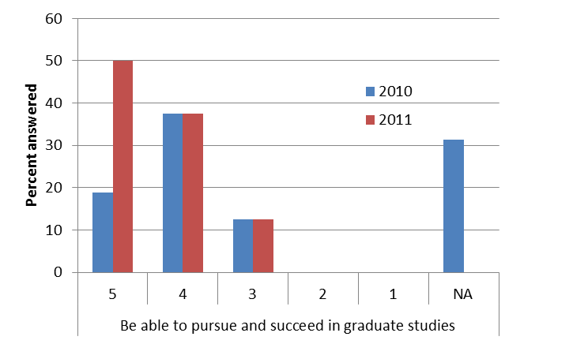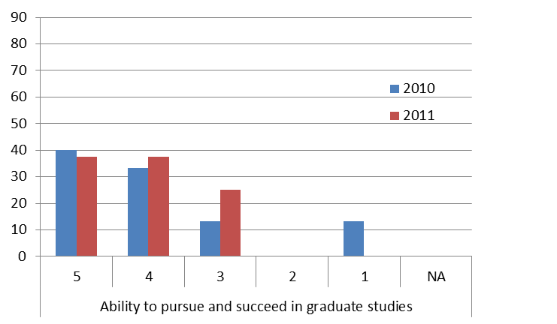

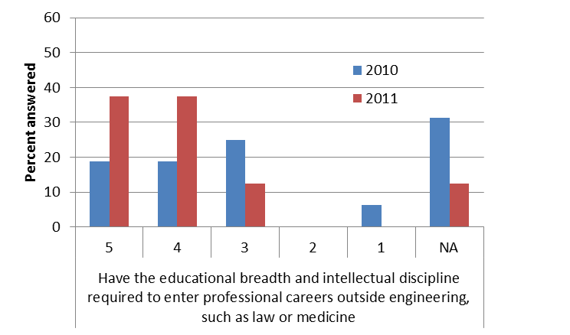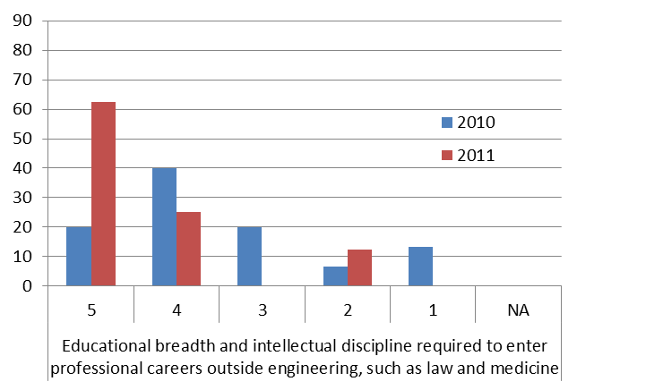

**Figure 4.2.** Industry representatives’ assessment of Program Educational Objectives from surveys conducted in 2010 and 2011. Plots on the left represent answers to: “We design our curriculum to enable our graduates to succeed in the following areas. Please provide feedback on how successful our program is in each of these areas.” Plots on the right side represent answers to: “What importance do you place on each of the criteria we use? Scale: 5 = Very Successful/Important, 1 = Not Successful/Important. Continued on the next page.

**How successful is our program in each of these areas?**

**What importance do you place on each of the criteria we use?**

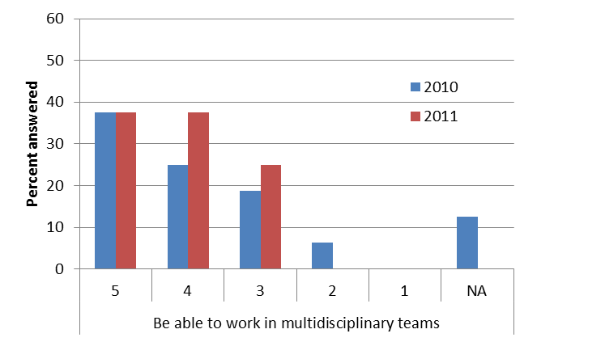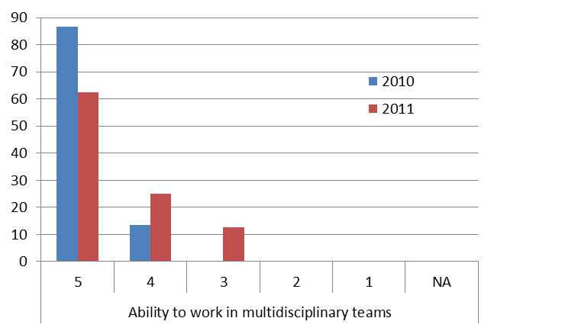

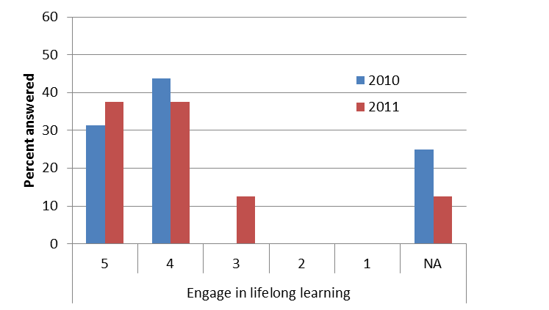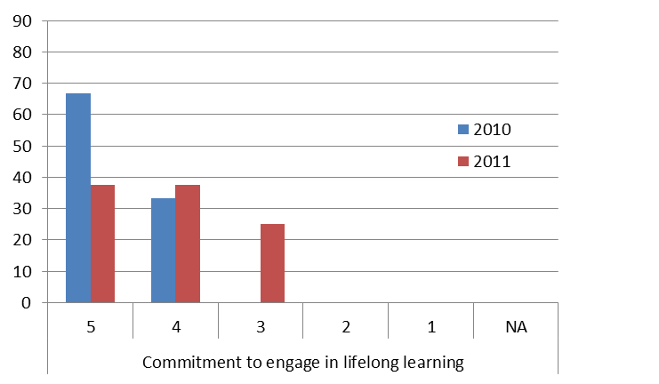

**Figure 4.2** **(continuation).** Industry representatives’ assessment of Program Educational Objectives from surveys conducted in 2010 and 2011. Plots on the left represent answers to: “We design our curriculum to enable our graduates to succeed in the following areas. Please provide feedback on how successful our program is in each of these areas.” Plots on the right side represent answers to: “What importance do you place on each of the criteria we use? Scale: 5 = Very Successful/Important, 1 = Not Successful/Important.

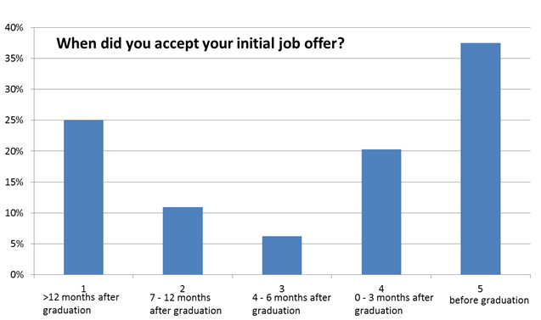

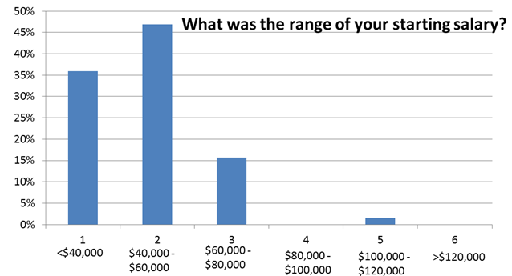

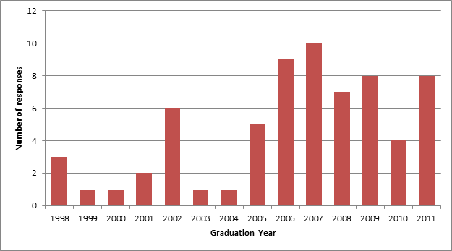

**Figure 4.3.** Responses to alumni survey about success at entering the work force for all graduating classes from 1998 to 2011. Data for all graduating classes are combined. (Top) Time required to obtain the first job offer. (Middle) Starting salary for graduates. (Bottom) Number of respondents for each graduation year.

**4.B. Student Outcomes**

To prepare students to attain our Program Educational Objectives we adopted the ABET Student Outcomes (a) through (k):

(a) an ability to apply knowledge of mathematics, science, and engineering

(b) an ability to design and conduct experiments, as well as to analyze and interpret data

(c) an ability to design a system, component, or process to meet desired needs within realistic constraints such as economic, environmental, social, political, ethical, health and safety, manufacturability, and sustainability

(d) an ability to function on multidisciplinary teams

(e) an ability to identify, formulate, and solve engineering problems

(f) an understanding of professional and ethical responsibility

(g) an ability to communicate effectively

(h) the broad education necessary to understand the impact of engineering solutions in a global, economic, environmental, and societal context

(i) a recognition of the need for, and an ability to engage in life-long learning

(j) a knowledge of contemporary issues

(k) an ability to use the techniques, skills, and modern engineering tools necessary for engineering practice.

**4.B.1. Student Outcome Assessment through Course Assignments**

Achieving the Student Outcomes in the Mechanical Engineering program requires students to complete courses in Mechanical Engineering and other departments across the campus.

Each course has a set of *course objectives* (not to be mistaken with Program Educational Objectives). These course objectives are designed so that our overall curriculum fulfills the requirements of the University of California, UC Riverside, the Bourns College of Engineering, and ABET. Our curriculum is also designed to address the needs of our constituencies. The instructor of each course implements the course objectives through a combination of readings, lectures, homework assignments, lab assignments, projects, quizzes, and examinations. The relationship between the course objectives and the Student Outcomes is documented in a matrix (e.g. Figure 4.11). The instructor selects particular exercises throughout the course to assess student performance on each course objective. The matrix is then used to compute performance on the Student Outcomes. The exercises used for assessment may include exam questions, quiz questions, homework questions, and class projects. The analysis of this data results in a quantitative measure of the efficiency with which the students achieve both the course objectives and the Student Outcomes. The precise details for computing efficiency from the assessment data are given in Section 4.C.2.

Assessment is conducted continuously throughout each Mechanical Engineering course. The instructor monitors student progress during the quarter and can make adjustments to the course content if it is apparent that more instruction is necessary for students to grasp a needed concept. At the end of each course, students are also asked to complete surveys in which they report their perceived level of accomplishment of both the course objectives and the Student Outcomes. We understand, however, that these surveys do not measure what students have actually learned, but rather measure their perceptions of what they have learned.

While there is a clear upper bound (100%) for performance on the course objectives, and thus the Student Outcomes, it is unlikely that this would ever be achieved. Instead, the program seeks to achieve continual improvement from one cohort to the next. When a class performs poorly on a course objective, the instructor examines the causes to determine if the remedy requires a local change to the course or if a larger change to the curriculum may be necessary. In the former case, the instructor modifies the instruction so as to correct the deficiency. When doing this, the instructor is careful to avoid reducing performance on other objectives by reducing the emphasis on them. In essence, the goal is to achieve Pareto optimality in which efforts to remedy deficient performance in one area do not diminish performance in other areas. In the latter case, the instructor consults with the undergraduate committee to initiate larger changes to the curriculum. Again, when making these changes the goal is to avoid diminishing performance in other areas. (Replacing ME 1 A/B/C with ME 2 is an example of a large change to the curriculum that resulted from this process.)

In most cases, we consider 60% efficiency of Student Outcomes and course objectives to be acceptable. We do not always achieve this standard, particularly in our freshmen classes where there are many students that are adapting to the rigors of the university.

At the end of the quarter, the instructor inserts copies of the assessment materials and other instructional materials, including the syllabus and lecture notes, into the “ABET course binder” for the course. Based on the results of the assessment, the instructor makes recommendations for improving the course. These recommendation are recorded on a form that is placed at the front of the ABET course binder for use by the next instructor. The instructor also records on this form how he or she addressed recommendations made by the prior instructor. These binders are stored in a designated ABET course binder storage area in the Mechanical Engineering office suite. Subsection 4.C describes how changes are implemented for continuous improvement.

To assess the overall effectiveness of our program, we aggregate the assessment data from the individual courses. The complete methodology, with examples, is described below in Subsection 4.C. Figure 4.4 presents the relative weights with which our curriculum emphasizes each of the Student Outcomes, the efficiency with which we achieved these outcomes, and the students’ perceptions (survey data) of achieving them. Because the weights sum to one, they represent the relative emphasis placed on each Student Outcome. (If all Student Outcomes had equal emphasis, all weights would be 9%.) Our curriculum has the greatest emphasis on Student Outcomes (a), (e) and (k) (an ability to apply knowledge of mathematics, science, and engineering; an ability to identify, formulate, and solve engineering problems; and an ability to use the techniques, skills, and modern engineering tools necessary for engineering practice, respectively). The other Student Outcomes each have roughly one fourth the weight of each of these three outcomes, which the faculty deem appropriate.

An analysis of the Student Outcome efficiencies across the last three years reveals a coefficient of variation (the ratio of the standard deviation and the mean) less than 6%. This indicates that the outcome efficiencies are relatively stable across years.

Figure 4.5 shows the combined efficiencies for the technical outcomes (Student Outcomes a, b, c, e and k), outcomes related to communication (Student Outcomes d and g), and outcomes related to broader skills (Student Outcomes f, h, i and j). The efficiencies fluctuate within a range of about 0.65 to 0.8. When only upper division courses are considered, the coefficient of variation is higher, with the maximum coefficient of variation being 15%. A closer examination of the data in Figure 4.5. shows that there is a relatively large improvement in efficiencies from 2009 to 2011 for most outcomes. For example, the efficiencies for communication outcomes improved from 67% to 78%, and the efficiencies for broader skills outcomes improved from 65% to 75%.

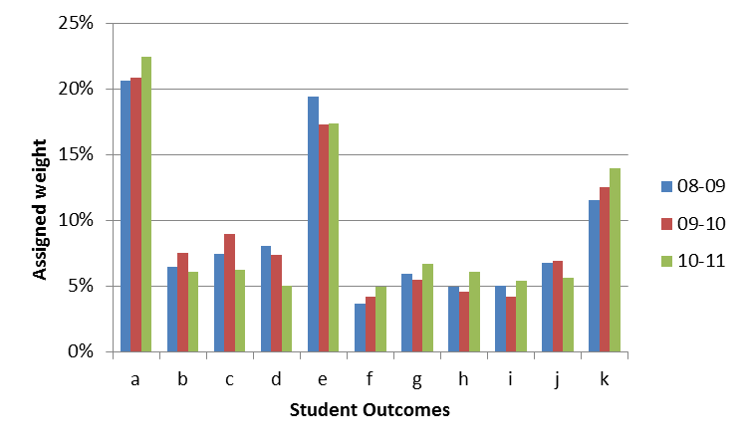

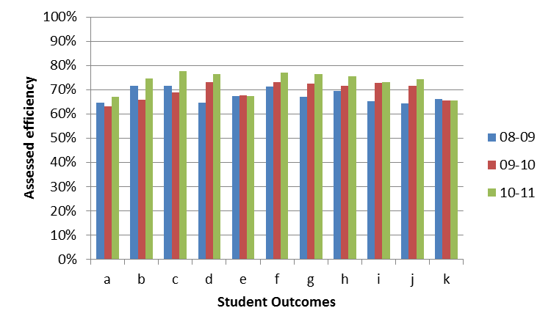

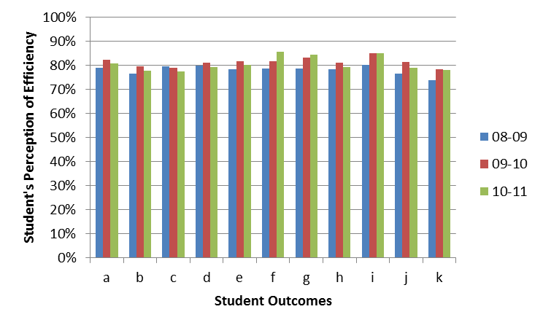

**Figure 4.4.** The relative weights with which the curriculum emphasizes each of the Student Outcomes, the efficiency with which these outcomes were achieved, and the students’ perceptions (survey data) of achieving them for academic years 08 – 09 through 10 – 11.

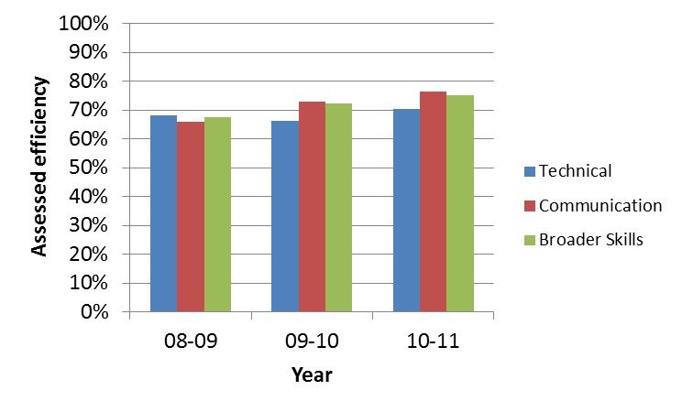

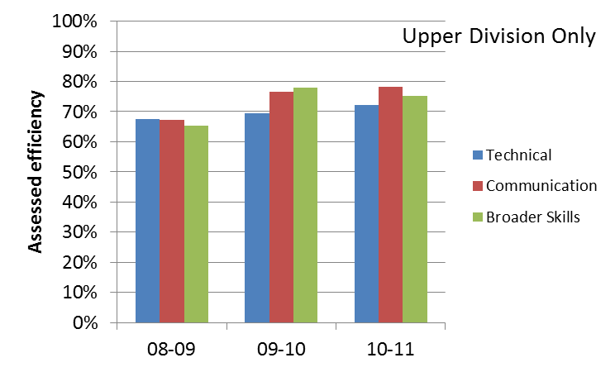

**Figure 4.5.** Combined Student Outcome efficiencies for academic years 08 – 09 through 10 – 11. Upper plot shows efficiencies for all courses in the program. Lower plot shows efficiencies only for upper division courses.

**4.B.2. Student Outcomes Assessment through Senior Exit Survey**

In addition to our objective assessment methods, we also survey our students and alumni to determine their perceptions of their accomplishment of the Student Outcomes. To ensure a 100% response rate, senior students must complete a survey when they submit an application for graduation. Survey results from our senior students are given in Figure 4.6. Alumni survey results are given in Figure 4.7. For the most part, both our seniors and alumni believe that they have achieved our Student Outcomes.

**Degree that engineering education enhanced ability to:**

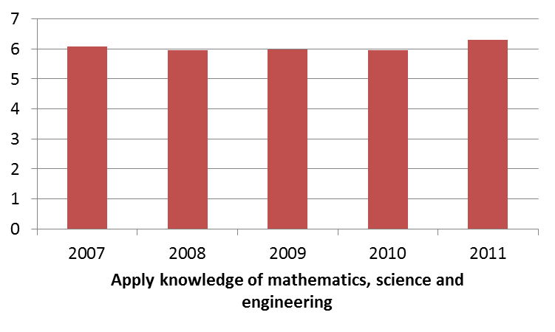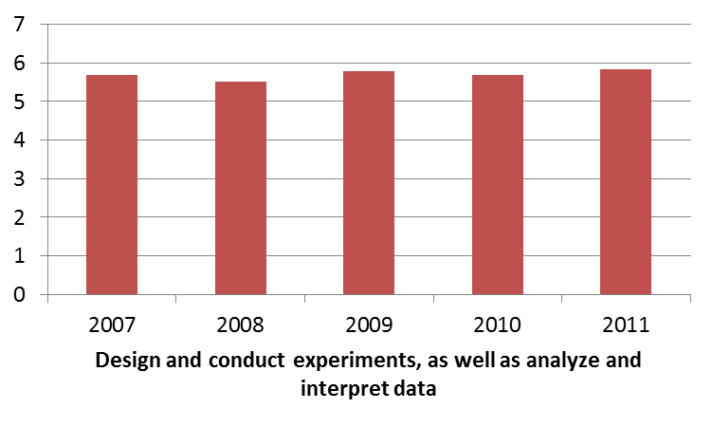

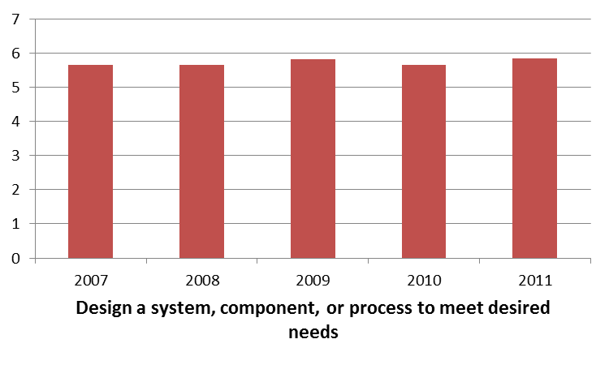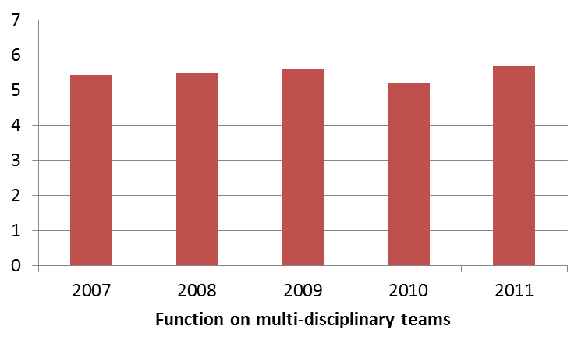

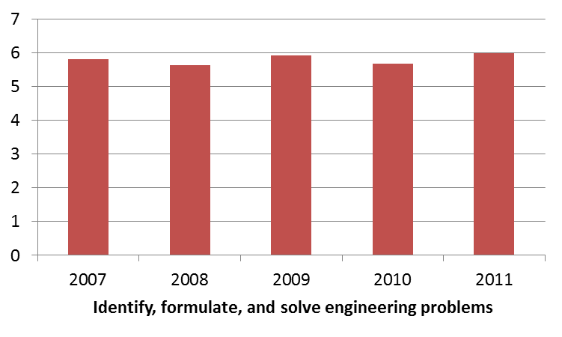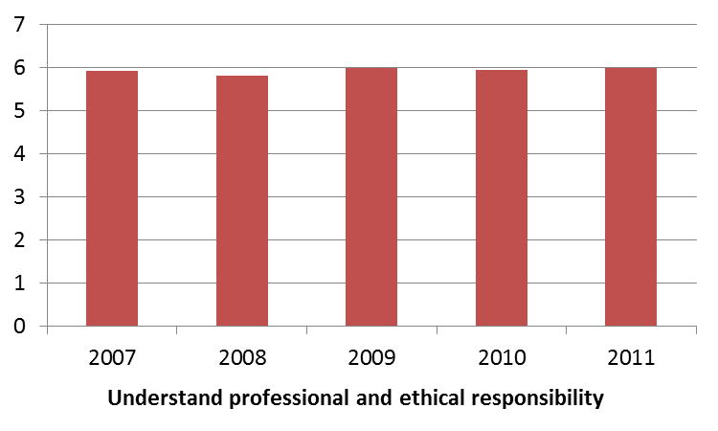

**Figure 4.6.** Results from a survey of senior students about their achievement of Student Outcomes by graduation year. Our graduating seniors were asked to rank how well our program enhanced their ability for all 11 Student Outcomes. Scale: (1) Not at all, (4) Moderate, (7) Extremely. The figure continues on the next page.

**Degree that engineering education enhanced ability to:**

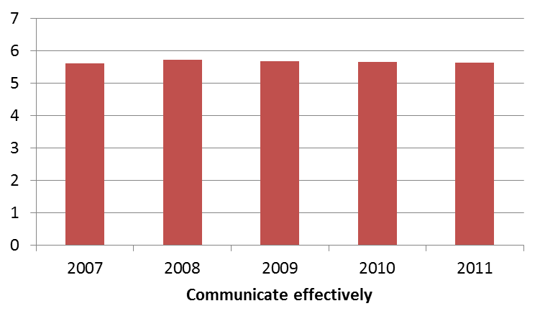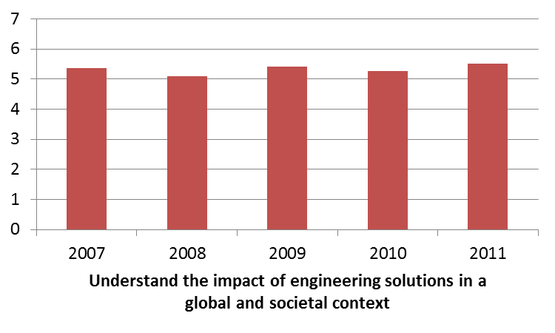

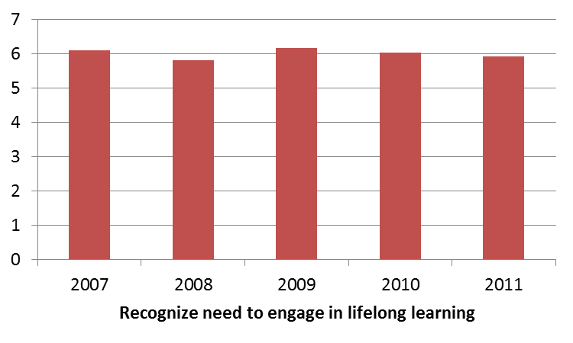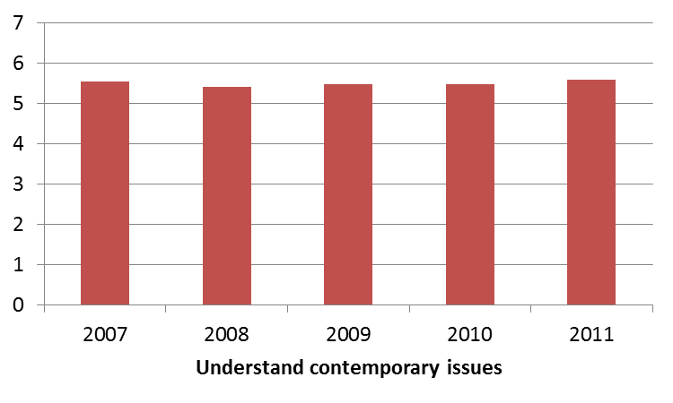

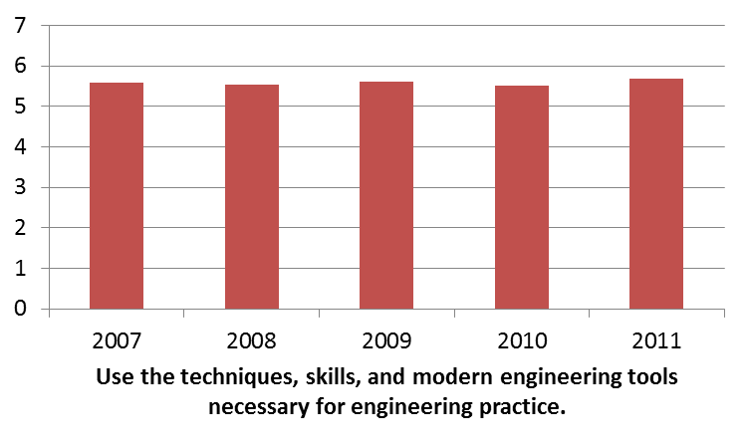

**Figure 4.6** **(continuation).** Results from a survey of senior students about their achievement of Student Outcomes by graduation year. Our graduating seniors were asked to rank how well our program enhanced their ability in all 11 student outcomes. Scale: (1) Not at all, (4) Moderate, (7) Extremely.

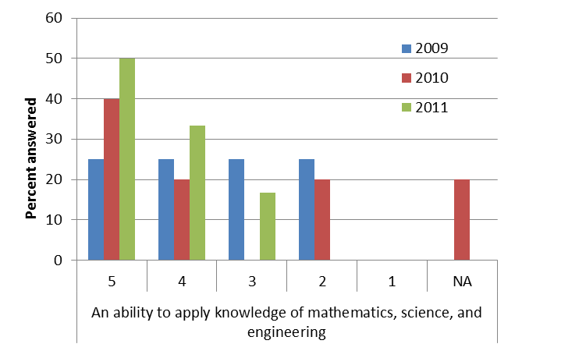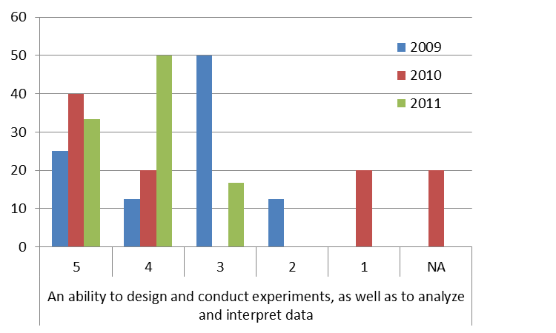

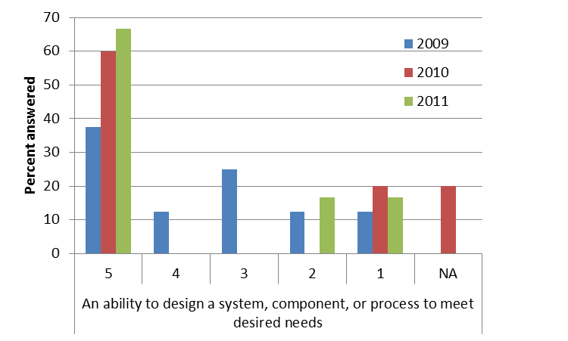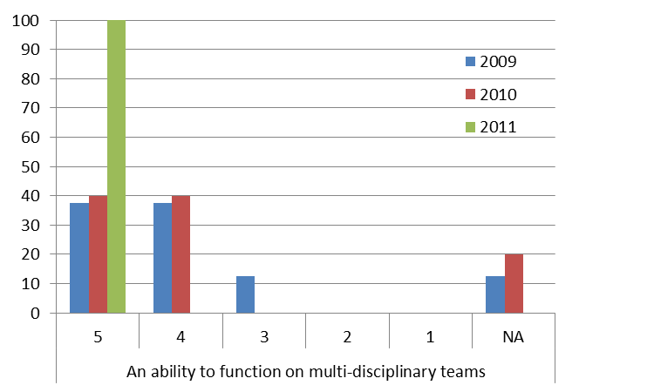

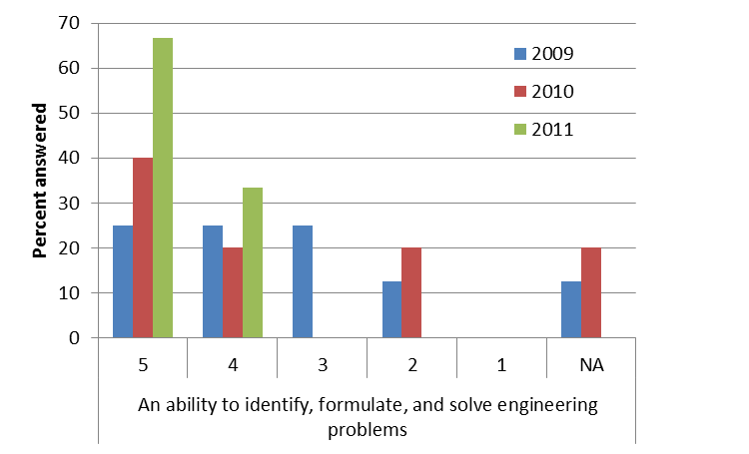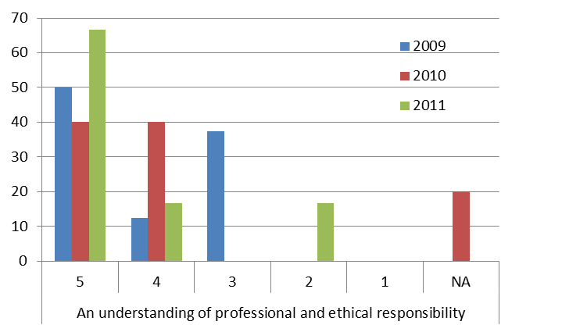

**Figure 4.7.** Results from a survey of alumni about their achievement of Student Outcomes. The question was “To what extent does your current work require you to possess each of the following?” The charts indicate the frequency of each response. Data is presented for students graduating during the period 2009 - 2011. Scale: 5 = Very much, 1= Not at all. (Figure continues on the next page.)

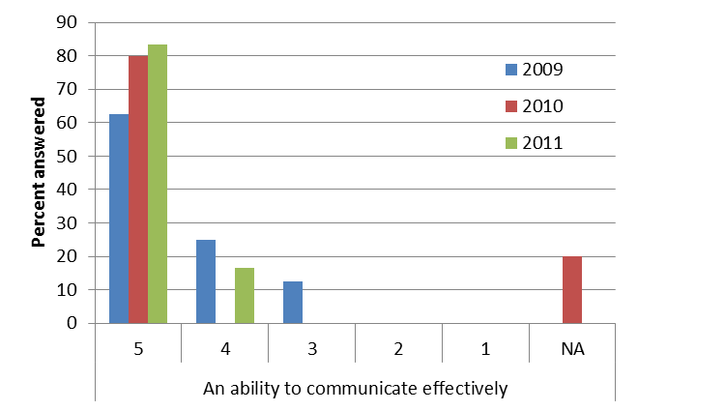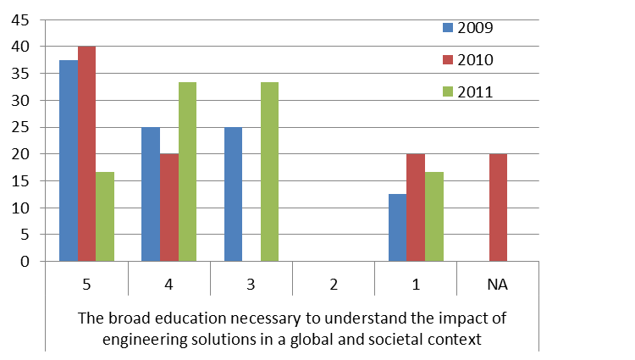

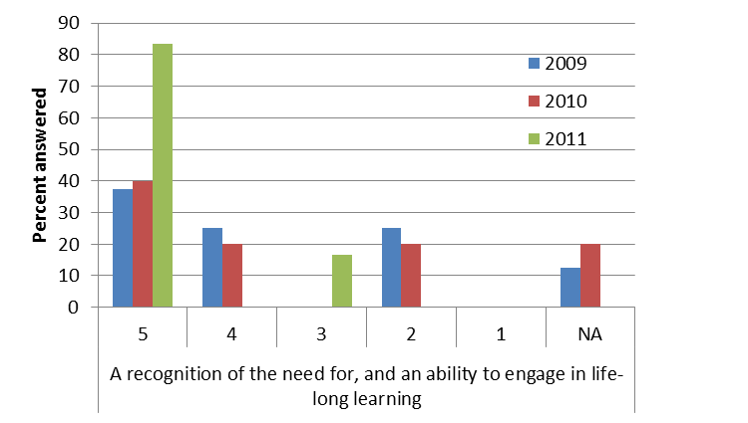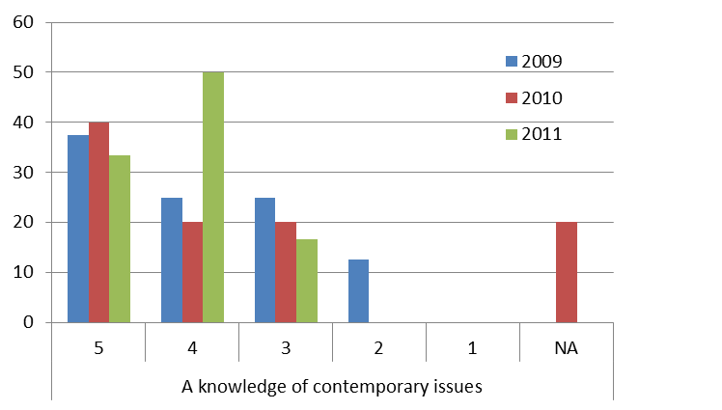

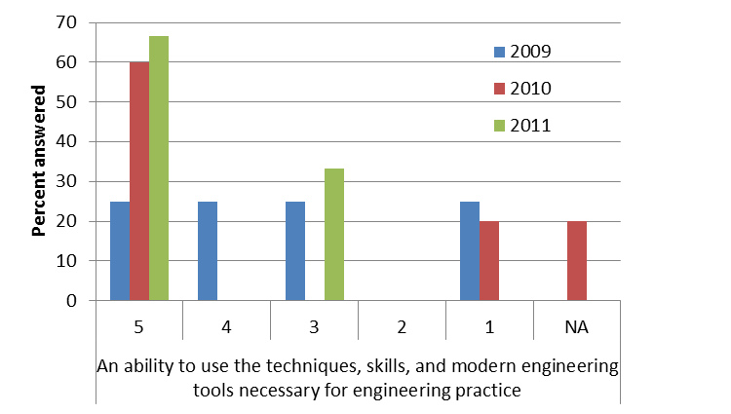

**Figure 4.7** **(continuation).** Results from a survey of alumni about their achievement of Student Outcomes. The question was “To what extent does your current work require you to possess each of the following?” The charts indicate the frequency of each response. Data is presented for students graduating during the period 2009 - 2011. Scale: 5 = Very much, 1 = Not at all.

**4.C. Continuous Improvement**

Program modifications occur at several levels. However, the department chair, with the assistance of the undergraduate committee, is ultimately responsible for all curricular changes. These changes may be driven by both our stakeholders and our assessment process. Changes in Program Educational Objectives are made in consultation with our stakeholders during our stakeholder meetings. Changes to the curriculum, such as the introduction or removal of a course, are initiated by the program faculty, typically at departmental retreats or regular faculty meetings. Likewise, significant course changes, such as the introduction or removal of a laboratory component, are also initiated by the program faculty. All changes to the curriculum, as well as any significant course changes, must be formally approved by the undergraduate committee, the program faculty, the BCOE Executive Committee, and the Academic Senate (Figure 4.8.). Approved changes appear in the next edition of the UC Riverside General Catalog. Minor changes to a course, such as the choice of a new textbook, are implemented by the instructor. The department chair and undergraduate committee are always available to the faculty for consultation on teaching issues.

Our faculty regularly discuss teaching and share insights about teaching with each other. Thus, informal conversations between faculty do play a role in our process of continual improvement. Recognizing the importance of such conversations, the department recently deployed a Microsoft SharePoint system. This system provides a mechanism for faculty to formally record and communicate teaching insights and recommendations for improving the program. This ensures that the department chair, the undergraduate committee, and the entire department faculty have access to what would otherwise be “local” discussions between individual faculty.

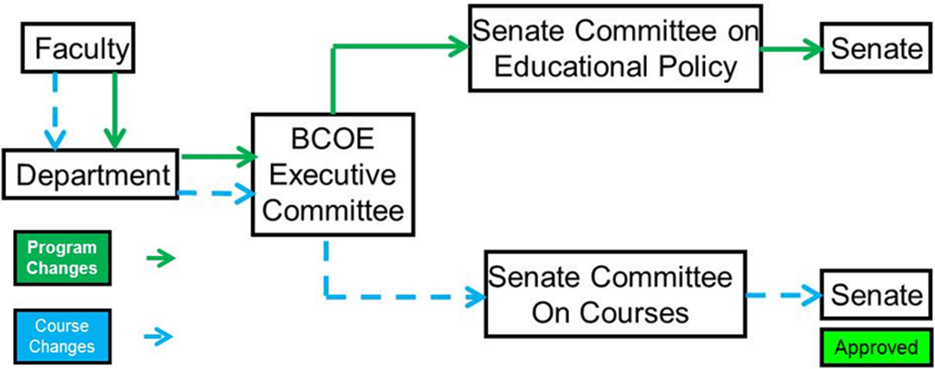

**Figure 4.8.** The process for implementing changes to course and the curriculum.

Our data collection system is streamlined so that all course-level assessment data are available by the time that course grades are due. This enables immediate assessment of the course objectives and Student Outcomes. This timely availability of data is especially important when there are two consecutive course offerings. This ensures that recommendations for course improvements can be provided to the next instructor prior to the start of the second offering.

At the end of each class, the instructor reviews the assessment data including quantitative performance on both course objectives and Student Outcomes, and qualitative performance on these measured with student surveys. The instructor uses this data to recommend changes to improve the course. In making these recommendations, the instructor may also consider a variety of other qualitative data. This may include particular types of errors students made on homework and exam problems, feedback from students during office hours, and faculty course evaluations administered by campus. The recommendations are recorded on a form included in the ABET course binder (see Appendix I for the assessment form template). Significant issues are discussed with the undergraduate committee and the program faculty.

When a course is taught the next time, the instructor reviews the course changes recommended by the previous instructor and identifies suitable improvements. Often, the same instructor teaches the course repeatedly, thus there is solid “institutional knowledge” of the evolution of the course, its purpose, and the performance of typical students. Regardless of whether the instructor is new or continuing, the instructor summarizes on a new recommendation form any changes he or she made to address the previous recommendations. Even if the instructor is the same each time the course is offered, we have found this documentation process to be useful for maintaining the continuity in consecutive course offerings. At the end of the course, the instructor adds to the new form recommendations for the next instructor, and the process repeats.

If the instructor identifies deficiencies that require changes to other courses or the curriculum as a whole, the instructor consults with the undergraduate committee to initiate those changes. Typically the undergraduate committee will begin by examining the issues and identifying possible courses of action. These suggestions are then discussed by the faculty, typically at a faculty meeting. Significant changes then proceed through the formal approval process in Figure 4.8. For example, the faculty identified that ME 1 A/B/C did not adequately prepare our freshmen for success in the program. After significant analysis and discussion, this process resulted in the replacement of ME 1 with ME 2.

Figure 4.9 summarize the system used by the Mechanical Engineering program to “foster the systematic improvement in the quality of engineering education that satisfies the needs of constituencies in a dynamic and competitive environment.” This system considers input from our stakeholders, quantitative data from our assessment of course objectives and Student Outcomes, and surveys of our students and stakeholders about our achievement of Student Outcomes and Program Educational Objectives. All of this data is used to drive continual improvement in our program. These improvements may be program-level improvements, such as the introduction of a new course, or course level-improvements, such as the introduction of a new topic in a course.

Course objectives are formulated to yield Student Outcomes, which in turn prepare students to achieve the Program Educational Objectives. We assess achievement of Student Outcomes by assessing achievement of course objectives. We also use surveys of students, alumni, and employers to assess achievement of Student Outcomes and Program Educational Objectives. We do not have absolute performance targets for the achievement of Student Outcomes. Instead, we monitor trends in performance from year to year, with the goal of continuous improvement. We also monitor the overall emphasis (weight) that our curriculum places on each objective. These quantitative and qualitative assessment techniques are described in the next sections.

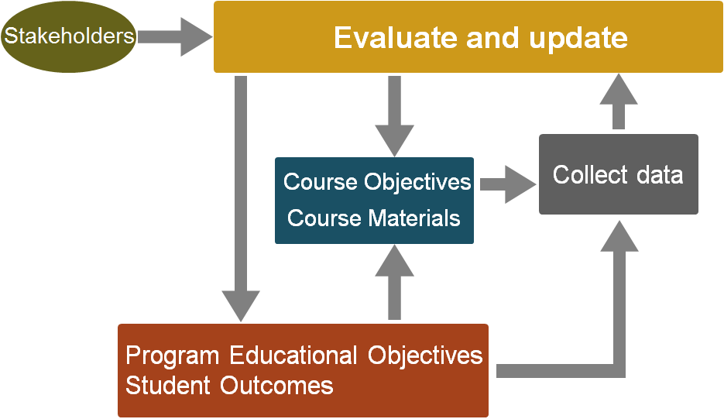

**Figure 4.9.** System to make continuous improvement in the program to achieve the Program Educational Objectives.

**4.C.1. Quantitative Assessment of Student Outcomes based on Student Performance**

Every Mechanical Engineering course has a set of course objectives that are designed to ensure that students completing the class have the knowledge and skills essential to that course (see schematic on Figure 4.10). These course objectives are linked to Student Outcomes using the objective-outcome matrix. A typical matrix is shown in Figure 4.11.

The instructor selects specific coursework, such as quiz and exam problems, homework problems, and projects, to assess performance on course objectives. A matrix is used to map performance on the selected coursework to performance on the course objectives, as illustrated in Figure 4.12.

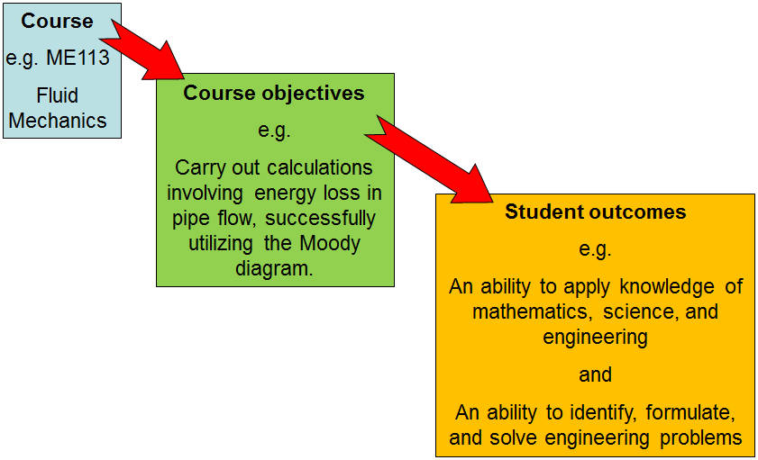**Figure 4.10.** Each course has course objectives that contribute to achievement of the Student Outcomes.

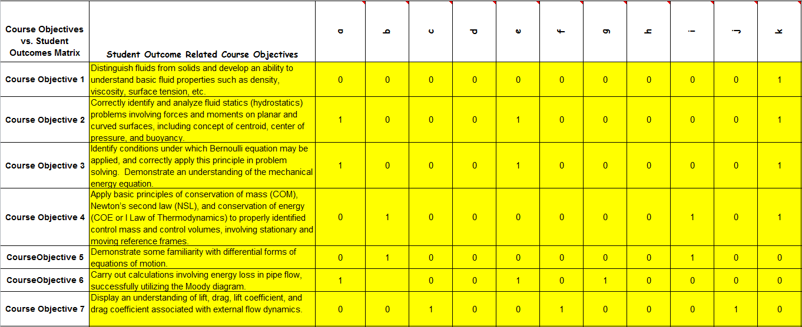

**Figure 4.11.** Course objectives are mapped to the Student Outcomes they help achieve. A “1” indicates that the course objective and Student Outcome are linked, while a “0” indicates that they are not.

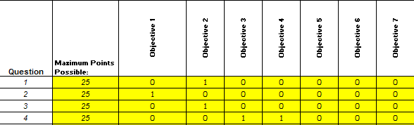**Figure 4.12.** Relationship between selected coursework and the course objectives. A “1” indicates that the assignment and the course objective are linked, while a “0” indicates that they are not.

The efficiency with which a course achieves a particular course objective is computed from the scores students achieve on the coursework selected to assess that course objective. The weight assigned to a particular course objective depends of the fraction of the assessment problems related to that particular objective. The precise formulas for computing these efficiencies and weights are given below in section 4.C.2. “Example of Weight and Efficiency Calculation.”

The efficiency with which a course achieves a particular Student Outcome is defined as the average efficiency of the course objectives that are mapped to that outcome. The weight assigned to a particular Student Outcome is defined as the sum of course objective weights mapped to that outcome normalized by the sum of all course objective weights. Again, the details for these calculations are given below in the section 4.C.2.

We have developed software tools to automate processing of the quantitative assessment data. To use these tools, the instructor must perform two primary tasks. The first is to define the matrix relating course objectives to Student Outcomes (e.g., Figure 4.11). This matrix is stored as an Excel spreadsheet. Typically, this matrix is constant from one course offering to the next. Therefore, the instructor typically begins with the matrix from the previous offering of the course and makes any necessary changes. The second task is to identify which coursework will be used for assessment, and to create a matrix mapping this coursework to the course objectives (e.g., Figure 4.12). This matrix is also stored as an Excel spreadsheet. During the term, the teaching assistants record student performance in this spreadsheet. At the end of the quarter, these two spreadsheets are used to automatically compute the efficiencies and weights for the course objectives and Student Outcomes.

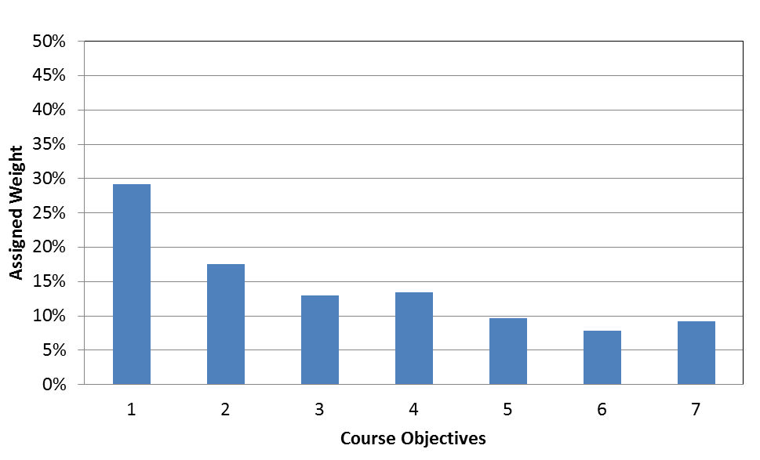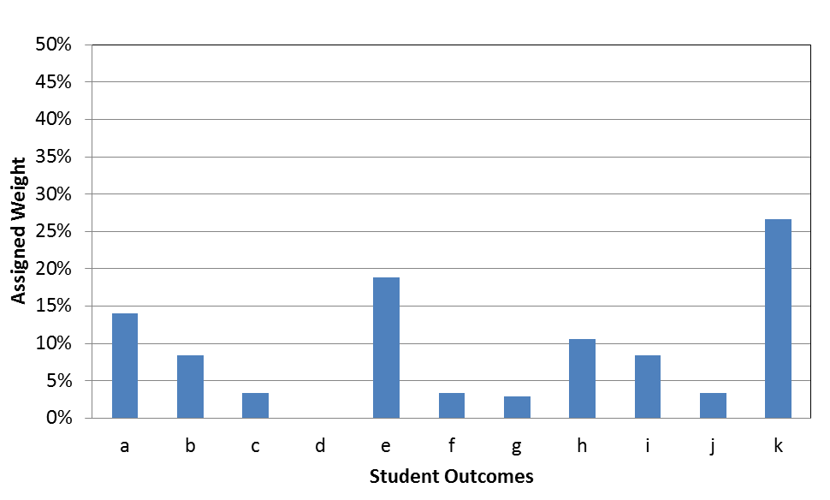

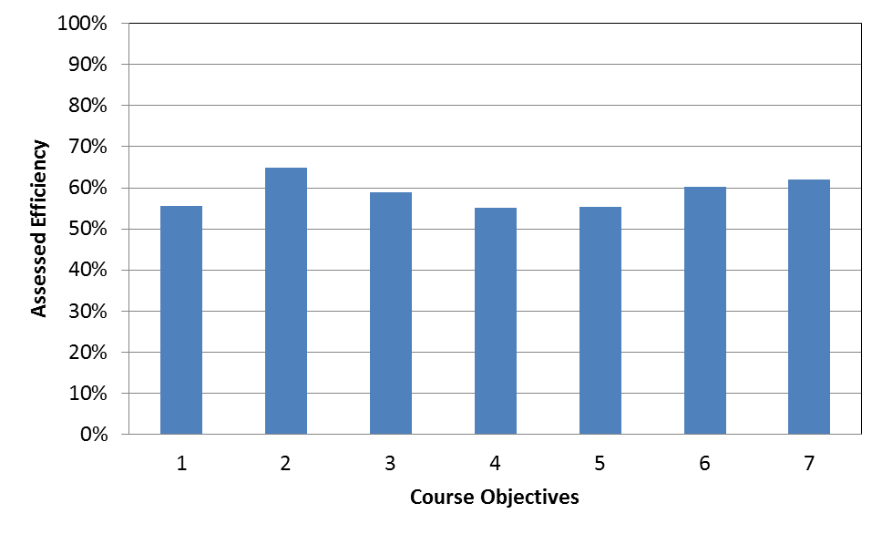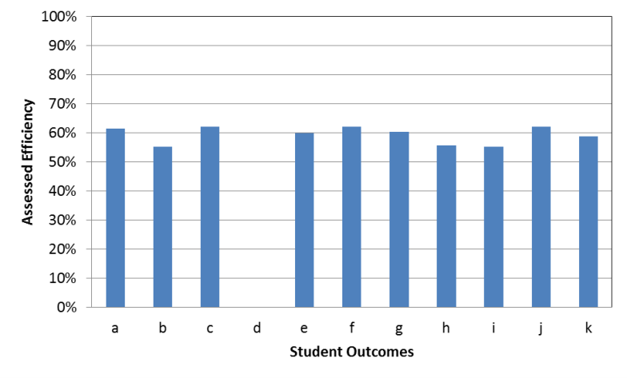

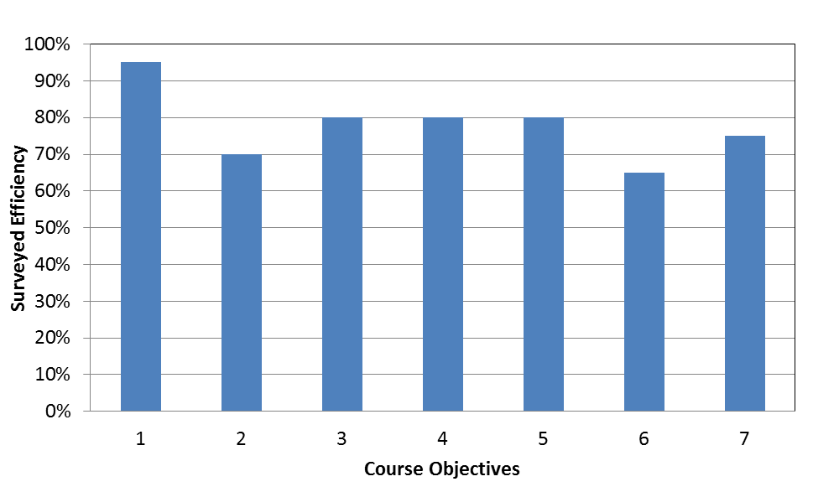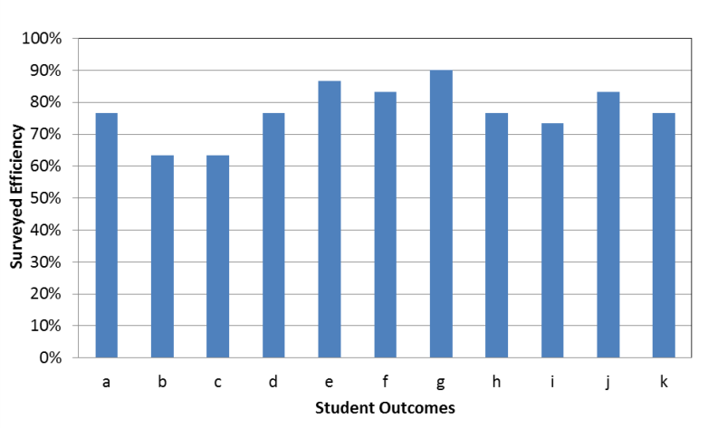

**Figure 4.13.** Weights and actual and surveyed efficiencies for Student Outcomes and course objectives for the winter 2012 offering of ME 113.

We provide several resources to help teaching assistants and instructors with our ABET processes. First, each quarter, all teaching assistants enroll in our ME 302 Apprentice Teaching course, which provides them with instruction on our ABET procedures. Also, the undergraduate committee is always available to provide assistance to instructors and teaching assistants who need help with these procedures. Finally, a senior graduate student and the ABET committee chair review the ABET materials each quarter to ensure accuracy and completeness.

We also survey students at the end of each course to determine their perceptions of their achievement of the course objectives and Student Outcomes. These results are included in the ABET binder for each course. Figure 4.13 shows typical student responses. Students almost always perceive that their achievement of these is greater than our quantitative assessment indicates. For this reason, we question the usefulness of these surveys and are considering discontinuing their use.

As indicated in Section 4.B. “Student Outcomes,” we aggregate the assessment data from the individual courses to assess the overall effectiveness of our program. Figure 4.4 shows the results of this analysis for the past three years.

The campus also has its own assessment instruments to evaluate student perceptions and performance. The most significant assessment tool is the UC Undergraduate Experience Survey, or UCUES. This is a uniform questionnaire that is administered at all UC campuses, although each campus can add their own additional questions. The questionnaire is currently administered every two years, although there is some discussion of administering it annually. The UCUES provides a basis for comparison with all of the other UC campuses (except UC San Francisco, which has no undergraduate programs). The campus also conducts “Faculty Course Evaluations” at the end of each quarter. In these surveys, which are administered online via our iEval system, students rate, among other things, their satisfaction with the course and the instructor’s teaching. The campus has developed a relational database (200 fields) containing longitudinal data about student performance. The database has access controls to protect the privacy of the students. As the database is populated with new information, it should be a valuable resource for providing information on the performance of engineering students in non-engineering courses and for evaluating their overall experiences. We expect to have access to this database in the near future.

**4.C.2. Example of Weight and Efficiency Calculation**

In this section, we provide an example of computing weights and efficiencies for course objectives and Student Outcomes. Consider a fictional course that has three course objectives that are related to four Student Outcomes as illustrated in Figure 4.14. The course objectives are evaluated with problems selected from three assignments as illustrated in Figure 4.15. Three problems from assignment 1 are used for assessment. Two of these address Objective 1 and the other addresses Objective 2. As a result, assignment 1 has a weight of 66.66% for Objective 1 and 33.33% for Objective 2. All of the problems selected from assignment 2 are related to Objective 2. Thus this assignment produces a weight of 100% for Objective 2. In a similar way, assignment 3 provides weights of 25% for both Objective 1 and 2, and a weight of 50% for Objective 3.

|  |  |  |  |  |
| --- | --- | --- | --- | --- |
|  | **Outcome 1** | **Outcome 2** | **Outcome 3** | **Outcome 4** |
| **Objective 1** | 1 | 0 | 1 | 1 |
| **Objective 2** | 0 | 1 | 0 | 0 |
| **Objective 3** | 0 | 1 | 1 | 0 |

**Figure 4.14.** A fictitious course that has three course objectives related to four Student Outcomes.

|  |  |  |  |  |  |  |  |  |  |
| --- | --- | --- | --- | --- | --- | --- | --- | --- | --- |
|  | **Assignment 1** | | | **Assignment 2** | | | **Assignment 3** | | |
| **Obj. 1** | **Obj. 2** | **Obj. 3** | **Obj. 1** | **Obj. 2** | **Obj. 3** | **Obj. 1** | **Obj. 2** | **Obj. 3** |
| **Quest. 1** | 1 | 0 | 0 | 0 | 1 | 0 | 1 | 0 | 0 |
| **Quest. 2** | 1 | 0 | 0 | 0 | 1 | 0 | 0 | 1 | 0 |
| **Quest. 3** | 0 | 1 | 0 | 0 | 1 | 0 | 0 | 0 | 1 |
| **Quest. 4** | 0 | 0 | 0 | 0 | 0 | 0 | 0 | 0 | 1 |

**Figure 4.15.** Problems selected from three assignments are used to assess the course objectives.

In general, the overall weight that a course *C* applies to course objective, *i,* is calculated as:



where is the weight applied to course objective *i* ofcourse *C* by assignment *j*. Here, *j* is summed over all assignments and *k* is summed over all course objectives. For example, the overall weight our fictitious course, *f*, applies to course objective one is:



In a similar way, we obtain  and. These weights are plotted in Figure 4.16. Using the weights for the course objectives, we can compute the weights for the Student Outcomes. In general, the overall weight that a course *C* applies to of the Student Outcome, *i,* is calculated as:



where  equals one if course objective *j* influences Student Outcome *i*, and equals zero otherwise. Here, *j* is summed over all course objectives and *k* is summed over all Student Outcomes. For example, using the table in Figure 4.14 to compute the values of , we can compute the weight that fictitious course *f* applies to Student Outcome 3:



Figure 4.17 shows all of the Student Outcome weights for this course. Note that these weights sum to one. Averaging the outcome weights () over all courses gives the weights that our program applies to each Student Outcome (e.g., the top of Figure 4.4). Note that a simple average is used here, because nearly all courses in the curriculum are four-unit courses.

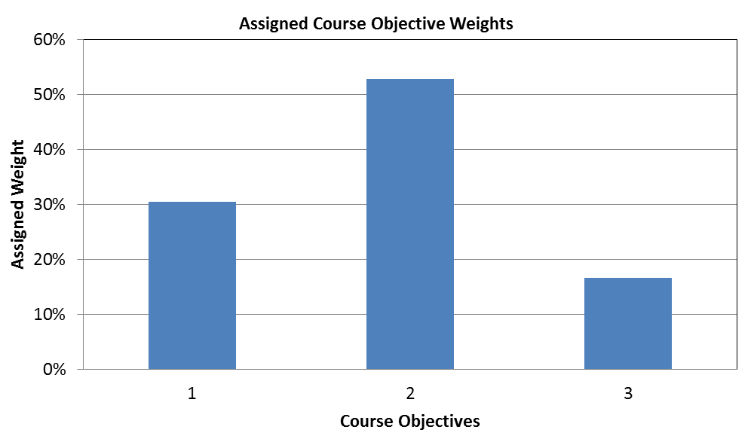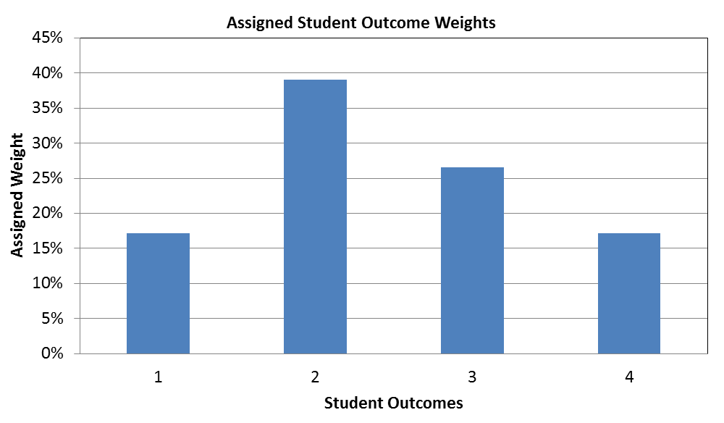

**Figure 4.16.** Assigned Course Objective weight **Figure 4.17**. Assigned Student Outcome weight

To determine the efficiency with which a course achieves its course objectives, we must know the average score students achieved on each of the problems used for assessment. Continuing with our example, we will assume that these scores are given in Figure 4.18 (top). These scores are combined with the matrix relating assessment questions to course objectives (Figure 4.15) to produce the matrix in Figure 4.18 (bottom). This matrix is similar to that in Figure 4.15, except that the ones have been replaced with scores. For each assignment, we then compute the average score for each course objective as shown in the last row of Figure 4.18 (bottom). For example, on assignment 1, students achieved an average performance of 75% on objective 1. We then average the averages for each course objective to obtain the efficiency with which the course achieves that objective. For example, the efficiency for achieving course objective 1 is the average of 75% and 38%, which is 56.5%. Similarly the efficiencies for achieving objectives 2 and 3 are 86.3% and 77.5%, respectively.

With the efficiencies for the course objectives, we can now compute the efficiencies for the Student Outcomes. The efficiency for a particular Student Outcome is defined as the average of the efficiencies of the course objectives related to that outcome. For example, because Student Outcome 2 is influenced by course objectives 2 and 3, the efficiency for this outcome is the average of 86.3% and 77.5%, which is 81.9%. The complete set of Student Outcome efficiencies for this fictitious course are given in Figure 4.20.

To calculate the Student Outcome efficiencies for the Mechanical Engineering program as a whole (e.g., Figure 4.4.), we compute a ***weighted average*** of the efficiencies from the individual courses. In this average, the efficiencies for a particular course (e.g. Figure 4.17) are weighted by the outcome weights () for that course.

|  |  |  |  |
| --- | --- | --- | --- |
|  | **Assignment 1** | **Assignment 3** | **Assignment 4** |
| **Question 1** | 80 % | 60 % | 38 % |
| **Question 2** | 70 % | 75 % | 96 % |
| **Question 3** | 90 % | 84 % | 73 % |
| **Question 4** |  |  | 82 % |

|  |  |  |  |  |  |  |  |  |  |
| --- | --- | --- | --- | --- | --- | --- | --- | --- | --- |
|  | **Assignment 1** | | | **Assignment 2** | | | **Assignment 3** | | |
| **Obj. 1** | **Obj. 2** | **Obj. 3** | **Obj. 1** | **Obj. 2** | **Obj. 3** | **Obj. 1** | **Obj. 2** | **Obj. 3** |
| **Quest. 1** | 80% |  |  |  | 60% |  | 38% |  |  |
| **Quest. 2** | 70% |  |  |  | 75% |  |  | 96% |  |
| **Quest. 3** |  | 90% |  |  | 84% |  |  |  | 73% |
| **Quest. 4** |  |  |  |  |  |  |  |  | 82% |
| **Average** | 75.0% | 90.0% |  |  | 73.0% |  | 38.0% | 96.0% | 77.5% |

**Figure 4.18.** (top) Student performance on questions used for assessment. (bottom) Student scores combined with the matrix relating assessment questions to course objectives (Figure 4.15).

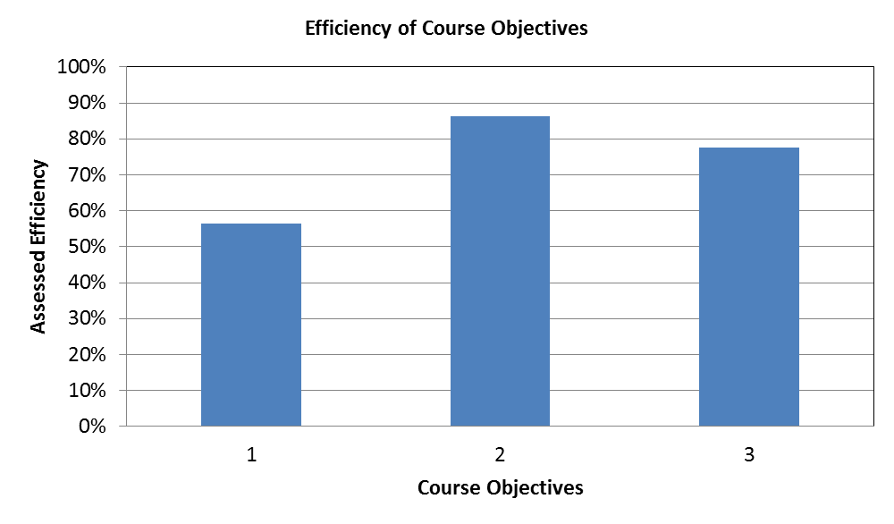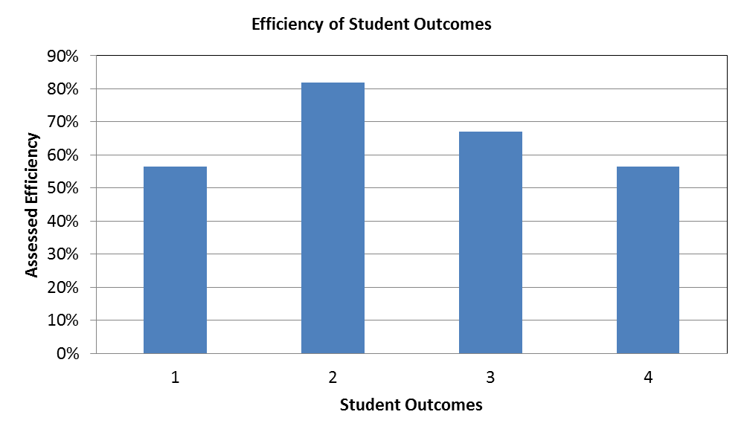

**Figure 4.19.** Efficiency of course objectives. **Figure 4.20.** Efficiency of Student Outcomes

**4.C.3. Examples of Curriculum Changes Resulting from our Continuous Improvement Process**

The complete set of course-level changes is listed in Table 2 (major) and Table 3 (minor) in the “Background” section.

**4.C.3.1. History of Course Plan Changes for Mechanical Engineering Program from 2009 to 2012**

***Catalog and Course Plan Changes implemented in the 2009 Catalog (AY 09-10)***

The Mechanical Engineering program made multiple changes to the curriculum during AY 08-09. These changes initiated were approved by the Academic Senate May 19, 2009 (<http://senate.ucr.edu/agenda/090519/Proposed%20Mech%20Engr%20Major%20Requirements.pdf>) and took effect in the 2009 Catalog (AY 09-10). These changes include:

* ME 2 – Introduction to ME: We carefully examined the strengths and weaknesses of the existing ME freshman experience and determined that the ME 1 A/B/C sequence did not adequately prepare our students for the challenges of the subsequent courses. As a remedy, we developed a new four-unit course, ME 2, which provides a comprehensive overview of mechanical engineering. This course teaches engineering problem solving skills without utilizing calculus, and is intended to provide a framework to help students connect concepts in subsequent courses. The ME Board of Advisors (BOA), which includes the industry representative component of our stakeholders, expressed enthusiasm for this change at our Annual BOA Meeting held on April 24, 2009. This four-unit course was first deployed in AY 2009-2010. ME1A/B/C is no longer required.
* ME 18 – Introduction to Engineering Computation: The course was changed from two units to three to absorb material from ME 1C (basic MATLAB programming), thus providing a more comprehensive introduction to engineering computation.
* ME 174 – Machine Design: ME 130 (Kinematics) was eliminated as a required course and replaced with ME 174. The latter covers strength-based design, an essential mechanical engineering topic that was absent from the curriculum. The inclusion of ME 174 in the required curriculum addresses deficiencies that were apparent in student performance in senior design, ME 175 B/C. ME 130 is now a technical elective.
* BIOL 003: This course was eliminated as a required course as it did not contribute material that is essential to the major. Now, only BIOL 005A and BIOL 005L, which focus on cell and molecular biology, are required.
* To help ME freshman stay connected with their major, the normal sequence of course offerings is: ME 2 in the winter quarter of the freshman year, followed by ME 9 in the spring quarter.

In the same year, we adjusted and the suggested course plan as summarized in Table 4.2.

**Table 4.2.** Suggested course plan changes adopted in 2009

|  |  |  |  |
| --- | --- | --- | --- |
|  | **2008 Suggested Course Plan** | **2009 Suggested Course Plan** | **Justification** |
| ME 1A | Scheduled 1st year, fall | Removed from course plan | Replaced by ME 2. |
| ME 1B | Scheduled 1st year, winter | Removed from course plan | Replaced by ME 2. |
| ME 1C | Scheduled 1st year, spring | Removed from course plan | Replaced by ME 2. |
| ME 2 | N/A | Scheduled 1st year, winter | Replaces ME 1. |
| ME 9 | Scheduled 2nd year, spring | Scheduled 1st year, spring | In spring of the 2nd year, students were overloaded with 20 units. Removing ME 1C from the spring of the 1st year enabled ME 9 to be moved to that term. This resulted in a more balanced workload and increased the opportunity for freshmen to connect with program faculty during the first year. |
| BIOL 3 | Scheduled 3rd year, winter | Removed from course plan | Course was removed from curriculum. |
| ME 130 | Scheduled 3rd year, spring | Removed from course plan | Replaced by ME 174. |
| ME 174 | Included as a Technical Elective (TE) | Scheduled 3rd year, spring. Removed as a TE. | Replaced ME 130. |

***Catalog and Course Plan Changes implemented in the 2010 Catalog (AY 10-11)***

There were no changes to the program or course plan in 2010.

***Catalog and Course Plan Changes implemented in the 2011 Catalog (AY 11-12)***

There were no program changes in 2011, but there were changes in the suggested course plan. These are summarized in Table 4.3.

**Table 4.3.** 2011 Course Plan Changes

|  |  |  |  |
| --- | --- | --- | --- |
|  | **2010 Suggested Course Plan** | **2011 Suggested Course Plan** | **Justification** |
| ME 103 | Scheduled 2nd year, spring | Scheduled 3rd year, fall | Offering ME 103 in the 3rd year rather than the 2nd, enables junior-level transfer students to progress in the major. Also, this provides an opportunity for students who fail ME 10 (a prerequisite) to repeat it in the spring of the 2nd year and still be on track for ME 103. |
| BIOL 005A/LA | Scheduled 3rd year, fall | Scheduled 2nd year, winter | Was moved to make room for ME 103. |
| STAT 100A | Scheduled in 2nd year, winter | Scheduled 2nd year, spring | Was moved to make room for BIOL 5A/LA. |
| ME 120 | Scheduled 3rd year, spring | Scheduled 3rd year, winter | Originally moved to balance teaching load for faculty. Change made permanent as it resulted in better distribution of work load for students. |

***Catalog and Course Plan Changes implemented in the 2012 Catalog (AY 12-13)***

We will recommend that students who placed into MATH 9B take PHYS 40A in the fall quarter of the freshmen year.

**4.D. Additional Information**

Copies of the assessment instruments and materials referenced in 4.A, 4.B, and 4.C are available for review by the site visit team.

Here we provide examples of improvements to specific courses in the curriculum resulting from our continuous improvement process.

**4.D.1. *ME 2, Introduction to Mechanical Engineering***

We carefully examined the strengths and weaknesses of the existing ME freshman experience and determined that the ME 1 A/B/C sequence did not adequately prepare our students for the challenges of the subsequent courses. The course lacked sufficient technical rigor and did not instill in students the strong work ethic needed for success in the program. As a remedy, we developed a new four-unit course, ME 2, which provides a comprehensive overview of mechanical engineering, including statics, fluid mechanics, and energy. This course teaches engineering problem-solving skills without utilizing calculus, and is intended to provide a framework to help students connect concepts in subsequent courses. The Mechanical Engineering Board of Advisors (BOA), which includes the industry component of our stakeholders, expressed their enthusiasm for this change at our Annual BOA Meeting held on April 24, 2009. This four-unit course was first deployed in AY 2009-2010. ME1A/B/C is no longer required.

Although students have a high opinion of the course, many students struggle with the material. For this reason, we offer the course in both the winter and spring terms. Students who are unable to pass the course in winter have an opportunity to repeat the course in spring and stay on track with their coursework.

When ME 2 was first offered in winter 2010, the course included a design project. Experience that quarter suggested that the design project was not the best use of student time. Rather, it was clear that students would benefit more from spending that time studying the core principles in the course. As a result, the design project was eliminated in future offerings of the course.

In the fall of 2010, the campus admitted an unusually large number of mechanical engineering freshmen. For the 2010-2011 academic year, the college set an admission target of 600 engineering students across all engineering majors, but the University admitted 850. Because of faulty enrollment estimates by the campus, the college accepted referrals from the College of Natural and Agricultural Science. Previously, the college accepted referrals only from other UC engineering colleges. Unfortunately, many of these students admitted were underprepared and performed poorly in the winter 2011 offering of ME 2. A significant fraction of the students had to repeat ME 2, and performed much better the second time. As a result of such experiences, the college has taken much greater control of the admissions process. The college has revised its admissions criteria and no longer accepts any referrals, even from other UC engineering colleges.

In the winter 2012 offering of ME 2, the best-performing students from the previous offering were invited to the first lecture to describe their strategies for succeeding in the class and avoiding pitfalls. These “experienced” students then answered questions posed by the new students. This interaction appeared to motivate the new students and instill in them an understanding of the work ethic needed for success. We found that students utilized office hours much more than in previous course offerings, which we attribute to the increased motivation. Overall, students performed better than in winter 2011, which we attribute to both increased motivation and tougher admission criteria.

In the spring 2012 offering of ME 2, we implemented a new early warning system (EW) to help with student success. This system identifies students who score below a threshold on initial quizzes, and invites them to attend additional advising from the UCR Academic Resource Center. This center also provides tutoring and supplemental instruction to all ME 2 students who desire it. A total of 26 students (out of the 85 enrolled) were identified by the early warning system due to their low performance on the initial quizzes. Four of these students (15%) withdrew from ME 2 shortly after receiving early warning notification, 14 (54%) attended advising, and eight (31%) did not respond.

**4.D.2. *ME 10, Statics***

Homework exercises are a cornerstone of modern instruction, especially in engineering. However, not much is known about how student homework activities contribute to the acquisition of expertise in engineering courses. To help answer this question, in the winter quarter of 2010, Professor Stahovich began an NSF-funded study to examine this issue (NSF award No. 0935239, “Transforming Statics Instruction through the Creation and Evaluation of Efficient and Effective Practice Experiences”). The project has two main foci: a fine-grained formative assessment process aimed at understanding how students attempt to solve problems, and the design of more effective and efficient practice experiences based on this assessment. The unique formative assessment process used in this project is enabled by a novel computing technology, Livescribe smartpens. These pens serve the same function as a traditional ink pen, but additionally, they digitize the pen strokes and store them as sequences of time-stamped coordinates. Students participating in this research study are given Livescribe smartpens that they use to complete all of their coursework. To date, nearly 400 students have participated in the study over three offerings of ME 10, producing a database of approximately 10 million pen strokes.

The Livescribe pens are used in conjunction with a digital coursework collection and grading system develop by Professor Stahovich and his research team (Figure 4.21). Once students complete a homework assignment, they use the “Ink Collector” application on a traditional PC to download their work from their smartpens and submit it to a secure server (Figure 4.22). The instructor or teaching assistants then downloads submitted homework and grades it using the “Ink Grader” software (Figure 4.23). Ink Grader allows the instructor to mark incorrect portions of a student’s work and assign an error from a predefined list of errors. The grade on the assignment is then automatically computed from the identified errors. Ink Grader converts each graded assignment to a password-protected PDF file and sends it to the corresponding student via e-mail.

Ink Grader compiles detailed statistics about the frequency of the various errors across all students in the class. These statistics provide important guidance to the instructor about the class’s performance. For example, statistics collected on the first midterm exam in the winter 2012 offering of ME 10 (Figure 4.24) revealed that students were having difficulty with trigonometry and geometry. As a result, the instructor provided a review of this material in lecture. The instructor recommended that, in the future, a review of geometry and trigonometry be provided at the beginning of ME 10. Additionally, the instructor recommended that a review of this material be included in ME 2, Introduction to Mechanical Engineering, and ME 9, Engineering Graphics & Design, which are taught in the freshmen year, and taken prior to ME 10.

The remainder of this subsection describes other research projects aimed at improving student learning in ME 10.

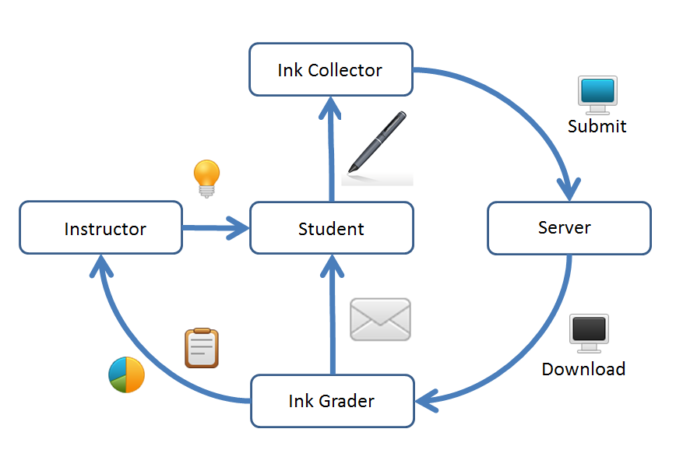

**Figure 4.21.** Digital coursework collection and grading system.

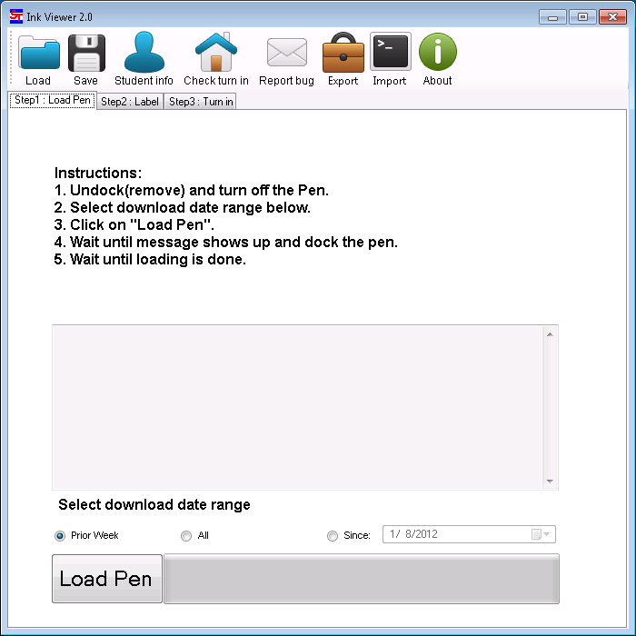

**Figure 4.22.** Ink Collector system: Students use this application download their coursework from a smartpen and submit it to a secure server for grading.

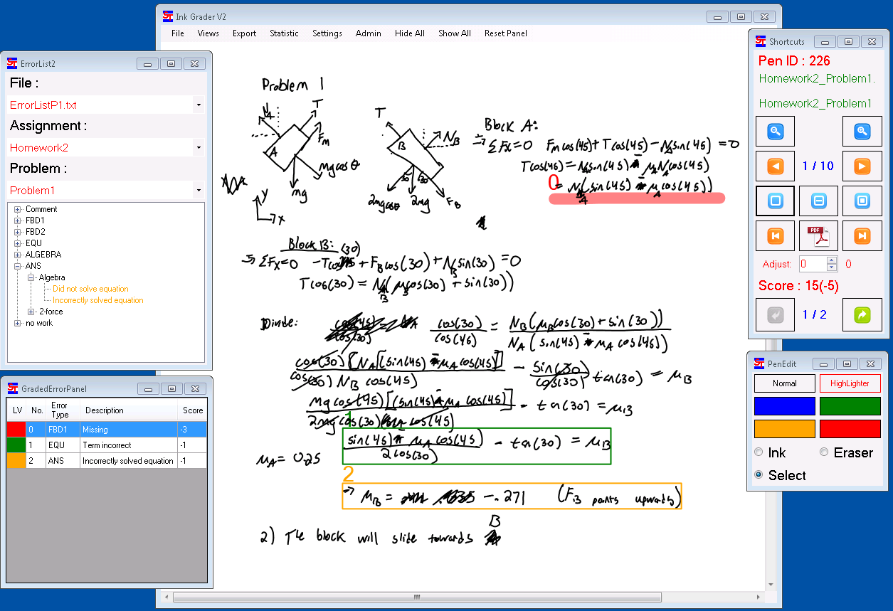

**Figure 4.23.** Ink Grader system. The main window contains the student’s solution to a homework problem. The instructor selects each incorrect portion of the solution and assigns an error from the hierarchical list of problem-solving errors in the top-left window. The grade is computed from the assigned errors and performance statistics are computed across all students.

|  |  |
| --- | --- |
| **Error** | **Frequency** |
| *Moment Arm for weight of bulldozer incorrect* | *55.6%* |
| Did not solve an equation that was written | 54.4% |
| *Angle for tension at C not calculated from Geometry* | *48.9%* |
| No calculation of the magnitude of the force at D | 45.6% |
| Y component of Tension term in the Sum Moments incorrect | 31.1% |
| X component of Tension term in the Sum Moments incorrect | 27.8% |
| *Angle for tension at C incorrectly calculated* | *24.4%* |
| Incorrect body selected for FBD | 23.3% |
| Sum of forces in the x-direction equation missing | 22.2% |
| Weight of boom term in Sum Moments incorrect | 16.7% |
| Pivot Incorrectly modeled on FBD | 16.7% |
| X component of Tension term in the Sum Moments missing | 14.4% |
| Diagram does not qualify as an FBD | 12.2% |
| Sum of moments about D missing | 11.1% |

**Figure 4.24.** Error statistics from problem one of midterm one in ME 10, winter 2012. The most common errors (in italics) were related to geometry.

***The relationship between homework habits and course performance.***

The formative assessment provided by the digital homework system in Figure 4.21 enables a variety of novel analyses of students learning. For example, Professor Stahovich has used the data to examine how student homework habits correlate with their performance in the course. In this analysis, a variety of temporal and spatial features are extracted from the pen stroke data collected from the students. These features include:

* Total Time on Homework: The time spent completing homework problems, excluding breaks greater than 10 minutes.
* Total Ink on Homework: The total length of the pen strokes (the distance the pen tip travels) from all homework assignments.
* Total Time on Quiz: The total time spent on all quizzes.
* Total Ink on Quiz: The total length of the pen strokes on all quizzes.
* Homework vs. Quiz speed: Each homework assignment was followed by an in-class quiz. This feature is the ratio of the homework solution time to the quiz solution time.
* Late Night Work: The percentage of homework pen strokes that were written between 1 a.m. and 5 a.m.
* Long Strokes: Percentage of homework pen strokes that are significantly longer than the mean. This feature gives a measure of how much of the work comprises free body diagrams rather than equations.
* Compliance: Measure of how much of the coursework was completed entirely on the smartpen. A student who solved the homework on scratch paper and copied the final solution with the smartpen has zero compliance. This value is self-reported by the student.
* Concept Score: The grade achieved on the physics force concept inventory deployed as a pretest at the beginning of the quarter.

These features are then used to construct a model (neural network) predicting student performance in the course. Figure 4.25 shows a comparison of actual performance in the course (course grade) versus the predicted performance. As the figure shows, there is a strong correlation between the two (R2 = 0.36). This result is surprising in that the predication does not consider the semantics of the students’ writing, but rather considers the amount of ink written and the time at which it is written. The only feature that directly considers the students’ knowledge is the score on the physics force concept inventory (cihub.org), which was given as a pretest at the beginning of the quarter. These results suggest that monitoring student homework activities provides a valuable opportunity to identify students at risk of poor performance in the course. Professor Stahovich and his research team are working towards creating an early warning system that does this.

For more details of this work, please see:

T. V. Arsdale and T. F. Stahovich: Does Neatness Count? What the Organization of Student Work Says About Understanding. In Proceedings of the 2012 American Society for Engineering Education Annual Conference and Exposition, 2012.

H. L. Lin, T. F. Stahovich, and J. Herold: Automatic Handwritten Statics Solution Classification and its Applications in Predicting Student Performance. In Proceedings of the 2012 American Society for Engineering Education Annual Conference and Exposition, 2012.

**Figure 4.25.** Actual course grade vs. predicted grade in ME 10. The predicted grade is computed with a neural network trained with features of extracted from the digital ink data submitted by the students. Grading scale: 1 = perfect performance, 0 = worst possible performance (no credit on any deliverable).

***Self-explanation***

Self-explanation is the process by which a student provides, in words, a summary of his or her own understanding. These self-explanations serve a metacognitive purpose, allowing students to evaluate and monitor their own understanding of concepts and enabling them to guide their own learning process. In the winter 2011 offering of ME 10, Professor Stahovich conducted a large-scale study to determine the benefits of self-explanation for statics instruction. The course was divided into four discussion sections. One section was selected as the experimental group while another served as the control. The students in the former were asked to answer a number of self-explanation questions for five of their nine homework assignments, while students in the latter were not asked to provide self-explanation. Students completed all of the coursework, including the self-explanation using smartpens.

A comparison of homework performance for the two groups demonstrated the expected result that students who generate self-explanations performed significantly better on their homework assignments than those who did not. Similarly, comparison of the performance on Steif’s statics concept inventory (cihub.org) showed that the experimental group had significantly greater learning gains for the fundamental statics concepts than did the control group.

While improvements in learning gains are an important result, the unique character of the data set – time-stamped pen strokes – enabled a much richer analysis of student performance. In particular, it enabled analysis of the process by which a student completes the problems in an assignment. To ground the analysis, three experts were asked to use smartpens to complete some of the same homework assignments the students completed. Information extraction techniques were then used to compare the work from the control and experimental groups to that of the experts. This analysis revealed that students who generated self-explanations solved problems more like the experts than did the students in the control group.

Because of the positive impact that self-explanation had on learning in ME 10, Professor Stahovich has continued to use this in the course. In the winter 2012 offering, he conducted an experiment to explore more effective methods for using self-explanation. For example, some students were provided with scaffolded self-explanation questions. The results of this experiment are still being analyzed. For more details of this work, please see:

J. Herold and T. F. Stahovich: Automatically Understanding Student Self-Explanations. In Proceedings of the 2012 American Society for Engineering Education Annual Conference and Exposition, 2012.

J. Herold and T. F. Stahovich: Characterizing Students’ Handwritten Self-Explanations. In Proceedings of the 2012 American Society for Engineering Education Annual Conference and Exposition, 2012.

***Newton’s Pen II – a pen-based tutoring system for Engineering Statics***

Professor Stahovich and his graduate students developed Newton’s Pen II, a pen-based tutoring system for Engineering Statics (NSF Award No. 0735695 “Design and Evaluation of a Pen-Based Tutoring System for Statics Instruction”). The system, shown in Figure 4.26, scaﬀolds students in the construction of free body diagrams and equilibrium equations for planar devices comprised of one or more rigid bodies. The system embodies several innovations including a novel instructional technique that focuses students’ attention on a system boundary as a tool for constructing free body diagrams, and a hierarchical feedback system which promotes independent problem-solving skills.

The system was first deployed in ME 10 in the winter quarter of 2010, and was used by over 100 students. Pre- and posttests were used to evaluate learning gains for the construction of free body diagrams for frame and machines problems requiring multiple free body diagrams for a correct solution. After using the system to solve only a single tutorial problem, students achieved clear learning gains from pre- to posttest. Furthermore, in a formal survey, students expressed somewhat favorable opinions about for the user interface design and the usefulness of the system for learning Statics. However, students did experience frustration with some of the program’s features, particularly its interpretation capabilities.

After this initial deployment, the user interface and interpretation capabilities were greatly improved. The system was subsequently used in winter 2011 and winter 2012. More details of the system can be found in:

C. Lee, T. F. Stahovich, and R. Calfee, “A Pen-Based Statics Tutoring System”, In Proceedings of the 2011 American Society for Engineering Education Annual Conference and Exposition, 2011.

C. Lee, J. Jordan, T. F. Stahovich, and J. Herold: Newtons Pen II: An Intelligent, Sketch-Based Tutoring System and its Sketch Processing Techniques. In Proceedings of the 9th Eurographics workshop on Sketch-based interfaces and modeling, SBIM ’12.

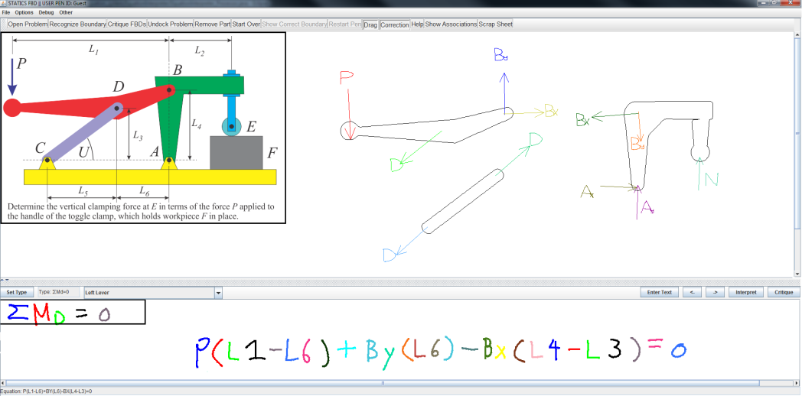

**Figure 4.26.** Newton’s Pen II: a pen-based tutoring system for Engineering Statics. The system scaﬀolds students in the construction of free body diagrams and equilibrium equations.

***The Effectiveness of “Pencasts” as an Instructional Medium***

A “pencast” is a type of video presentation in which recorded digital ink and audio are replayed in synchronization. To create a pencast, a Livescribe smartpen is used to record handwritten content with voice narration. For example, an instructor can use a smartpen to write the solution to a sample problem while explaining each step. When a student views the resulting pencast, the pen strokes and audio are replayed like a movie, with the explanation synchronized to the rendering of the strokes. While pencasts are becoming a popular instructional tool, their educational effectiveness has not been formally studied. Professor Stahovich conducted a study aimed at comparing the educational effectiveness of pencasts to that of traditional instructional media, specifically, traditional electronic documents. In each study session, students were given one of two tutorials explaining the solution to a statics problem involving friction. In one treatment, the tutorial was a pencast containing a handwritten solution to the sample problem accompanied by spoken explanation. In the other treatment, the tutorial was an electronic PDF document with content identical to that of the pencast. Each session included a pre- and posttest to measure learning gains. There were significant and equivalent learning gains for both treatments. Furthermore, an attitudinal survey revealed that students clearly prefer pencasts to PDFs. Thus, pencasts and PDFs were equally effective, while pencasts were strongly preferred by students.

**4.D.3 *ME 137, Environmental Fluid Mechanics***

In ME 137, Environmental Fluid Mechanics, the instructor developed a concept inventory examination which is administered as a pretest at the beginning of the quarter, and a posttest at the end. This exam consists of 10 questions in which students are asked about fundamental concepts in environmental fluid mechanics such as “what causes winds?” and “what causes ocean currents?” These questions focus on everyday concepts that are commonly misunderstood.

Results from the pre- and posttest are used to evaluate the course objectives and Student Outcomes as shown in Figure 4.27. (This is assessment is in addition to the ordinary methods of assessing course objectives and Students Outcomes used in all courses.) There is significant improvement from pre- to posttest for both. For example, on the pretest, only two course objectives had efficiencies of at least 60%, while all course objectives on the posttest did. Note that this course is focused on the math and physics behind environmental fluid mechanics, but the concept inventory considers only conceptual questions. Thus, the data Figure 4.27 represents learning gains in the understanding of everyday concepts, but does not measure learning gains in the theoretical and mathematical aspects of the course.

The course objectives for ME 137 are:

1. Demonstrate an understanding of radiative forcing of the atmosphere, including the greenhouse effect
2. Carry out calculations involving surface energy balance
3. Identify phenomena related to different atmospheric stability conditions
4. Scale and simplify the governing equations for various environmental flows
5. Apply the Thermal Wind Equations
6. Apply geostrophic balance for the upper atmospheric layers
7. Describe near surface flows using Ekman balance
8. Explain the effects of turbulence on mixing in the environment

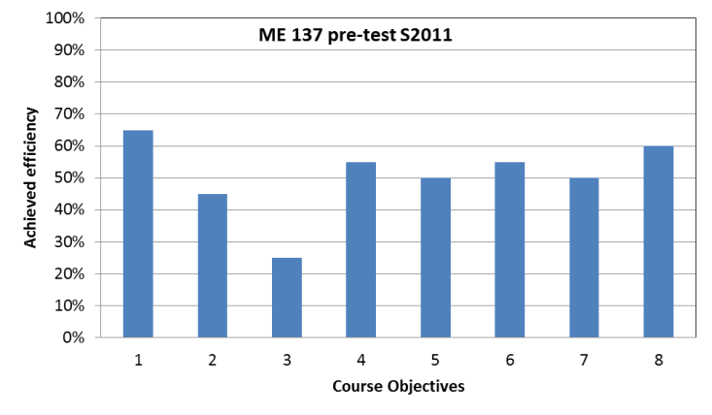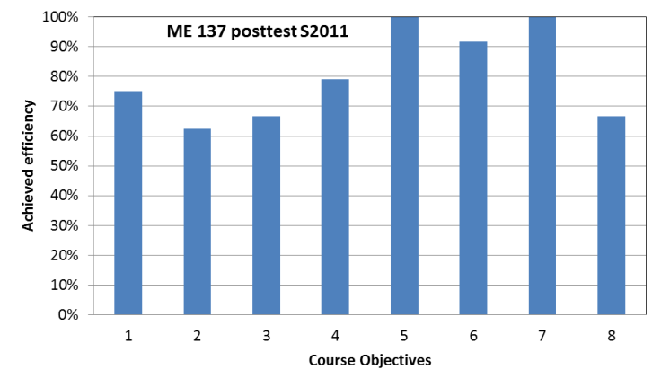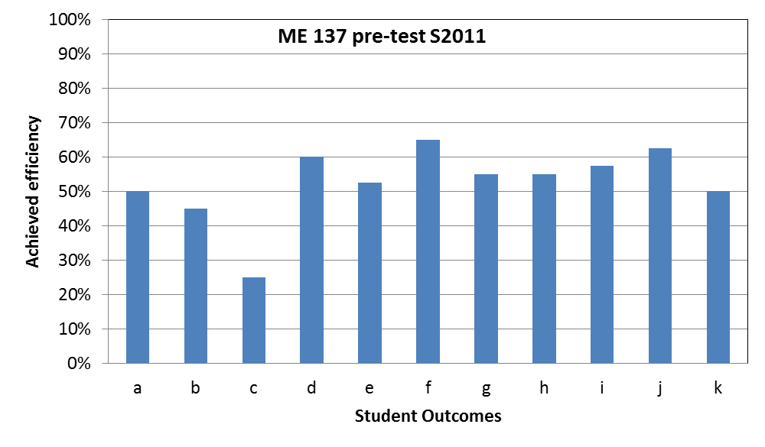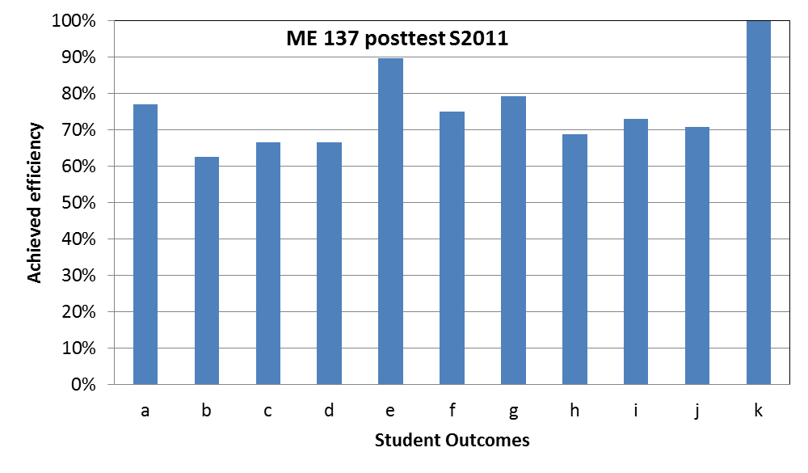

**Figure 4.27.** Course objectives and Student Outcomes efficiency on pre- (left) and posttest (right) for Environmental Fluid Mechanics (Spring 2011).

**4.D.4. *ME 110,* *Mechanics of Materials***

This course has been continuously taught by Professor Rao since the winter 2010 quarter. Achieved efficiencies for the course objectives and Student Outcomes for each offering are plotted in Figure 4.28.

The course objectives of ME 110 are:

1. Understand basic concepts of stress, strain and their relations based on linear elasticity.
2. Understand and know how to calculate stresses and deformation of a bar due to an axial loading under uniform and non-uniform conditions.
3. Understand and know how to calculate stresses and deformation of a torsional bar.
4. Understand how to develop shear-moment diagram of a beam and find the maximum moment/shear and their locations.
5. Understand how to calculate normal and shear stresses on any cross-section of a beam.
6. Understand and know how to calculate deflections of a beam under combined loads by using moments of moment-area and superpositions.
7. Understand and know how to calculate deflection of a beam, when a beam is statically indeterminate.
8. Understand and how to use Mohr’s circle to calculate principal stresses and angles in plane stress cases.
9. Able to apply all knowledge learned in the course to calculate stresses on pressure vessels, beams and structures under combined loadings

There is a clear upward trend in the efficiencies across consecutive offerings. This is likely due to both continuous improvement in the teaching of the course and improved preparation of the students resulting from the introduction of ME 2. The cohort taking ME 110 in the winter of 2012 was the first to take ME 2.

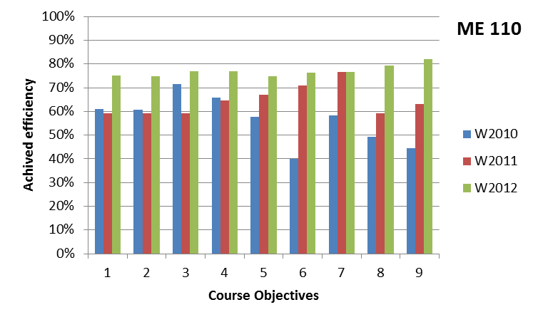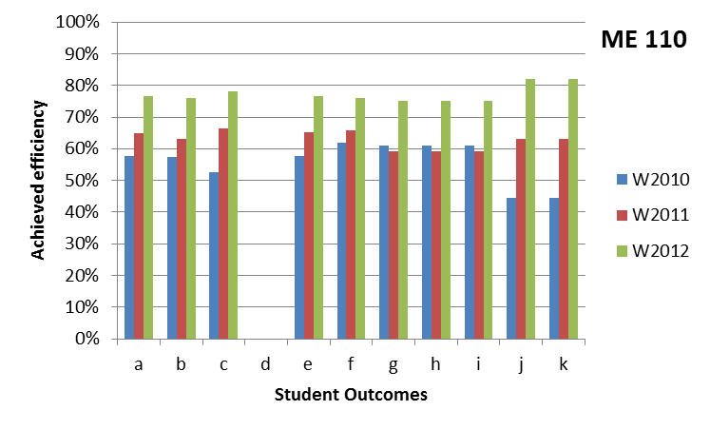

**Figure 4.28.** Achieved efficiencies of the course objectives and Student Outcomes in ME 110 for three consecutive offerings (Winter 2010, 2011, and 2012).

**4.D.5. *ME 135, Transport Phenomena***

ME 135, Transport Phenomena, is a required class taken by seniors in the fall quarter. The course covers advanced material not covered in the prerequisites ME 113 (Fluid Mechanics), ME 100A (Thermodynamics), and ME 116A (Heat Transfer). The topics include momentum, mass and heat transfer in external and internal laminar and turbulent flows, turbomachines, and one-dimensional compressible flow. The topics are treated at a level that prepares students for graduate study.

ME 135 is considered by students to be one of the most difficult courses in the ME curriculum, and the majority of the students struggle through the course. Until 2009, the class included a project that required students to analyze a system that involved interactions between heat, mass, and momentum transport. For example, in 2009, the students were asked to design and build a device that would measure environmental variables required to estimate the “comfort index”. This required students to understand the response of the human body to environmental variables. While the students appreciated such projects, they were also overwhelmed by the breadth and depth of the material covered in the class. The students also expressed the need for a reader for the course to avoid relying on several textbooks used in the prerequisite classes. In response to the difficulties experienced in coping with the class, the project was eliminated in 2010 and 2011.

In 2009, the course objectives were designed to achieve outcomes (a), (c), (e), and (g) (see footnote, Figure 4.29). The students scored very well, achieving nearly to 80% on outcomes (c) and (g), which are related to the project. However, their performance in outcomes (a) and (e), which are related to other course material, was only average. Surprisingly, as seen in Figure 4.29, their performance in these outcomes dropped in 2010 after the project was dropped. It is possible that the elimination of the project resulted in more material being covered in the class, which in turn led to student fatigue. Students did complain about the sheer volume of the material that they were expected to learn. In response to this, the course material was trimmed and reorganized, and he performance in achieving outcomes (a) and (e) recovered as shown in the figure.

At this point, the course is still evolving, and we have not yet reached a balance in the depth and breadth of the material covered in the class. A course reader would help a great deal.

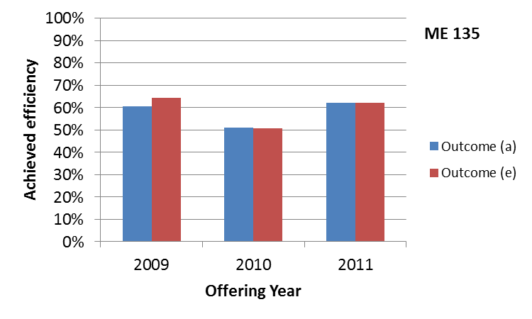

**Figure 4.29.** Efficiency of achieving Student Outcomes (a) and (e) in three course offerings of ME 135.

*Outcome (a): An ability to identify, formulate, and solve engineering problems

Outcome (c): An ability to design a system, component, or process to meet desired needs

Outcome (e): An ability to identify, formulate, and solve engineering problems

Outcome (g): An ability to communicate effectively

**4.D.6. *ME 156,* *Mechanical Behavior of Materials***

ME 156, Mechanical Behavior of Materials, has been continuously taught by Professor Rao since the spring quarter of 2009. Achieved efficiencies of the Student Outcomes and course objectives for each offering are plotted in Figure 4.30.

The course objectives for ME 156 are:

1. To provide an overview of mechanical behavior of material classes
2. To familiarize students with concepts of crystalline material mechanical behavior
3. To analyze material stress-strain behavior
4. To provide a basis for students to assess plastic deformation in materials
5. To familiarize students with key dislocation concepts
6. To familiarize students with concepts fracture mechanics
7. To familiarize students with important concepts in composite material behavior
8. To provide an overview of mech. behavior of polymers
9. To provide a basis for students to assess high temperature behavior of materials
10. To give students a basis for proper material selection in design

Both upward and downward trends are observed across the efficiencies. While the instructor focused on continuous improvement, the effects on the various course efficiencies are inconsistent. Note that the first cohort to take ME 002 has not yet taken ME 156, thus any benefits resulting from the introduction ME 002 in the freshman year is not a factor in these results.

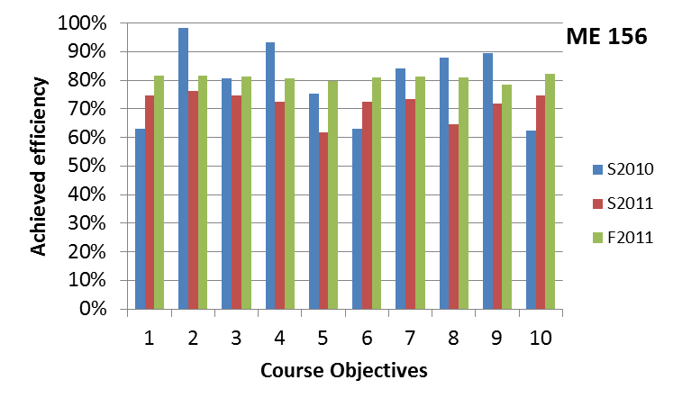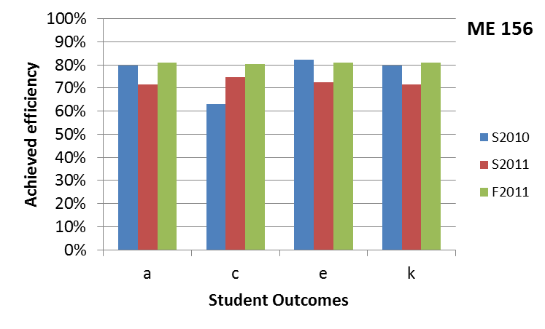

**Figure 4.30.** Achieved efficiencies of the course objectives and Student Outcomes in ME 156 for three consecutive offerings (spring 2010, spring 2011, and fall 2011).

**4.D.7. *ME 175 A/B/C, Professional Topics and Senior Design***

**Figure 4.30.** Student performance on technical communication skills in the capstone design course, ME 175 B/C. Each pair of columns represents a single offering of the 175 B/C sequence, which is designated by the quarter in which the sequence began. For example, the fall 2009 – winter 2010 offering are represented by the first two columns.

Experience with ME175B in fall 2009 and ME175C in winter 2010 revealed that students had difficulty with technical communication skills (Figure 4.30). This was communicated to the subsequent instructor of ME175B through the course recommendation form in the ABET binder and through face-to-face communication. The instructor for ME175B in winter 2010 provided greater coverage of technical communication skills in the lectures. The instructor also provided extensive feedback to the students on their writing in their design reports. Specifically, the instructor provided sentence-by-sentence analysis of grammar and writing style. Students were then given the opportunity to update their reports based on these editorial comments. Students were told that they could improve their prior grade if they edited their reports according to the suggestions. Figure 4.30 clearly shows the benefit of this approach. Nevertheless, recognizing that additional improvement in writing style was possible, the instructor included 10-minute writing assignments at the beginning of each lecture of ME 175C in spring 2010. The instructor encouraged students to read “Sin and Syntax” by Constance Hale and addressed the main topics from that book in lecture. This resulted in further improvement of the student’s technical communication skills in ME 175C.

Based on this experience, several of the grammar, style and format problems that occurred frequently in the reports were explicitly addressed in ME175A in fall 2010. Students were evaluated based on homework assignments that involved sentence analysis and correction, a 3-page report describing a mechanical device, and problems related to technical communication in the midterm and final examinations. The 3-page reports were edited sentence-by-sentence by the instructor. The students were again given the opportunity to rewrite their reports, incorporating the changes suggested by the instructor, to obtain a better grade.

The immediate impact of these changes to ME 175A on the writing skills of students in ME 175B in fall of 2010 is apparent in Figure 4.30. Unfortunately, these performance gains did not persist into ME 175C in winter 2011. This suggests that it is important to sustain the focus on technical communication by reiterating style throughout the ME 175 series.

In the fall quarter of 2011, the instructor of ME 175A worked with the ME 175B instructor to directly address issues with the quality of the writing on the senior design reports. (About half of the ME 175A students concurrently enroll in ME 175B, while the rest take ME 175B in the next quarter.) During two lecture periods, ME 175A students critiqued the reports from ME 175B. The students in ME 175B then had an opportunity to rewrite their reports. The instructor of ME 175 B reported that this resulted in substantial improvements in writing in the course. Even the students who began 175 B in the winter appeared to write much better than students usually do in that class.

Until the fall of 2008, strength-based design was included in ME 175A. In the spring of 2009, ME 174, Machine Design, was taught for the first time as a required course. With the introduction of this new course, strength-based design was eliminated from ME 175A in fall 2009, enabling increased coverage of professional ethics. Ethics is taught using a variety of case studies including the Ford Pinto Case Study, the Goodrich-Air Force A7D Brake Problem Case Study, and case studies from the National Society of Professional Engineers (NSPE). These case studies, particularly those from NSPE, allowed not only direct evaluation of students’ understanding of ethics, but also enabled greater emphasis on contemporary issues and the need for lifelong learning. Efficiencies for Student Outcome (f), an understanding of professional and ethical responsibility, for ME 175A are shown in Figure 4.31. Due to an error in data processing, assessment data for this this outcome were collected but not processed in 2009. However, in both 2010 and 2011, students did achieve over 70% efficiency on this outcome.

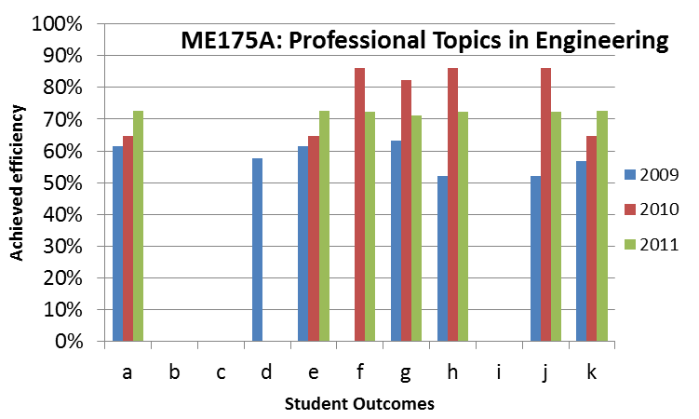

**Figure 4.31.** Efficiency for Student Outcomes in ME175A

# CRITERION 5. CURRICULUM

### 5.A. Program Curriculum

**5.A.1. Plan of Study**

Table 5.1 presents the complete course of study for students in the Mechanical Engineering program. The program operates on a quarter system. Another view of the curriculum is presented in “Criterion 1. Students, subsection F. Graduation Requirements.” In that section, Table 1.7 organizes the curriculum into lower and upper division courses, and Table 1.8 lists the technical electives.

Table 5.1. Curriculum

Mechanical Engineering

|  |  |  |  |  |  |  |  |  |  |  |  |  |  |
| --- | --- | --- | --- | --- | --- | --- | --- | --- | --- | --- | --- | --- | --- |
| MECHANICAL ENGINEERING PROGRAM COURSES | | | | Required, Elective or a Selected Elective (R, E, SE) | Subject Area (Credit History) | | | | | | Last Two Terms the Course was Offered: | Maximum Section Enrollment for Last Two Terms Course was Offered: | |
| *Lists all courses in the program by term starting with  first term of first year and ending with the last term of the final year* | | | |
|  | Department and Course Number | Title | | Math & Basic Sciences | Engineering Topics | | General Education | Courses with design component | |
| Yr 1, 1st Term | ENGL 001A | Beginning Composition | | R |  |  | | 4 |  | | W2012, F2011 | 917, 1136 | |
| Yr 1, 1st Term | MATH 009A | First Year Calculus | | R | 4 |  | |  |  | | W2012, F2011 | 275, 440 | |
| Yr 1, 1st Term | Breadth __________ | Humanities/Social Sciences | | R |  |  | | 4 |  | | S2012, W2012 |  | |
| Yr 1, 2nd Term | ENGL 001B | Intermediate Composition | | R |  |  | | 4 |  | | W2012, S2011 | 1716, 2145 | |
| Yr 1, 2nd Term | MATH 009B | First Year Calculus | | R | 4 |  | |  |  | | W2012, F2011 | 848, 756 | |
| Yr 1, 2nd Term | ME 002 | Intro to Mechanical Engineering | | R |  | 4 | |  |  | | S2012, W2012 | 85, 150 | |
| Yr 1, 2nd Term | PHYS 040A | Physics (Mechanics) | | R | 5 |  | |  |  | | W2012, F2011 | 354, 283 | |
| Yr 1, 3rd Term | ENGL 001C or Alternate* | Applied Intermediate Composition | | R |  |  | | 4 |  | | W2012, F2011 | 23, 22 | |
| Yr 1, 3rd Term | MATH 009C | First Year Calculus | | R | 4 |  | |  |  | | W2012, F2011 | 407, 423 | |
| Yr 1, 3rd Term | ME 009 | Engineering Graphics & Design | | R | 4 |  | |  | X | | S2012, S2011 | 137, 144 | |
| Yr 1, 3rd Term | PHYS 040B | Physics (Heat/Waves/Sound) | | R | 5 |  | |  |  | | W2012, S2011 | 260, 345 | |
| Yr 2, 1st Term | CHEM 001A & CHEM 01LA | General Chemistry & Lab | | R | 5 |  | |  |  | | W2012, F2011 | 539, 1140 | |
| Yr 2, 1st Term | MATH 046 | Differential Equations | | R | 4 |  | |  |  | | W2012, F2011 | 272, 421 | |
| Yr 2, 1st Term | ME 018 | Intro to Engineering Computations | | R |  | 3 | |  |  | | F2011, F2010 | 128, 98 | |
| Yr 2, 1st Term | PHYS 040C | Physics (Electricity/Magnetism) | | R | 5 |  | |  |  | | F2011, S2011 | 289, 244 | |
| Yr 2, 2nd Term | BIOL 005A & BIOL 005LA | Cell & Molecular Biology & Lab | | R | 5 |  | |  |  | | W2012, F2011 | 874, 794 | |
| Yr 2, 2nd Term | CHEM 001B & CHEM 01LB | General Chemistry & Lab | | R | 5 |  | |  |  | | W2012, S2011 | 977, 724 | |
| Yr 2, 2nd Term | MATH 010A | Multivariable Calculus | | R | 4 |  | |  |  | | W2012, F2011 | 331, 257 | |
| Yr 2, 2nd Term | ME 010 | Statics | | R |  | 4 | |  | X | | S2012, W2012 | 64, 150 | |
| Yr 2, 3rd Term | EE 001A & EE 01LA | Engineering Circuit Analysis I & Lab | | R |  | 4 | |  |  | | F2011, S2011 | 175, 145 | |
| Yr 2, 3rd Term | MATH 010B | Multivariable Calculus | | R | 4 |  | |  |  | | W2012, F2011 | 196, 100 | |
| Yr 2, 3rd Term | STAT 100A | Introduction to Statistics | | R | 5 |  | |  |  | | S2012, W2012 | 307, 307 | |
| Yr 2, 3rd Term | Breadth __________ | Humanities/Social Sciences | | R |  |  | | 4 |  | |  |  | |
| Yr 3, 1st Term | ME 100A | Thermodynamics | | R |  | 4 | |  |  | | F2011, F2010 | 114, 110 | |
| Yr 3, 1st Term | ME 103 | Dynamics | | R |  | 4 | |  | X | | F2011, S2011 | 41, 107 | |
| Yr 3, 1st Term | ME 114 | Intro to Materials Science & Engr | | R |  | 4 | |  |  | | F2011, F2010 | 128, 111 | |
| Yr 3, 1st Term | Breadth __________ | Humanities/Social Sciences | | R |  |  | | 4 |  | |  |  | |
| Yr 3, 2nd Term | ME 110 | Mechanics of Materials | | R |  | 4 | |  | X | | W2012, W2011 | 115, 107 | |
| Yr 3, 2nd Term | ME 113 | Fluid Mechanics | | R |  | 4 | |  |  | | W2012, W2011 | 119, 85 | |
| Yr 3, 2nd Term | ME 118 | Mechanical Engr. Modeling & Analysis | | R |  | 4 | |  | X | | W2012, W2011 | 105, 98 | |
| Yr 3, 2nd Term | ME 120 | Linear Systems and Controls | | R |  | 4 | |  |  | | W2012, W2011 | 96, 65 | |
| Yr 3, 3rd Term | ME 116A | Heat Transfer | | R |  | 4 | |  |  | | S2012, S2011 | 86, 74 | |
| Yr 3, 3rd Term | ME 170A | Experimental Techniques | | R |  | 4 | |  |  | | S2012, S2011 | 98, 87 | |
| Yr 3, 3rd Term | ME 174 | Machine Design | | R |  | 4 | |  | X | | S2012, S2011 | 94, 83 | |
| Yr 4, 1st Term | ME 135 | Transport Phenomena | | R |  | 4 | |  |  | | F2011, F2010 | 70, 50 | |
| Yr 4, 1st Term | ME 170B | Experimental Techniques | | R |  | 4 | |  | X | | F2011, F2010 | 65, 67 | |
| Yr 4, 1st Term | ME 175A | Professional Topics | | R |  | 2 | |  |  | | F2011, F2010 | 78, 63 | |
| Yr 4, 1st Term | Breadth __________ | HUMANITIES/SOCIAL SCIENCES | | R |  |  | | 4 |  | |  |  | |
| Yr 4, 2nd Term | ME 175B | Mechanical Engr Design | | R |  | 3 | |  | X | | W2012, F2011 | 44, 28 | |
| Yr 4, 2nd Term | Technical Elective** | MECHANICAL ENGINEERING | | R |  | 4 | |  |  | |  |  | |
| Yr 4, 2nd Term | Technical Elective** | MECHANICAL ENGINEERING | | R |  | 4 | |  |  | |  |  | |
| Yr 4, 2nd Term | Breadth __________ | HUMANITIES/SOCIAL SCIENCES | | R |  |  | | 4 |  | |  |  | |
| Yr 4, 3rd Term | ME 175C | Mechanical Engr Design | | R |  | 3 | |  | X | | S2012, W2012 | 44, 28 | |
| Yr 4, 3rd Term | Technical Elective** | MECHANICAL ENGINEERING | | R |  | 4 | |  |  | |  |  | |
| Yr 4, 3rd Term | Technical Elective** | MECHANICAL ENGINEERING | | R |  | 4 | |  |  | |  |  | |
| Yr 4, 3rd Term | Breadth __________ | HUMANITIES/SOCIAL SCIENCES | | R |  |  | | 4 |  | |  |  | |
| Mechanical Engineering Tech Electives in 4 Focus Areas4 courses (at least 16 units) of Technical Elective Coursework from one Focus Area must be completed by 4th year. | | | | | | | | | | | | | |
| Focus Area | **TECHNICAL ELECTIVES** |  | |  |  |  |  | | |  |  | |  |
| General ME | ME 100B | Thermodynamics | | SE |  | 4 |  | | |  | W2007, W2006 | | 9, 33 |
| General ME | ME 116B | Heat Transfer | | SE |  | 4 |  | | |  | W2011, W2010 | | 41, 44 |
| General ME | ME 117 | Combustion & Energy Systems | | SE |  | 4 |  | | |  | W2012, S2011 | | 42, 31 |
| General ME | ME 121 | Feedback Control | | SE |  | 4 |  | | |  | S2012, F2005 | | 37, 51 |
| General ME | ME 122 | Vibrations | | SE |  | 4 |  | | |  | S2012, W2011 | | 32, 57 |
| General ME | ME 130 | Kinematic & Dynamic Analysis of Mechanisms | | SE |  | 4 |  | | |  | S2008, F2007 | | 45, 59 |
| General ME | ME 131 | Design of Mechanisms | | SE |  | 3 |  | | | X | F2002, F2001 | | 8, 22 |
| General ME | ME133 | Introduction to Mechatronics | | SE |  | 4 |  | | |  | S2012, F2010 | | 44, 30 |
| General ME | ME 136 | Envir. Impacts of Energy Prod & Conversion | | SE |  | 4 |  | | |  | S2012, W2011 | | 15, 40 |
| General ME | ME 137 | Environmental Fluid Mechanics | | SE |  | 4 |  | | |  | S2011, W2010 | | 6, 26 |
| General ME | ME 138 | Transport Phenomena in Living Systems | | SE |  | 4 |  | | |  | F2011, F2009 | | 15, 20 |
| General ME | ME 153 | Finite Element Methods | | SE |  | 4 |  | | |  | W2012, S2011 | | 34, 60 |
| General ME | ME 156 | Mechanical Behavior of Materials | | SE |  | 4 |  | | |  | F2011, S2011 | | 25, 43 |
| General ME | ME 176 | Sustainable Product Design | | SE |  | 4 |  | | | X | W2012 | | 30 |
| General ME | ME 180 | Optics & Lasers in Engineering | | SE |  | 4 |  | | |  | W2012, S2008 | | 46, 28 |
| General ME | *ME 197 | Research for Undergraduates | | SE |  | 4 |  | | | X | S2012, W2012 | | 9, 7 |
| Materials & Structures | ME 100B | Thermodynamics | | SE |  | 4 |  | | |  | W2007, W2006 | | 9, 33 |
| Materials & Structures | ME 116B | Heat Transfer | | SE |  | 4 |  | | |  | W2011, W2010 | | 41, 44 |
| Materials & Structures | ME 121 | Feedback Control | | SE |  | 4 |  | | |  | S2012, F2005 | | 37, 51 |
| Materials & Structures | ME 122 | Vibrations | | SE |  | 4 |  | | |  | S2012, W2011 | | 32, 57 |
| Materials & Structures | ME 153 | Finite Element Methods | | SE |  | 4 |  | | |  | W2012, S2011 | | 34, 60 |
| Materials & Structures | ME 156 | Mechanical Behavior of Materials | | SE |  | 4 |  | | |  | F2011, S2011 | | 25, 43 |
| Materials & Structures | ME 180 | Optics & Lasers in Engineering | | SE |  | 4 |  | | |  | W2012, S2008 | | 46, 28 |
| Materials & Structures | *ME 197 | Research for Undergraduates | | SE |  | 4 |  | | | X | S2012, W2012 | | 9, 7 |
| Energy & Environment | ME 100B | Thermodynamics | | SE |  | 4 |  | | |  | W2007, W2006 | | 9, 33 |
| Energy & Environment | ME 116B | Heat Transfer | | SE |  | 4 |  | | |  | W2011, W2010 | | 41, 44 |
| Energy & Environment | ME 117 | Combustion & Energy Systems | | SE |  | 4 |  | | |  | W2012, S2011 | | 42, 31 |
| Energy & Environment | ME 136 | Envir. Impacts of Energy Prod & Conversion | | SE |  | 4 |  | | |  | S2012, W2011 | | 15, 40 |
| Energy & Environment | ME 137 | Environmental Fluid Mechanics | | SE |  | 4 |  | | |  | S2011, W2010 | | 6, 26 |
| Energy & Environment | ME 138 | Transport Phenomena in Living Systems | | SE |  | 4 |  | | |  | F2011, F2009 | | 15, 20 |
| Energy & Environment | *ME 197 | Research for Undergraduates | | SE |  | 4 |  | | | X | S2012, W2012 | | 9, 7 |
| Design & Manufacturing | ME 121 | Feedback Control | | SE |  | 4 |  | | |  | S2012, F2005 | | 37, 51 |
| Design & Manufacturing | ME 122 | Vibrations | | SE |  | 4 |  | | |  | S2012, W2011 | | 32, 57 |
| Design & Manufacturing | ME 130 | Kinematic & Dynamic Analysis of Mechanisms | | SE |  | 4 |  | | |  | S2008, F2007 | | 45, 59 |
| Design & Manufacturing | ME 131 | Design of Mechanisms | | SE |  | 4 |  | | |  | F2002, F2001 | | 8, 22 |
| Design & Manufacturing | ME133 | Introduction to Mechatronics | | SE |  | 4 |  | | |  | S2012, F2010 | | 44, 30 |
| Design & Manufacturing | ME 153 | Finite Element Methods | | SE |  | 4 |  | | |  | W2012, S2011 | | 34, 60 |
| Design & Manufacturing | ME 156 | Mechanical Behavior of Materials | | SE |  | 4 |  | | |  | F2011, S2011 | | 25, 43 |
| Design & Manufacturing | ME 176 | Sustainable Product Design | | SE |  | 4 |  | | |  | W2012 | | 30 |
| Design & Manufacturing | ME 180 | Optics & Lasers in Engineering | | SE |  | 4 |  | | |  | W2012, S2008 | | 46, 28 |
| Design & Manufacturing | *ME 197 | Research for Undergraduates | | SE |  | 4 |  | | | X | S2012, W2012 | | 9, 7 |
| TOTALS-ABET BASIC-LEVEL REQUIREMENTS | | | | | 63 | 87 | 36 | | |  |  | |  |
| OVERALL UNITS FOR COMPLETION OF THE PROGRAM | | | | | 186 | | | | |  |  | |  |
| PERCENT OF TOTAL | | | | | 33.8 | 46.8 | 19.4 | | |  |  | |  |
| Total must satisfy either credit hours or percentage | | | Minimum Quarter Credit Hours | | 48 | 72 |  | | |  |  | |  |
| Minimum Percentage | | 25 | 37.5 |  | | |  |  | |  |

**5.A.2. Alignment of the Curriculum with the Program Educational Objectives**

The Mechanical Engineering Program Educational Objectives are achieved through a curriculum that offers:

* Strong training in the areas of mathematics, science, and the fundamentals of mechanical engineering that comprise the discipline.
* Laboratory and hands-on experience to strengthen the understanding of fundamental principles, with opportunities for teamwork and written and oral communication.
* Extensive use of computer simulation and modeling in the solution of problems and for design.
* Application of engineering principles to the solution of design problems typical of modern mechanical engineering practice.
* Coverage of design for manufacturability, engineering economics, and engineering ethics to emphasize the relationship between design, fabrication, cost, and impact on society.
* Flexibility in the curriculum enabling students to personalize their studies. Each student may chose a focus area and technical electives within that focus. Likewise, students may participate in independent research, and can select from a variety of senior design projects, typically sponsored by industry or government agencies.
* A well-rounded and balanced education with required studies in selected areas of the Humanities and Social Sciences.

The curriculum is carefully designed to align with the Program Educational Objectives as described here:

**Educational Objective 1:** To produce mechanical engineers who have the knowledge and skills to adapt to the changing engineering environment in industry

In addition to their training in mathematics (MATH 9A, MATH 9B, MATH 9C, MATH 10A, MATH 10B, MATH 46), chemistry (CHEM 1A, CHEM 1B), physics (PHYS 40A, PHYS 40B, PHYS 40C), and biology (BIOL 5A, BIOL 5LA), our students acquire skills in core mechanical engineering sciences (including mechanics, fluids, thermodynamics, heat transfer, and materials), engineering modeling, and design. This material is reinforced through two major laboratory courses focused on data acquisition and project based experiments. The program culminates in a capstone senior design course (ME 175 B/C) in which students learn design methodology which they use to create a solution to a substantial, open-ended design problem. To complete this design project, students must apply the engineering principles learned throughout the curriculum.

Engineering problem solving and design are emphasized throughout the curriculum, starting in the freshman year. The former is first taught in Introduction to Mechanical Engineering (ME 2), while the latter is first taught in Engineering Graphics and Design (ME 9). These courses are intended to enable our students to participate in industrial internships after only one year in the program.

Because communication skills are essential for success in industry, the Mechanical Engineering curriculum emphasizes both oral and written communication in many of the courses. Several of our courses (see Table 5.1 for courses with a design component) include design projects that require a student to write a report and\or give an oral presentation. The two major laboratory courses, Experimental Techniques ME 170A and ME170B, require frequent detailed laboratory reports. The capstone design course series, ME 175 A/B/C, has a strong emphasis on technical communication. ME 175A (Professional Topics) explicitly teaches technical communication skills, and 175B and C require extensive reports and frequent oral presentations. Additionally, ME 175A provides training in professional ethics, equipping our students for the complex social and ethical issues they will face in the workplace.

**Educational Objective 2:** To produce mechanical engineers who are able to pursue and succeed in graduate studies

The technical rigor of our curriculum prepares students for advanced graduate degrees in mechanical engineering and other allied fields. The curriculum begins with a strong foundation of mathematical tools relevant to engineering science, including applied linear algebra, multivariable calculus, and ordinary and partial differential equations. Our engineering courses focus on fundamental principles, with a strong emphasis on theory, thus equipping our students for advanced work.

In addition, the curriculum enables students to conduct research under faculty supervision for credit as a technical elective. Faculty are available to advise students about career options including advanced graduate studies. Senior students with a GPA of 3.0 and above (the minimum required for admission to most U.S. graduate programs) are invited to an annual presentation by the Department’s Graduate Advisor to discuss graduate research opportunities in the Department. Furthermore, these students are also eligible to take one mechanical engineering graduate course as a technical elective.

**Educational Objective 3:** To produce mechanical engineers who have the educational breadth and the intellectual discipline required to enter professional careers outside engineering, such as business and law.

The reasoning skills and intellectual discipline inculcated by our curriculum are essential for success in professions outside of engineering. In particular, the ability to formulate and solve problems and the ability to make and test assumptions are fundamental in many professions including, for example, business, law, and medicine. In addition, the College has breadth requirements that include English composition, Humanities, Social Sciences, and Ethnicity. This rich set of skills enables our graduates to make contributions to society in a multitude of fields.

**Educational Objective 4:** To produce mechanical engineers who have an ability to work in multi-disciplinary teams.

The importance of teamwork is emphasized throughout the curriculum. For example, the College’s “Learning Communities” program enrolls first year students in the same sections of math and science courses each quarter of the freshman year. This enables students to create academic and social networks to help them meet the challenges of a rigorous engineering curriculum. Some instructors in ME 2 (Introduction to Mechanical Engineering) advise students in the course to work and learn in teams. Some of our courses include team-based projects (Table 5.1). Students are required to work in teams in our laboratory courses (ME 170A/B). Finally, the program culminates with a significant two-quarter-long team project in the capstone design sequence (ME 175 B/C) taken in the senior year.

**Educational Objective 5:** To produce mechanical engineers who engage in a lifetime of learning

Through numerous means, our program prepares our students to engage in lifelong learning. (a) Many of our courses include problems in which students apply engineering principles to everyday life. For example, in ME 18 (Introduction to Engineering Computation) students learn how the characteristics of an automobile design relate to fuel consumption. In ME 175 A (Professional Topics), students learn how to apply the principles of engineering economics to mortgages, retirement planning, and bond initiatives in state elections. These exercises encourage students to apply analytical skills to problems outside engineering. (b) In many of our courses, students must complete projects that require independent research to understand the requirements of the problem and the nature of possible solutions. In a recent offering of ME 9 (Engineering Graphics and Design), for example, students were required to design a food press for an industrial kitchen. This required them to conduct research on the requirements for such a device, available solutions, and mechanisms that could be adapted for the solution. Our capstone design course (ME 175 B/C) requires extensive independent study. Students must gain expertise in multiple areas that go well beyond the standard curriculum. (c) Our students have an opportunity to engage in undergraduate research which teaches them how to explore and solve open-ended, unsolved problems. These problems typically require students to conduct a review of the literature and to understand the state of the art. (d) Our curriculum emphasizes fundamental principles and theory. Thus, our students’ knowledge is not limited to specific application areas.

All of these activities provide students with the confidence and self-discipline required to take on complex and unfamiliar problems. These traits form the foundation for lifelong learning.

As described in “Criterion 4. Continuous Improvement,” we formulated our Program Educational Objectives with input from our Board of Advisors and Stakeholders. We assess achievement of these Objectives by a variety of means including surveys of employers and alumni and through meetings with our Board of Advisors and Stakeholders.

#### 5.A.3. Relationships of Curriculum to the Student Outcomes

Next we will discuss how each of the Student Outcomes is addressed in the Mechanical Engineering undergraduate curriculum. (Table 5.2 summarizes the relationship between the courses and the Student Outcomes.) Note that the prerequisite structure (Table 5.3) ensures that, prior to taking each course, students have the necessary knowledge and skills to master the course material.

**Outcome (a):**An ability to apply knowledge of mathematics, science and engineering

Nearly all of the courses in our curriculum are designed to address this outcome. Students receive training in mathematics (MATH 9A, MATH 9B, MATH 9C, MATH 10A, MATH 10B, MATH 46), chemistry (CHEM 1A, CHEM 1B), physics (PHYS 40A, PHYS 40B, PHYS 40C), and biology (BIOL 5A, BIOL 5LA). They also receive extensive training in the core disciplines that comprise mechanical engineering including rigid-body mechanics, strength of materials, materials science, fluid dynamics, thermodynamics, heat transfer, and design.

The relative weight of this outcome in the curriculum is approximately 20% (Figure 4.4).

**Outcome (b):**An ability to design and conduct experiments, as well as analyze and interpret data

The program has two significant laboratory experiences. ME 170A, Experimental Techniques, covers the fundamentals of experimental techniques used in engineering, including the use of instrumentation, uncertainty analysis, and interpretation of data. In ME 170B, Experimental Techniques, students use the skills learned in ME 170A to design and conduct advanced, project-oriented experiments to achieve stated goals. This course includes experiments drawn from both the thermal and the mechanical sciences to ensure that students appreciate the need to integrate their knowledge in solving engineering problems. The course is offered in the senior year to ensure that students have a thorough grounding in the topics required to design the experiments. In addition, many of our technical elective courses have laboratory components.

Beginning in ME 18, Introduction to Engineering Computation, which is offered in the sophomore year, students learn to program in Matlab, which is essential for data analysis. Also, in the sophomore year, students take STAT 100A, Introduction to Statistics, which provides students with knowledge of statistical analysis needed for data analysis. In ME 118, Mechanical Engineering Modeling & Analysis, students learn methods to formulate empirical and mechanistic models to explain data. This course also covers the use of statistics for data analysis. Both ME 170A and ME 170B require extensive analysis, interpretation, and presentation of experimental data. Both of these courses emphasize uncertainty analysis.

The relative weight of this outcome in the curriculum is approximately 7% (Figure 4.4).

**Outcome (c):**An ability to design a system, component, or process to meet desired needs within realistic constraints such as economic, environmental, social, political, ethical, health and safety, manufacturability, and sustainability

Design is emphasized in many courses in the curriculum; Table 5.1 lists the courses with a design component. The first substantial design experience occurs in ME 9, Engineering Graphics and Design. In this course, students learn to use CAD tools and gain experience designing devices to meet specified requirements. Design projects are also used to reinforce concepts in our engineering science courses. For example, a project in ME 10, Statics, required students to use the principles of equilibrium analysis to design a band saw. In ME 118, Mechanical Engineering Modeling & Analysis, students worked in groups to create a numerical model with which they designed the major features of a hybrid automobile to meet specified performance requirements, such as gas mileage and time to reach 60 mph. Courses such as ME 117 (Combustion and Energy Systems), ME 136 (Environmental Impacts of energy Production and Conversion) and ME 137 (Environmental Fluid Mechanics) stress environmental concerns. ME 174, Machine Design, focuses on the design of mechanical components, such as shafts and gears. The course emphasizes strength-based design, including static and fatigue failure. ME 175 A, Professional Topics, emphasizes professional ethics and economic analysis. This course is followed by the capstone design sequence, ME 175 B/C which develops the student’s ability to generate, evaluate and present solutions to realistic, open-ended engineering design problems. In solving these problems, students must satisfy a variety of real-world constraints including economic, environmental, social, ethical, safety, manufacturability, performance, reliability, and lifecycle constraints.

The relative weight of this outcome in the curriculum is approximately 8% (Figure 4.4).

**Outcome (d):**An ability to function on multidisciplinary teams

Although the teams in most mechanical engineering classes are comprised primarily of mechanical engineering students, the team members are expected to take on roles that cross disciplinary lines. For example, senior design projects typically require expertise in a wide range of disciplines including electrical engineering (e.g., electronic circuits, microprocessors, and sensors), computer science (e.g., embedded software and simulation), structural analysis, economic analysis, market research, manufacturing, etc. For example, senior design projects have included devices for cleaning diesel particulate filters, devices for capturing space debris, devices for cleaning heart stents, consumer products, waste water treatment systems, renewable energy, and sustainability. Our broad curriculum – which includes math, chemistry, biology, materials science, circuits and instrumentation, and all of the core mechanical engineering disciplines – provides our students with the ability to take on a variety of technical roles and to communicate effectively with other disciplines.

The relative weight of this outcome in the curriculum is approximately 7% (Figure 4.4).

**Outcome (e):**An ability to identify, formulate, and solve engineering problems

This important outcome is emphasized in nearly every course in the Mechanical Engineering curriculum. One of the strengths of the curriculum is that our introductory mechanical engineering course, ME 2, provides our students with significant experience in engineering problem solving in the freshman year.

The relative weight of this outcome in the curriculum is approximately 18% (Figure 4.4).

**Outcome (f):**An understanding of professional and ethical responsibility

In ME 2, Introduction to Mechanical Engineering, students are introduced to the concepts of professional and ethical responsibility as they apply to both academic and professional pursuits. ME 10, Statics, provides formal training in professional ethics. This course includes an ethics case study (the Collapse of the Senior Road Tower Antenna) in which students explore issues of legal and ethical responsibility. ME 175A, Professional Topics, has substantial coverage of ethics and professional responsibility. For example, students study the National Society of Professional Engineers (NSPE) code of ethics and analyze case studies available from NSPE. ME 175C covers legal liability. Finally, ME 136 (Environmental Impacts of Energy Production and Conversion), ME 137 (Environmental Fluid Mechanics), and ME 176 (Sustainable Product Design) consider issues of sustainability.

The relative weight of this outcome in the curriculum is approximately 5% (Figure 4.4).

**Outcome (g):**An ability to communicate effectively

The curriculum includes three quarters of English Composition (ENGL 1 A/B/C). Additionally, students are required to write reports and make oral presentations in many courses throughout the curriculum. For example, several courses have design projects that require design reports (Table 5.1 lists the courses with a design component). The two main laboratory courses, Experimental Techniques, ME 170A and B, provide significant experience in writing engineering laboratory reports. Much of the content in ME 175A, Professional Topics, is focused on technical communication. This course teaches the conventions of professional technical writing and reviews common writing errors. ME 175A also provides training in oral and poster presentations. In the capstone design course, ME 175 B/C, students produce numerous design reports and give multiple poster and oral presentations. The course instructor provides students with extensive feedback about their writing and presentations. This labor-intensive mentoring process contributes greatly to the students’ technical communication skills.

The relative weight of this outcome in the curriculum is approximately 6% (Figure 4.4).

**Outcome (h):**The broad education necessary to understand the impact of engineering solutions in a global, economic, environmental, and societal context

Many courses in the curriculum help students to understand the larger context in which engineers work. For example, through a case study, students in ME 10, Statics, explore issues of legal and ethical responsibility. ME 175A, Professional Topics, has substantial coverage of engineering economics, ethics, and professional responsibility. Students in this course, for example, gain the skills necessary to understand the tax implications of a large public works project funded by bonds. The capstone design sequence, ME 175 B/C, provides an instruction to legal liability. Furthermore, design projects in this sequence provide experience with a variety of global, economic, environmental, and societal issues. Recent projects have included the design of equipment for processing peanut harvests for use in developing countries, sustainable power generation, and the design of energy-efficient consumer appliances (e.g., clothes dryers). ME 136, Environmental Impacts of Energy Production & Conversion, helps student understand the impact of engineering production and conversion on society. Both this course and ME 137 (Environmental Fluid Mechanics) explore the societal and economic impacts of air pollution. Finally, ME 176, Sustainable Product Design, is focused directly on issues of sustainability.

The relative weight of this outcome in the curriculum is approximately 5% (Figure 4.4).

**Outcome (i):**Recognition of the need for and an ability to engage in lifelong learning

Through numerous means, our program prepares our students to engage in lifelong learning. (a) Many of our courses include problems in which students apply engineering principles to everyday life. For example, in ME 18 (Introduction to Engineering Computation) students learn how the characteristics of an automobile design relate to fuel consumption. In ME 175A (Professional Topics), students learn how to apply the principles of engineering economics to mortgages, retirement planning, and bond initiatives in state elections. These exercises encourage students to apply analytical skills to problems outside engineering. (b) In many of our courses, students must complete projects that require independent research to understand the requirements of the problem and the nature of possible solutions. In a recent offering of ME 9 (Engineering Graphics and Design), for example, students were required to design a food press for an industrial kitchen. This required them to conduct research on the requirements for such a device, available solutions, and mechanisms that could be adapted for the solution. Our capstone design course (ME 175 B/C) requires extensive independent study. Students must gain expertise in multiple areas that go well beyond the standard curriculum. (c) Our students have an opportunity to engage in undergraduate research which teaches them how to explore and solve open-ended, unsolved problems. These problems typically require students to conduct a review of the literature and to understand the state of the art. (d) Our curriculum emphasizes fundamental principles and theory. Thus, our students’ knowledge is not limited to specific application areas.

All of these activities provide students with the confidence and self-discipline required to take on complex and unfamiliar problems. These traits form the foundation for lifelong learning.

The relative weight of this outcome in the curriculum is approximately 5% (Figure 4.4).

**Outcome (j):**Knowledge of contemporary issues

Many of our courses include examples and problems that require students to learn about contemporary issues. For example, after the earthquake in Japan in 2011, students in ME 2 (Introduction to Mechanical Engineering) solved a heat transfer problem based on the Fukushima Daiichi Nuclear Power Plant failure. Students in ME 118 completed a design project concerning hybrid automobiles, which have become increasingly important with the rise in fossil fuel prices and concerns for global warming. During a recent California state election, students in ME 175A (Professional Topics) examined the financial implications of a bond initiative. Likewise, lectures in ME 175A have covered the collapse of the US mortgage market and the 2008 collapse of the US banking system. Senior design projects address a wide variety of contemporary issues including sustainability. Also, several technical electives directly address contemporary issues. For example, students in ME 136 (Environmental Impacts of Energy Production & Conversion) were asked to write a short paper on global climate change and to study alternative fuels.

The relative weight of this outcome in the curriculum is approximately 6% (Figure 4.4).

**Outcome (k):**Ability to use the techniques, skills, and modern engineering tools necessary for engineering practice

While our curriculum emphasizes the theory behind engineering principles, it also provides students with experience in the practical application of these principles. The knowledge and skills provided by the curriculum are integrated in our capstone design sequence (ME 175 B/C), which provides students with a realistic experience of engineering practice.

The curriculum also provides students with skill in using the computational tools and techniques that are essential to modern engineering practice. In ME 9, Engineering Graphics and Design, students learn to use SolidWorks for design and analysis. This course also teaches the conventions for formal engineering drawings and CAD models. ME 18, Introduction to Engineering Computation, and ME 118, Engineering Modeling, provide skills in computer programing, numerical methods, and numerical modeling using MATLAB. ME 170A and ME 170B provide skills in modern experimental techniques and experimental design. These courses also provide students with skill and experience using modern data acquisition hardware and LABVIEW software.

The relative weight of this outcome in the curriculum is approximately 12% (Figure 4.4).

**Table 5.2.** The weights each course applies to each Student Outcome. Data is averaged over the period fall 2009 through winter 2012. Courses marked with an asterisk (*) were not taught during this period.



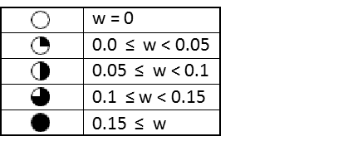

**5.A.4. Prerequisite Structure**

Table 5.3. describes the prerequisite structure for the Mechanical Engineering curriculum. The second column in the table lists the prerequisites for each course. The third column (“Required For”) lists the subsequent courses that depend directly on each course. For example, ME 002 has MATH 005 as a prerequisite and in turn is a prerequisite for ME 009 and ME 018.

**Table 5.3.** Prerequisite structure of Mechanical Engineering curriculum. See Table 1.7 for the course names.

|  |  |  |
| --- | --- | --- |
| **Course** | **Prerequisite** | **Required for** |
| MATH 009A | MATH 005 or high school equivalent | MATH 009B, PHYS 040A |
| MATH 009B | MATH 009A | MATH 009C, MATH 046, MATH 10A |
| MATH 009C | MATH 009B | ME 010, PHYS 040B, PHYS 040C |
| MATH 046 | MATH 009B | ME 103, ME 110, ME 113, ME 116A, ME 118, ME 138, EE 001A, EE 01LA |
| MATH 010A | MATH 009B | MATH 010B, ME 100A |
| MATH 010B | MATH 010A |  |
| BIOL 5A & 5LA | CHEM 1A & 1LA |  |
| PHYS 040A | MATH 009A | ME 010, PHYS 040B |
| PHYS 040B | PHYS 040A, MATH 009C | ME 100A, ME 113, ME 138, PHYS 040C |
| PHYS 040C | PHYS 040B, MATH 009C | ME 114, EE 1A & 1LA |
| CHEM 1A & 1LA |  | BIOL 5A & 5LA, CHEM 1B & 1LB |
| CHEM 1B & 1LB | CHEM 1A & 1LA | ME 114 |
| EE 1A & 1LA | MATH 046, PHYS 040C | ME 120, ME 170A |
| STAT 100A | MATH 009A |  |
| ENGL 001A |  | ENGL 001B |
| ENGL 001B | ENGL 001A | ENGL 001C |
| ENGL 001C | ENGL 001B |  |
| ME002 | MATH 005 or high school equivalent | ME 009, ME 018 |
| ME 003 |  |  |
| ME 004 |  |  |
| ME 005 |  |  |
| ME 009 | ME 002 | ME 130, ME 174, ME 175A |
| ME 010 | MATH 009C, PHYS 040A | ME 103, ME 110, ME 113, ME 180 |
| ME 018 | ME 002 | ME 100A, ME 100A, ME 110, ME 113, ME 118 |
| ME 100A | MATH 010A, ME 018, PHYS 040B | ME 116A, ME 117, ME 135, ME 136, ME 137 |
| ME 100B | ME 100A |  |
| ME 103 | MATH 046, ME 010, ME 018 | ME 120, ME 122, ME 130, ME 170B, ME 174, ME 176 |
| ME 110 | MATH 046, ME 010, ME 018 | ME 156, ME 170B, ME 174, ME 176, ME 180 |
| ME 113 | MATH 046, PHYS 040B, ME 010, ME 018 | ME 116A, ME 117, ME 135, ME 136, ME 137, ME 138, ME 170B, ME 175B, ME 176 |
| ME 114 | CHEM 001B, PHYS 040C | ME 156, ME 174 |
| ME 116A | MATH 046, ME 100A, ME 113 | ME 117, ME 135, ME 136, ME 170B, ME 175B, ME 176 |
| ME 116B | ME 116A |  |
| ME 117 | ME 100A, ME 113, ME 116A |  |
| ME 118 | MATH 046, ME 018 | ME 121, ME 153, ME 170A |
| ME 120 | EE 001A, EE 01LA, ME 103 | ME 121, ME 133 |
| ME 121 | ME 118, ME 120 |  |
| ME 122 | ME 103 |  |
| ME 130 | ME 009, ME 103 | ME 131 |
| ME 131 | ME 130 |  |
| ME 133 | ME 120 |  |
| ME 135 | ME 100A, ME 113, ME 116A |  |
| ME 136 | ME 100A, ME 113, ME 116A |  |
| ME 137 | ME 100A, ME 113 |  |
| ME 138 | ME 113, MATH 046, PHYS 040B |  |
| ME 140 | ME 018, ME 103, ME 113 |  |
| ME 153 | ME 118 |  |
| ME 156 | ME 110, ME 114 |  |
| ME 170A | EE 001A, EE 01LA, ME 118 | ME 170B, ME 175B, ME 180 |
| ME 170B | ME 103, ME 110, ME 113, ME 116A, ME 170A |  |
| ME 174 | ME 009, ME 103, ME 110, ME 114 | ME 175B |
| ME 175A | ME 009 | ME 175B |
| ME 175B | ME 113, ME 116A, ME 170A, ME 174, ME 175A | ME 175B |
| ME 175C | ME 175B |  |
| ME 176 | ME 103, ME 110, ME 113, ME 116A |  |
| ME 180 | ME 010, ME 110, ME 170A |  |

**5.A.5. Satisfying Requirements for Depth of Study in Each Subject Area**

Table 5.1 lists the courses in the Mechanical Engineering curriculum by scheduled term. The curriculum is consistent with the Student Outcomes listed in Criterion 3 and the Program Educational Objectives discussed in Criterion 2. The curriculum is structured to provide the necessary background in mathematics and basic sciences (chemistry, biology, and physics) to prepare our graduates to be innovators in the 21st century. Students learn the fundamentals of Mechanical Engineering, including design and experimental techniques, through lecture classes, laboratory classes, technical electives, and a major capstone design project. The curriculum also includes a general education component consistent with the college and university requirements for the B.S. degree. The details of the curriculum are provided below:

(a) Mathematics and basic sciences: The curriculum includes a total of 63 quarter credit hours of mathematics and science. The program requires six quarters of basic mathematics (MATH 9A, MATH 9B, MATH 9C, MATH 10A, MATH 10B, and MATH 46), including introductory calculus of one variable, advanced calculus of several variables, and ordinary differential equations. In addition, a basic course in statistics (STAT 100A) provides students with the fundamentals of probability, distributions, and hypothesis testing. The required chemistry courses (CHEM 1A and CHEM 1B) provide an introduction to the basic principles of chemistry. This is accompanied by laboratory training (CHEM 1LA and CHEM 1LB) designed to reinforce these principles. Students are also required to take three quarters of general physics (PHYS 40A, PHYS 40B, and PHYS 40C) covering particle physics, rigid body motion, heat, sound, electricity, and magnetism. These courses include a laboratory component illustrating the experimental foundations of physical principles and their applications. A unique aspect of the program is that students are required to take a biology course (BIOL 5A) that covers cell and molecular biology. Students also study experimental methods relevant to these topics (BIOL 5L). These courses help prepare our students to function in the biomedical industry.

(b) Engineering topics: The curriculum includes a total of 87 quarter credit hours of engineering topics. Freshmen begin with ME 2, Introduction to Mechanical Engineering, which provides an overview of the fundamental topics that comprise the major. This course teaches engineering problem-solving skills without utilizing calculus, and is intended to provide a framework to help students connect concepts in subsequent courses. The course is intended to help students make a successful transition from high school to college, and to improve retention by keeping students connected with the Mechanical Engineering faculty. Freshmen also learn about CAD and engineering design in ME 9. This course helps to impress upon students, early in the curriculum, the importance of design in engineering.

The curriculum has a strong focus on mechanics. In the sophomore year, students learn the foundations of mechanics by studying statics (ME 10). During the junior year, students complete courses in rigid body dynamics (ME 103), linear dynamic systems (ME 120), the properties of engineering materials (ME 114), and solid mechanics (ME 110). The concepts and skills from these courses are then integrated and applied to strength-based design in our machine design course (ME 174), which is taken at the end of the junior year. This course is the capstone mechanics course.

The curriculum also has a strong focus on thermal and fluid system. During the junior year, students take courses in fluid mechanics (ME 113), thermodynamics (ME 100A), and heat transfer (ME116A). In the fall quarter, students take transport phenomena (ME 135), which covers advanced topics in fluid mechanics, thermodynamics, and heat transfer. This course is the capstone thermal/fluids course.

Computation is a fundamental element of engineering practice. During the sophomore year, students take an introductory course in engineering computation (ME 18), which introduces programming concepts with Matlab. In the junior year, students take a course in engineering modeling (ME 118), in which Matlab is used for numerical analysis and modeling.

The program has two significant laboratory experiences. ME 170A, Experimental Techniques (junior year), provides the fundamentals of experimental techniques used in engineering, including the use of instrumentation, uncertainty analysis, and interpretation of data. In ME 170B, Experimental Techniques, students use the skills learned in ME 170A to design and conduct advanced, project-oriented experiments to achieve stated goals. This course includes experiments drawn from both the thermal and the mechanical sciences to ensure that students appreciate the need to integrate their knowledge in solving engineering problems. The course is offered in the senior year to ensure that students have a thorough grounding in the topics required to design the experiments. These courses provide students with significant experience in analyzing and interpreting data. Additionally, students gain experience in technical communication by writing numerous laboratory reports. Finally, many of our technical elective courses also have laboratory components.

The program culminates in a 3-quarter-long capstone design sequence (ME 175A/B/C). ME 175A, Professional Topics, covers technical communication, professional ethics, and engineering economics. This course is followed by the project portion of the course, ME 175B/C, which develops the student’s ability to generate, evaluate and present solutions to realistic, open-ended engineering design problems. In solving these problems, students must satisfy a variety of real-world constraints including economic, environmental, social, ethical, safety, manufacturability, performance, reliability, and lifecycle constraints.

Students must complete four technical electives from an approved list (Table 1.8). These electives include courses in:

(a) thermal\fluids engineering: Thermodynamics (ME 100B), Heat Transfer (ME 116B) , and Transport Phenomena in Living Systems (ME 138);

(b) energy and sustainability: Combustion & Energy Systems (ME 117), Environmental Impacts of Energy Production & Conversion (ME 136), Environmental Fluid Mechanics (ME 137), and Sustainable Product Design (ME 176);

(c) mechanics and design: Feedback Control (ME 121), Vibrations (ME 122), Kinematic & Dynamic Analysis of Mechanisms (ME 130), Design of Mechanisms (ME 131), Introduction to Mechatronics (ME133), Finite Element Methods (ME 153), Mechanical Behavior of Materials (ME 156); and Optics & Lasers in Engineering (ME 180).

In addition, the curriculum enables students to conduct research under faculty supervision for credit as a technical elective. Students with a GPA of 3.0 and above (the minimum required for admission to most U.S. graduate programs) are also eligible to take one mechanical engineering graduate course as a technical elective.

(c) General education: Program students have a breadth requirement consistent with the College requirements and approved by the University. It provides a framework for students to realize their potential as contributing members of society. In the area of English composition, students have to complete a sequence of three courses culminating in applied intermediate composition (ENGL 1 A/B/C). This course addresses the function of writing in a range of contemporary situations, including that of the academy, from a critical and theoretical perspective. Strategies for personal and public writing in a multicultural context are emphasized. In humanities, students are required to take one course in world history, one course in one of the areas of fine arts, literature, philosophy, or religious studies. Additional course requirements are described in Appendix I. In the area of social sciences, program students are required to take one course in economics or political science, one from anthropology, psychology, or sociology. Finally, students are required to take one course that deals with general concepts and issues in the study of race and ethnicity in California and the United States.

#### 5.A.6. Major Design Experience

The program culminates in a capstone design sequence (ME 175 B/C) in which students work in teams for 20 weeks to complete a substantial engineering design project. The goal of this sequence is to develop the student’s ability to generate, evaluate and present solutions to realistic, open-ended engineering design problems. In this course, students are taught an effective design process comprising problem definition, conceptualization, modeling and analysis, prototyping, and evaluation (Figure 5.1). The course has a strong emphasis on technical communication with students producing multiple written reports, poster presentations, and oral presentations of their design solution and project activities.

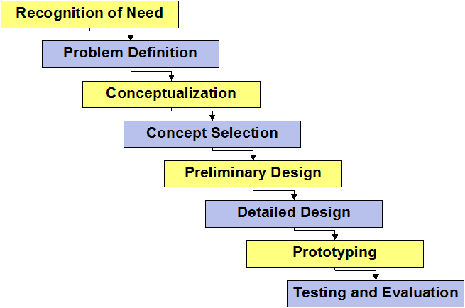

**Figure 5.1.**  The Engineering Design Process used in capstone design (ME 175 B/C).

The capstone design sequence requires copious faculty contact time with the student design teams. The course includes both a lecture and laboratory component. During the latter, the instructor provides extensive individualized mentoring to each design team. Specifically, the instructor guides students in the design process and in the details of their specific design solution. Additionally, the instructor provides students with extensive feedback about their writing and presentations. This labor-intensive mentoring process contributes greatly to the students’ technical communication skills.

To provide a realistic engineering design experience, students are typically provided with projects sponsored by industry and government agencies, such as NASA. The sponsors typically provide additional mentoring to the student teams. Recent project sponsors include: NASA (Johnson Space Center), California Steel Industries, and Ironman Parts & Services. The course instructor works with prospective sponsors to develop topics for design projects. The characteristics of an ideal design project are:

* An open-ended design problem.
* Objectives are (or can be) well defined.
* Requires creativity in developing possible solutions.
* Requires the use of analytical, experimental and\or computational methods in selecting, evaluating, and refining solutions.
* Involves physical or virtual prototyping.
* Can be completed within two quarters.
* Is not linked to any intellectual property issues.
* Is not mission-critical to the sponsoring company.

At the beginning of the course, students state their preferences for the available design projects. Students also state their preferences for teammates. The instructor assigns students to projects and teams based in part on their preferences.

During the two-quarter design sequence, each student team produces the following project deliverables:

* Problem Definition Report.
* Conceptual Design Report.
* Preliminary Design Report.
* Prototype Plan.
* Physical or virtual (simulation) prototype.
* Design Evaluation Report.
* Final Comprehensive Design Report.

The design projects are subject to a variety of real-world constraints including economic, environmental, social, ethical, safety, manufacturability, performance, reliability, and lifecycle constraints. Many of these constraints are imposed by the project sponsor. Prior to constructing a design prototype, students must perform engineering analysis to demonstrate that their design satisfies the constraints. Depending on the specific project, the analysis may require expertise in thermal/fluids engineering, mechanics, materials, controls, etc. In this way, the course requires students to apply the engineering principles learned throughout the curriculum.

Completing a design project requires extensive independent study. Students must gain expertise in multiple areas that go well beyond the standard curriculum. For example, in addition to expertise in mechanical engineering, the projects often require expertise in electrical engineering (e.g., electronic circuits, microprocessors, and sensors), computer science (e.g., embedded software and simulation), market research, manufacturing, etc. Recent projects have included the design of agricultural equipment for use in developing countries, sustainable power generation, the design of energy-efficient consumer appliances, devices for cleaning diesel particulate filters, and devices for capturing space debris.

Each design team must produce a set of work drawings for their design adequate for a machinist to manufacture it. These drawings must follow the standards of professional mechanical drawings, including standards for dimensioning and tolerancing.

An example of a senior design problem statement is given in Appendix E.

#### 5.A.7. Cooperative Education

#### Our program does not allow cooperative education to satisfy curricular requirements.

#### 5.A.8. Materials Available During Site Visit

The Mechanical Engineering department will provide the following materials for review during the visit by the ABET Examiners:

1. Course files, which will include syllabi, textbook information, lectures notes, homework assignments, midterm and final examinations, and examples of student coursework. Each file will also include a course matrix, a summary of the student performance in achieving course objectives and Student Outcomes, and recommendations for continuous improvement.
2. Minutes of meetings and discussions held by faculty and stakeholder groups to formulate course objectives and modify the program in response to assessment results.
3. Survey forms used to measure attainment of course objectives and Student Outcomes.
4. Alumni and employer survey questionnaires and results.
5. Laboratory manuals describing experimental procedures.
6. Health and safety manuals used in laboratories.
7. Equipment lists.
8. University evaluations of teaching by faculty members.

### 5.B. Course Syllabi

Appendix A includes a syllabus for each course used to satisfy the mathematics, science, and discipline-specific requirements.

# CRITERION 6. FACULTY

**6.A. Faculty Qualifications**

All of the faculty and lecturers hold doctorates in mechanical engineering earned from research universities in the United States. The credentials of the faculty are summarized in Table 6.1 and their resumes are in Appendix B. All faculty are actively engaged in scholarly research and supervise graduate students pursuing both M.S. and Ph.D. degrees. As part of their research activities, faculty publish articles in leading journals, attend technical conferences, and generate extramural funding for research from various agencies. Currently, the Mechanical Engineering faculty have funding from the following agencies, companies, and foundations: National Science Foundation, Air Force Office of Scientific Research – Centro de Investigacion en Materiales Avanzados, University of California Institute for Mexico and the United States, Chancellor’s Strategic Initiatives Award, Defense Advanced Research Projects Agency, Army Research Office, Hyundai/Kia Motors, Winston Global Energy Limited, Hewlett-Packard, Microsoft, Bill and Melinda Gates Foundation, 3M, Brithinee Electric, South Coast Air Quality Management District, California Air Resources Board, and California Energy Commission.

The faculty comprises six full professors, three associate professors, and six assistant professors. Their research expertise spans air quality (3 faculty), bioengineering (5), controls (1 faculty), design (2 faculty), human-computer interaction (2 faculty), materials (4 faculty), mechanics (1 faculty), microfluidics (1 faculty), and thermo fluids (5 faculty). Some faculty are engaged in theoretical and computational research, while others are engaged in experimental research. There are three part-time lecturers that teach regularly (other part-time lectures are occasionally used to fill temporary needs). These lecturers contribute additional expertise in the areas of dynamics & controls, engineering design, and mechatronics. The faculty and lecturers have sufficient breadth of expertise to teach all required and elective courses, including lecture and laboratory courses.

**6.B. Faculty Workload**

Faculty workload is summarized in Table 6.2. Each faculty member is expected to teach four courses during the three academic quarters. Assistant Professors teach only three courses until they achieve tenure. Faculty members are expected to teach a minimum of one undergraduate course per year; they usually teach at least two undergraduate courses and in some cases, they teach four. Faculty members with significant administrative responsibilities and service responsibilities (e.g., Dean, Chair, and Graduate Advisor) have a reduced teaching load.

Table 6.1. Faculty Qualifications

Mechanical Engineering

|  |  |  |  |  |  |  |  |  |  |  |  |
| --- | --- | --- | --- | --- | --- | --- | --- | --- | --- | --- | --- |
| **Faculty Name** | **Highest Degree Earned- Field and Year** | **Rank 1** | **Type of Academic Appointment2**  **T, TT, NTT** | **FT or PT3** | **Years of Experience** | | | **Professional Registration/ Certification** | **Level of Activity4**  **H, M, or L** | | |
| **Govt./Ind. Practice** | **Teaching** | **This Institution** | **Professional Organizations** | **Professional Development** | **Consulting/summer work in industry** |
| Reza Abbaschian | Ph.D., Materials Science and Engineering 1971 | P | T | FT | 0 | 34 | 7 | None | H | H | L |
| Guillermo Aguilar | Ph.D., Mechanical Engineering, 1999 | ASC | T | FT | 1 | 11 | 9 | None | H | M | M |
| Elisa Franco | Ph.D., Control and Dynamical Systems, 2011 | AST | TT | FT | 0 | 1 | 1 | None | M | M | L |
| Javier E. Garay | Ph.D., Materials Science and Engineering, 2004 | ASC | T | FT | 0 | 8 | 8 | None | L | L | L |
| Heejung Jung | Ph.D., Mechanical Engineering-2003 | AST | TT | FT | 5.5 | 6 | 6 | None | M | L | L |
| Lorenzo Mangolini | Ph.D., Mechanical Engineering, 2007 | AST | TT | FT | 3 | 2 | 2 | None | L | M | L |
| Cengiz S. Ozkan | Ph.D., Materials Science and Engineering, 1997 | P | T | FT | 5 | 27 | 11 | None | H | H | L |
| Marko Princevac | Ph.D., Mechanical Engineering, 2003 | ASC | T | FT | 0.5 | 9 | 8 | None | H | L | L |
| Masaru P. Rao | Ph.D., Material Engineering, 2001 | AST | TT | FT | 1 | 5 | 3 | None | L | L | L |
| Thomas Stahovich | Ph.D., Mechanical Engineering, 1995 | P | T | FT | 1 | 16 | 9 | None | M | H | L |
| Hideaki Tsutsui | Ph.D., Mechanical Engineering 2009 | AST | TT | FT | 0 | 1 | 1 | None | M | M | L |
| Kambiz Vafai | Ph.D., Mechanical Engineering, 1980 | P | T | FT | 0 | 30 | 12 | None | H | H | M |
| Venkatadriagaram, Sundararajan (V. Sundar) | Ph.D., Mechanical Engineering, 2000 | AST | TT | FT | 4 | 8 | 8 | None | M | M | L |
| Venkatram, Akula | Ph.D., Mechanical Engineering, 1974 | P | T | FT | 15 | 19 | 19 | Ontario Canada PE | M | L | M |
| Xu, Guanshui (Alex) | Ph.D., Mechanical Engineering 1994 | P | T | FT | 3 | 14 | 14 | None | M | L | M |

1. Code: P = Professor ASC = Associate Professor AST = Assistant Professor I = Instructor A = Adjunct O = Other

2. Code: T = Tenured TT = Tenure Track NTT = Non Tenure Track

3. Code: FT = Full-time PT = Part-time Appointment at the institution.

4. The level of activity (high, medium or low) reflects an average over the year prior to the visit plus the two previous years.

Table 6.2. Faculty Workload Summary

Mechanical Engineering

|  |  |  |  |  |  |  |  |
| --- | --- | --- | --- | --- | --- | --- | --- |
| **Faculty Member (name)** | **PT or FT1** | **Classes Taught (Course No./Credit Hrs.)** | **Classes Taught (Course No./Credit Hrs.)** | **Program Activity Distribution3** | | |  |
|  |  | **Term and Year2** | **Term and Year2** |  |  |  | **% of Time Devoted** |
|  |  | **Previous Academic Year 2011** | **Current Academic Year 2012** | **Teaching** | **Research or Scholarship** | **Other4** | **to the Program5** |
| Abbaschian, Reza | FT | N/A |  | 0% | 40% | 60% | 100% |
| Aguilar, Guillermo | FT | SPRING: ME113 (4) | FALL: ME138 (4), ME250 (1),  WINTER: ME240A (4), ME250 (1),  SPRING: ME250 (1) | 40% | 40% | 20% | 100% |
| Dames, Chris  (no longer at UCR) | FT | FALL: ME243 (4), ME250 (1),  WINTER: ME122, (4), ME250 (1),  SPRING: ME250 (1) | N/A | 40% | 40% | 20% | 100% |
| Franco, Elisa | FT | N/A | SPRING: ME121 (4) | 40% | 40% | 20% | 100% |
| Garay, Javier | FT | FALL:ME114 (4),  WINTER:ME278 (4) | FALL: ME114 (4),  WINTER: ME278 (4) | 40% | 40% | 20% | 100% |
| Jung, HeeJung | FT | FALL:ME170B (4),  WINTER: ME136 (4) | FALL:ME170B (4),  WINTER: ME117 (4),  SPRING: ME136 (4) | 40% | 40% | 20% | 100% |
| Mangolini, Lorenzo | FT | FALL: ME100A (4),  WINTER: ME113 (4) | FALL: ME100 (4),  WINTER: ME113 (4),  SPRING: ME243 (4) | 40% | 40% | 20% | 100% |
| Ozkan, Cengiz | FT | FALL: ME18 (3),  WINTER: ME120 (4), ME272 (4),  SPRING: ME120 (4), ME170A (4) | FALL: ME270 (4),  WINTER: ME180 (4), ME272 (4) | 40% | 40% | 20% | 100% |
| Princevac, Marko | FT | FALL: ME240A (4), ME302 (1),  WINTER: ME002 (4), ME302 (1),  SPRING: ME2 (4), ME302 (1) | FALL: ME242 (4), ME302 (1),  WINTER: ME002 (4), ME302 (1),  SPRING: ME302 (1) | 40% | 40% | 20% | 100% |
| Rao, Masa | FT | FALL: ME290 (3),  WINTER: ME110 (4),  SPRING: ME156 (4) | FALL: ME156 (4),  WINTER: ME110 (4),  SPRING: ME174 (4) | 40% | 40% | 20% | 100% |
| Stahovich, Tom | FT | WINTER: ME010 (4) | FALL: ME175A (2),  WINTER: ME010 (4) | 40% | 40% | 20% | 100% |
| Tsutsui, Hideaki | FT | N/A | WINTER: ME273 (4),  SPRING: ME116A (4) | 40% | 40% | 20% | 100% |
| Vafai, Kambiz | FT | WINTER: ME116B (4), ME241A (4), SPRING: ME116A (4) | FALL: ME4 (4), ME200 (4),  WINTER: ME241A,  SPRING: ME116A (4) | 40% | 40% | 20% | 100% |
| Venkatadriagaram, Sundararajan (V. Sundar) | FT | FALL: ME175A (2) | FALL: ME103 (4),  WINTER: ME176 (4),  SPRING: ME170A (4) | 40% | 40% | 20% | 100% |
| Venkatram, Akula | FT | FALL: ME135 (4) | FALL: ME18 (3), ME135 (4),  SPRING: ME002 (4), ME255 (4) | 40% | 40% | 20% | 100% |
| Xu, Guanshui (Alex) | FT | FALL: ME261 (4),  WINTER: ME118 (4) | WINTER: ME153 (4),  SPRING: ME122 (4), ME267 (4) | 40% | 40% | 20% | 100% |

1. FT = Full Time Faculty or PT = Part Time Faculty
2. For the academic year for which the self-study is being prepared.
3. Program activity distribution is in percent of effort in the program and totals 100%.
4. Sabbatical leave, etc., indicated as "Other."
5. Out of the total time employed at the institution.

**6.C. Faculty Size**

As described above, the department has fifteen full-time faculty members and three part-time lecturers that teach regularly (other part-time lectures are occasionally used to fill temporary needs). Teaching appointments for lectures for the last five academic years are summarized in Table 6.3. The faculty and lecturers have sufficient breadth of expertise to teach all required and elective courses.

**Table 6.3.** Lecturer appointments from 2007/08 to 2011/12.



Faculty members are actively engaged in service to the department, college, campus, and the University of California. Examples from AY 2011-2012 include Dean of the College (Dr. Abbaschian), member of the College Executive Committee (Dr. Ozkan), Chair of the Department (Dr. Stahovich), Chair of Department Graduate Program Committee and Graduate Advisor (Dr. Aguilar), Chair of Department Undergraduate Committee and Undergraduate Advisor (Dr. Princevac), Chair of the Department Planning Committee (Dr. Vafai), Chair of the Department Faculty Search Committee (Dr. Rao), Chair of the Material Science Program (Dr. Garay), and Chair of ABET Accreditation and Assessment Committee (Dr. Princevac).

In addition, as part of their service contributions and professional development, faculty serve as editors and on editorial boards of major journals, review papers and proposals, and organize and participate in conferences. While faculty members conduct research, teaching, and service, the primary duty of lecturers is teaching and service.

In addition to classroom teaching, faculty members are expected to hold office hours during which students obtain one-on-one help with their studies. Faculty also mentor students who participate in undergraduate research. Each year, approximately half of the faculty serve as faculty mentors to the freshmen. During the mentoring process, the faculty offer career counseling, provide guidance for academic and professional success, and encourage students to pursue internship and research opportunities. Freshman mentoring is conducted once a quarter in group sessions. During each session, the faculty engage students in an informal conversation and solicit feedback from the students about their experience in their first-year. This feedback is an important part of the continuous improvement process.

Four of the faculty have significant industrial experience and several more are actively engaged in research sponsored by industry. Several companies that hire our graduates, or plan to do so, sponsor our senior design projects. This helps the faculty remain engaged with these companies.

**6.D. Professional Development**

All faculty members are expected to be active in research and professional activity throughout their careers. Faculty stay current in their research fields by following the technical literature and by attending conferences, symposia, and workshops. In addition, as part of their service contributions and professional development, faculty serve as editors and on editorial boards of journals, review papers and proposals, and organize conferences.

The Campus and College provide numerous opportunities for professional development including workshops on teaching skills, interpersonal skills, and regulations that impact research, such as export control law. State law and University policy also requires training in sexual harassment prevention, laboratory safety, conflict of interest, and other similar matters.

The National Science Foundation requires grantees to provide training in the responsible conduct of research to all trainees who are paid on NSF grants. In response, UCR and the College have established training resources including an on-line tutorial. Departments are encouraged to include topics in research ethics in their seminar series and courses. In providing training to their students, faculty remain current in this area.

Faculty and lecturers are involved in various student clubs in the department and college. Examples include: American Society of Mechanical Engineers (Advisor Dr. Sawyer), Society of Automotive Engineers (Advisor Dr. Jung), and Society for Hispanic Professional Engineers (Advisors Drs. Aguilar and Garay).

**6.E. Authority and Responsibility of Faculty**

All faculty are actively engaged in all aspects of the program including: the establishment and revision of the Program Educational Objectives and Student Outcomes; the creation and revision of courses and the curriculum; and the development and implementation of the processes for the assessment and continuous improvement of the program. Decisions on all curricular matters require the formal approval of the faculty. This usually occurs during a departmental meeting with a formal vote. Changes to the program may be initiated directly by the faculty or may be recommended by the undergraduate committee.

Once changes to the curriculum have been formally approved by undergraduate committee and the program faculty, these changes must then be approved by the BCOE Executive Committee and the Academic Senate as shown in Figure 4.8.

The Undergraduate Committee, under the direction of the committee Chair, performs a variety of tasks related to the maintenance of the program such as: handling of petitions for prerequisite waivers, handling of requests for articulation of classes from other institutions, organization of mentoring sessions, maintenance of catalog course descriptions, oversight of the assessment and continuous improvement process, recruitment and outreach activities.

According to UC policy, the Department Chair is ultimately responsible for planning the programs of the department in teaching, research, and other functions. The chair is expected to keep the curriculum of the department under review, and to maintain a climate that is hospitable to creativity, diversity, and innovation. The Chair’s duties include: making teaching assignments in accordance with the policy described in Regulation #750 of the Academic Senate, making other assignments of duty to members of the department staff; preparing the schedule of courses and of times and places for class meetings; and establishing and supervising procedures for compliance with University regulations on the use of guest lecturers and Academic Senate Regulation #546 on special studies courses.

# CRITERION 7. FACILITIES

This section summarizes the program’s facilities in terms of the ability to support the attainment of the Program Educational Objectives and Student Outcomes and to provide an atmosphere conducive to learning.

**7.A.** **Offices, Classrooms and Laboratories**

Instructional classrooms are provided by the University and the College of Engineering and are centrally administered by the campus. Typically, a tentative list of course offerings is prepared in the spring quarter for the following academic year. This list is developed by the Chair of the department of Mechanical Engineering with input from the Chairs of the departmental Undergraduate and Graduate Program Committees, and in coordination with program advisors in the College Student Affairs Office. Multiple-quarter offerings of key courses are determined at this stage, based on the previous year’s demand and projections for the upcoming academic year. In addition, the number of discussion section offerings for each course is determined. Most classrooms offered by the campus and the college are equipped with multi-media equipment, computers, and internet connections for the classroom instructor.

A summary of our laboratory facilities is given here. More information is included in Appendix C.

A 1733-square-foot laboratory (B213AA) is used mostly for instruction associated with ME 170A. The laboratory has 14 experimental stations. Each station has a computer equipped with LABVIEW software for data acquisition and analysis, a signal generator, a DC power supply, a digital multimeter, and an oscilloscope. The lab also has instrumentation for measuring temperature, pressure, strain, and vibration. Examples of this equipment include strain gauges, strain gauge beams and holders, accelerometers, model 355 flow meters, gas regulators, high-pressure gas supplies, pressure gauges, thermocouples, thermistors, infrared thermometers, pressure transducers, water baths, blowers, air speed indicators, stirring hotplates, a resistance decade box, a Mettler Toledo AB104 analytical balance, a Mettler Toledo AB104 topload balance, 110 V transformer, and various resistors, capacitors, and operational amplifiers.

In addition to equipment for data acquisition, B213AA has a mechatronics laboratory used mostly for instruction associated with technical elective ME 133, Introduction to Mechatronics. The equipment includes:

1. GE-FANUC 23 point Programmable Logic Controllers (IC200UAL006 PLC), 10 each.
2. GE-FANUC Proficy Logic Developer software, 10 each.
3. PLC Nano/Micro/Programming Cable for interface between PLC and PC.
4. 18 DIP Microcontrollers (Arduino, PIC16F84, and PIC16F628).
5. Arduino Software programming environment & Micro Engineering Lab USB programmer with accessories (2).
6. Micro Engineering Lab PIC Basic Pro compiler (2 copies).
7. Micro Engineering Lab integrated development environment (IDE) windows software.
8. Electronics components (micro switches, proximity sensors, 4 MHz microprocessor crystals, LED, Transistors, Power Transistors, Logic components (AND, OR, NAND, NOR), Motorola LS7084 chip for optical encoder interface, and operational amplifiers).
9. NI data acquisition board NI DAQ PCI-6221 (10).
10. Robotics experiments (10, each includes 5 arms, 2 DC motors, 2 optical encoders, and 2 power amplifier).
11. Pneumatic experiments (10, each includes 1 linear potentiometer, 1 optical encoder, 1 pneumatic actuator, and power amplifier).

A 977 square foot laboratory (B164) used primarily for instruction associated with ME 170B. Major equipment includes:

1. Four personal computers for data analysis.
2. A small wind tunnel.
3. Thermal radiation apparatus consisting of black aluminum plates with thermocouples, anodized steel and aluminum plates with thermocouples, polished steel and aluminum plates with thermocouples, freestanding thermocouples, Linear Laboratories C-1700 Radiometer, thermocouple temperature readout, vernier calipers, power supply unit, anemometer, hand held thermometer.
4. Instron Universal testing machine supplied with computer, vernier calipers, sample specimens of aluminum, plain carbon steel, stainless steel, and nylon.
5. Rope testing apparatus consisting of static rope, dynamic rope, support rope and pulley arrangements, weights for calibration, strain gage with computer, DBK-43 strain gage card, and ruler.
6. Accelerometer and accelerometer tilt table supplemented with power supply unit, cantilever beam with strain gages mounted, weights, spring, vernier calipers, digital millimeter, meter stick, balance, stand, computer with DBK-12 multiplexer card and DBK-43 strain gage card, three-option expansion card cable, beaker, trough, and washers of 1¼’’, 2’’ and 2½’’ diameter.
7. Sonic Anemometer.
8. Refrigeration cycle test setup.
9. 3-point and 4-point configuration attachments for bending testing, in-house built apparatus for undamped and damped vibration testing, and an in-house built apparatus for dynamical tensile testing.

Available teaching equipment for ME 180 includes one set of photoelastic polariscope, one 2 mW He-Ne laser, two linear polarizers, two quarter wave plates, one integrating sphere, and eight pairs of safety goggles. These are located in the Nano Mechanics and Materials Laboratory. ME 180 also uses advanced optical characterization equipment available in shared laboratory facilities on campus.

A 1022-square-foot teaching lab (B162) shared with the department of Chemical and Environmental Engineering. Relevant equipment utilized for instruction in ME 170B includes:

1. Armfield Multi-Pump test rig model C3-00 supplemented with hook and point gauge, thermocouple, and stopwatch.
2. Armfield fluid friction apparatus, model C6, supplemented with thermocouple, stopwatch, Vernier caliper, sudden contraction, sudden expansion, ball valve (fully open), globe valve (fully open), gate valve (fully open, ½ open), Venturimeter, 90 degree elbow, smooth pipe with 17.5 mm diameter, and rough pipe with 17.5 mm diameter.

Design Studio - In 2005, the program acquired a 2665-square-foot space (B265) for use as a design studio. It provides space for senior design project assembly, preparation of posters, and discussions.

**7.A.1. Research Laboratories**

In addition to computing laboratories supervised by faculty, the department has several major experimental research laboratories. These include:

1. Laboratory of Transport Phenomena for Biomedical Applications
2. Laboratory for Advanced Materials Processing and Synthesis
3. Biomaterials and Nanotechnolgy Laboratory
4. Graphene Materials and Devices Laboratory
5. Laboratory for Environmental Flow Modeling
6. Smart Tools Laboratory
7. Nano Mechanics and Materials Laboratory
8. Biomedical Microdevices Laboratory
9. Regenerative Microengineering Laboratory
10. Optical Characterization Laboratory
11. Environmental Aerosol Research Laboratory
12. Laboratory for Plasma Processing of Nanomaterials
13. Integrated Manufacturing Lab

Although these laboratories are used by faculty and graduate students for their research, program students have access to these laboratories for carrying out directed research and earning technical elective credit (ME197).

**7.B. Computing Resources**

Information technology support, services and facilities are available from several sources for use by the programs of The Bourns College of Engineering and its students, faculty, and staff:

1. Campus-wide support, services, and facilities are provided by Computing and Communications (C&C) and managed by full-time professional staff.
2. The College, through its programs of Chemical/Environmental Engineering, Computer Science and Engineering, Electrical Engineering, and Mechanical Engineering, and its Research units also provide a variety of technical services and support.

Details of these support, services, and facilities are as follows.

**7.B.1. C&C Overview**

C&C (which includes the Instructional Technology Group, Computing Infrastructure and Security, the Computer Support Group, and Communications) is under the direction of the Associate Vice Chancellor of Computing & Communications who reports to the Executive Vice Chancellor & Provost. The Instructional Technology Group, Computer Support Group, and Communications sub-units have primary responsibility for providing network access and general computing services to the UC Riverside campus.

**7.B.1.1. Support Services**

* **Instructional Technology Support**

C&C’s Instructional Technology Group offers faculty and students technical and pedagogical support that is specific to the academic discipline. The Instructional Technology Group emphasizes a "hands-on" approach to its services including Blackboard (learning management system) training and support and the management and support of campus site-licensed software.

* **Classroom Technology Support**

C&C provides classroom technology support, services, and infrastructure services (e.g. connection to the wireless network, projection systems, etc.). UCR’s technology-enabled classrooms include the following:

* The capability to present materials from a variety of sources, including (at a minimum) DVD, document camera, a personal computer, laptop computer, and internet.
* Chalkboard or whiteboard that is available and viewable at the same time digital or analog presentations are underway.
* Combination of high-powered data projectors and/or lighting zone controls that allow students to take notes and view presentation material at the same time.
* “Self-service” design which allows instruction to occur without the aid of technical operators and without the delivery of equipment.
* Based on the academic discipline, sound systems and data projection resolution requirements may drive certain classroom minimum standards.

UCR has implemented “clicker” technology in all its classrooms. In actual use on this campus clicker technology has been shown to:

* Increase attendance (sometimes dramatically)
* Coax participation from normally non-participative students
* Create a more engaging lecture environment

Additionally, all UCR classrooms are equipped with podcasting capabilities. This can be in the form of audio podcasting or lecture capture as supported by Echo360 course capture technology. Students in these classrooms will have on-demand access to archived educational content as presented during lecture, including a video camera feed and classroom audio.

* **General Technology Support**

C&C provides UCR faculty and students with technology to assist them in their instructional and academic pursuits. Services like e-mail, iLearn (Blackboard Learning Management System), and the wireless network ensure that all UCR faculty and students can stay connected with their colleagues, peers and the rest of the world. The Computer Support Group provides desktop computing support for faculty and staff. Services include consulting on hardware, software and networking, plus assistance with acquiring, learning and using stand-alone or networked computers (Windows, Macintosh, Linux, and UNIX platforms). Services offered include telephone support, on-site and carry-in services, on-line remote support, a knowledge base and software downloads. C&C also implemented and spearhead the Microcomputer Support Specialist (MSS) program, which provides decentralized departmental support.

* **Multimedia Development and Research Visualization Support**

This group provides creative full service web and graphic design for the UCR campus and community. With fully integrated, back-end programming solutions tailored to each client's specific needs, the group supports the university's efforts to secure extramural funds and the campus’s various outreach efforts.

**7.B.1.2. Facilities and Infrastructure**

* **Computer Labs**

Student Computing Services maintains four public computer labs featuring approximately 149 computers available for academic use by all UCR students, with open hours of approximately 160 hours per week. Faculty instructing a course may reserve the public computing facilities for instructional use or request to have software installed on the machines. Lab assistance and software checkout is available in the labs. C&C provides research software (SAS, SPSS, Mathematica) in most public computer labs.

* **Classrooms and Learning Spaces**

The Multimedia Technologies Group maintains all of UCR's general assignment classrooms that have been equipped with data/video projectors, document cameras, DVD players, PC computers on the network, computer interfaces for laptop users and network connections. Lecture halls are also equipped with wireless microphones and multiple (two to three) projection systems. The Multimedia Technologies Group has led the design and implementation of “smarter” classrooms, such as the Flex Rooms and the Hyperstruction Studio. These rooms feature mobile furniture, whiteboards on every wall, and multiple projection systems.

All general assignment classrooms are equipped with a multimedia controller maintained by C&Cs Multimedia Technologies Group to operate the various presentation technologies and audio equipment. Internet connectivity is via a robust wired and wireless network. Each multimedia controller has a “Help” button for the instructor to alert technicians if there is a problem with the equipment.

A help desk has a staff at all times, and at least one field technician is available on campus during instructional hours. Either the help desk (working remotely) or the field technician (in the classroom) can quickly resolve any problem that occurs. In a survey (most recently conducted in 2011), 90% of instructors responded that UCR’s available classroom technology either "Completely" or "Mostly" met their pedagogical needs.

* **Research Technology**

As part of UCR’s Cyberinfrastructure (CI) strategy, C&C supports three computational cluster support models. These include departmentally maintained clusters, dedicated clusters, and a shared collaborative cluster. Three programs are described as follows:

1. A centrally managed, standardized/dedicated cluster of processors, in which researchers pay an annual fee for essentially unlimited use.
2. A collaborative computational cluster, in which each PI can buy a certain amount of hardware, which Computing and Communications will manage. The PI has priority access to the equipment that he or she acquired, plus access to the entire cluster as available. UCR’s collaborative cluster provides a shared system as a computing resource for campus researchers with limited financial resources.
3. Departmentally maintained clusters that are centrally managed. This type of cluster is meant for researchers who have computing needs that fall outside of the campus cluster standards. These systems are built to particular PI/lab/center specifications and managed by PI funded staff, but housed within C&C’s data center. C&C also provides other research technology support, ranging from network creation and configuration, colocation support, budget preparation, equipment configuration, and cloud services provisioning.

* **Wired and Wireless Networks**

UCR supports 1,200+ wireless access points that provide wireless connectivity to approximately 8,000 concurrent users daily. Additionally, the campus network backbone consists of 10 GB fiber-optic connections, with a minimum of 1 GB capacity to each building on campus. The campus has more than 500,000 feet of air blown fiber conduit, which enables the addition of fiber connectivity essentially “on demand”.

**7.B.1.3. Other Services and Support**

* **Libraries**

The UCR Libraries have over 400 public computers among the four campus libraries with selected information resources and software to support and enhance student learning and the research and scholarship activities of the University. Specialized software has been installed on the Learning Commons Computers located in Rivera Library 1st Floor, Rivera Basement, Rivera 2nd Floor, Rivera 3rd Floor, and Science Library 1st Floor. 20 wireless laptops/netbooks are available in Rivera and Science Libraries to faculty, students and staff.

* **CENIC Regional Higher Education Network**

C&C provides support and maintenance of off-campus network access via connections to the CENIC regional higher education network. All Bourns College of Engineering computing facilities and faculty have high-speed access to CENIC members (e.g. other UC campuses, private research universities in California, the California State University System, etc.) and to Internet2 via C&C support of the CENIC network.

Two computing laboratories are dedicated to program students. Room B207 located in Bourns Hall is a 1671-square-foot facility that includes 40 networked computers and a networked printer. Room B238, also in Bourns Hall, is a 2038-square-foot facility that was acquired in 2006 to keep pace with growth in the program enrollment. It houses 22 additional computers and a networked printer. B238 is open at all times for ME students. Courses that require computer use during class time are scheduled in B207. At all other times, the lab is open to all ME students. The computers run Windows and have the most recent versions of Matlab, Solidworks, Microsoft Office, and other various engineering applications. The computers in B207 are also equipped with Lanschool – a program that enables monitoring of all computers with an ability to broadcast material from the instructor’s computer. This facilitates classroom instruction and is conducive to effective learning of software tools.

**7.C. Guidance**

We take a great pride in providing hands-on experience to our undergraduate students. This comes as a part of our curriculum (e.g., laboratory courses and senior design) or through extracurricular, professional society, activities (e.g., human powered vehicle, Formula SAE, and Mini Baja). To ensure safety, we established efficient and effective training policies.

Prior to being allowed to work or to spend time in the machine shop, students are first directed to <http://www.me.ucr.edu/machine_shop.html> to download and study the “Machine shop guidelines”. Students then take the Machine Shop Safety Test. The test has 70 questions and a student must get at least 90% of the answers correct in order to be allowed into the shop. The completed tests are signed and filed away in the machine shop manager’s office. Our machine shop manager ensures that everyone is aware of the safety rules.

After students complete basic safety training, they are provided with more advanced training for the specific machines they need to use. We have developed Standard Operating Procedures (SOP) for both the milling Machine and the lathe. Once a student has studied an SOP, he or she is given a Basic User Safety Test (BUST) for that machine. The BUST is graded by the machine shop manager and signed by the student and the machine shop manager. The student must respond correctly to at least 90% of the questions before he/she can proceed with practical training. The back (signature) page of the BUST is also used to keep track of the hours of experience. After a certain number of hours (depending on the individual and the complexity or required operations), the student is approved to operate the equipment without the shop manager’s direct oversight. These records are also kept in the machine shop manager’s office.

Regular machine shop hours are Monday through Friday from 8 a.m. to 5 p.m. We also have policies in place for after-hours use. With special permission, trained TAs or other staff may supervise students in the shop providing the following rules are observed.

* Under no circumstances may any work be done in the shop after 10:00 p.m.
* Students wishing to use the shop after hours must check in with the supervisor before 5:00 p.m.
* No more than 4 machine tools may be in use at any time under TA supervision.
* The shop may be used on weekends only with special permission.

All documents (Machine Shop Guidelines, manuals for lathes and milling machine), tests (General Machine Shop Safety, Standard Operating Procedure for the Lathe, Standard Operating Procedure for the Milling Machine), and log books are available for examination at the site during the visit.

**7.D. Maintenance and Upgrading of Facilities**

We are optimistic about our ability to accommodate continued growth. Bourns Hall is approximately 21 years old and provides more than 100,000 square feet of office, classroom, and wet laboratory space for the Bourns College of Engineering. The B-wing of Bourns Hall has a cleanroom. Winston Chung Hall is seven years old and has 98,177 assignable square feet of office, classroom, and dry lab space. The College recently opened the Materials Science and Engineering Building which has 76,940 square feet available for laboratories, offices, and classrooms. The Material Science and Engineering Building has a cleanroom facility which will augment the nanofabrication capacity of the cleanroom in Bourns Hall. There is ongoing planning for the Engineering III and Engineering IV buildings. However, formal plans are not yet in place.

The Bourns College of Engineering provides equipment funds annually to upgrade and acquire equipment. In addition, the College provides facilities to house and operate the equipment. A brief recent history of funding is provided in the Table 7.1.

**Table 7.1.** Mechanical Engineering Instructional Equipment Funds received from BCOE.

|  |  |  |  |  |  |
| --- | --- | --- | --- | --- | --- |
|  | FY 07-08 | FY 08-09 | FY 09-10 | FY 10-11 | FY 11-12 |
| Allocation | 117,849 | 30,000 | 46,000 | 31,254 | 9,976 |

In 2007-2008 we conducted major upgrades of our facilities for ME170 A/B and for senior design ME 175 A/B/C.

In 2008-2009 we purchased 45 new computers for the ME computer Lab in Bourns B207 and updated instrumentation for 14 lab stations for ME 170A.

In 2009-2010 we purchased the refrigeration performance apparatus ($20,000), materials science experiments (microscope and furnace) $21,000 and Solidworks license renewal $5,000.

In 2010-2011, the College provided $31,254 for the program. $15,000 was used to purchase a CNC plasma cutter which is located in the machine shop. This is an example of equipment that is used both for research and for undergraduate student instruction, especially for senior design. We used $3,000 for assignment drop boxes to streamline the submission of projects and homework assignments in our large classes. The remaining funds were used for software licenses, equipment for in-class demos, a tablet PC, and repair of existing laboratory setups.

For 2011-2012 we received $9,976. These funds, which were just received, will be spent on equipment for our laboratory courses.

In addition, most BCOE undergraduate lab courses charge a ($20-50/student) Course Materials Fee. Per UCR policy, these fees can only be used to purchase expendable laboratory materials and supplies including chemicals, glassware, software, computers, etc. For FY 10/11, approximately $210,000 was generated in Course Materials Fees by BCOE academic programs.

**7.E. Library Services**

Library collections that support the Bourns College of Engineering are located in the Orbach Science Library. The Orbach Science Library can seat 1,500 persons and has individual carrels, study tables and 25 group study rooms. The library makes available 79 computer workstations for students to use in their research and study, and another 32 computers to support information literacy instruction. The entire UCR library system provides both wired and wireless access to the internet for student laptop use. Students can also check out laptops at the Circulation Desk.

Normal library hours during the regular school year are as follows:

Monday-Thursday 7:30am – 11pm

Friday 7:30am to 5:00pm

Saturday Noon to 5:00pm

Sunday 1:00pm to11:00pm.

The Orbach Science Library maintains a professional staff of eight librarians, who provide reference and research assistance to engineering students, faculty, and staff. One of these librarians has additional expertise in engineering and assists engineering students, faculty, and staff with locating research materials. The Engineering Librarian and Subject Specialist also offers tutorials and classes on engineering information topics, and maintains web pages and path-finders to assist engineering students, faculty, and staff in locating the information they need.

The UCR Libraries offers a full range of reference services, including walk-up, telephone, and 24/7 e-mail reference services (Ask A Librarian) through a UC-wide and national network as well as by appointment. The Orbach Science Library reference desk is staffed 52 hours per week during the academic year (9am-8pm. Monday-Thursday, 9am-5pm on Friday) and 40 hours per week during inter-session periods. In addition to these standard services, engineering students can receive additional reference help from other reference librarians who are assigned to the Science Information Services desk. The Engineering Librarian is available for extended consultation on Senior Design or other research projects.

Incoming freshmen typically receive library orientation sessions in their introductory classes. They might also have additional information literacy instruction in classes that require independent research, such as senior design classes. One-on-one or group tutorials are available for any research topic that might be desired and helpful to engineering students.

**7.E.1. Library Collections**

**7.E.1.1. Books**

Engineering books are acquired as part of the Orbach Science Library’s purchasing profile, ordered from catalogs or suggested by students, faculty, and staff. Within the past three years, the library has initiated the purchase of engineering e-books and currently supports and maintains a collection of thousands of electronic books in the discipline. The Libraries provides licensed access to all of the current Springer books online, many of the e-books from the CRC EngNetBase, the Knovel Collection, the Wiley Online collection and many more.

Recently, through a special competitive initiative, the UCR Libraries has brought to our campus, from its former Berkeley location, the extensive and world class Water Resources and Archives Collection (WRCA) containing many materials relevant to dam and bridge construction which is also available to engineering students and researchers from across UCR and the UC system.

**7.E.1.2. Journals**

The Libraries currently subscribe to 121 engineering print journals, and Engineering students have access to a vast collection of online journals (94,770 unique titles). UCR maintains access, for example, to all of the journals and proceedings of IEEE, OSA, MRS, and ACM, as well as either proceedings or journals from many other societies. Faculty, staff, and students may suggest new books, journals or other media to be purchased by the library. Library users may request materials that are not available on campus through Interlibrary Loans, and the materials will be made available to them at no cost in a very reasonable amount of time.

**7.E.2. Research (Journal Article) Databases**

UC Riverside engineering students have access to a number of journal databases to assist them in their research in engineering and in other areas of study. Through co-investments with the other UC campuses and the California Digital Library (CDL) Inspec, Compendex, and the Web of Science as well as SciFinder Scholar for chemistry and chemical engineering and Biosis or MEDLINE for biotechnological literature are all available to engineering faculty and students. UCR also licenses Water Resources Abstracts locally with the arrival on our campus in 2010 of the Water Resources Archives and Collections.

A summary of library collections is given in Table 7.2, followed by library expenditures in Table 7.3.

**Table 7.2.** Library collections

|  |  |  |
| --- | --- | --- |
|  | **Books** | **Periodicals** |
| Entire Institutional Library | 2,810,229: (Print Vols.) 404,191: (e-Books)  Total Vols.: 3,214,420 | 6,329 (Active Local Titles) |
| Engineering and Computer Science | 71,757 Print / 29305 online | 168 print / 3976 online |

**Table 7.3.** Library expenditures

|  |  |  |  |
| --- | --- | --- | --- |
|  | **2008-2009** | **2009-2010** | **2010-2011** |
| Expenditures for Engineering (Total) | $75,749 | $75,107 | $45,975 |
| Print Books | $13,264 | $11,824 | $9,629 |
| *Local Costs Only for Engineering Periodicals Subscriptions | $47,589 | $47,706 | **$21,163 |
| E-Book Packages (EngNetbase, O’Reilly) | $7,043 | $7,332 | $6,483 |
| ***Research Databases | $15,185 | $14,741 | $15,957 |

* This figure does not include the total amount ($2.4 million ) expended annually by the UCR Libraries as co-investments with other UC campuses and the California Digital Library (CDL) to support access to e-journals, e-books, and electronic databases. The value of the e-journals for supporting engineering alone is over a million dollars annually.

** This figure reflects a major journal cancellation which included duplicate and low use titles especially targeting print titles that duplicated e-journal titles. This was a UCR project in response to budget reductions.

*** Cost for Compendex and Inspec databases. Other databases such as SciFinder, Water Resources Abstracts, Web of Science support multiple disciplines, in addition to Engineering.

**7.F. Overall Comments on Facilities**

All facilities and equipment are inspected by the laboratory safety officer (LSO) as per the campus Environmental Health & Safety (EHS) requirements. This role is currently being held by our machine shop manager. Also, all instrumentation is checked by teaching assistants and/or the course instructor before students can use it.

The College of Engineering uses a variety of resources and strategies to increase our community’s safety and security and to protect the environment. BCOE follows the University of California Policy on the Management of Health, Safety and the Environment – a system-wide policy applied to all UC campuses. The policy has received personal commitment from the President of the University of California. BCOE also works closely with UCR’s Office of Environmental Health & Safety (EHS), the UCR Police Department, and the Office of Risk Management to implement UC safety policies and best practices. UCR EHS uses methods developed by the system-wide Environment, Health, & Safety Leadership Council to bring safety, health, and sustainability into work practices at all levels.

BCOE employs a full time Safety & Facilities Coordinator. This individual coordinates the facilities, health, safety, and training activities for the entire college. The Safety & Facilities Coordinator represents BCOE on the campus Research Integrated Safety Committee (RISC) and the campus Laboratory Safety Officers group. The current vice-Chair of the RISC committee is a faculty member in the Mechanical Engineering program. Membership on these committees enables BCOE to stay abreast with the current safety best practices, regulations and policies and to help BCOE to manage special laboratory processes and potential hazards. The Safety & Facilities Coordinator also participates in UC system-wide laboratory safety conference calls and facilitates monthly meetings of the BCOE department and program Laboratory Safety Officers. BCOE uses the many implementation tools for safety and compliance, training courses, and guidelines developed by the UCR Environmental Health & Safety’s Laboratory / Research Safety program. These guidelines and tools address common hazards from chemical, radiological, and biological sources. They also specify guidelines for field research safety and general safety.

Maintaining safe laboratories provides a safe and healthy environment for faculty and students to pursue research ideas and contribute to their fields. BCOE Laboratory Safety Officers (LSOs) act as their departments’ safety liaisons and are the Chemical Hygiene Officer and Hazard Communication officer for their departments. They direct and advise faculty, staff, and students on laboratory safety, the proper handling and disposal of chemicals; perform department lab safety audits; provide and document safety training; and attend both campus and college-wide Laboratory Safety Officer meetings. Safety information and best practices are shared between College departments via the BCOE Laboratory Safety Officers group. In addition to maintaining instructional labs, LSOs are responsible for safety in laboratory courses. Safety documentation is managed by the LSO in concert with the department administrative staff.

At the institutional level, the University of California is committed to achieving excellence in providing a healthy and safe working environment, and to supporting environmentally sound practices in the conduct of University activities. It is University policy to comply with all applicable health, safety, and environmental protection laws, regulations, and requirements. To meet this standard of excellence, the University implements management initiatives and best practices to systematically integrate health, safety, and environmental considerations and sustainable use of natural resources into all activities. All University activities are to be conducted in a manner that ensures the protection of students, faculty, staff, visitors, the public, property, and the environment. The University’s goal is to prevent all workplace injuries and illnesses, environmental incidents, and property losses or damage. Achieving this goal is the responsibility of every member of the University community. Supervisors have particular responsibility for the activities of those people who report to them.

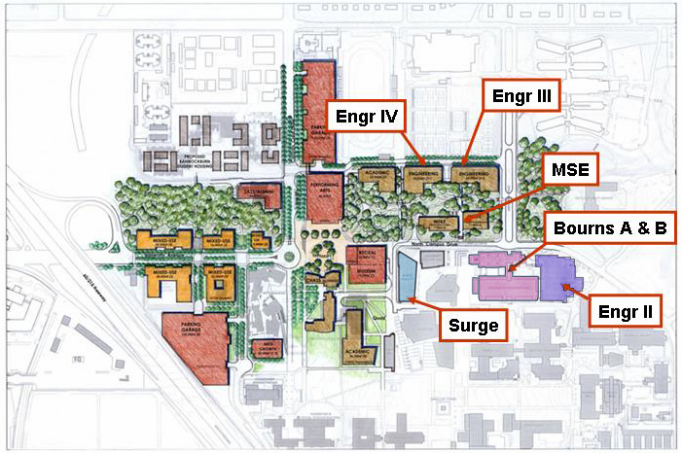

**Figure 7.1.** Locations of Bourns Hall (A & B), Winston Chung Hall (Engr II), Materials Science and Engineering (MSE) Building (open in 2010), and future Engineering III and Engineering IV locations. Surge was the temporary home of the Computer Science and Engineering Department before Winston Chung Hall (Engr II) opened in the summer of 2005. The College now has no offices or labs in Surge.

# CRITERION 8. INSTITUTIONAL SUPPORT

**8.A. Leadership**

The Mechanical Engineering Department is led by a Chair who is nominated by the Engineering Dean and approved by the Faculty Senate. The Chair has responsibility for organizing the faculty to ensure the quality, integrity, and continuity of the program. The Department is also supported by full time department staff as discussed in Section 8.C.

The Department Chair appoints faculty to serve on the undergraduate committee and selects one member to serve as the Undergraduate Advisor. The Advisor leads the committee and has responsibility for overseeing course content, catalog course descriptions, new course approvals, and the redesign or removal of obsolete courses. The Advisor and Chair are the primary points of contact for the staff in the BCOE Student Affairs Office. The Chair and Advisor discuss each year’s course offerings and teaching assignments. The Chair has the responsibility for the final decisions.

The course offerings determine the Mechanical Engineering TA and grader requirements. The Mechanical Engineering Graduate Advisor, with oversight by the Department Chair, assigns TAs and graders to courses.

The Undergraduate Advisor also serves as the Chair of the Department’s ABET Accreditation and Assessment Committee. This committee includes the Department Chair and the undergraduate committee members. The ABET committee is responsible for developing and implementing our assessment and continuous improvement processes.

This organizational structure has proven to provide efficient and effective management of the program.

### 8.B. Program Budget and Financial Support

The program is supported by full-time departmental staff, part-time student assistants, teaching assistants, readers, and graders as needed to support individual courses and program administration. The College provides Student Advisors who interact with program students, monitor academic progress, enable registration, and direct them to appropriate services on campus for tutoring, career counseling, etc. Tutoring service is provided at the Learning Center and in the student dormitories (free for students living on campus). The College has developed a Professional Milestones Program to enable each program student to prepare for internships, job interviews, and research opportunities.

The College provides funds to support teaching assistants, graders, and readers, assigned based on course enrollment and need for laboratory supervision. Teaching Assistants conduct discussion sessions in which students are exposed to additional problems and concepts to reinforce material covered in lectures, and to enable students to complete course assignments. All instructors and teaching assistants maintain posted office hours for assisting students outside scheduled classes. The program has a designated Undergraduate Advisor (currently Dr. Princevac) to oversee curricular matters and to offer advice on curricular issues.

The University of California, Riverside has a multi-step budget development process. The major steps in the annual process are:

February: Campus Budget Call Letter is distributed and meetings held with academic units to discuss faculty projection models

March: Comprehensive Planning Documents are submitted to the Executive Vice Chancellor

April: Individual unit hearings with senior UCR management

May: Input and feedback from Faculty Senate Committee on Planning and Budget to Executive Vice Chancellor

June: Final unit budgets announced

All BCOE academic programs receive Permanent University funding for tenure track faculty, program staff, materials, and supplies. Table 8-1 summarizes Permanent University funding allocations to BCOE departments over the last five fiscal years. Table 8.1 shows the 5-year Permanent and Temporary budget history for the Bourns College of Engineering.

**Table 8.1.** College of Engineering permanent funding history for academic programs.



In addition, BCOE academic departments receive Temporary University funding each fiscal year for lecturers, teaching assistants, instructional equipment, etc. The amounts of these annual allocations over the last five fiscal years can be found in Table 8.2. Each program individually allocates the Temporary University funding it receives for teaching assistants and graders. Typically, each lab section is supported by a 25% time TA.

Details of BCOE offices, classrooms and Laboratories can be found in Criterion 7.

**Table 8.2.** College of Engineering temporary funding history for academic programs.



BCOE budgets approximately $300,000/year for instructional equipment acquisition and upgrades. These funds are allocated to BCOE academic programs on an annual request basis. The instructional equipment obtained by this process over the past three fiscal years is:

**Bioengineering**

* Bioinstrumentation Laboratory (BIEN 130L):
  + Lab Quest, Spirometer, O2 Sensors, etc.
  + Pasco Stress Strain testers
  + Balance
  + Gel Columns
  + Ni ELVIS
  + Computers and monitors for Ni ELVIS
  + BioPac MP36
  + Stress-strain Experiments
  + Lung Capacity Experiment
* Biotechnology Laboratory (BIEN 155):
  + Gene Pulser Xcell System
  + Biomate 3 UV-Vis Spectrophotometer
  + Pipettes
  + Electrophoresis
  + Combination biotech pH electrode
  + Eppendorf Mastercycler
  + UV/Vis/NIR Spectrophotometer
  + Undergrad Computer Facility
  + Micro Centrifuge
  + Balance 400-500g
  + Electrophoresis
  + Gene Pulser Xcell Main Unit

**Chemical and Environmental Engineering**

* Ozone Generator
* Spectronic 200 Spectrophotometers
* Micro 100 Lab Turbidimeters
* New Brunswick Scientific Excella E5 and E10
* Adjustable volume pipetters
* UV Lamp
* Masterflex L/S Economy Variable
* Computers
* Nanotechnology Processing Lab (CHE 161):
  + Multi-channel potentiostat
  + Antivibration table
  + Electrical Measurement
  + Mass Flow Controllers
  + Computer controlled DC power supply
  + Portable fume hood
  + Incubator
* Lab Benches and equipment for BH 235

**Computer Science and Engineering**

* Lab Chairs
* Lab Tables
* Windows Terminal Server license
* Remark Office OMR upgrade
* Supermicro Server Chassis
* AMD Server Processors
* Intel SATA drives
* Hitachi 3TB hard drives
* 8 GB RAM
* Kodak i1220 scanner
* MSDN AA License
* File Server support contract renewal
* File Server
* RBC27 Batteries
* Barebones server
* Mac Workstations
* RAM, hard drives, displays, licenses, etc
* Projector mounts
* Supplemental NICS
* Vmware ESC+ Infrastructure

**Electrical Engineering**

* Instructional Clean Room (for EE 136)
* Lab Equipment for WCH 126:
  + Digital multimeters and power supplies
  + Replacement PCs and monitors
  + Oscilloscopes
  + Function Generators
  + Metal Lab Stools
  + New Server
  + HP Laserjet P4015n networkable printer
  + FPGA Evaluation boards
* Computers and monitors for WCH 121

**Mechanical Engineering**

* Repair two experimental stations and upgrade four (ME 170A)
* SolidWorks (ME 9 and ME 175)
* CNC Plasma cutter (Senior Design)
* Homework crop boxes
* Classroom demonstrations
* Refrigeration performance apparatus
* Controls experiment system
* Materials science experiments
* Replacement computers for ME 170A
* SolidWorks license renewal
* Computers for ME Computer Lab (B207)
* Parts for lab workstations for ME 170A

**Materials Science and Engineering**

* MSE 01, MSE 100, etc.
  + Educational atomic force microscopes
  + Educational optical microscopes
  + Cabinets for chemical storage
  + Supplies and materials
* MSE 160 and MSE 161:
  + Table-top X-ray Diffractometer
  + CFAMM time for SEM (per year)
  + FTIR
  + Laser for RAMAN
  + UV-Vis Spectrometer
  + Board and software for TGA/DTA
  + Photoluminescence system
  + Multistir plates
  + pH meters and probes
  + Ultrasonicator with housing
  + Beaker and stir bar sets
  + High resolution Optical Microscope
  + Composites kits
  + Balances
  + Portable Fume Hood
  + Multimeter

In addition, most BCOE undergraduate lab courses charge a Course Materials Fee of $20 to $50 per student. Per UCR policy, these fees can be used only to purchase expendable laboratory materials and supplies including chemicals, glassware, software, computers, etc. For FY 10/11, approximately $210,000 was generated in Course Materials Fees by BCOE academic programs.

### 8.C. Staffing

The total headcount of administrative, instructional and technical staff in BCOE for FY 11/12 can be found in Appendix D2.

Several years ago, BCOE centralized the following functions in the Dean’s Office: undergraduate student affairs and advising; contract/grant pre-award processing and academic personnel. All other administrative functions (purchasing, payroll, graduate student support, etc.) are provided at the departmental level. The Mechanical Engineering department has 5 full time staff members (Financial and Administrative Officer, Contracts and Grant Analyst, Purchasing and Personnel Assistant, Graduate Program Assistant, and Machine Shop Manager - <http://www.me.ucr.edu/mepeople/staff.html>). Computer system administration staff is shared with BCOE. There is an active search process for hiring one more full time staff member – the undergraduate laboratory manager. We expect to fill this position during the summer months. Over the past five fiscal years, the number of BCOE administrative and technical staff has decreased by 8.75 FTE due to UCR budget reductions. However, all but 0.25 FTE of these positions have occurred in central Dean’s Office operations and were accomplished with little direct impact on BCOE’s academic programs.

During each fiscal year, BCOE administrative and technical staff salaries are compared with salaries of similar positions within BCOE and within other UCR academic and administrative units. Any significant salary lags are addressed through UCR’s staff equity and reclassification process. During the past two fiscal years, 10-11 staff reclass/equities were processed per year. This process has helped to reward and retain experienced BCOE staff.

In addition to offering staff on-line and in-class training necessary to perform job responsibilities (i.e., payroll, purchasing, etc.), UCR offers extensive career development training programs including:

* Certificate programs in Building Core Competencies, Diversity Training, Performance Management, Professional Academic Advising, Professional Graduate Student Advising and Work Leadership
* Emerging Leader (mentorship) Program
* Management Skills Assessment Program

Most of the above training is at no cost to the employee. All required and optional training is offered through UCR’s Human Resource’s Learning Center. The completion of an employee’s required and optional training is recorded in UCR’s automated Learning Management System (LMS).

**8.D. Faculty Hiring and Retention**

**8.D.1. Faculty Recruitment Process**

BCOE is still growing toward its target size of approximately 120 faculty members. Despite budget pressures, faculty recruitment is an annual event. The basic faculty hiring process is:

1. Each year, departments are asked to submit a faculty recruitment plan that is consistent with their strategic plan.
2. The recruitment plan is sent to the Dean for review.
3. The Dean then outlines a collective recruitment plan for the College and requests ladder-rank faculty lines from the Provost.
4. The Provost makes an allocation of ladder-rank faculty lines to the College and the Dean determines the overall priorities for the College.
5. The Dean notifies the departments of any faculty lines they have authorization to fill.
6. The department then forms a faculty committee to prepare a detailed recruitment plan for the position(s). The detailed recruitment plan includes a listing of the search committee, written ads and where they will be placed, flyers for distribution at professional conferences, letter templates for bulk mailings to other relevant departments, an affirmative action plan, and a deadline for priority recruitment.
7. Those detailed plans are sent to the Dean, Provost, and Affirmative Action offices for approval.
8. Once approved, ads are placed, mailings are sent, and the College on-line recruitment website is opened. All applications are received through the College recruitment website.
9. All applications received by the priority deadline are reviewed by the faculty search committee. The committee assesses how well the applicants meet the goals of the department and their potential as a faculty colleague.
10. An initial short-list is developed, then further refined until a list of interviewees is developed.
11. Once the list of interviewees is developed, it is shared with the department at large, the Dean, and the Affirmative Action office. The Affirmative Action office requires the reasons for not giving further consideration to candidates.
12. Once the department, Dean, and Affirmative Action Office approve the list, the candidates are invited to campus for an interview, where they give two seminars, meet with department and other potentially relevant faculty, and the Dean.
13. Following the interviews, the department recommends one or more candidates to the Dean for approval to make an offer of appointment.  Upon his approval, the candidates are informed of the offer.
14. The offer is contingent upon approval through the campus policies (Academic Personnel Manual and the Call) for faculty appointments. Procedures differ depending on level of appointment.
15. Once a formal offer is signed and approved by the Chancellor, the candidate becomes a faculty member in the department.

**8.D.2. Faculty Retention**

### The primary strategy for retention is to maintain an atmosphere conducive to achieving excellence. The institution (Department, College, and Campus) strives to recognize excellence in all areas of performance including teaching, research, and service. The institution provides sufficient resources for the faculty to advance their research including initial complement funds, laboratory space, and assigned students. Annual training is provided for improving teaching skills through UCR’s “scholarship of teaching and learning” series (<http://instruction.ucr.edu/scholarship_teaching.html>). The faculty is encouraged to take online training on a regular basis in topic areas such as Health and Safety, Information Security, Leadership, Effective Use of Advanced Technology in the Classroom, etc. They are given assignments to college and campus committees to provide opportunities for professional growth. Accelerated promotion opportunities are provided for outstanding performance. Junior faculty are provided with mentoring by senior faculty members.

### The support provided by the institution helps our faculty to be highly successful. As a result, our faculty are attractive to other engineering programs. If a faculty member receives an offer from another institution, UCR provides a matching offer to help retain that individual. These strategies and actions are predominately successful.

### 8.E. Support of Faculty Professional Development

Faculty professional development funds are provided to assistant professors as part of their faculty start-up packages. The University has a normal sabbatical program to maintain faculty currency. In addition, the Academic Senate provides travel assistance grants, and the campus provides grants to support innovative teaching. Also, funds are available to all faculty from their faculty support accounts, which are funded by a number of activities including a (small) portion of indirect costs generated by grants and contracts.

The University offers leaves of absence with pay to attend professional meetings or other University business in addition to its normal sabbatical leave program in order to maintain faculty currency.  The University also offers other types of leave with or without pay that may extend over a longer period of time, for good cause.  The University Leave policies are covered in section V. (Benefits and Privileges) of the Academic Personnel Manual (APM) <http://www.ucop.edu/acadpersonnel/apm/sec5-pdf.html>.

The College provides funds to cover the cost of the faculty member’s replacement while on leave. Faculty are also given latitude to modify class schedules/exams to some extent when necessary to accommodate specific professional development needs that require short or intermittent absences during the academic year.  In some cases, other department faculty assist with covering a particular class or exam.

# PROGRAM CRITERIA

**1. Curriculum**

Table 5.1 describes the Mechanical Engineering curriculum, which includes a total of 63 quarter credit hours of mathematics and science. (See Section 5 for complete details of the curriculum.) The program requires six quarters of basic mathematics including calculus of one variable (MATH 9A, MATH 9B, MATH 9C), calculus of multiple variables (MATH 10A, MATH 10B), and ordinary differential equations (MATH 46). In addition, a basic course in statistics (STAT 100A) provides students with the fundamentals of probability, distributions, and hypothesis testing. These math courses provide math skills that are applied throughout the curriculum. Students are required to complete basic science courses in chemistry (CHEM 1A, CHEM 1LA, CHEM 1B, and CHEM 1LB) and physics (PHYS 40A, PHYS 40B, and PHYS 40C). These science courses provide the foundation for nearly all of the engineering courses in the curriculum.

The curriculum includes 87 quarter credit hours of core mechanical engineering topics. There is a strong focus on mechanical systems. In the sophomore year, students learn the foundations of mechanics by studying statics (ME 10). During the junior year, students complete courses in rigid body dynamics (ME 103), linear dynamic systems (ME 120), the properties of engineering materials (ME 114), and solid mechanics (ME 110). The concepts and skills from these courses are then integrated and applied to strength-based design in our machine design course (ME 174), which is taken at the end of the junior year. This course is the capstone mechanics course.

The curriculum also has a strong focus on thermal and fluid system. During the junior year, students take courses in fluid mechanics (ME 113), thermodynamics (ME 100A), and heat transfer (ME116A). In the fall quarter, students take transport phenomena (ME 135), which covers advanced topics in fluid mechanics, thermodynamics, and heat transfer. This course is the capstone thermal/fluids course.

Engineering analysis is emphasized in nearly all mechanical engineering courses. Students learn geometric modeling in ME 9, Engineering Graphics & Design. They learn to formulate empirical and mechanistic models in ME 118, Mechanical Engineering Modeling & Analysis.

The program has two significant laboratory courses, ME 170A and ME 170B, Experimental Techniques. In these courses, students learn the fundamentals of experimental techniques used in engineering, including the use of instrumentation, uncertainty analysis, and interpretation of data. These courses include experiments drawn from both the thermal and mechanical sciences.

Design is emphasized in many courses in the curriculum; Table 5.1 lists the courses with a design component. The first substantial design experience occurs in ME 9, Engineering Graphics and Design. In this course, students learn to use CAD tools and gain experience designing devices to meet specified requirements. The most significant design experience occurs in the capstone design sequence, ME 175 B/C which develops the student’s ability to generate, evaluate and present solutions to realistic, open-ended engineering design problems. In solving these problems, students must satisfy a variety of real-world constraints including economic, environmental, social, ethical, safety, manufacturability, performance, reliability, and lifecycle constraints. The projects include both thermal and mechanical systems.

Together, this set of courses, laboratory experiences, and design experiences prepares our students to work professionally in both thermal and mechanical systems areas.

**2. Faculty**

All Mechanical Engineering faculty members are active researchers, and thus maintain currency in their specialty areas. See Criterion 6 for more details of the qualifications of the faculty. Some upper division courses are taught by part-time lecturers, all of whom have Ph.D. degrees. These lectures are employed in industry and thus maintain currency in their specialty areas.

1. <http://senate.ucr.edu/agenda/060530/_PROPOSED_CHANGE_IN_THE_BS_IN_MECHANICAL_ENGINEERING.pdf>
2. <http://senate.ucr.edu/agenda/090519/Proposed%20Mech%20Engr%20Major%20Requirements.pdf>
3. <http://www.google.com/publicdata/explore?ds=z1ebjpgk2654c1_&ctype=l&strail=false&bcs=d&nselm=h&met_y=unemployment_rate&fdim_y=seasonality:U&scale_y=lin&ind_y=false&rdim=country&idim=city:PA062350&ifdim=country&tstart=632131200000&tend=1334214000000&hl=en&dl=en&ind=false&q=unemployment+rate+riverside+ca>